**Heuristic Algorithm**

**Greedy:**

We must satisfy this:

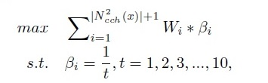

to meet demands of upper-layer safety applications, the beacon rate of vehicles can range from 1 Hz to 10 Hz. To satisfy the fairness of each vehicle, the minimum beacon rate bmin should be 1/10 beacon/frame.

All vehicles are first assigned with the minimum beacon rate min; for the remaining medium resource, vehicles are first ranked according to the link weight W and the vehicle with the largest W is then assigned with more medium resource until reaching max.

For the purpose of making reliability and safe environment, packet Inter-reception time(IRT) is considered as Wi. So, we need to make a Dataset of some earlier values of Inter-reception time of vehicles. we can obtain n samples somehow in a form of < IRT1, IRT5 and IRT10, label>.

**Tabu Search:**

Initial solution of Tabu Search algorithm can be defined using current state, previous state or random initialization methods. Given initial solution, Tabu Search algorithm generates a collection of new solutions called neighborhood set. To obtain neighborhood set, Tabu Search selects the values of transmission range and transmission rate between 10-1000 meters, and 3-27 Mbps, respectively, based on DSRC standard. The standard values for transmission rate are defined 3, 4.5, 6, 9, 12, 18, 24, and 27 Mbps. The potential values for transmission range are 10, 50, 100, 126, 150, 210, 300, 350, 380, 450, 550, 650, 750, 850, 930, 971, and 1000 m. Then, by finding feasible solutions in the neighborhood set, candidate solution list is developed. Candidate list is searched for selecting the best solution. The best solution is the solution that has minimum values of delay and jitter. In Delay formula, we can put Transmission Datarate and Transmission Range, then try to choose values that minimize delay.

Some possible solutions instead of [delay, jitter]:

1: [Delay, pdr]

2: [Delay, Inter-reception time]: Packet inter-reception time (PIR) is defined as the interval of time elapsed between two successful beacon receptions, and is promoted as a metric that describes the level of “situation-awareness” achieved on board vehicles more accurately than PDR. PIR is a metric that is also closely related to jitter. In the article of Mrs Taherkhani, Jitter doesn’t directly affect by Transmission rate or transmission range. delay affects on jitter, and delay is minimized, so they concluded Tabu search minimize both of them (delay and jitter). jitter and delay affects reception time. So by minimizing these two metrics, we can conclude Packet inter-reception time is reduced.

3: Beside allocation Transmission Datarate and Transmission Range, according to below formula, we also can calculate by tabu search Wmin according to density, in order to minimize the collision probability.

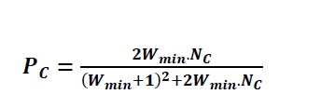

PC is also the collision probability calculated in exponential back-off mechanism of 802.11. NC denotes the number of contenders within the transmission range.

4:

