 O-RAN.WG1.O-RAN-Architecture-Description-v07.00

Technical Specification

O-RAN Architecture Description

Copyright © 2022 by the O-RAN ALLIANCE e.V.

The copying or incorporation into any other work of part or all of the material available in this specification in any form without the prior written permission of O-RAN ALLIANCE e.V. is prohibited, save that you may print or download extracts of the material of this specification for your personal use, or copy the material of this specification for the purpose of sending to individual third parties for their information provided that you acknowledge O-RAN ALLIANCE as the source of the material and that you inform the third party that these conditions apply to them and that they must comply with them.

O-RAN ALLIANCE e.V., Buschkauler Weg 27, 53347 Alfter, Germany

Register of Associations, Bonn VR 11238, VAT ID DE321720189

Contents

Chapter 1. Introductory Material 4

1.1 Scope 4

1.2 References 4

1.3 Definitions and Abbreviations 6

1.3.1 Definitions 6

1.3.2 Abbreviations 7

Chapter 2. O-RAN Overview 10

2.1 Scope and Objectives 10

Chapter 3. General O-RAN Architecture Principles 11

Chapter 4. O-RAN Architecture 12

4.1 Overall Architecture of O-RAN 12

4.2 O-RAN Control Loops 14

4.3 Description of O-RAN Functions 14

4.3.1 Service Management and Orchestration (SMO) 14

4.3.2 Near-RT RIC 17

4.3.3 O-CU-CP 17

4.3.4 O-CU-UP 18

4.3.5 O-DU 18

4.3.6 O-RU 18

4.3.7 O-eNB 18

4.3.8 O-Cloud 19

4.4 Relevant Interfaces in O-RAN Architecture 19

4.4.1 A1 Interface 19

4.4.2 O1 Interface 20

4.4.3 O2 Interface 20

4.4.4 E2 Interface 20

4.4.5 O-Cloud Notification Interface 20

4.4.6 Open Fronthaul Interface 20

4.4.7 E1 Interface 20

4.4.8 F1-c Interface 20

4.4.9 F1-u Interface 20

4.4.10 NG-c Interface 21

4.4.11 NG-u Interface 21

4.4.12 X2-c Interface 21

4.4.13 X2-u Interface 21

4.4.14 Xn-c Interface 21

4.4.15 Xn-u Interface 21

4.4.16 Uu Interface 21

4.4.17 CTI (Cooperative Transport Interface) 21

4.5 UE Associated Identifiers Used in O-RAN 21

4.6 O-RAN Security Architecture 22

4.6.1 O-RAN Security Benefits 23

4.6.2 O-RAN Threat Analysis 23

4.6.3 O-RAN Security Protocols 23

4.6.4 Considerations for a Zero-Trust Architecture 23

4.6.5 Planned Security Enhancements 24

Chapter 5. O-RAN Information Model (IM) Principles 25

Annex A (Informative): Implementation Options of O-RAN Functions and Network Elements 26

A.1 Shared Cell 26

A.2 FHGW Function 27

A.3 Near-RT RIC 28

A.4 Near-RT RIC, O-CU-CP, O-CU-UP, O-DU and O-RU 28

A.5 Cooperative Transport 33

Revision History 34

History 38

# Introductory Material

## Scope

This Technical Specification has been produced by the O-RAN Alliance.

The contents of the present document are subject to continuing work within O-RAN WG1 and may change following formal O-RAN approval. Should the O-RAN Alliance modify the contents of the present document, it will be re-released by O-RAN Alliance with an identifying change of release date and an increase in version number as follows:

Release xx.yy

where:

xx the first digit is incremented for all changes of substance, i.e., technical enhancements, corrections, updates, etc. (the initial approved document will have xx=01).

yy the second digit is incremented when editorial only changes have been incorporated in the document.

zz the third digit included only in working versions of the document indicating incremental changes during the editing process.

For the very first draft version of this document, the version shall be 00.00.01, followed by working versions 00.00.02, 00.00.03, etc. until an approved version is agreed for publication, which shall be numbered 01.00. After the first version is published, the next working version shall be 01.00.01, followed by 01.00.02, 01.00.03 and so on until the next published version is approved, which (if a minor revision with editorial changes only) shall be numbered 01.01 or (if a major revision) shall be numbered 02.00. No published version of this document shall include three digit-groups.

The present document defines the O-RAN architecture and interfaces.

## References

The following documents contain provisions which, through reference in this text, constitute provisions of the present document.

- References are either specific (identified by date of publication, edition number, version number, etc.) or non‑specific.

- For a specific reference, subsequent revisions do not apply.

- For a non-specific reference, the latest version applies. In the case of a reference to a 3GPP document (including a GSM document), a non-specific reference implicitly refers to the latest version of that document.

1. 3GPP TR 21.905: “Vocabulary for 3GPP Specifications”.
2. 3GPP TR 38.801: “Study on new radio access technology: Radio access architecture and interfaces (Release 14)”.
3. 3GPP TS 23.501: “System Architecture for the 5G System (5GS); Stage 2”.
4. 3GPP TS 28.622: " Generic Network Resource Model (NRM); Stage 2".
5. 3GPP TS 32.101: “Technical Specification Group Services and System Aspects; Telecommunication management; Principles and high level requirements (Release 15)”.
6. 3GPP TS 36.401: “ Evolved Universal Terrestrial Radio Access Network (E-UTRAN); Architecture Description”.
7. 3GPP TS 36.420: “Evolved Universal Terrestrial Radio Access Network (E-UTRAN); X2 general aspects and principles”.
8. 3GPP TS 38.300 “NR; NR and NG-RAN Overall Description; Stage 2”.
9. 3GPP TS 38.401: "NG-RAN; Architecture description".
10. 3GPP TS 38.420: “NG-RAN; Xn general aspects and principles”.
11. 3GPP TS 38.460: "NG-RAN; E1 general aspects and principles".
12. 3GPP TS 38.470: "NG-RAN; F1 general aspects and principles".
13. O-RAN.SFG.Security-Protocols-Specifications-v03.00: “O-RAN Security Focus Group; Security Protocols Specifications v03.00”.
14. O-RAN.SFG.Security-Requirements-Specifications-v03.00: “O-RAN Security Focus Group; Security Requirements Specifications v03.00”.
15. O-RAN.SFG.Threat-Model-v03.00: “O-RAN Security Focus Group; Security Threat Modeling and Remediation Analysis v03.00”.
16. O-RAN White Paper: “O-RAN: Towards an Open and Smart RAN”, October 2018.
17. O-RAN.WG1.Information Model and Data Models-v01.00: “O-RAN Working Group 1; O-RAN Information Model and Data Models Specification”.
18. O-RAN.WG1.Use-Cases-Analysis-Report-v08.00: “O-RAN Working Group 1; Use Cases Analysis Report v08.00”.
19. O-RAN.WG1.Use-Cases-Detailed-Specification-v08.00: “O-RAN Working Group 1; Use Cases Detailed Specification v08.00”.
20. O-RAN-WG2.A1GAP-v02.03: “O-RAN Working Group 2; A1 interface: General Aspects and Principles v02.03”.
21. O-RAN.WG2.Non-RT-RIC-ARCH-TS-v02.00: “O-RAN Working Group 2; Non-RT RIC Architecture Technical Specification v02.00”.
22. ORAN-WG3.E2GAP.0-v02.02 “O-RAN Working Group 3; Near-Real-time RAN Intelligent Controller Architecture & E2 General Aspects and Principles v02.02”.
23. ORAN-WG3.E2SM-v02.01: “O-RAN Working Group 3; Near-Real-time RAN Intelligent Controller E2 Service Model (E2SM) v02.01”.
24. O-RAN.WG4.CTI-TCP.0-v02.00: “Cooperative Transport Interface; Transport Control Plane Specification v02.00”.
25. O-RAN.WG4.CTI-TMP.0-v02-00: “Cooperative Transport Interface; Transport Management Plane Specification v02.00”.
26. O-RAN-WG4.CUS.0-v09.00: “O-RAN Fronthaul Working Group; Control, User and Synchronization Plane Specification v09.00”.
27. O-RAN-WG4.MP.0-v09.00: “O-RAN Alliance Working Group 4; Management Plane Specification v09.00”.
28. O-RAN-WG6.CAD-v03.00: “Cloud Architecture and Deployment Scenarios for O-RAN Virtualized RAN v03.00”.
29. O-RAN.WG6.O-Cloud Notification API for Event Consumers -v02.01: “O-RAN Working Group 6; O-Cloud Notification API Specification for Event Consumers v02.01”.
30. ORAN.WG7.IPC-HRD-Opt8.0-v03.00: “O-RAN WG7; Hardware Reference Design Specification for Indoor Picocell FR1 with Split Architecture Option 8 v03.00”.
31. O-RAN-WG10.OAM-Architecture-v07.00: “O-RAN WG1 Operations and Maintenance Architecture v07.00”.
32. O-RAN-WG10.O1-Interface-v07.00: “O-RAN Operations and Maintenance Interface Specification v07.00”.
33. Rose, S., Borchert, O., Mitchell, S., and Connelly, S., NIST SP 800-207: “Zero-Trust Architecture”, U.S. NIST, August 2020, <https://csrc.nist.gov/publications/detail/sp/800-207/final>.
34. SP 800-52, Revision 2: “Guidelines for the Selection, Configuration, and Use of Transport Layer Security (TLS) Implementations”, U.S. NIST, August 2019, <https://csrc.nist.gov/publications/detail/sp/800-52/rev-2/final>.

## Definitions and Abbreviations

### Definitions

For the purposes of the present document, the terms and definitions given in 3GPP TR 21.905 [1] and the following apply. A term defined in the present document takes precedence over the definition of the same term, if any, in 3GPP TR 21.905 [1].

**E2 Node:** A logical node terminating E2 interface. In this version of the specification, O-RAN nodes terminating E2 interface are:

* for NR access: O-CU-CP, O-CU-UP, O-DU or any combination as defined in [22],
* for E-UTRA access: O-eNB as defined in Section 4.3.7.

**Managed Application:** The definition of Managed Application is given in O-RAN Operations and Maintenance Architecture [31].

**Managed Element:** The definition of a Managed Element (ME) is given in 3GPP TS 28.622 [4], Section 4.3.3.

**Managed Function:** The definition of a Managed Function (MF) is given in 3GPP TS 28.622 [4], Section 4.3.4.

**Near-RT RIC:** O-RAN Near-Real-Time RAN Intelligent Controller: A logical function that enables near-real-time control and optimization of RAN elements and resources via fine-grained data collection and actions over E2 interface. It may include AI/ML (Artificial Intelligence / Machine Learning) workflow including model training, inference and updates. Please refer to [22] for more information

**Non-RT RIC:** O-RAN Non-Real-Time RAN Intelligent Controller: A logical function within SMO that drives the content carried across the A1 interface. It is comprised of the Non-RT RIC Framework and the Non-RT RIC Applications (rApps) whose functions are defined below. Please refer to [20] for more information.

**Non-RT RIC Applications (rApps):** Modular applications that leverage the functionality exposed via the Non-RT RIC Framework’s R1 interface to provide added value services relative to RAN operation, such as driving the A1 interface, recommending values and actions that may be subsequently applied over the O1/O2 interface and generating “enrichment information” for the use of other rApps. The rApp functionality within the Non-RT RIC enables non-real-time control and optimization of RAN elements and resources and policy-based guidance to the applications/features in Near-RT RIC. Please refer to [21] for more information.

**Non-RT RIC Framework:** That functionality internal to the SMO that logically terminates the A1 interface to the Near-RT RIC and exposes to rApps, via its R1 interface, the set of internal SMO services needed for their runtime processing. The Non-RT RIC Framework functionality within the Non-RT RIC provides AI/ML workflow including model training, inference and updates needed for rApps. Please refer to [21] for more information.

**NMS:** A Network Management System for the O-RU as specified in [27] to support legacy Open Fronthaul M-Plane deployments (prior to version 5 of [27]).

**O-Cloud:** O-Cloud is a cloud computing platform comprising a collection of physical infrastructure nodes that meet O-RAN requirements to host the relevant O-RAN functions (such as Near-RT RIC, O-CU-CP, O-CU-UP, and O-DU), the supporting software components (such as Operating System, Virtual Machine Monitor, Container Runtime, etc.) and the appropriate management and orchestration functions. Please refer to [28] for more information.

**O-CU-CP**: O-RAN Central Unit – Control Plane: a logical node hosting the RRC and the control plane part of the PDCP protocol. Please refer to Section 4.3.3 for more information.

**O-CU-UP**: O-RAN Central Unit – User Plane: a logical node hosting the user plane part of the PDCP protocol and the SDAP protocol. Please refer to Section 4.3.4 for more information.

**O-DU**: O-RAN Distributed Unit: a logical node hosting RLC/MAC/High-PHY layers based on a lower layer functional split. Please refer to Section 4.3.5 for more information.

**O-eNB:** An eNB [6] or ng-eNB [8] that supports E2 interface. Please refer to Section 4.3.7 for more information.

**O-RU**: O-RAN Radio Unit: a logical node hosting Low-PHY layer and RF processing based on a lower layer functional split. This is similar to 3GPP’s “TRP” or “RRH” but more specific in including the Low-PHY layer (FFT/iFFT, PRACH extraction). Please refer to Section 4.3.6 for more information.

**O1**: Interface between SMO framework as specified in Section 4.3.1 and O-RAN managed elements, for operation and management, by which FCAPS management, PNF (Physical Network Function) software management, File management shall be achieved.

**O2**: Interface between SMO framework as specified in Section 4.3.1 and the O-Cloud for supporting O-RAN virtual network functions. Please refer to [28] for more information.

**Open FH M-Plane**: Management interface controlling the O-RU, generally driven from the O-DU but in the case of the hybrid topology also driven from the SMO. Please refer to [27] for more details.

**SMO:** A Service Management and Orchestration system as described in Section 4.3.1**.**

**xApp**: An application designed to run on the near-RT RIC. Such an application is likely to consist of one or more microservices and at the point of on-boarding will identify which data it consumes and which data it provides. The application is independent of the near-RT RIC and may be provided by any third party. The E2 enables a direct association between the xApp and the RAN functionality [22].

### Abbreviations

For the purposes of the present document, the abbreviations given in 3GPP TR 21.905 [1] and the following apply. An abbreviation defined in the present document takes precedence over the definition of the same abbreviation, if any, in 3GPP TR 21.905 [1].

3GPP 3rd Generation Partnership Project

5GC 5G Core

5GS 5G System

AAL Accelerator Abstraction Layer

API Application Programing Interface

AI Artificial Intelligence

AMF Access and Mobility Functions

CM Configuration Management

CMTS Cable Modem Termination System

CSP Communications Service Provider

CTI Cooperative Transport Interface

D-TLS Datagram Transport Layer Security

DOCSIS Data Over Cable Service Interface Specification

DM Data Model

E-UTRA Evolved Universal Terrestrial Radio Access

E-UTRAN Evolved Universal Terrestrial Radio Access Network

EN-DC E-UTRAN New Radio – Dual Connectivity

eNB evolved Node B

FCAPS Fault, Configuration, Accounting, Performance, Security

FFT Fast Fourier Transform

FHGW Fronthaul Gateway

FHM Fronthaul Multiplexer

FM Fault Management

gNB next generation Node B

gNB-CU gNB Central Unit

gNB-DU gNB Distributed Unit

iFFT inverse Fast Fourier Transform

IM Information Model

IPSec Internet Protocol Security

LAN Local Area Networks

LLS Lower Layer Split

LTE Long Term Evolution

MA Managed Application

MAC Media Access Control

ME Managed Element

MF Managed Function

ML Machine Learning

NAC Network Access Control

Near-RT RIC Near-Real-Time RAN Intelligent Controller

NETCONF Network Configuration Protocol

NFV Network Function Virtualization

NG Next Generation

NG-RAN Next Generation RAN

NIST National Institute of Standards and Technology

NMS Network Management System

Non-RT RIC Non-Real-Time RAN Intelligent Controller

NR 5G New Radio

O-Cloud O-RAN Cloud

O-CU-CP O-RAN Central Unit – Control Plane.

O-CU-UP O-RAN Central Unit – User Plane

O-DU O-RAN Distributed Unit

O-eNB O-RAN eNB

O-RAN Open RAN

O-RU O-RAN Radio Unit

OLT Optical Line Terminal

ONU Optical Network Unit

Open FH Open Fronthaul

PDCP Packet Data Convergence Protocol

PHY Physical layer

PKI Public Key Infrastructure

PKIX Public Key Infrastructure (X.509)

PM Performance Management

PNF Physical Network Function

PON Passive Optical Network

PRACH Physical Random Access Channel

RAN Radio Access Network

rApp Non-RT RIC Application

RAT Radio Access Technology

RF Radio Frequency

RLC Radio Link Control

RRC Radio Resource Control

RRH Remote Radio Head

RRM Radio Resource Management

RRU Remote Radio Unit

RT Real Time

RU Radio Unit

SBA Service Based Architecture

SBOM Software Bill of Materials

SDAP Service Data Adaptation Protocol

SMO Service Management and Orchestration

SSHv2 Secure Shell 2.0

TLS Transport Layer Security

TN Transport Node

TR Technical Report

TRP Transmission and Reception Point

TS Technical Specification

TU Transport Unit

VNF Virtualized Network Function

UE User Equipment

UL Up Link

WG Working Group

xApp Near-RT RIC Application

xNF Any Network Function

ZTA Zero Trust Architecture

# O-RAN Overview

## Scope and Objectives

O-RAN activities are guided by the following objectives [16]:

* Leading the industry towards open, interoperable interfaces, RAN virtualization, and big data and AI enabled RAN intelligence.
* Maximizing the use of common-off-the-shelf hardware and merchant silicon and minimizing proprietary hardware
* Specifying APIs and interfaces, driving standards to adopt them as appropriate, and exploring open source where appropriate
* The O-RAN Architecture identifies the key functions and interfaces adopted in O-RAN.

# General O-RAN Architecture Principles

This section contains the general O-RAN architecture principles as described below.

* The O-RAN architecture and interface specifications shall be consistent with 3GPP architecture and interface specifications to the extent possible.
* This document shall represent the O-RAN architecture at the time of its publication and may evolve as deemed appropriate by the O-RAN community.

# O-RAN Architecture

## Overall Architecture of O-RAN

Figure 4.1‑1 below provides a high-level view of the O-RAN architecture. It shows that the four key interfaces – namely, A1, O1, Open Fronthaul M-plane and O2 – connect SMO (Service Management and Orchestration) framework to O-RAN network functions and O-Cloud. As depicted in this figure, the O-Cloud includes the O-Cloud Notification interface [29] which is available for the relevant O-RAN network functions (e.g., Near-RT RIC, O-CU-CP, O-CU-UP and O-DU) to receive O-Cloud related notifications.

Figure 4.1‑1 below also illustrates that the O-RAN network functions can be VNFs (Virtualized Network Function), i.e., VMs or Containers, sitting above the O-Cloud and/or PNFs (Physical Network Function) utilizing customized hardware. All O-RAN network functions are expected to support the O1 interface when interfacing the SMO framework.

The Open Fronthaul M-plane interface, between SMO and O-RU, is to support the O-RU management in hybrid mode, as specified in [27]. The O-RU termination of the O1 interface towards the SMO as specified in [31] is under study. The management architecture of the flat mode [31] and its relation to O1 interface for the O-RU is a subject for future study.

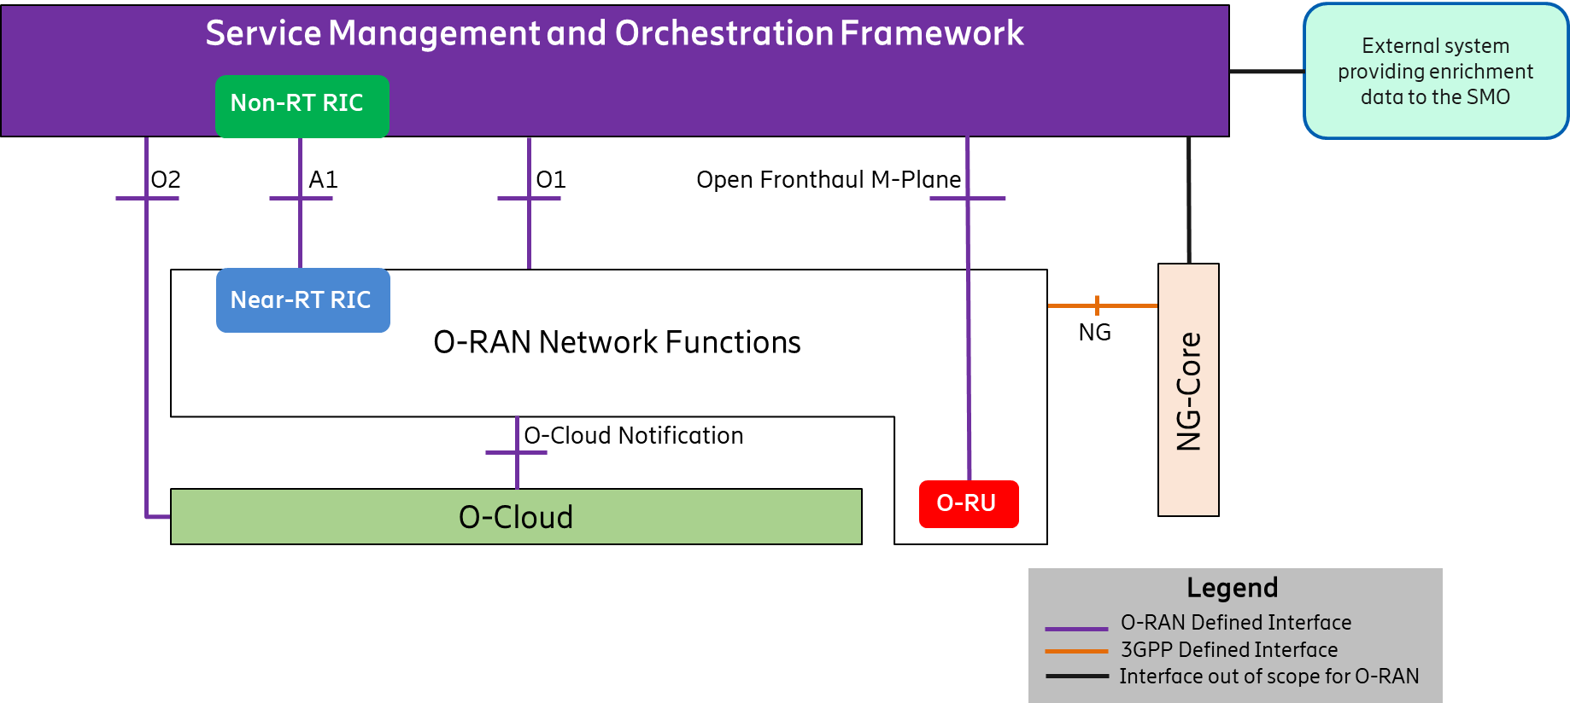

Figure 4.1‑1: High Level Architecture of O-RAN

Within the logical architecture of O-RAN, as shown in Figure 4.1‑2 below, the radio side includes Near-RT RIC, O-CU-CP, O-CU-UP, O-DU, and O-RU functions. The E2 interface connects O-eNB to Near-RT RIC. Although not shown in this figure, the O-eNB does support O-DU and O-RU functions with an Open Fronthaul interface between them.

As stated earlier, the management side includes SMO Framework containing a Non-RT-RIC function. The O-Cloud, on the other hand, is a cloud computing platform comprising a collection of physical infrastructure nodes that meet O-RAN requirements to host the relevant O-RAN functions (such as Near-RT RIC, O-CU-CP, O-CU-UP and O-DU etc.), the supporting software components (such as Operating System, Virtual Machine Monitor, Container Runtime, etc.) and the appropriate management and orchestration functions. The virtualization of O-RU is for future study.

As shown in this figure, the O-RU terminates the Open Fronthaul M-Plane interface towards the O-DU and SMO as specified in [27].

**Note:** The LLS (O-DU to O-RU interface) specified in Sections 4.3.5 and 4.3.6 (Split Option 7-2x) is the Open Fronthaul interface described in the O-RAN Open Fronthaul Specification [26]. Other LLS options [2] may be considered for reference designs when the relevant interfaces are described in specifications created by related open industry initiatives (e.g., the Small Cell Forum for Split Option 6) or in O-RAN white-box hardware specifications (e.g., Split Option 8).

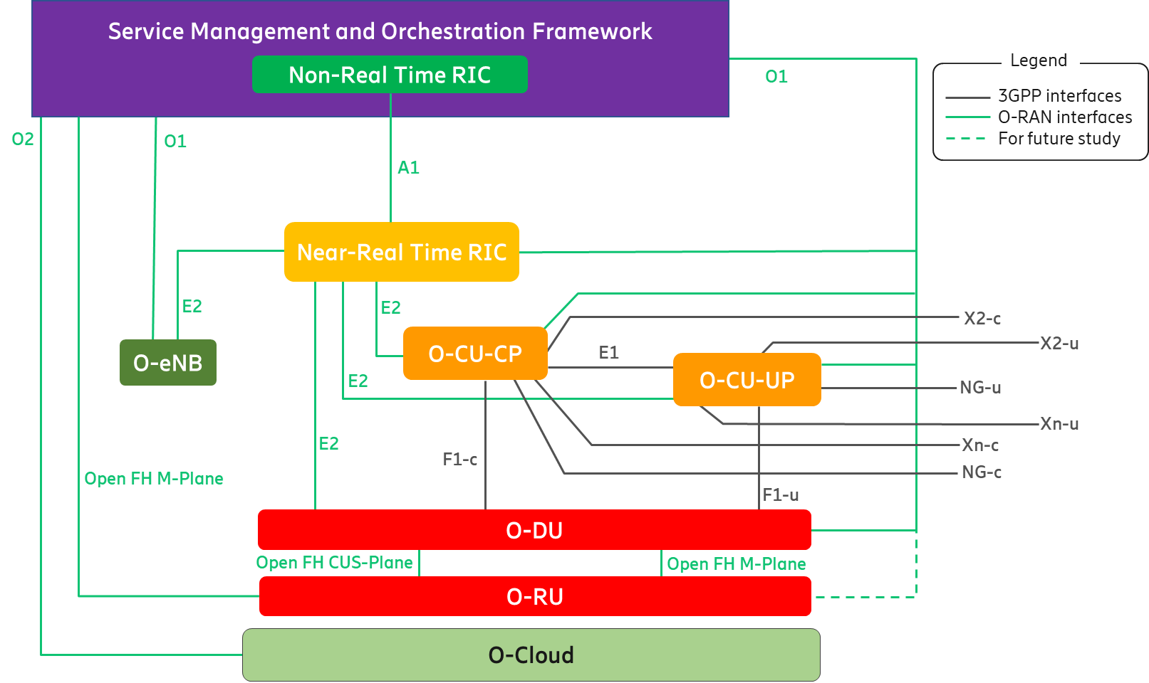

Figure 4.1‑2: Logical Architecture of O-RAN

The following figure shows the Uu interface between UE and O-RAN components as well as between UE and O-eNB. As shown in Figure 4.1‑3 below, the dotted box denotes all the O-RAN functions required to support the Uu interface for NR. The O-eNB, on the other hand, terminates the Uu interface for LTE. Please refer to Section 4.4.16 for more details.

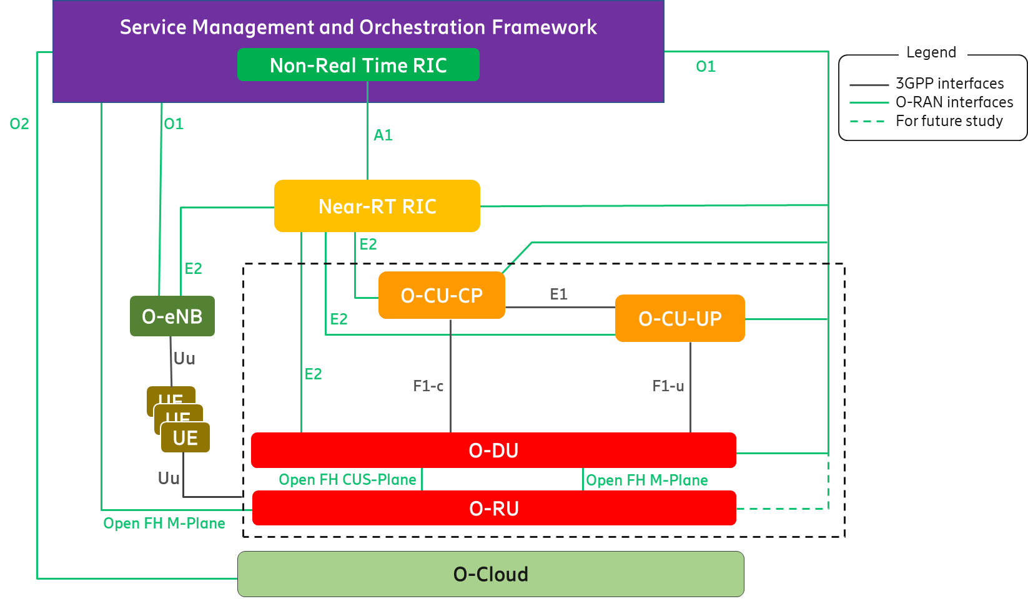

Figure 4.1‑3: Uu interface for O-RAN components and O-eNB

## O-RAN Control Loops

The O-RAN architecture supports at least the following control loops involving different O-RAN functions:

* Non-RT (Non-Real Time) control loops
* Near-RT (Near-Real Time) control loops
* RT (Real Time) control loops

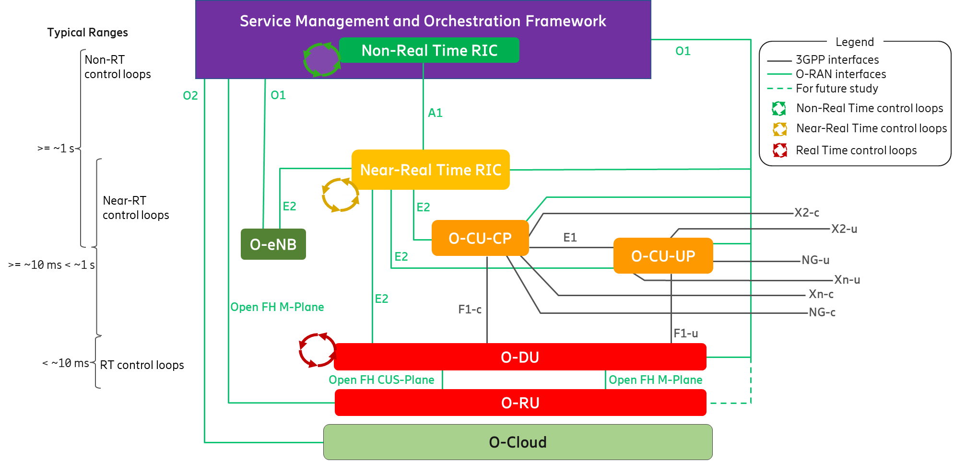

Figure 4.2‑1: O-RAN Control Loops

As shown in Figure 4.2‑1 above, the control loops are defined based on the controlling entity and the architecture shows the other logical nodes with which the control loop host interacts.

Control loops exist at various levels and run simultaneously. Depending on the use case, they may or may not interact with each other. The use cases for the Non-RT and Near-RT control loops and the interaction between the RICs for these use cases are fully defined by O-RAN Use Cases Analysis Report [18]. This report [18] also defines relevant interaction for the O-CU-CP and O-DU control loops, responsible for call control and mobility, radio scheduling, HARQ, beamforming etc. along with slower mechanisms involving SMO management interfaces.   
The timing of these control loops is use case dependent. Typical execution time for use cases involving the Non-RT control loops are 1 second or more; Near-RT control loops are in the order of 10 milliseconds or more; control loops in the E2 Nodes can operate below 10 milliseconds. (e.g., O-DU radio scheduling).

For any specific use case, however, a stable solution would require the loop time in the non-RT RIC and/or SMO management plane processes to be significantly longer than the loop time for the same use case in the control entities stated above.

## Description of O-RAN Functions

### Service Management and Orchestration (SMO)

#### SMO Architecture Principles

Service Based Architecture (SBA) introduces the roles of service producer and service consumer together with standardized service-based interfaces. These standardized service-based interfaces enable interoperability within the SMO. SBA is not concerned with the implementation, but it defines logical functions in their service producer and consumer roles. When properly applied the SBA approach can enable the following:

* Validates produced services with consumer use cases.
* Identifies service operations with their information model defining semantic behaviour.
* Specifies the API and a data model for a syntactic interface.
* Identifies common services that can be produced by a single producer such as those that are commonly used by multiple internal consumers (e.g., authentication, authorization, service registration and discovery, data management, etc.).

#### SMO Functionality

This section describes the functionality provided by the SMO in O-RAN. In a Service Provider’s Network, there can be many management domains such as RAN management, Core Management, Transport Management, End to End Slice Management etc. In the O-RAN architecture, SMO is responsible for RAN domain management. The SMO description in this architecture document is focused on the SMO services that support the RAN. The key capabilities of the SMO that provide RAN support in O-RAN are:

* FCAPS interface to O-RAN Network Functions
* Non-RT RIC for RAN optimization
* O-Cloud Management, Orchestration and Workflow Management

The SMO performs these services through four key interfaces to the O-RAN Elements.

* A1 Interface between the Non-RT RIC in the SMO and the Near-RT RIC for RAN Optimization.
* O1 Interface between the SMO and the O-RAN Network Functions for FCAPS support.
* In the hybrid model, Open Fronthaul M-plane interface between SMO and O-RU for FCAPS support.
* O2 Interface between the SMO and the O-Cloud to provide platform resources and workload management.

SMO does not define any formal interface towards the Non-RT RIC. An SMO deployment, therefore, may make its own design choice for creating a boundary towards the Non-RT RIC Framework, or choose not to implement a clear boundary at all.

The following definitions apply to the functionality of the SMO:

* Non-RT RIC Framework Anchored Functionality – This functionality is associated with the Non-RT RIC Framework itself. Examples include the A1 and R1 interfaces (see Section 4.3.1.2).
* O-RAN SMO Framework Anchored Functionality – This functionality is not associated with the Non-RT RIC Framework. Examples include the O1, Open FH M-plane and O2 interfaces.
* Non-anchored Functionality – This functionality may or may not be associated with the Non-RT RIC Framework.

These terms and the relationships between the functions are illustrated in Figure 4.3‑1 below. Extending the “Functions that enable rApps” outside the Non-RT RIC (i.e., into the SMO Framework), as shown in this figure, denotes that the R1 services being exposed may either come from the Non-RT RIC or the SMO.

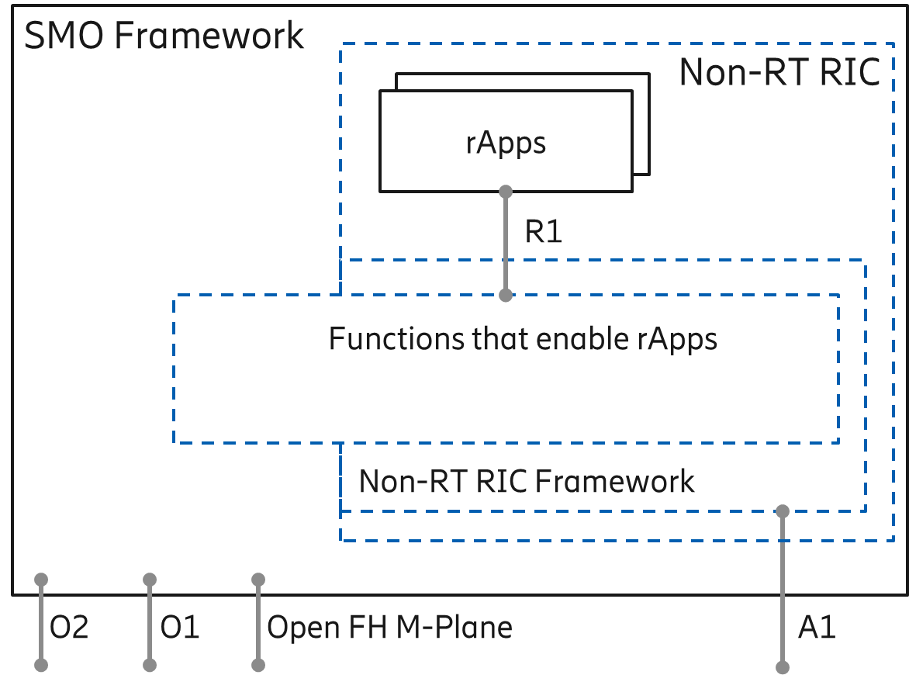

Figure 4.3‑1: Exposure of SMO and Non-RT RIC Framework Services

Please refer to [21] for more details.

##### SMO support for FCAPS to O-RAN Network Functions

The SMO provides support for O-RAN network function FCAPS via the O1 Interface. The O1 Interface is defined in [32]. The O1 interface is aligned to the degree possible with the 3GPP specifications for RAN element management. In its role of supporting the FCAPs capabilities of O-RAN Network Functions, the SMO is providing support as described in [5]. The following FCAPS functions defined in the O1 Specification are examples of the functionality across the O1 interface. See [32] for a fully defined list.

* Performance Management (PM)
* Configuration Management (CM)
* Fault Management (FM)
* File Management
* Communications Surveillance (Heartbeat)
* Trace
* Physical Network Function (PNF) Discovery
* PNF Software Management.

The Open Fronthaul M-plane interface, as defined in [27], is specific for supporting FCAPS to the O-RU. The following FCAPS functions, as defined in [27], are examples of capabilities supported across this Open Fronthaul M-plane interface.

* “Start-up” installation
* SW management
* Configuration management
* Performance management
* Fault Management
* File Management

##### Non-RT RIC

Non-Real Time RAN Intelligent Controller (Non-RT RIC) is the functionality internal to the SMO in O-RAN architecture that provides the A1 interface to the Near-Real Time RIC.

The primary goal of Non-RT RIC is to support intelligent RAN optimization by providing policy-based guidance, ML model management and enrichment information to the near-RT RIC function so that the RAN can optimize, e.g., RRM under certain conditions [20]. It can also perform intelligent radio resource management function in non-real-time interval (i.e., greater than 1 second).

Non-RT RIC can use data analytics and AI/ML training/inference to determine the RAN optimization actions for which it can leverage SMO services such as data collection and provisioning services of the O-RAN nodes as well as the O1 and O2 interfaces.

The Non-RT RIC is comprised of two sub-functions:

* Non-RT RIC Framework – Functionality internal to the SMO Framework that logically terminates the A1 interface and exposes the required services to rApps through its R1 interface.
* Non-RT RIC Applications (rApps) – Modular applications that leverage the functionality exposed by the Non-RT RIC Framework to perform RAN optimization and other functions. Services exposed to rApps via the R1 interface enable rApps to obtain information and trigger actions (e.g., policies, re-configuration) through the A1, O1, O2 and Open FH M-Plane related services.

The Non-RT RIC Framework is responsible for exposing all required functionality to the rApps, whether from the Non-RT RIC Framework, or the SMO Framework.

For more information, please refer to [21].

##### O-Cloud Management, Orchestration and Workflow Management

The SMO provides the capability of managing the O-Clouds as well as providing support for the orchestration of platform and application elements and workflow management. The SMO utilizes the O2 interface to the O-Cloud to provide these capabilities. The O2 interface supports the management of the cloud infrastructure and the use of the cloud resources allocated to the RAN. The O2 interface will be fully specified in the O2 interface specification by Working Group 6. The example functionalities should be supported but are not limited to the following:

* Discovery and administration of O-Cloud Resources
* Scale-In, Scale-Out for O-Cloud
* FCAPS (PM, CM, FM, Communication Surveillance) of O-Cloud
* Software Management of Cloud Platform
* Create, Delete Deployments and Associated Allocated O-Cloud Resources
* Scale-In, Scale-Out Deployments and Allocated O-Cloud Resources
* FCAPS (PM, FM) of Deployments and Allocated O-Cloud Resources
* Software Management of Deployments

### Near-RT RIC

It is a logical function that enables near real-time control and optimization of E2 Nodes functions and resources via fine-grained data collection and actions over the E2 interface with control loops in the order of 10 ms-1s. The Near-RT RIC hosts one or more xApps that use E2 interface to collect near real-time information (e.g., on a UE basis or a Cell basis) and provide value added services. The Near-RT RIC control over the E2 Nodes is steered via the policies and the enrichment data provided via A1 from the Non-RT RIC.

The RRM functional allocation between the Near-RT RIC and the E2 Node is subject to the capability of the E2 Node exposed over the E2 interface by means of the E2 Service Model [23], in order to support the use cases described in [19]. The E2 service model describes the functions in the E2 Node which may be controlled by the Near-RT RIC and the related procedures, thus defining a function-specific RRM split between the E2 Node and the Near-RT RIC. For a function exposed in the E2 Service Model [23], the near RT RIC may e.g., monitor, suspend/stop, override or control via policies the behavior of E2 Node.

In the event of a Near-RT RIC failure, the E2 Node will be able to provide services but there may be an outage for certain value-added services that may only be provided using the Near-RT RIC.

### O-CU-CP

The O-CU-CP terminates the NG-c, X2-c, Xn-c, F1-c and E1 interfaces as well as the RRC and PDCP (for SRB) protocols towards the UE as specified in [9].

The O-CU-CP terminates E2 interface to Near-RT RIC as specified in [22].

The O-CU-CP terminates O1 interface towards the SMO as specified in [31].

The O-CU-CP terminates NG-c interface to 5GC as specified in [8].

The O-CU-CP terminates X2-c interface to eNB or to en-gNB in EN-DC as specified in [7] [8].

The O-CU-CP terminates Xn-c to gNB or ng-eNB as specified in [8] [10].

### O-CU-UP

The O-CU-UP terminates the NG-u, X2-u, S1-u, Xn-u, F1-u and E1 interfaces as well as the PDCP and SDAP protocols towards the UE as specified in [9].

The O-CU-UP terminates E2 interface to Near-RT RIC as specified in [22].

The O-CU-UP terminates O1 interface towards the SMO as specified in [31].

The O-CU-UP terminates NG-u interface to 5GC as specified in [8].

The O-CU-UP terminates X2-u interface to eNB or to en-gNB in EN-DC as specified in [7] [8].

The O-CU-UP terminates Xn-u to gNB or ng-eNB as specified in [8] [10].

### O-DU

The O-DU terminates the E2 and the F1 interface (according to the principles described in Section 4.4.8), and the Open Fronthaul interface (also known as LLS interface [26]) as well as the RLC, MAC and High-PHY functions of the radio interface towards the UE.

The O-DU terminates the O1 interface towards the SMO as specified in [31].

The O-DU terminates the Open Fronthaul M-Plane interface, towards the O-RU, to support O-RU management either in hierarchical model or hybrid model, as specified in [27].

The O-DU may support CTI to a TN to control UL bandwidth allocation to TUs for UL LLS traffic on shared point-to-multipoint transport network (TN is a PON OLT or DOCSIS CMTS, TU is a PON ONU or DOCSIS Cable Modem). The CTI is specified in [24] and [25]. An informative overview of the CTI is shown in Annex A.

### O-RU

The O-RU terminates the Open Fronthaul interface (also known as LLS interface [26]) as well as Low-PHY functions of the radio interface towards the UE. This is a physical node.

The O-RU terminates the Open Fronthaul M-Plane interface towards the O-DU and SMO as specified in [27].

The O-RU termination of the O1 interface towards the SMO as specified in [31] is under study.

### O-eNB

The O-eNB terminates:

* the S1, X2 and E2 interfaces as well as the RRC, PDCP, RLC, MAC and PHY layers of the LTE-Uu radio interface towards the UE in case O-eNB is an eNB as defined in [6].
* the NG, Xn and E2 interfaces as well as the RRC, SDAP, NR PDCP, RLC, MAC and PHY layers of the LTE-Uu radio interface towards the UE in case O-eNB is an ng-eNB as defined in [8].

The O-eNB supports O-DU and O-RU functions with an Open Fronthaul interface between them as specified in [26] and [27].

### O-Cloud

O-Cloud is a cloud computing platform comprising a collection of physical infrastructure nodes that meet O-RAN requirements to host the relevant O-RAN functions (i.e., Near-RT RIC, O-CU-CP, O-CU-UP, and O-DU), the supporting software components (such as Operating System, Virtual Machine Monitor, Container Runtime, etc.) and the appropriate management and orchestration functions which satisfies the following criteria:

* Exports the O-RAN O2 interface for cloud and workload management to provide functions such as infrastructure discovery, registration, software lifecycle management, workload lifecycle management, fault management, performance management, and configuration management.
* Exports O-RAN Accelerator Abstraction Layer (AAL) API towards the hosted O-RAN workloads for hardware accelerator management.
* Exports O-Cloud Notification interface towards the hosted O-RAN workloads in order to notify the workloads of critical notifications (e.g., PTP synchronization states).
* Satisfies one or more of the deployment scenarios and their associated requirements as outlined in the O-RAN Cloud Architecture and Deployment Scenarios specification [28] and subsequent detailed scenario specifications published by O-RAN.
* The virtualization of the O-RU is for future study.

## Relevant Interfaces in O-RAN Architecture

The following interfaces are defined and maintained by O-RAN:

* A1 interface
* O1 interface
* O2 interface
* E2 interface
* O-Cloud Notification interface
* Open Fronthaul interface

The following interfaces are defined and maintained by 3GPP, but seen also as part of the O-RAN architecture:

* E1 interface
* F1-c interface
* F1-u interface
* NG-c interface
* NG-u interface
* X2-c interface
* X2-u interface
* Xn-c interface
* Xn-u interface
* Uu interface

Following sections describe the termination points of O-RAN defined interfaces and 3GPP interfaces adopted by O-RAN.

### A1 Interface

A1 interface is between Non-RT-RIC and the Near-RT RIC functions [20].

A1 is the interface between the Non-RT RIC function in SMO and the Near-RT RIC function. A1 interface supports three types of services as defined in [20]:

* Policy Management Service
* Enrichment Information Service
* ML Model Management Service

A1 policies have the following characteristics compared to persistent configuration [19] [20]. A1 policies,

* are not critical to traffic;
* have temporary validity;
* may handle individual UE or dynamically defined groups of UEs;
* act within and take precedence over the configuration;
* are non-persistent, i.e., do not survive a restart of the near-RT RIC.

### O1 Interface

The O1 interface is between O-RAN Managed Element and the management entity as defined in [31].

### O2 Interface

The O2 interface is between the SMO and O-Cloud as introduced in [28].

### E2 Interface

E2 is a logical interface connecting the near-RT RIC with an E2 Node as defined in [22].

* An E2 Node is connected to only one near-RT RIC.
* A near-RT RIC can be connected to multiple E2 Nodes.

The protocols over E2 interface are based exclusively on Control Plane protocols. The E2 functions are grouped into the following categories:

* Near-RT RIC Services (REPORT, INSERT, CONTROL and POLICY, as described in [22]).
* Near-RT RIC support functions, which include, e.g., E2 Interface Management (E2 Setup, E2 Reset, Reporting of General Error Situations etc.) and Near-RT RIC Service Update (capability exchange related to the list of E2 Node functions exposed over E2 etc.).

### O-Cloud Notification Interface

The O-Cloud Notification interface allows event consumer such as an O-DU deployed on O-Cloud to subscribe to events/status from the O-Cloud. The cloud infrastructure will provide event producer to enable cloud workloads to receive events/status that might be known only to the infrastructure.

### Open Fronthaul Interface

The Open FH (Fronthaul) Interface is between O-DU and O-RU functions [26] [27]. The Open FH Interface includes the CUS (Control User Synchronization) Plane and M (Management) Plane. In hybrid mode, the Open FH M-Plane interface connects the O-RU to the SMO for FCAPS functionality.

### E1 Interface

The E1 interface, as defined by 3GPP, is between the gNB-CU-CP and gNB-CU-UP logical nodes [9] [11]. In O-RAN, it reuses the principles and protocol stack defined by 3GPP but is adopted between the O-CU-CP and the O-CU-UP functions.

### F1-c Interface

The F1-c interface, as defined by 3GPP, is between the gNB-CU-CP and gNB-DU logical nodes [9] [12]. In O-RAN, it reuses the principles and protocol stack defined by 3GPP but is adopted between the O-CU-CP and the O-DU functions, as well as for the definition of interoperability profile specifications.

### F1-u Interface

The F1-u interface, as defined by 3GPP, is between the gNB-CU-UP and gNB-DU logical nodes [9] [12]. In O-RAN, it reuses the principles and protocol stack defined by 3GPP but is adopted between the O-CU-UP and the O-DU functions, as well as for the definition of interoperability profile specifications.

### NG-c Interface

The NG-c interface, as defined by 3GPP, is between the gNB-CU-CP and the AMF in the 5GC [8]. It is also referred as N2 in [8]. In O-RAN, it reuses the principles and protocol stack defined by 3GPP but is adopted between the O-CU-CP and the 5GC.

### NG-u Interface

The NG-u interface, as defined by 3GPP, is between the gNB-CU-UP and the UPF in the 5GC [8]. It is also referred as N3 in [8]. In O-RAN, it reuses the principles and protocol stack defined by 3GPP but is adopted between the O-CU-UP and the 5GC.

### X2-c Interface

The X2-c interface is defined in 3GPP for transmitting control plane information between eNBs or between eNB and en-gNB in EN-DC as specified in [7] [8]. In O-RAN, it reuses the principles and protocol stack defined by 3GPP but is adopted for the definition of interoperability profile specifications.

### X2-u Interface

The X2-u interface is defined in 3GPP for transmitting user plane information between eNBs or between eNB and en-gNB in EN-DC as specified in [7] [8]. In O-RAN, it reuses the principles and protocol stack defined by 3GPP but is adopted for the definition of interoperability profile specifications.

### Xn-c Interface

The Xn-c interface is defined in 3GPP for transmitting control plane information between gNBs, ng-eNBs or between ng-eNB and gNB as specified in [8] [10]. In O-RAN, it reuses the principles and protocol stack defined by 3GPP but is adopted for the definition of interoperability profile specifications.

### Xn-u Interface

The Xn-u interface is defined in 3GPP for transmitting user plane information between gNBs, ng-eNBs or between ng-eNB and gNB as specified in [8] [10]. In O-RAN, it reuses the principles and protocol stack defined by 3GPP but is adopted for the definition of interoperability profile specifications.

### Uu Interface

The UE to e/gNB interface in 3GPP is denoted as the Uu interface. The Uu is a complete protocol stack from L1 to L3 and as such, seen as a whole, it terminates in the NG-RAN. If the NG-RAN is decomposed, different protocols terminate at different reference points and none of them has been defined by O-RAN. Since the Uu messages still flow from the UE to the intended e/gNB managed function, it is not shown in the O-RAN architecture as a separate interface to a specific managed function. For more information on the Uu interface between the UE and the NG-RAN, please refer to chapters 5.2 and 5.3 of [9].

### CTI (Cooperative Transport Interface)

Interface between the O-DU and TN to dynamically control bandwidth allocations to TUs when using a shared point-to-multipoint transport network. The CTI is specified in [24] and [25].

## UE Associated Identifiers Used in O-RAN

As described earlier (Sections 4.3.1.2 and 4.3.2), the Non-RT RIC and Near-RT RIC enable intelligent RAN optimization via A1, O1 and E2 interfaces respectively.

To support intelligent RAN optimization, the Non-RT RIC with rApps and Near-RT RIC with xApps utilize the knowledge of different UE associated events reported by the O-RAN functions over E2 and O1 interfaces. Both the Non-RT RIC and Near-RT RIC may need to correlate different UE associated events reported by the O-RAN functions for the same UE. In order to facilitate this correlation task, the reporting O-RAN function includes a set of UE associated identifiers with any report containing UE specific information.

The Table 4.5‑1 below shows the set of UE associated identifiers to be reported by any O-RAN function over O1 and E2 interfaces for any UE associated information.

|  |  |  |
| --- | --- | --- |
| UE associated identifier | Reference Specification | Comments |
| AMF UE NGAP ID | 3GPP TS 38.413 | Reported by O-CU-CP and O-eNB for UEs connected to 5GC. |
| GUAMI | 3GPP TS 38.413 | Reported by O-CU-CP and O-eNB for UEs connected to 5GC. |
| MME UE S1AP ID | 3GPP TS 36.413 | Reported by O-eNB for UEs connected to EPC. |
| GUMMEI | 3GPP TS 36.413 | Reported by O-eNB for UEs connected to EPC. |
| gNB-CU UE F1AP ID | 3GPP TS 38.473 | Reported by O-CU-CP and O-DU. |
| gNB-CU-CP UE E1AP ID | 3GPP TS 38.463 | Reported by O-CU-CP and O-CU-UP. |
| RAN UE ID | 3GPP TS 38.473  3GPP TS 38.463 | Reported by O-CU-CP, O-CU-UP and O-DU when available/allocated. |
| M-NG-RAN node UE XnAP ID | 3GPP TS 38.423 | Identifier reported when the UE operates in DC with 5GC. Reported by O-CU-CP and O-eNB. |
| Global NG-RAN Node ID | 3GPP TS 38.423 | Identifier reported when the UE operates in DC with 5GC. Identifies the peer gNB/ng-eNB and is reported in conjunction with the M-NG-RAN node UE XnAP ID to ensure that the UE can be uniquely identified over Xn interface. Reported by O-eNB and O-CU-CP. |
| MeNB UE X2AP ID | 3GPP TS 36.423 | Identifier reported when the UE operate in DC with EPC. Reported by O-CU-CP and O-eNB. |
| Global eNB ID | 3GPP TS 36.423 | Identifier reported when the UE operate in DC with EPC. Identifies the peer eNB and is reported in conjunction with the MeNB UE X2AP ID to ensure that the UE can be uniquely identified over X2 interface. Reported by O-CU-CP and O-eNB. |

Table 4.5‑1: UE Associate Identifiers Used in O-RAN

Additionally, the Non-RT RIC and Near-RT RIC may initiate messages towards the O-RAN functions which are associated with specific UEs. In such cases, the Non-RT RIC and Near RT RIC may include one or more of the UE associated identifiers specified in the Table 4.5‑1 above with any UE associated messages over A1 and E2 interface for identification of the UE in the O-RAN functions.

## O-RAN Security Architecture

The goal of the O-RAN ALLIANCE is to achieve a secure, open, and interoperable RAN. Building upon security advancements from the 3GPP and IETF standards development organizations, the O-RAN ALLIANCE is specifying an O-RAN security architecture that enables 5G CSP (Communication Service Providers) to deploy and operate O-RAN with the same level of confidence as a 3GPP-specified RAN. The O-RAN ALLIANCE is strengthening O-RAN’s security posture by mitigating risk across its attack surface while pursuing the goals of a ZTA (Zero-Trust Architecture). This section further explains O-RAN’s inherent security benefits, threats, attack surface, and security controls to mitigate risk.

### O-RAN Security Benefits

O-RAN’s openness and disaggregated architecture provide the following inherent security benefits:

* Open-source software enables transparency and common control
* Open interfaces ensure use of and interoperability of secure protocols and security features
* Disaggregation enables supply chain security through diversity
* Increased visibility enables enhanced intelligence leveraging AI and ML.

### O-RAN Threat Analysis

The foundation of security is the threat analysis, which includes identification of threats, attack surface, assets, and stakeholders. The O-RAN Architecture includes new interfaces and functions, expanding the attack surface to introduce new security risks. O-RAN also shares common security risks with virtualized software in cloud-based deployments. O-RAN threats and attack surface are provided below.

#### O-RAN Threats

Threats against the O-RAN system can be grouped into four categories.

* **Architectural threats**, including functions, interfaces, and protocols.
* **Cloud threats**, including cloud hardware and software infrastructure.
* **Supply chain threats**, including use of open-source software.
* **Physical threats,** which is considered outside the scope of O-RAN.

#### O-RAN Attack Surface

O-RAN’s attack surface is divided into six main groups.

* **Additional functions**: SMO, Non-RT RIC (including rApps), and Near-RT RIC (including xApps).
* **Additional open interfaces**: A1, E2, O1, O2, and Open FH (7-2x).
* **Modified architecture**: Lower Layer Split with Open FH (7-2x).
* **Trust Chain**: Decoupling of hardware and software along with use of third-party xApps and rApps.
* **Containerization and Virtualization**: Container and cloud security risks.
* **Open-source software**: Exposure to zero-day vulnerabilities and public exploits.

**Note**: The first 3 items in the list above are O-RAN specific. The last 3 items in the list are not exclusive to O-RAN.

For further information about the O-RAN’s threat modeling, see the “Security Threat Modeling and Remediation Analysis” document [15].

### O-RAN Security Protocols

O-RAN specifies configuration and cipher suites for use of the following security protocols on O-RAN interfaces: SSHv2 (Secure Shell 2.0), TLS 1.2 and 1.3, DTLS (Datagram Transport Layer Security) 1.2, IPsec (Internet Protocol Security), and NETCONF (Network Configuration Protocol) over Secure Transport on O-RAN interfaces. For further information about O-RAN security protocols see the “Security Protocols Specifications” document [13]. Additional information about where these protocols are used in O-RAN Alliance working group specifications to enforce confidentiality, authenticity, integrity and least privilege can be found in the “Security Requirements Specifications” document [14].

### Considerations for a Zero-Trust Architecture

O-RAN is following 3GPP security design tenets and industry best practices working toward the guiding principle of zero-trust, so that O-RAN delivers the level of security expected by 5G network operators and users. Internal and external threats must be considered in a ZTA. Traditionally, the RAN was considered trusted, but zero-trust assumes there is no implicit trust of a user or asset based upon physical location, network location, or ownership. This increases risk for RAN security by increasing likelihood scoring, a component of risk. A ZTA, as defined in NIST 800-207 [33], includes support for a PKI (Public Key Infrastructure) with certificate-based mutual authentication.

### Planned Security Enhancements

The following security enhancements are under consideration for the future:

* Mandatory support for TLS 1.3, where TLS is specified, to comply with NIST’s directive to have support by January 1, 2024 [34].
* Secure the Open FH (7-2x):
  + Mandatory support for TLS and PKIX (Public Key Infrastructure X.509) for mutual authentication on the Open FH M-Plane.
  + Secure the Open FH CUS-Plane.
  + 802.1x Port-based NAC (Network Access Control) solution for protection of Point-to-Point LAN segments across O-RAN architecture.
* Secure the Near-RT RIC and xApps.
* Secure the Non-RT RIC and rApps.
* Secure the O-Cloud.
* Transversal O-RAN guidelines for the following topics:
* SBOM (Software Bill of Materials).
* Secure contribution and use of open-source software.

The above list is not considered to be an exhaustive nor static list. As security threats and exploits are constantly evolving, the security posture and requirements should be periodically re-assessed.

# O-RAN Information Model (IM) Principles

O-RAN shall align its Information Model (IM) with 3GPP to the extent possible. The additional O-RAN extensions to its IM and DMs (Data Model) are described in [17].

Annex A (Informative): Implementation Options of O-RAN Functions and Network Elements

1. Shared Cell

Shared cell [26] is defined as the operation for the same cell by several O-RUs with one or multiple component carriers. It can be deployed in either FHM (Fronthaul Multiplexer) or Cascade mode as described below.

In FHM mode, the shared cell may be realized by placing an FHM function between an O-DU and several O-RUs that may have one or multiple component carriers from these O-RUs. FHM function may be modelled as an O-RU with LLS Fronthaul support (same as normal O-RU) along with the copy and combine function (additional to normal O-RU), but without radio transmission/reception capability. The Figure A.1-1 below shows how each O-RU can be used for either operating in the same cell (Single Cell Scenario) or in different cells (Multiple Cells Scenario) by configuring the FHM function.

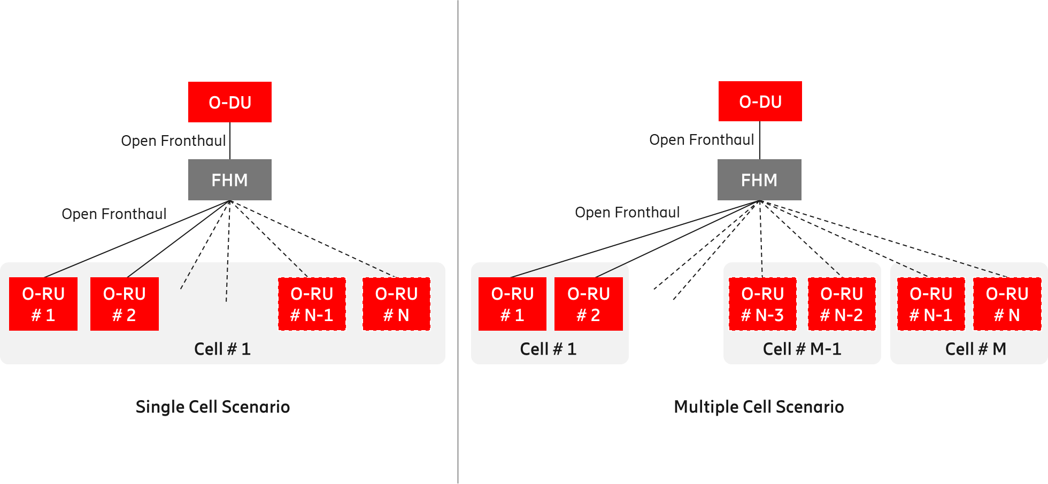

Figure A.1-1: Shared cell deployment using FHM mode

In Cascade mode, the shared cell is realized by several O-RUs cascaded in chain. In this case, one or more O-RUs are inserted between the O-DU and the O-RU. The O-RUs in the cascaded chain except for the last O-RU shall support Copy and Combine function. Figure A.1-2 below shows an implementation of Cascade mode shared cell.

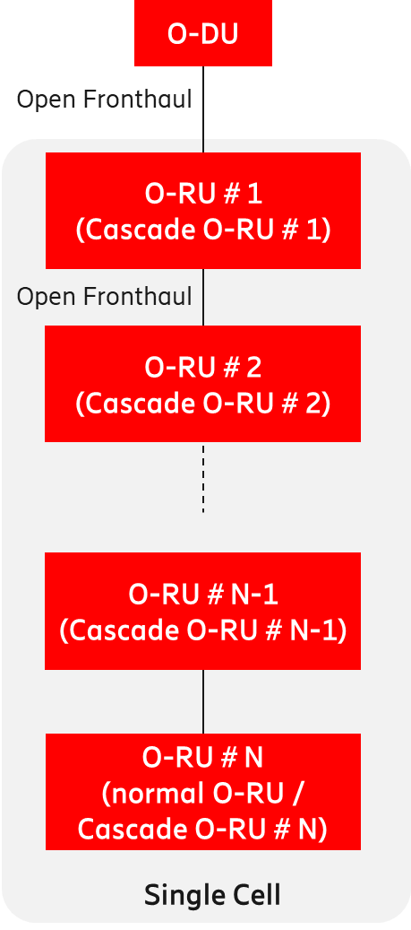

Figure A.1-2: Shared cell deployment using Cascade mode

The Cascade mode, as described above, is implemented within the O-RU.

Please refer to [26] for additional information.

1. FHGW Function

The FHGW (Fronthaul Gateway) function may be placed between the O-DU and RU/RRU (Radio Unit / Remote Radio Unit) with the following O-RAN specified interfaces:

* The interface between O-DU and FHGW function is Open Fronthaul (Option 7-2x).
* The interface between FHGW function and RU/RRU is subject to reference implementation developed by any relevant O-RAN WG (e.g., WG7). An example of such reference implementation is described in [30]. The exact specification of this interface (i.e., between FHGW function and RU/RRU) is for future study.
* The interface between FHGW function and RU/RRU shall not support Open Fronthaul (Option 7-2x).
* The FHGW function may be packaged with other functions (such as Ethernet switching) in a physical product, as considered within WG7.

The Figure A.2-1 below depicts the deployment of the FHGW function using O-RAN specified interfaces.

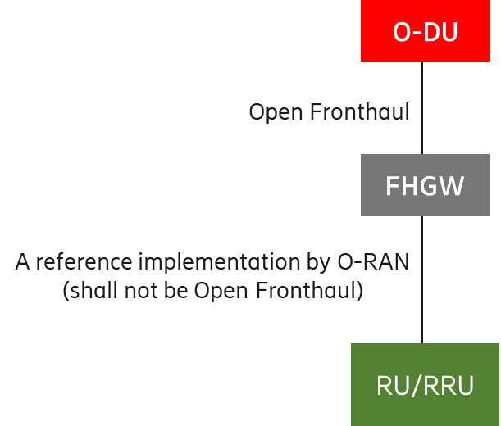

Figure A.2-1: Deployment of O-DU and RU/RRU using FHGW function

1. Near-RT RIC

The Near-RT RIC can control multiple E2 Nodes or can control a single E2 Node. The following figures show two implementation options of Near-RT RIC.

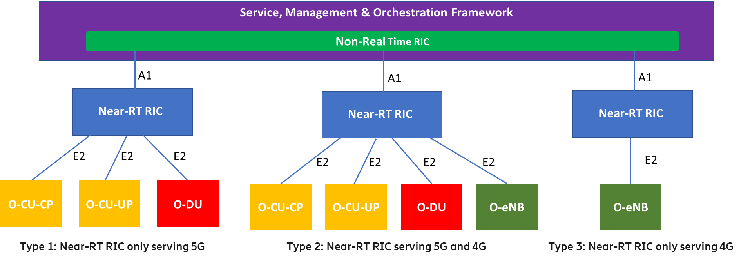

Figure A.3-1: Centralized Near-RT RIC Serving 4G and 5G Simultaneously

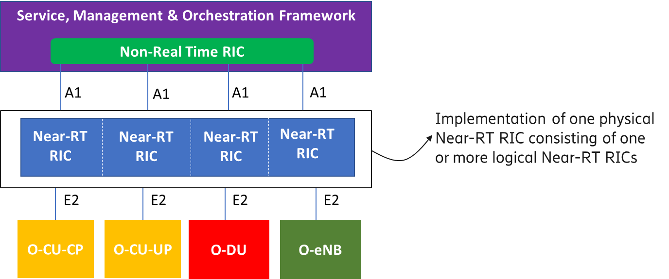

Figure A.3-2: Distributed Near-RT RIC

1. Near-RT RIC, O-CU-CP, O-CU-UP, O-DU and O-RU

Although the O-RAN architecture specify the O-RAN nodes Near-RT RIC, O-CU-CP, O-CU-UP, O-DU and O-RU as separate entities, it is possible in the implementation to bundle some or all of these O-RAN nodes, and thus collapsing some of the internal interfaces such as F1-c, F1-u, E1 and E2. At least the following implementation options are possible:

* Disaggregated network functions as per O-RAN architecture
* Bundle the O-CU-CP and O-CU-UP
* Bundle the O-CU-CP, O-CU-UP and O-DU
* Bundle the Near-RT RIC, O-CU-CP and O-CU-UP
* Bundle the O-CU-CP, O-CU-UP, O-DU and O-RU
* Bundle the O-DU and O-RU
* Bundle the Near-RT RIC, O-CU-CP, O-CU-UP, O-DU and O-RU

Bundling of O-RAN nodes is supported by the O-RAN specified interfaces O1 and E2. For the O1 interface, the bundled functions will be managed as separate Managed Functions belonging to a single Managed Element as specified in [31]. For the E2 interface the bundled functions can be exposed as part of the E2 Service Model towards the Near-RT RIC (see Annex A in [22]).

**Note:** In the implementation options where the Near-RT RIC function is bundled with other O-RAN functions it may only control E2 Nodes of the same RAT (Radio Access Technology) type (e.g., a bundled near-RT RIC and O-CU-CP may only control E2 Nodes O-CU-UP and O-DU) which are not bundled with Near-RT RIC.

**Note:** Bundling multiple instances of the same type of O-RAN function is supported.

Please see the figures (i.e., Figure A.4-1 through Figure A.4-7) below.



Figure A.4-1: Disaggregated Network Functions

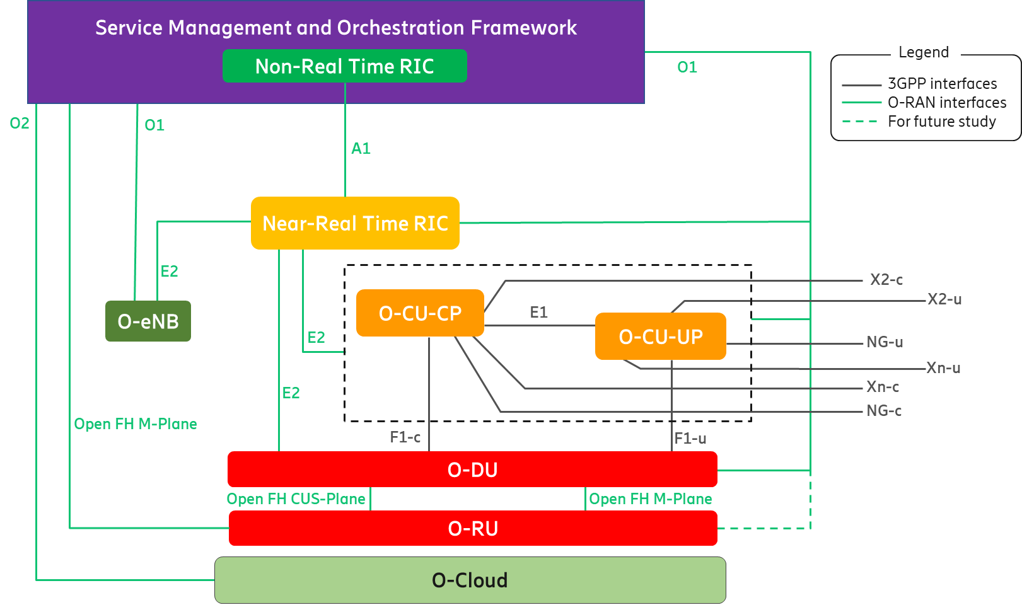

Figure A.4-2: Aggregated O-CU-CP and O-CU-UP

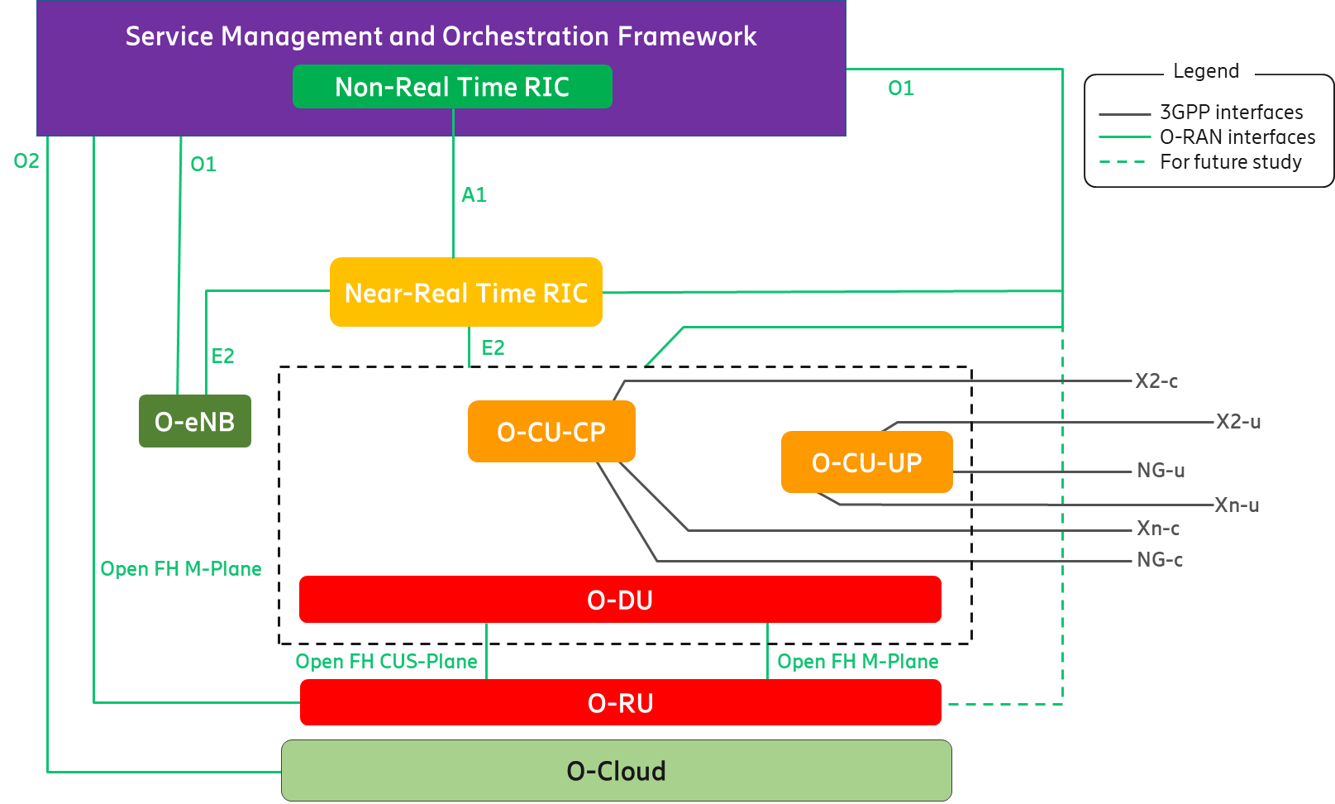

Figure A.4-3: Aggregated O-CU-CP, O-CU-UP and O-DU

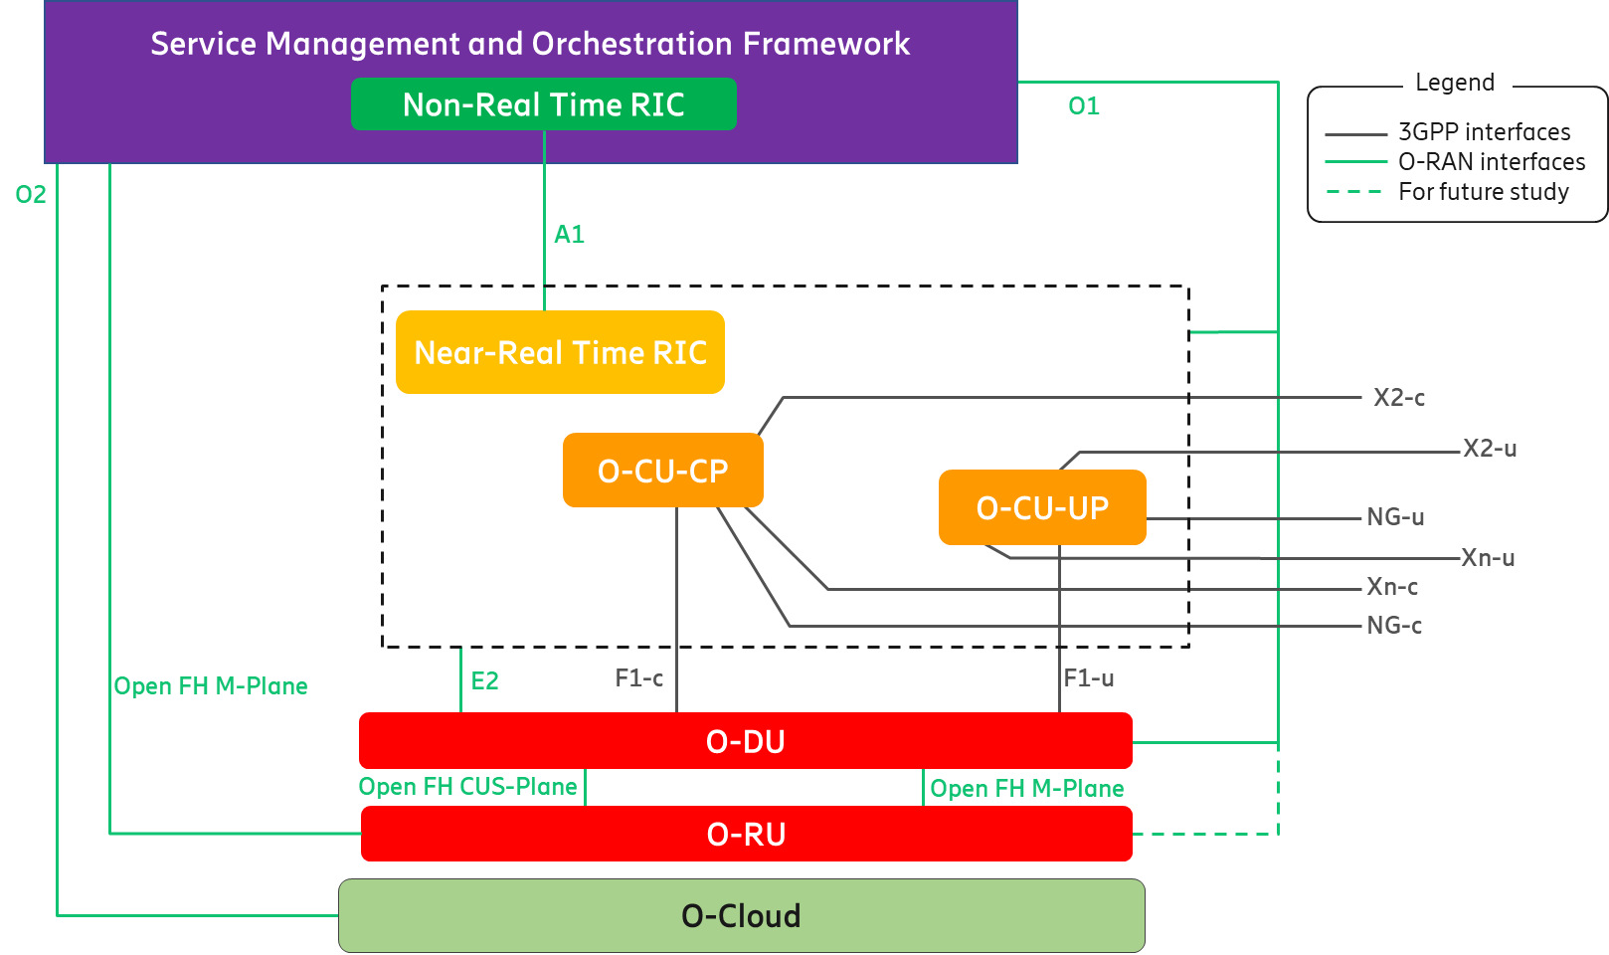

Figure A.4-4: Aggregated Near-RT RIC, O-CU-CP and O-CU-UP

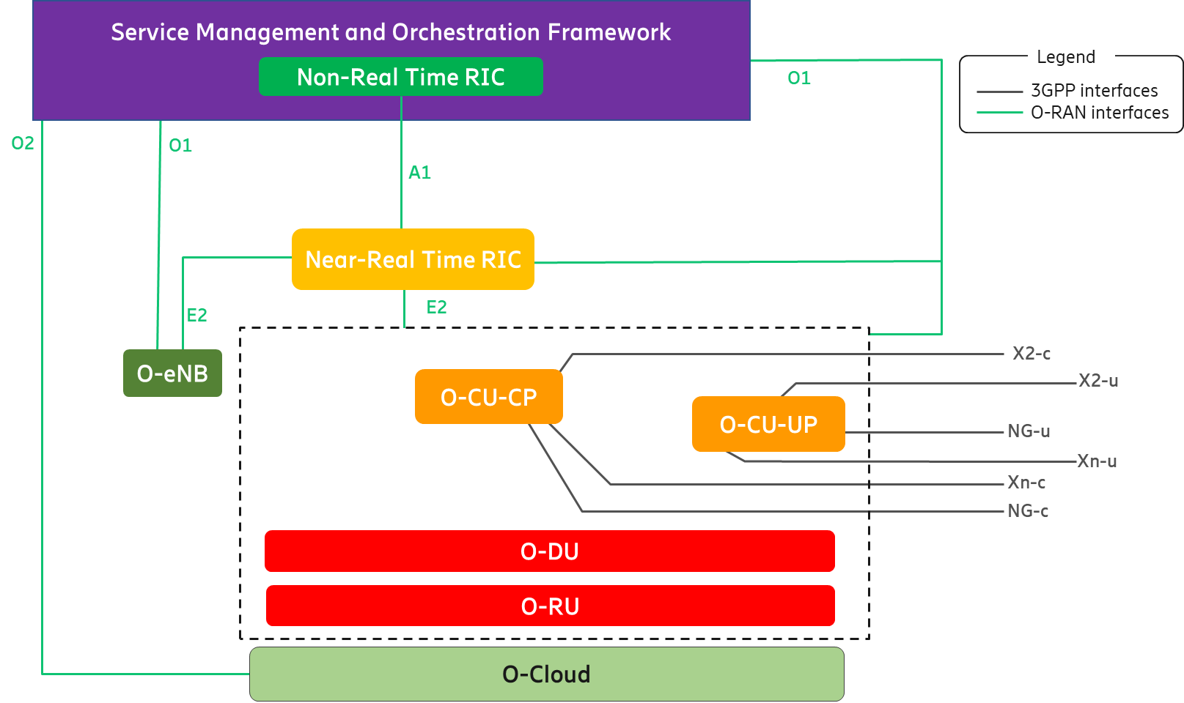

Figure A.4-5: Aggregated O-CU-CP, O-CU-UP, O-DU and O-RU

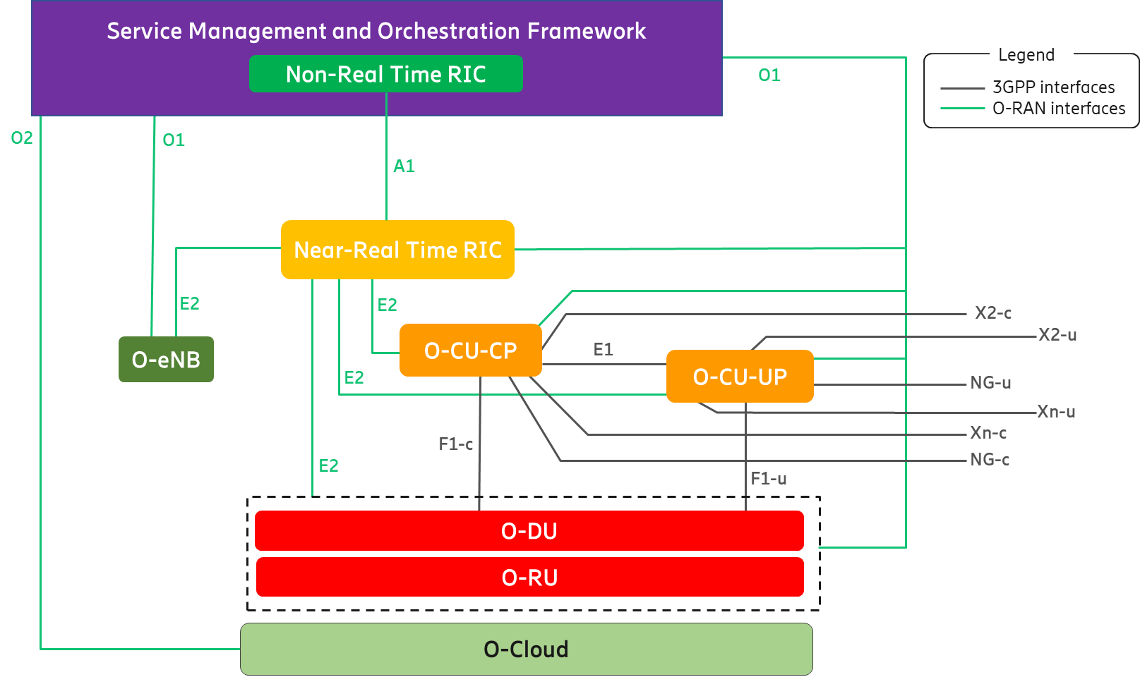

Figure A.4-6: Aggregated O-DU and O-RU

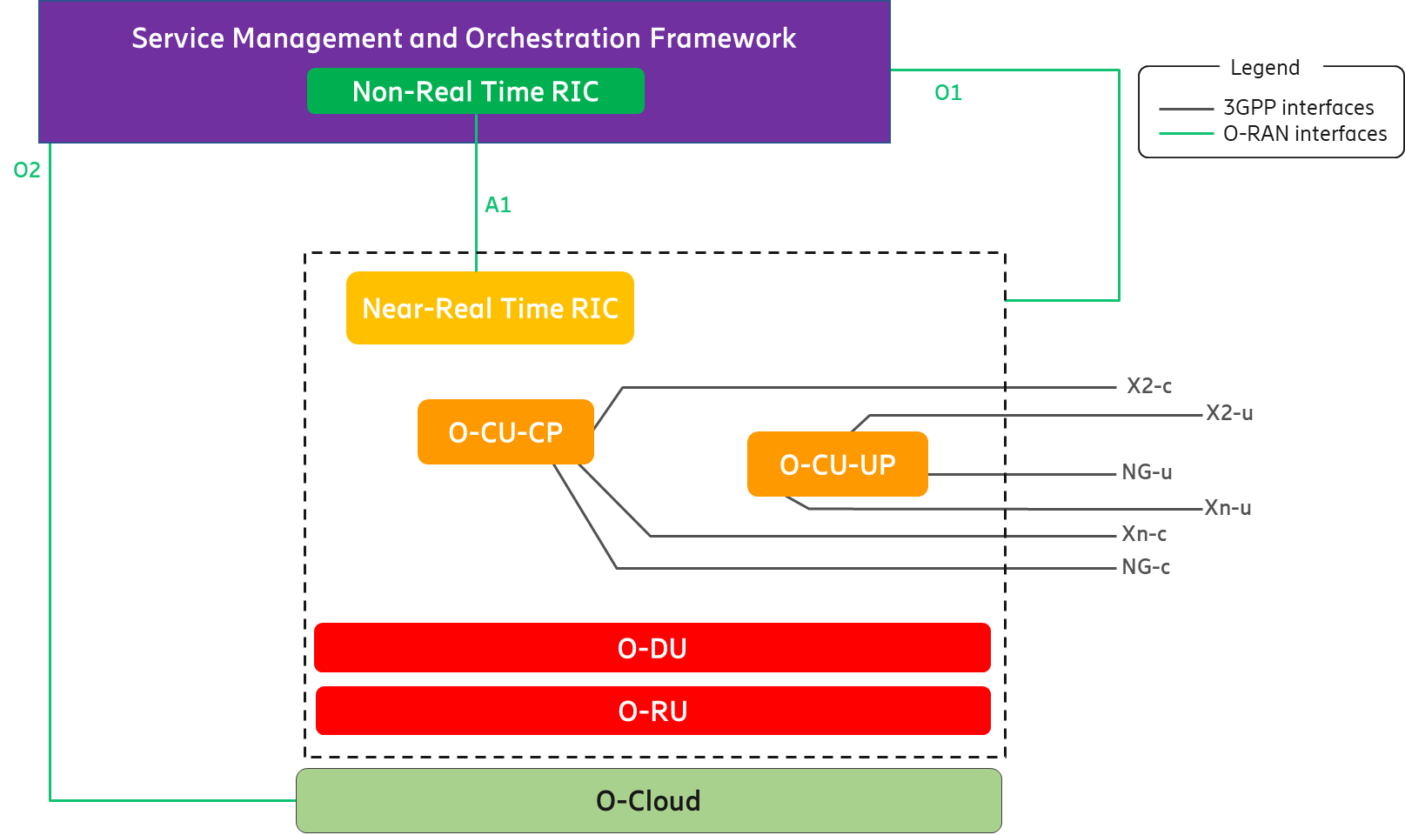

Figure A.4-7: Aggregated Near-RT RIC, O-CU-CP, O-CU-UP, O-DU and O-RU

1. Cooperative Transport

To enhance the resource utilization and reduce the latency of UL LLS traffic when using a shared point-to-multipoint transport network requiring resource allocation (such as PON or DOCSIS), the O-RAN architecture supports a cooperative transport feature. The cooperative transport feature is based on the O-DU’s knowledge of the expected uplink LLS traffic from a given O-RU which is provided to the associated (PON or DOCSIS) TN in the transport network. This enables the TN to dynamically allocate the correct bandwidth over the shared transport network to the TU that is used by the O-RU. The CTI signaling is described in [24]. To support the CTI, the O-DU is configured over the O1 interface with CTI client specific configuration as described in [25]. Note that there can be intermediate nodes between the O-DU and the TN, they will forward the CTI messages transparently but will not participate to CTI interactions.

A simplified architecture of the CTI is shown in figure A.5-1 below. The SMO, O-DU and O1 interface shown in this figure are part of the O-RAN Logical Architecture (please see Sections 4.3.1, 4.3.5 and 4.4.2, respectively), whereas the TN and Transport OAM, are the components of the transport network. For detailed specification and reference architecture, please see [24] and [25].

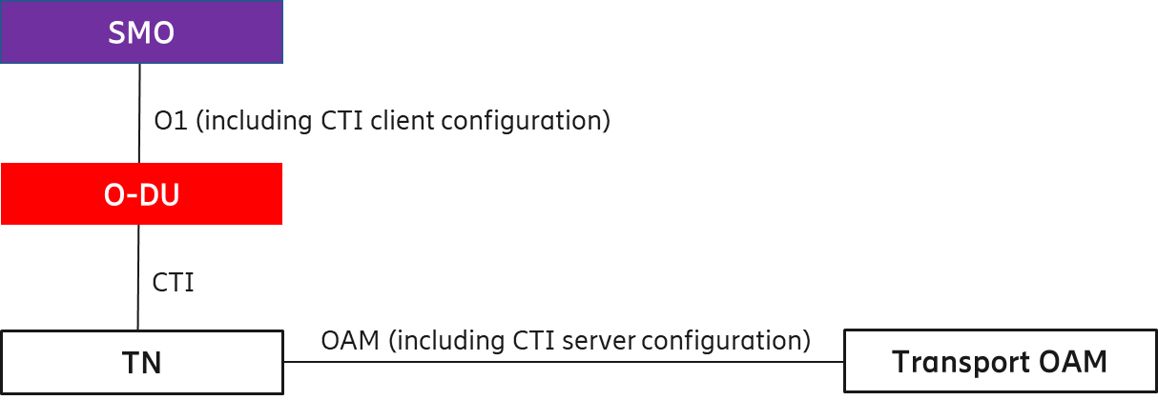

A.5-1: Simplified CTI Architecture

**Note**: Placing the transport network components in a topological view of the O-RAN architecture is for future study.

Revision History

|  |  |  |  |
| --- | --- | --- | --- |
| **Date** | **Revision** | **Editor(s)** | **Description** |
| 2019.09.06 | 00.01 | Haseeb Akhtar (Ericsson) | * First draft of O-RAN Architecture Description Document. |
| 2019.10.12 | 00.02 | Haseeb Akhtar (Ericsson) | * Added the contact names of sponsoring organizations. * Figure 4.1‑3 to show the UEs clustered together. * Added a description of Non-RT RIC (Section 4.3.1). |
| 2019.10.14 | 00.03 | Haseeb Akhtar (Ericsson) | * Added DT as one of the co-sponsors. * Revised the description of Non-RT RIC (Section 4.3.1). * Added a description of Near-RT RIC (Section 4.3.2). * Updated the versioning format as per O-RAN guidance. |
| 2019.10.16 | 00.04 | Haseeb Akhtar (Ericsson) | * Revised the description of Non-RT RIC (Section 4.3.1). * Minor editorial corrections. |
| 2019.10.17 | 00.05 | Cagatay Buyukkoc (AT&T) | * Added Orange as one of the co-sponsors. |
| 2020.01.16 | 01.00 | Paul Smith (AT&T)  Jinri Huang (CMCC)  Chai Li (CMCC)  Haseeb Akhtar (Ericsson) | * Added the CR on ‘v1.0 work items of Architecture Description’ (PA19). |
| 2020.03.25 | 02.00.01 | Haseeb Akhtar (Ericsson) | * Added the CR on ‘O-RAN Network Function implementation options’ (v02). |
| 2020.05.18 | 02.00.02 | Haseeb Akhtar (Ericsson) | * Added the CR on ‘revised definitions’ (v03). * Added the CR on ‘revised text for multiple LLS options’ (v02). |
| 2020.05.28 | 02.00.03 | Haseeb Akhtar (Ericsson) | * Added the CR on ‘architecture principle in chapter 3’ (v02). |
| 2020.06.11 | 02.00.04 | Haseeb Akhtar (Ericsson) | * Added the revised CR on ‘text for multiple LLS options’ (v3). The multiple LLS option text was moved from the descriptions of O-DU and O-RU (Sections 4.3.5 and 4.3.6) to ‘Overall Architecture of O-RAN’ (Section 4.1). |
| 2020.07.13 | 02.00.05 | Haseeb Akhtar (Ericsson) | * Editorial changes based on the comments from Vikas Dixit (JIO) and Changlan Tsai (ITRI) during WG1 vote. |
| 2020.07.15 | 02.00.06 | Haseeb Akhtar (Ericsson) | * Removed all track changes from the document for TSC review. |
| 2020.07.24 | 02.00.07 | Haseeb Akhtar (Ericsson) | * Removed ‘-0’ from the name since the Architecture Description does not have any ‘branch’ document. |
| 2020.10.30 | 0.2.00 | Haseeb Akhtar (Ericsson) | * Removed the extension ‘.07’ from the name. * Updated copyright statement in the title page. |
| 2020.09.27 | 03.00.01 | Haseeb Akhtar (Ericsson) | * Added the CR on ‘description of Uu interface’ (v02). |
| 2020.10.20 | 03.00.02 | Haseeb Akhtar (Ericsson) | * Added the CR on ‘Architecture Description editorial changes’ (v02). |
| 2020.10.29 | 03.00.03 | Haseeb Akhtar (Ericsson) | * Added the CR on ‘FHM and FHGW implementation options’ (v07). * Added the CR on ‘Architecture Description updates for V5 WG4 M-Plane’ (v04). * Added the CR on ‘Managed Application definition’ (v02). * Added the CR on ‘SMO description’ (v02). |
| 2020.10.30 | 03.00.04 | Haseeb Akhtar (Ericsson) | * Added the CR on ‘O-RAN Architecture Description Document Updates for R1 Interface Changes’ (v09). * Addressed comments from Vikas Dixit (JIO) on correcting the references. * Made minor editorial changes in ‘References’ section. |
| 2020.11.02 | 03.00.05 | Haseeb Akhtar (Ericsson) | * Added the CR on ‘Adding Legend to Architecture Figures’ (v02). * Replaced ‘Near RT RIC’ with ‘Near-RT RIC’ in Figure 4.3-1. * Added ‘xNF’ in the ‘Abbreviations’ section. |
| 2020.11.05 | 03.00.06 | Haseeb Akhtar (Ericsson) | * Addressed comment from Linda Horn (Nokia) on correcting the text as per the CR on ‘SMO description’ (v02). * Added 'E-UTRA', 'E-UTRAN', 'FFT', 'iFFT', 'O-Cloud', 'PRACH', 'RF', 'RRC', 'RRH' and 'TRP' in the ‘Abbreviations’ section. * Replaced ‘Other RAN xNF’ with ‘Other O-RAN xNF’ in Figure 4.3-1. |
| 2020.11.12 | 03.00.07 | Haseeb Akhtar (Ericsson) | * Addressed comment from Anil Umesh (DCM) to remove the sentence 'FHM function may be implemented as part of O-DU or as part of O-RU or as an independent network element between O-DU and O-RU' from the document (Section A2). |
| 2020.11.21 | 03.00.08 | Haseeb Akhtar (Ericsson) | * Addressed comment from Vishwanath Ramamurthi (Verizon) to remove the words ‘Optionally, and only’ from the sentence ‘Optionally, and only in the hybrid model, Open Fronthaul M-plane interface between SMO and O-RU for FCAPS support’ (Section 4.3.1). |
| 2020.11.25 | 03.00 | Haseeb Akhtar (Ericsson) | * Changed the year in copyright message to ‘2021’. * Removed the last two digits of the version for external publication. |
| 2021.03.02 | 04.00.01 | Haseeb Akhtar (Ericsson) | * Added the CR on ‘Control Loop Timing Clarifications’ (rev 6). * Added the CR on ‘SMO to O-RU OAM Link’ (v02). * Added the CR on ‘Architecture Description Editorial Changes’ (v02). |
| 2021.03.03 | 04.00.02 | Haseeb Akhtar (Ericsson) | * Addressed comment from Jinri Huang (CMCC) to change ‘use cases involving the Non-RT RIC control loop’ to ‘use cases involving the Non-RT control loops’ (Section 4.2). * Made editorial changes in ‘O-RAN Control Loops’ (Section 4.2) to the text consistent with this document. * Added RT (Real Time) in the ‘Abbreviations’ section. |
| 2021.03.05 | 04.00.03 | Haseeb Akhtar (Ericsson) | * Created a clean version for WG1 voting. |
| 2021.03.09 | 04.00.04 | Haseeb Akhtar (Ericsson) | * Added TR (Technical Report), TS (Technical Specification) and UE (User Equipment) in ‘Abbreviations’ section. |
| 2021.03.18 | 04.00.05 | Haseeb Akhtar (Ericsson) | * Addressed a comment from Vikas Dixit (JIO) on correcting the version format from x.y.z to xx.yy.zz (Section 1.1). |
| 2021.03.18 | 04.00 | Haseeb Akhtar (Ericsson) | * Created a clean version for the approvals of TSC and EC/Board. * Removed the last two digits of the version for external publication. |
| 2021.07.07 | 05.00.01 | Haseeb Akhtar (Ericsson) | * Added the CR on ‘O-RAN Architecture Description Editorial Changes’ (v04). |
| 2021.07.07 | 05.00.02 | Haseeb Akhtar (Ericsson) | * Added the CR on ‘Addition of CTI’ (v04). * Added UL (Up Link) in the ‘Abbreviations’ section. |
| 2021.07.07 | 05.00.03 | Haseeb Akhtar (Ericsson) | * Added the CR on ‘Non-RT RIC Enhancements’ (v07). |
| 2021.07.08 | 05.00.04 | Haseeb Akhtar (Ericsson) | * Corrected the typo in the caption of Figure A.5-1. * Created a clean version for WG1 voting. |
| 2021.07.09 | 05.00.05 | Haseeb Akhtar (Ericsson) | * Corrected a typo in the header of section ‘4.4.16 CTI (Cooperative Transport Interface)’ as pointed out by William C. Babilonia, Red Hat. * Corrected other typos in the text added for this version (v05.00). |
| 2021.07.15 | 05.00.06 | Haseeb Akhtar (Ericsson) | * Corrected some typos in the ‘Revision History’ section. |
| 2021.07.16 | 05.00 | Haseeb Akhtar (Ericsson) | * Created a clean version for the approvals of TSC and EC/Board. * Removed the last two digits of the version for external publication. |
| 2021.09.21 | 06.00.01 | Haseeb Akhtar (Ericsson) | * Added the CR on ‘Addition of M-Plane (v02)’. |
| 2021.10.06 | 06.00.02 | Haseeb Akhtar (Ericsson) | * Added the CR on ‘Security Architecture (v02)’. |
| 2021.10.12 | 06.00.03 | Haseeb Akhtar (Ericsson) | * Added the CR on ‘Addition of UE Identifiers (v03)’. |
| 2021.10.20 | 06.00.04 | Haseeb Akhtar (Ericsson) | * Added the CR on ‘Architecture Description Editorial Changes (v02)’. |
| 2021.10.30 | 06.00.05 | Haseeb Akhtar (Ericsson) | * Added the CR on ‘O-Cloud Notification API (v04)’. |
| 2021.11.07 | 06.00.06 | Haseeb Akhtar (Ericsson) | * Created a clean version for the approval of WG1. |
| 2021.11.18 | 06.00 | Haseeb Akhtar (Ericsson) | * Removed last two digits of the version for external publication. |
| 2022.07.12 | 07.00.01 | Haseeb Akhtar (Ericsson) | * Add the CR on ‘Service Based Architecture Description (v06)’. |
| 2022.07.17 | 07.00.02 | Haseeb Akhtar (Ericsson) | * Add the CR on ‘Editorial Changes in Architecture Description 07.00 (v03)’. |
| 2022.07.22 | 07.00.03 | Haseeb Akhtar (Ericsson) | * Update Reference [14] to v03.00 and move ‘Revision History’ to end of the document as per comments from Vikas Dixit (JIO). |
| 2022.07.25 | 07.00.04 | Haseeb Akhtar (Ericsson) | * Added ‘History’ section at end of the document as per comment from Vikas Dixit (JIO). |
| 2022.07.25 | 07.00.05 | Haseeb Akhtar (Ericsson) | * Created a clean version for WG1 voting. |

History

|  |  |  |
| --- | --- | --- |
| Date | Revision | Description |
| 2021.11.18 | 06.00.06 | Published as Final version 06.00 |
| 2021.07.16 | 05.00.06 | Published as Final version 05.00 |
| 2021.03.18 | 04.00.05 | Published as Final version 04.00 |
| 2020.11.25 | 03.00.08 | Published as Final version 03.00 |
| 2020.10.30 | 02.00.07 | Published as Final version 02.00 |
| 2020.01.16 | 00.05 | Published as Final version 01.00 |