Building a genetic map in an hexaploid full-sib population using MAPpoly

Marcelo Mollinari, Guilhereme Pereira, A Augusto F Garcia and Zhao-Bang Zeng

2018-11-20

Table of Contents

# Introduction

mappoly (v. 0.1.0) is an under development R package to construct genetic maps in autopolyploids with even ploidy levels. In its current version, mappoly can handle ploidy levels up to 8 when using hidden Markov models (HMM), and up to 12 when using the two-point simplification. All the two-point based functions are fast enough to run on standard computers. However, we strongly recommend to use high-performance computation for HMM-based analysis, especially for ploidy levels higher than 4.

Here we assume that the genotypic data is available and in the format required by mappoly. In a future version, this document will include instructions about genotype calling and vcf files. The primary purpose of this tutorial is to show some functions available in mappoly and how to use them in as sequential fashion to construct a genetic map. The derivation of the HMM used in mappoly can be found in (Mollinari and Garcia 2018)(<https://doi.org/10.1101/415232> ).

mappoly is not available in CRAN, but you can install it from Git Hub. Within R, you need to install and load the package devtools:

install.packages("devtools")

To install mappoly from Git Hub use

devtools::install_github("mmollina/mappoly")

# Loading mappoly

To load mappoly, simply type

library(mappoly)

# hexafake data set

In this tutorial, we use a simulated data set to guide the user though the basic steps of a genetic map construction using the functions available in mappoly. The simulated data set is distributed with mappoly and can be loaded using

data("hexafake")

The hexafake data set contains 1500 markers distributed in three linkage groups and scored in a full-sib autohexaploid population containing 300 individuals. We denote the parents of this population $P$ and $Q$. The parental linkage phase and the recombination fraction used to simulate the population can be found in inst\doc\ folder, also distributed with mappoly. To inspect the data set, we just type

hexafake

## This is an object of class 'mappoly.data'  
## Ploidy level: 6   
## No. individuals: 300   
## No. markers: 1500   
##   
## This dataset contains sequence information.  
## ----------  
## No. of markers per dosage in both parents:  
## dP dQ freq  
## 0 1 361  
## 0 2 83  
## 0 3 19  
## 0 4 5  
## 0 5 1  
## 1 0 394  
## 1 1 147  
## 1 2 67  
## 1 3 20  
## 1 4 6  
## 1 5 3  
## 2 0 107  
## 2 1 66  
## 2 2 54  
## 2 3 40  
## 2 4 9  
## 3 0 22  
## 3 1 24  
## 3 2 26  
## 3 3 16  
## 4 0 3  
## 4 1 14  
## 4 2 10  
## 5 0 2  
## 5 1 1

The program prints a summary of the data set showing the ploidy level, the number of individuals and the number of markers. Also it prints the frequency of the possible markers dosage combination in both parents. A graphical representation of the frequencies can be obtained using

plot(hexafake)

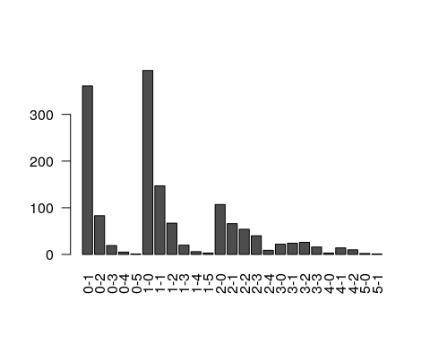

The numbers separated by a dash indicate the dose in parents $P$ and $Q$ respectively.

At this point, we need to select the set of markers we want to perform the analysis. To select all markers in the data set, we use the function make_seq_mappoly with arg = 'all'. It is also possible to load data only for a specific sequence using arg = 'seqx', where x is the number of the sequence, provided in the input file. This feature can be useful in cases where the information about chromosomes or scaffold is available. It is also possible to load specific markers using a vector of numbers indicating the positions of the markers in the data set. Here, we select all markers

all.mrk<-make_seq_mappoly(input.obj = hexafake, arg = 'all')

In real data sets, closely linked markers can carry exactly the same information about a specific genomic region and can be excluded from the analysis without modifying the results. To identify those markers we use

filt.mrk<-elim_redundant(input.seq = all.mrk)  
new.seq<-make_seq_mappoly(filt.mrk)

In this case, we could eliminate 190 markers (13%) from the 1500 available.

plot(filt.mrk)

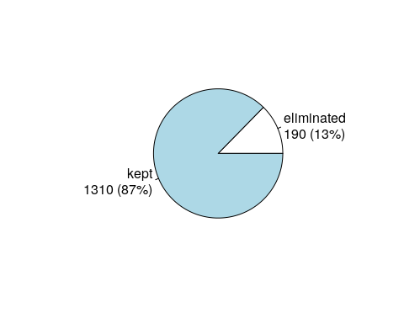

# Two-point analysis

Once the markers where selected, wee need to compute the pairwise recombination fraction between all selected markers (two-point analysis). First, let us load the genotype counts ($ζ_{T_{k},T_{k^{′}}}(l_{P},l_{Q})$) defined in equation 20 in (Mollinari and Garcia 2018)(<https://doi.org/10.1101/415232> ). This object is fundamental to perform the dimension reduction of the transition space.

counts<-cache_counts_twopt(input.seq = new.seq, get.from.web = TRUE)

## Internet conectivety ok.  
## Loading genotype counts from web

counts

## This is an object of class 'cache.info'  
## -----------------------------------------------------  
## Ploidy level: 6   
## No. marker combinations: 2401   
## -----------------------------------------------------

The function est_pairwise_rf estimates all the pairwise recombination fractions in the sequence provided. Since the output object is too big to be fully displayed on the screen , mappoly shows a summary. Notice that parallel computation is available and in this case we used 16 CPU’s to perform the computations.

all.rf.pairwise <- est_pairwise_rf(input.seq = new.seq,   
 count.cache = counts,   
 n.clusters = 16)  
all.rf.pairwise

To assess the recombination fraction between a particular pair of markers, say 802 and 959, we use

all.rf.pairwise$pairwise$`802-959`

## LOD_ph rf LOD_rf  
## 2-2 0.000000 0.09356626 7.171220091  
## 3-2 -1.227626 0.28061984 6.214118480  
## 2-3 -1.227626 0.28061984 6.214118480  
## 3-1 -1.790012 0.14123804 5.651732223  
## 1-3 -1.790012 0.14123804 5.651732223  
## 3-3 -2.781879 0.37084615 5.105580976  
## 2-1 -7.169449 0.38978155 0.001771538  
## 1-2 -7.169449 0.38978155 0.001771538  
## 1-1 -7.172574 0.49995416 0.001353473  
## 2-0 -7.442947 0.49995416 0.001202309  
## 0-2 -7.442947 0.49995416 0.001202309  
## 1-0 -7.444241 0.49995416 0.002497107  
## 0-1 -7.444241 0.49995416 0.002497107  
## 3-0 -7.737330 0.33572880 0.150129983  
## 0-3 -7.737330 0.33572880 0.150129983  
## 0-0 -7.893650 0.49991909 0.006189804

plot(all.rf.pairwise, first.mrk = 802, second.mrk = 959)

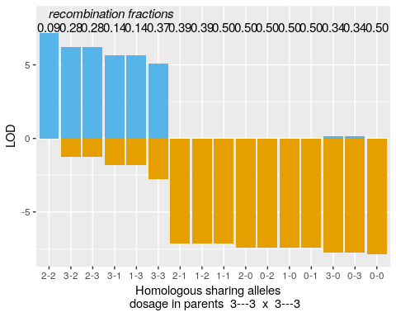

In this case, 802-959 represents the position of the markers in the original data set. The name of the rows in the output is of the form x-y, where x and y indicate how many homologous chromosomes share the same allelic variant in parents $P$ and $Q$, respectively (see (Mollinari and Garcia 2018)(<https://doi.org/10.1101/415232> ) and (Mollinari et al. 2019) for notation). The first column indicates the LOD Score in relation to the most likely linkage phase configuration. The second column shows the recombination fraction, and the third indicates the LOD Score comparing the likelihood under no linkage ($r=0.5$) and the estimated recombination fraction (evidence of linkage). In the next step, the two-point object should be converted into recombination fraction and LOD Score matrices. To select the recombination fractions for each one of the marker combinations, one needs to assume thresholds for the three columns observed in the previous output. The arguments thresh.LOD.ph and thresh.LOD.rf set LOD Scores thresholds for the second most likely linkage phase configuration and recombination fraction. Here we assume thresh.LOD.ph = 0 and thresh.LOD.rf = 0, thus no matter how likely is the second best option, all the computed values will be considered. The argument thresh.rf = 0.5 indicates that the maximum accepted recombination fraction is 0.5. To convert these values in a recombination fraction matrix, we use the function rf_list_to_matrix

## INFO: Going singlemode. Using one CPU.

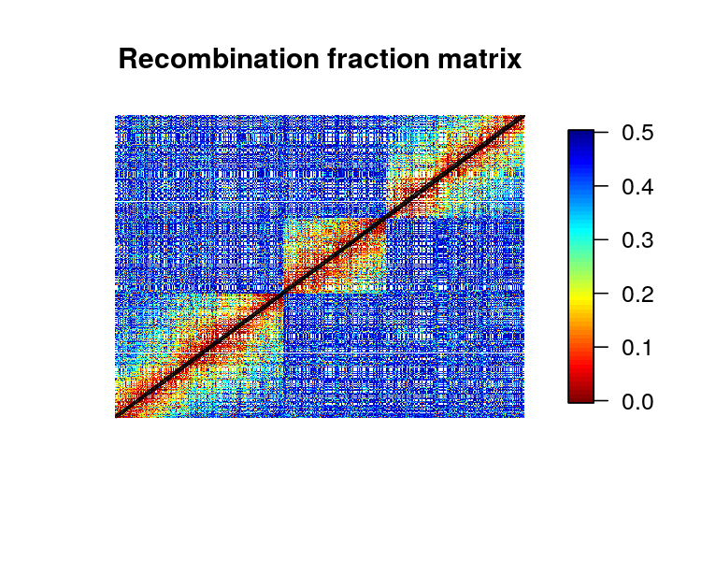

In the previous case, the thresholds allowed to plot almost all points in the recombination fraction matrix. The empty cells in the matrix indicate markers where it is impossible to detect recombinant events using two-point estimates (e.g., between $1×0$ and $0×1$ marker). If these values become more stringent (LOD higher and lower rf), the matrix becomes more sparse. It is also important to notice that since the simulated data is ordered, it is possible to see a clear block diagonal pattern on the recombination fraction matrix.

# Assembling linkage groups

The function group_mappoly assign markers to linkage groups using the recombination fraction matrix obtained above. The user can provide an expected number of groups or run the interactive version of the function using inter = TRUE. Since in this simulation we know the number of linkage groups, we use expected.groups = 3. If the data set provides the chromosome where the markers are located, the function allows to compare the groups obtained using the pairwise recombination fraction and the chromosome information provided using the comp.mat = TRUE. Please refer to (Mollinari et al. 2019) for a real data set example.

mat <- rf_list_to_matrix(input.twopt = all.rf.pairwise,   
 thresh.LOD.ph = 2) # LOD = 2 to avoir false positives

## INFO: Going singlemode. Using one CPU.

grs <- group_mappoly(input.mat = mat,  
 input.seq = new.seq,  
 expected.groups = 3,  
 comp.mat = TRUE,   
 inter = FALSE)

## Warning in group_mappoly(input.mat = mat, input.seq = new.seq,  
## expected.groups = 3, : NAs introduced by coercion

## Warning in group_mappoly(input.mat = mat, input.seq = new.seq,  
## expected.groups = 3, : There is no physical reference information to  
## generate a comparison matrix

grs

## This is an object of class 'mappoly.group'  
## ------------------------------------------  
## Criteria used to assign markers to groups:  
##   
## - Number of markers = 1310   
## - Number of linkage groups = 3   
## - Number of markers per linkage groups:   
## group n.mrk  
## 1 538  
## 2 329  
## 3 443  
## ------------------------------------------

plot(grs)

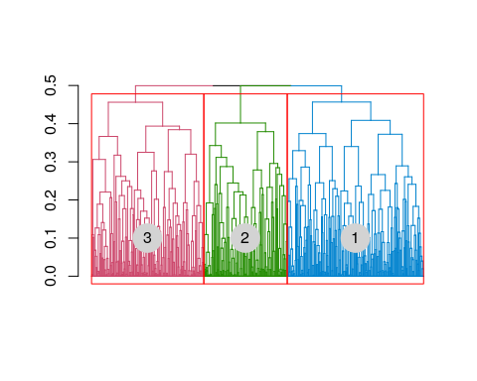

Once the linkage groups are properly assembled, we use the function make_seq_mappoly to make marker sequences from the group analysis.

LGS<-vector("list", 3)  
for(j in 1:3)  
 LGS[[j]] <- make_seq_mappoly(hexafake, new.seq$seq.num[grs$groups.snp == j])

# Estimating the map for a given order

The estimation of the genetic map for a given order involves the computation of recombination fraction between adjacent markers and also finding the linkage phase configuration of those markers in the parents. The core function to perform these tasks in mappoly is est_rf_hmm_sequential. This function uses the pairwise recombination fraction as the first source of information to sequentially position the allelic variants in specific homologous chromosomes. For situations where pairwise analysis has limited power, the it relies on the likelihood obtained through a hidden Markov model (HMM) (Mollinari and Garcia 2018, Mollinari et al. (2019)). Once all markers are positioned, the final map is reconstructed using the HMM multipoint algorithm.

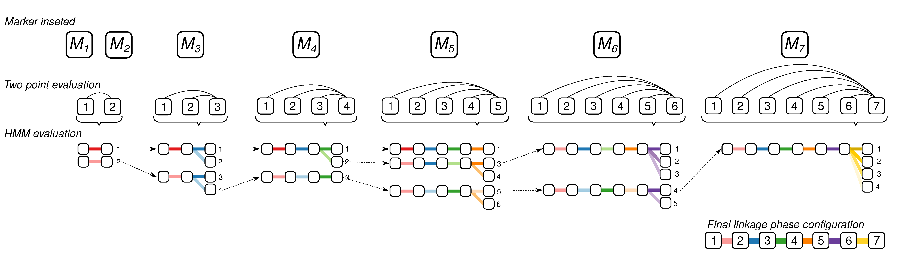

Example of linkage phase configuration estimation using sequential search space reduction and HMM evaluation.

To control the inclusion and phasing of the markers in the chain, several arguments are available. thres.twopt receives the threshold to whether when the linkage phases compared via two-point analysis should be considered and the HMM analysis should not be used to infer the linkage phase (A. K. A. $η$ in (Mollinari and Garcia 2018)(<https://doi.org/10.1101/415232> )). thres.hmm receives the threshold for keeping competing maps computed using HMM (if the two-point analysis was not enough) in the next round of marker insertion. extend.tail indicates the number of markers that should be considered at the end of the chain to insert a new marker. tol and tol.final receive the desired accuracy to estimate the sub-maps during the sequential phasing procedure and the desired accuracy in the final map. phase.number.limit receives the limit number of linkage phase configurations to be tested using HMM. info.tail is a logical argument and if TRUE uses the complete informative tail (last markers in the chain that allow all homologous to be distinguished in the parents) of the chain to calculate the likelihood of the linkage phases. In the fallowing example, we use the package paralell to perform the construction of the three linkage groups simultaneously.

## Performing parallel computation  
 cl <- parallel::makeCluster(3)  
 parallel::clusterEvalQ(cl, require(mappoly))  
 maps.given.order <- parallel::parLapply(cl,  
 LGS,  
 est_rf_hmm_sequential,  
 thres.twopt = 3,  
 thres.hmm = 10,  
 extend.tail = 50,  
 twopt = all.rf.pairwise,  
 tol = 0.1,   
 tol.final = 10e-4,   
 verbose = FALSE,   
 rf.lim = 0.1,   
 phase.number.limit = 60,   
 info.tail = TRUE,   
 reestimate.single.ph.configuration = FALSE)  
 parallel::stopCluster(cl)

maps.given.order

## [[1]]  
## This is an object of class 'mappoly.map'  
## Ploidy level: 6   
## No. individuals: 300   
## No. markers: 538   
## No. linkage phases: 1   
##   
## ---------------------------------------------  
## Number of linkage phase configurations: 1  
## ---------------------------------------------  
## Linkage phase configuration: 1  
## map length: 116.39  
## log-likelihood: -14128.22  
## LOD: 0  
## ~~~~~~~~~~~~~~~~~~  
##   
## [[2]]  
## This is an object of class 'mappoly.map'  
## Ploidy level: 6   
## No. individuals: 300   
## No. markers: 329   
## No. linkage phases: 1   
##   
## ---------------------------------------------  
## Number of linkage phase configurations: 1  
## ---------------------------------------------  
## Linkage phase configuration: 1  
## map length: 55.41  
## log-likelihood: -7940.97  
## LOD: 0  
## ~~~~~~~~~~~~~~~~~~  
##   
## [[3]]  
## This is an object of class 'mappoly.map'  
## Ploidy level: 6   
## No. individuals: 300   
## No. markers: 443   
## No. linkage phases: 1   
##   
## ---------------------------------------------  
## Number of linkage phase configurations: 1  
## ---------------------------------------------  
## Linkage phase configuration: 1  
## map length: 102.95  
## log-likelihood: -12461.68  
## LOD: 0  
## ~~~~~~~~~~~~~~~~~~

The results were stored in a list format in the object maps.given.order. A graphical representation of the linkage groups including the linkage phase configurations and the distance between markers can be obtained using 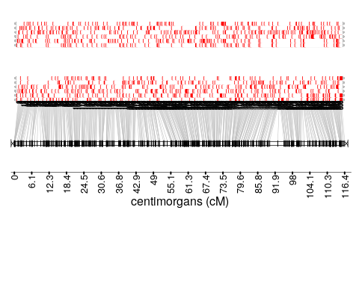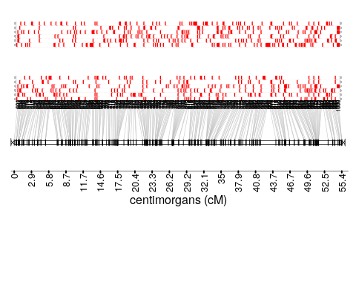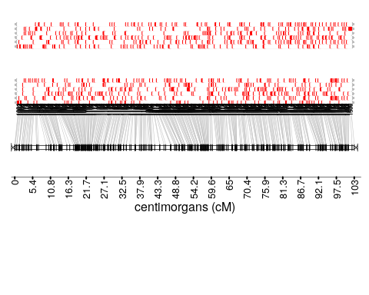

## [,1] [,2] [,3]   
## path NULL NULL NULL   
## name "GRID.VP.13" "GRID.VP.16" "GRID.VP.19"  
## n 1 1 1

In these figures, the red and white rectangles indicate the two possible allelic variants. Each horizontal line containing these rectangles indicates one of the six homologous chromosomes which are grouped in homology groups. The top homology group represents parent $P$ and the bottom represents parent $Q$. Now, let us compare the linkage phase configurations and the length from the simulated and the estimated genetic map. For parent $P$ we have

h1.given.P <- lapply(maps.given.order, function(x) x$maps[[1]]$seq.ph$P)  
temp <- read.csv2("~/repos/MAPpoly/inst/doc/phase_sim_hexa_P.csv")[,2:7]  
h2.given.P <- lapply(h1.given.P,   
 function(x, temp) ph_matrix_to_list(temp[names(x),]),   
 temp = temp)  
is.same.haplo.P <-NULL  
for(i in 1:3)  
 is.same.haplo.P <- c(is.same.haplo.P, compare_haplotypes(m = 6,   
 h1 = h1.given.P[[i]],   
 h2 = h2.given.P[[i]])$is.same.haplo)  
is.same.haplo.P

## [1] TRUE TRUE TRUE

The results for all three linkage groups returned TRUE, meaning that the linkage phase configuration was correctly inferred for all linkage groups. For parent $Q$ we have

h1.given.Q <- lapply(maps.given.order, function(x) x$maps[[1]]$seq.ph$Q)  
temp <- read.csv2("~/repos/MAPpoly/inst/doc/phase_sim_hexa_Q.csv")[,2:7]  
h2.given.Q <- lapply(h1.given.Q,   
 function(x, temp) ph_matrix_to_list(temp[names(x),]),   
 temp = temp)  
is.same.haplo.Q <-NULL  
for(i in 1:3)  
 is.same.haplo.Q <- c(is.same.haplo.Q, compare_haplotypes(m = 6,   
 h1 = h1.given.Q[[i]],   
 h2 = h2.given.Q[[i]])$is.same.haplo)  
is.same.haplo.Q

## [1] TRUE TRUE TRUE

Thus, for both parents, the linkage phase configuration was correctly estimated.

# Ordering markers

So far we reestimated the map using the simulated order. In real situations, unless a genomic information is provided, we need to order the markers using an optimization technique. Here, we use the MDS (multidimensional scaling) algorithm, proposed in the context of genetic mapping by (Preedy and Hackett 2016). It requires a recombination fraction matrix, which will be transformed in distance using a mapping function (in this case we use Haldane’s mapping function). First, let us gather the pairwise recombination fractions for all three linkage groups

## INFO: Going singlemode. Using one CPU.  
## INFO: Going singlemode. Using one CPU.  
## INFO: Going singlemode. Using one CPU.

Now, for each matrix contained in the object in mt, we use the MDS algorithm

mds.ord <- lapply(mt, mds_mappoly)

## Stress: 0.265143590147656  
## Nearest Neighbour Fit: 5238.94901969669  
## Mean Nearest Neighbour Fit: 9.7378234566853  
## Stress: 0.255222953140157  
## Nearest Neighbour Fit: 3882.0756194952  
## Mean Nearest Neighbour Fit: 11.7996219437544  
## Stress: 0.271446129580154  
## Nearest Neighbour Fit: 3995.89837429857  
## Mean Nearest Neighbour Fit: 9.02008662369881

Now, let us compare the estimated and the simulated order using

op <- par(mfrow = c(1, 3),   
 pty = "s")   
sapply(mds.ord, function(x) {  
 plot(x = x$confplotno,   
 y = x$locimap$confplotno,   
 xlab = "simulated order",   
 ylab = "estimated order")  
 })

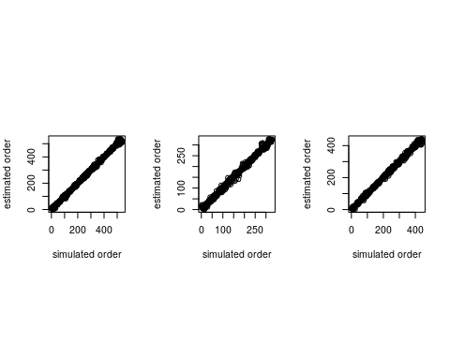

## [[1]]  
## NULL  
##   
## [[2]]  
## NULL  
##   
## [[3]]  
## NULL

par(op)

Although we can observe several local inconsistencies, the global diagonal patterns indicate a very good order for all linkage groups.

### Reestimating the genetic map

Now, given the estimated order, we reestimate the final map using the function est_rf_hmm_sequential

## Performing parallel computation  
 LGS.mds<-lapply(mds.ord, make_seq_mappoly)  
 cl <- parallel::makeCluster(3)  
 parallel::clusterEvalQ(cl, require(mappoly))  
 maps.denovo <- parallel::parLapply(cl,  
 LGS.mds,  
 est_rf_hmm_sequential,  
 thres.twopt = 3,  
 thres.hmm = 10,  
 extend.tail = 50,  
 twopt = all.rf.pairwise,  
 tol = 0.1,   
 tol.final = 10e-4,   
 verbose = FALSE,   
 rf.lim = 0.1,   
 phase.number.limit = 60,   
 info.tail = TRUE,   
 reestimate.single.ph.configuration = FALSE)  
 parallel::stopCluster(cl)

maps.denovo

## [[1]]  
## This is an object of class 'mappoly.map'  
## Ploidy level: 6   
## No. individuals: 300   
## No. markers: 538   
## No. linkage phases: 1   
##   
## ---------------------------------------------  
## Number of linkage phase configurations: 1  
## ---------------------------------------------  
## Linkage phase configuration: 1  
## map length: 217.27  
## log-likelihood: -22439.04  
## LOD: 0  
## ~~~~~~~~~~~~~~~~~~  
##   
## [[2]]  
## This is an object of class 'mappoly.map'  
## Ploidy level: 6   
## No. individuals: 300   
## No. markers: 329   
## No. linkage phases: 1   
##   
## ---------------------------------------------  
## Number of linkage phase configurations: 1  
## ---------------------------------------------  
## Linkage phase configuration: 1  
## map length: 104.97  
## log-likelihood: -12058.15  
## LOD: 0  
## ~~~~~~~~~~~~~~~~~~  
##   
## [[3]]  
## This is an object of class 'mappoly.map'  
## Ploidy level: 6   
## No. individuals: 300   
## No. markers: 443   
## No. linkage phases: 1   
##   
## ---------------------------------------------  
## Number of linkage phase configurations: 1  
## ---------------------------------------------  
## Linkage phase configuration: 1  
## map length: 190.52  
## log-likelihood: -19256.76  
## LOD: 0  
## ~~~~~~~~~~~~~~~~~~

Graphical representations

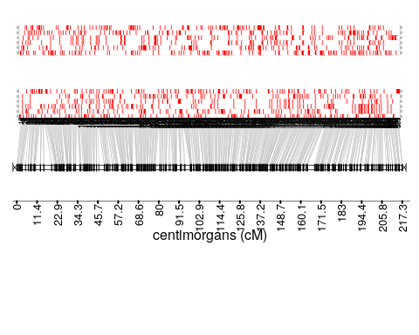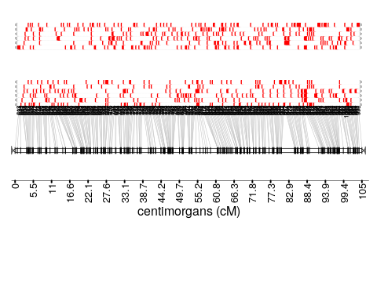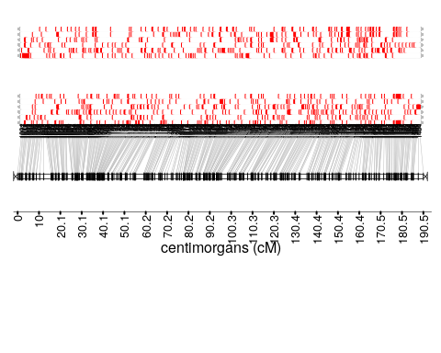

## [,1] [,2] [,3]   
## path NULL NULL NULL   
## name "GRID.VP.22" "GRID.VP.25" "GRID.VP.28"  
## n 1 1 1

Again, let us compare the simulated and the estimated linkage phases and the length of the map. For parent $P$ we have

h1.denovo.P <- lapply(maps.denovo, function(x) x$maps[[1]]$seq.ph$P)  
temp <- read.csv2("~/repos/MAPpoly/inst/doc/phase_sim_hexa_P.csv")[,2:7]  
h2.denovo.P <- lapply(h1.denovo.P,   
 function(x, temp) ph_matrix_to_list(temp[names(x),]),   
 temp = temp)  
is.same.haplo.P <-NULL  
for(i in 1:3)  
 is.same.haplo.P <- c(is.same.haplo.P, compare_haplotypes(m = 6,   
 h1 = h1.denovo.P[[i]],   
 h2 = h2.denovo.P[[i]])$is.same.haplo)  
is.same.haplo.P

## [1] TRUE TRUE TRUE

And for parent $Q$ we have

h1.denovo.Q <- lapply(maps.denovo, function(x) x$maps[[1]]$seq.ph$Q)  
temp <- read.csv2("~/repos/MAPpoly/inst/doc/phase_sim_hexa_Q.csv")[,2:7]  
h2.denovo.Q <- lapply(h1.denovo.Q,   
 function(x, temp) ph_matrix_to_list(temp[names(x),]),   
 temp = temp)  
is.same.haplo.Q <-NULL  
for(i in 1:3)  
 is.same.haplo.Q <- c(is.same.haplo.Q, compare_haplotypes(m = 6,   
 h1 = h1.denovo.Q[[i]],   
 h2 = h2.denovo.Q[[i]])$is.same.haplo)  
is.same.haplo.Q

## [1] TRUE TRUE TRUE

The results indicate a correct linkage phase estimation in all linkage groups. However, due to local marker misplacement, the re-estimated map is longer than the one estimated considering the simulated (correct) order. Since these local misplacement didn’t cause big disturbances in the map, the results obtained using the MDS algorithm still provide a good order to proceed with further analysis.

# Genotype conditional probabilities

In order to use the genetic map in QTL, we need to obtain the conditional probability of all possible 400 genotypes along the three linkage groups for all individuals in the full-sib population. This can be computed using the function calc_genoprob.

genoprob <- lapply(maps.denovo, calc_genoprob)

Each position of the object genoprob contains two elements: an array of dimensions $400×number of markers×number of individuals$ and the position of the markers in the maps in centimorgans. A graphical representation of the genotype probabilities along the three linkage groups in any individual (in this case individual 1) can be obtained using

ind <- 1  
dg <- sapply(genoprob, function (x) max(x$map))  
dg <- dg/max(dg)  
layout(matrix(1:3, ncol = 3), widths = dg)  
for(i in 1:3)  
{  
 d <- genoprob[[i]]$map  
 image(t(genoprob[[i]]$probs[,,ind]),  
 col=RColorBrewer::brewer.pal(n=9 , name = "YlOrRd"),  
 axes=FALSE,  
 xlab = "Markers",  
 ylab = "",  
 main = paste("LG", i))  
 axis(side = 1, at = d/max(d),  
 labels =rep("", length(d)), las=2)  
}

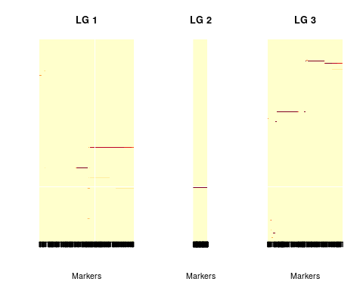

In this figure, the x-axis represents the genetic map and the y-axis represents the 400 possible genotypes in the full-sib population. The color scale varies from dark purple (high probabilityes) to light yellow (low probabilities). The genoprob object obtained here can be used to perform QTL analysis using the R package QTLpoly (G. da S. Pereira et al. 2019), which is an under development software to map multiple QTLs in full-sib families of outcrossing autopolyploid species.

# References

Mollinari, Marcelo, and Antonio AF Garcia. 2018. “Linkage Analysis and Haplotype Phasing in Experimental Autopolyploid Populations with High Ploidy Level Using Hidden Markov Models.” *Plos One*, no. Under review. <https://doi.org/10.1101/415232>.

Mollinari, Marcelo, Olokulu Bode, Pereira Guilhereme da S., Dorcus Gemenet, Craig Yencho, and Zhao-Bang Zeng. 2019. “Construction of an Integrated High-Density Map in Hexaploid Sweetpotato Using Mappoly,” no. in preparation.

Pereira, Guilherme da Silva, Dorcus C. Gemenet, Marcelo Mollinari, Bode Olukolu, Federico Diaz, Veronica Mosquera, Wolfgang Gruneberg, Awais Khan, Craig Yencho, and and Zhao-Bang Zeng. 2019. “Multiple Qtl Mapping in Autopolyploids: A Random-Effect Model Approach with Application in a Hexaploid Sweetpotato Full-Sib Population,” no. in preparation.

Preedy, K. F., and C. A. Hackett. 2016. “A Rapid Marker Ordering Approach for High-Density Genetic Linkage Maps in Experimental Autotetraploid Populations Using Multidimensional Scaling.” *Theor. Appl. Genet.* 129 (11): 2117–32. doi:[10.1007/s00122-016-2761-8](https://doi.org/10.1007/s00122-016-2761-8).