ПРАВИТЕЛЬСТВО РОССИЙСКОЙ ФЕДЕРАЦИИ НАЦИОНАЛЬНЫЙ ИССЛЕДОВАТЕЛЬСКИЙ УНИВЕРСИТЕТ «ВЫСШАЯ ШКОЛА ЭКОНОМИКИ»

Факультет Бизнеса и Менеджмента

Школа бизнес-информатики

Пояснительная записка

OrderMaker

Исполнители:

Студенты

Национального исследовательского университета «Высшая школа экономики»

Факультета Бизнеса и Менеджмента

В.Г. Лукьянова

М.М. Монастырская

В.Ю. Паланова

Преподаватель:

С.Г. Ефремов

2016

Оглавление

**Элементы оглавления не найдены.**

***Name of project****:* OrderMaker

***Annotation****:* The aim of this application could be named creating a service for working in restaurants(cafes) . Service contains three main branches: from the side of customer, administrator and waiter. Customer, using this service, has possibility to call waiter, to check his order, to demand bill. Administrator is allowed to see everything, check and add new dishes, tables, waiters. Waiter through this application could make new order by adding new dishes for chosen table.

***Repository****:* <https://github.com/mmonastyrskaya/ordermaker>

***Participants:***

Maria Monastyrskaya 144 - Database and API

Valeria Palanova 144 - Application Logic and Test

Valeria Lukyanova 144 - UI and WPF

**Interface**

1. For each participant of process there are personal window, which could be chosen at the beginning.

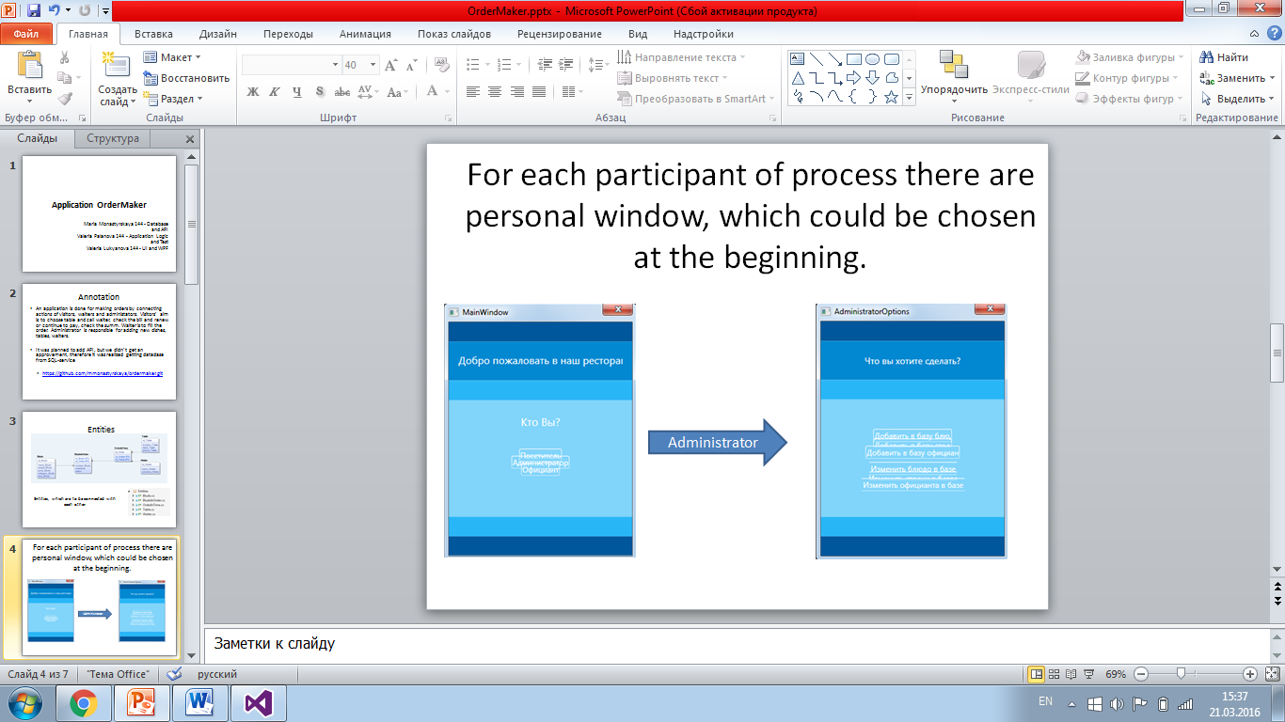

1. Administrator isn’t reliable for making orders between waiter and tables. His responsibilities are to add new tables, waiters, dishes in any time, in any step of process.

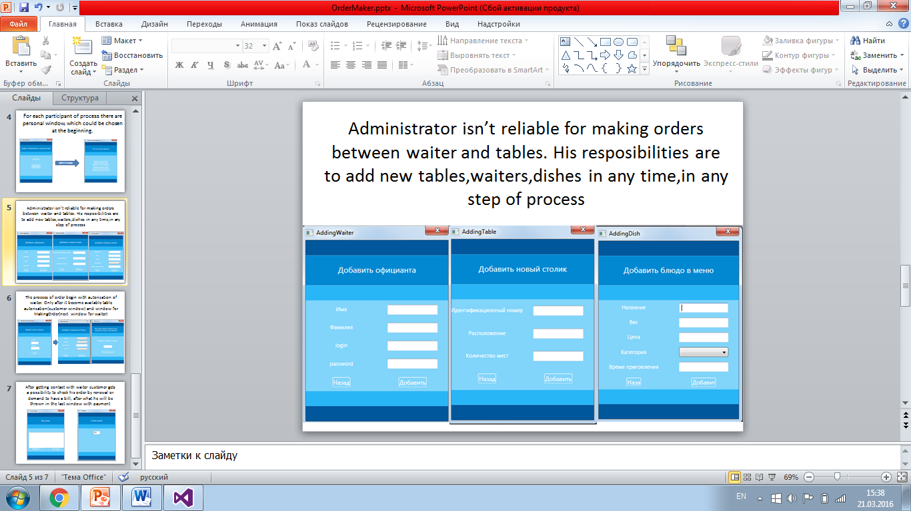

1. The process of order begins with authorization of waiter. Only after it become available table authorization(customer window) and window for MakingOrder(next window for waiter)

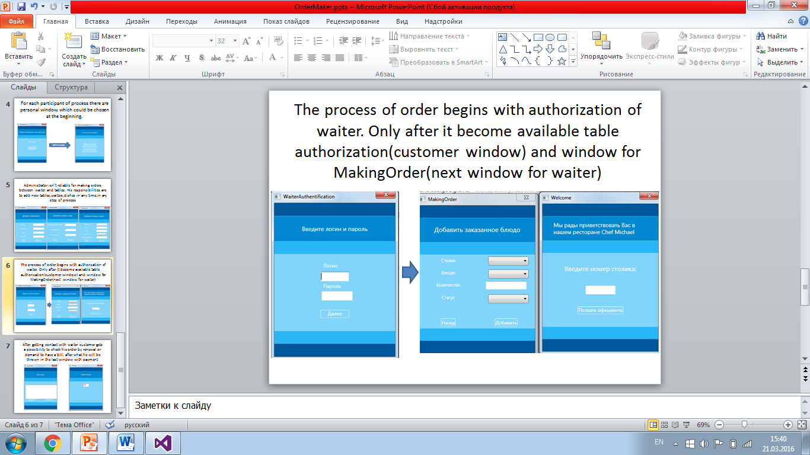

1. After getting contact with waiter customer gets a possibility to check his order by renewal or demand to have a bill, after what he will be thrown in the last window with payment.

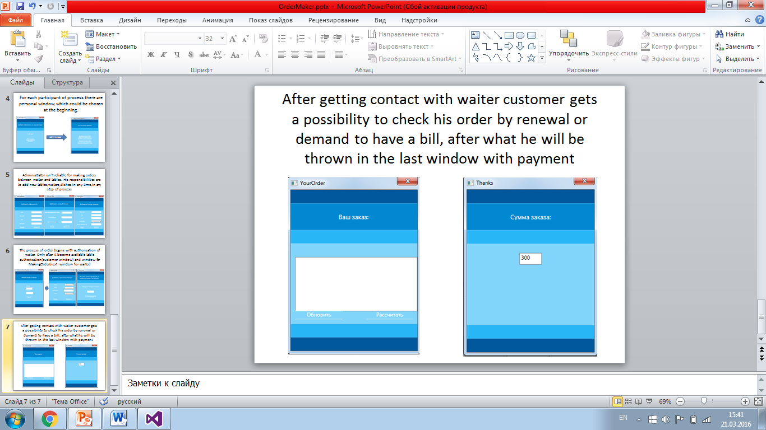

## Classes

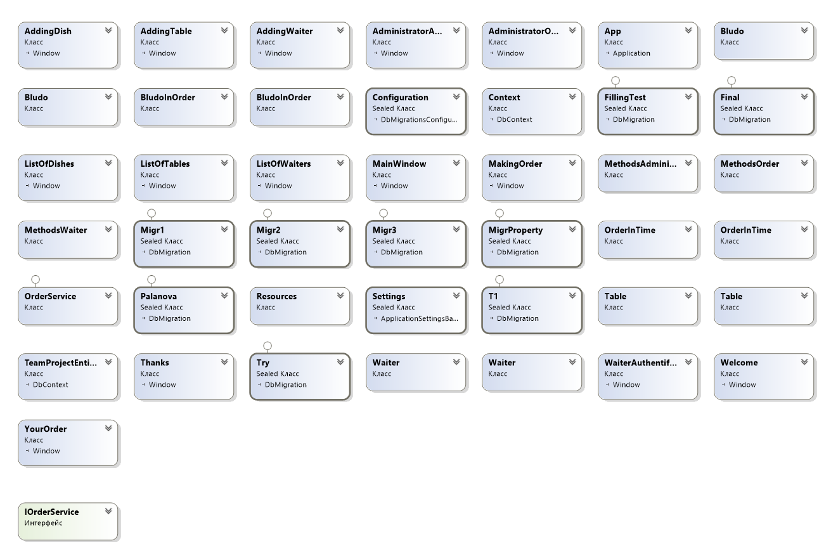

1. Entities: Bludo, BludoInOrder, Waiter, Table, OrderInTime – are main 3 entities.
2. Classes MethodsOrder, MethodsWaiter, MethodsAdministrator contain main methods each participant could do. They also connected with Entities as even create them.
3. Classes AddingDish, AddingTable, AddingWaiter are connected with interface and get values for filling in entities.
4. Classes ListOfDishes, ListOfTables, ListOfWaiters are connected with class MethodsAdministrator, because of Administrator’s only responsibilities. Fill lists, change them if necessary.
5. AdministratorOptions –WPF window for realizing options Administrator could do, get values from interface.
6. MainWindow - WPF window shown at the beginning for choosing participant.
7. Making order – get necessary values to create order.
8. Thanks is the last window for visitor to show the sum.
9. Updating Dish,UpdatingWaiter, UpdateTables are connected with administrator methods to change values, also show this window
10. WaiterAutificaton is a window for waiter to log in, checked through adminidtrator.
11. Welcome is a beginning window for visitor where he chooses the table.
12. YourOrder is a second window for visitor for looking the points of order or going on to the payment.
13. Orderservice is to download foreign database to local.
14. IOrderService is an interface for realization necessary methods – getting all values we need.
15. Context defines an environment.