**C Sc 335 Analysis and Design Artifacts for Jukebox**

*Each team complete this form, put it in your project in a folder named* **doc** *and push to Github. This will be part of your Iteration 1 grade*

**1) Team Members**: Michelle Monteith + Jamie David

**2) Candidate Objects**

List the most important objects, or an inheritance hierarchy name, and the responsibility of each.

|  |  |
| --- | --- |
| **Candidate Object** | **Responsibility in 1 or 2 sentences** |
| Jukebox | Hold a song list and plays songs chosen by a user. |
| Song | A song. Tracks the length, title, and artist of the song. |
| Students | Interacts with the Jukebox, has a magnetic ID card that it can access songs with. Is allowed 1500 min of “free” Jukebox music. |
| Day | Limits how many times one song can be played and how many times a student a student can pick songs. |
| Administrator | Can act like a student, but can also remove other accounts. |

**3) Class Diagram:** Write a UML Class Diagram that shows all of your candidate objects from above. Show any relationships between them the classes such as inheritance or interface implementation. Draw general associations such as dependency or aggregation. Label some to help explain things. Add any multiplicity adornments that seem appropriate. Use notes to explain things if you feel it will help. Each UML class must show the class name. For full credit, each class must have an average of at least one attribute per class. There must be an average of about 1.5 methods per class.

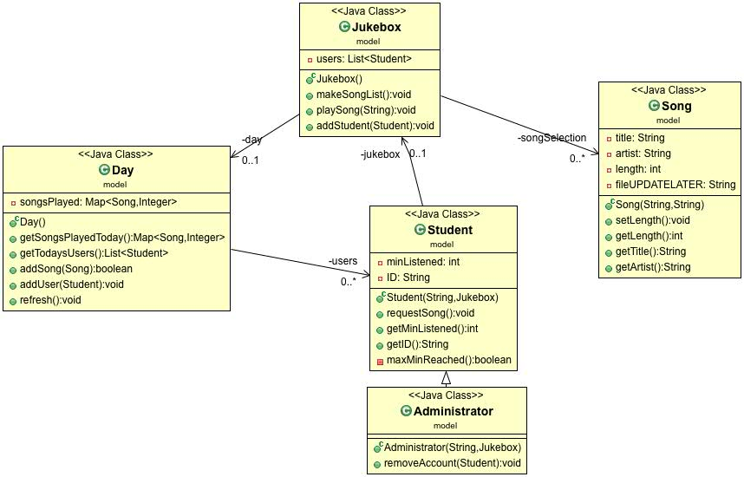

**4) Sequence Diagram:** Write a UML Sequence Diagram should show the most important scenario you can think of. Your sequence diagram should show most of your candidate objects you listed above and how they communicate with each other.

