Diamond sizes

2022-09-12

We have data about 53940 diamonds. Only 126 are larger than 2.5 carats. The distribution of the remainder is shown below:

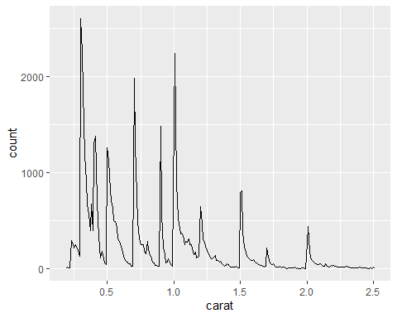

```{r}  
#| out-width: "70%"  
#| fig-align: center  
  
smaller |>   
 ggplot(aes(y = price, x = color)) +   
 geom_bar(stat = "identity")  
```

|  |
| --- |
|  |

```{r}  
#| tbl-cap: Una tabla con `flextable`  
library(flextable)  
```

Attaching package: 'flextable'

The following object is masked from 'package:purrr':  
  
 compose

```{r}  
#| tbl-cap: Una tabla con `flextable`  
copy_mtcars <- mtcars  
copy_mtcars$brand <- row.names(mtcars)  
copy_mtcars <- copy_mtcars[ , c(12,1:11)]  
  
ft <- flextable(copy_mtcars[1:5, ])  
ft <- autofit(ft)  
ft  
```

| brand | mpg | cyl | disp | hp | drat | wt | qsec | vs | am | gear | carb |
| --- | --- | --- | --- | --- | --- | --- | --- | --- | --- | --- | --- |
| Mazda RX4 | 21.0 | 6 | 160 | 110 | 3.90 | 2.620 | 16.46 | 0 | 1 | 4 | 4 |
| Mazda RX4 Wag | 21.0 | 6 | 160 | 110 | 3.90 | 2.875 | 17.02 | 0 | 1 | 4 | 4 |
| Datsun 710 | 22.8 | 4 | 108 | 93 | 3.85 | 2.320 | 18.61 | 1 | 1 | 4 | 1 |
| Hornet 4 Drive | 21.4 | 6 | 258 | 110 | 3.08 | 3.215 | 19.44 | 1 | 0 | 3 | 1 |
| Hornet Sportabout | 18.7 | 8 | 360 | 175 | 3.15 | 3.440 | 17.02 | 0 | 0 | 3 | 2 |

```{r}  
#| tbl-cap: Una tabla con `knitr`  
  
knitr::kable(mtcars[1:5, ])  
```

Una tabla con knitr

|  | mpg | cyl | disp | hp | drat | wt | qsec | vs | am | gear | carb |
| --- | --- | --- | --- | --- | --- | --- | --- | --- | --- | --- | --- |
| Mazda RX4 | 21.0 | 6 | 160 | 110 | 3.90 | 2.620 | 16.46 | 0 | 1 | 4 | 4 |
| Mazda RX4 Wag | 21.0 | 6 | 160 | 110 | 3.90 | 2.875 | 17.02 | 0 | 1 | 4 | 4 |
| Datsun 710 | 22.8 | 4 | 108 | 93 | 3.85 | 2.320 | 18.61 | 1 | 1 | 4 | 1 |
| Hornet 4 Drive | 21.4 | 6 | 258 | 110 | 3.08 | 3.215 | 19.44 | 1 | 0 | 3 | 1 |
| Hornet Sportabout | 18.7 | 8 | 360 | 175 | 3.15 | 3.440 | 17.02 | 0 | 0 | 3 | 2 |