Megan Mosier
06/14/2026
CSD-340 Assignment 3.3

HTML Validator Results:

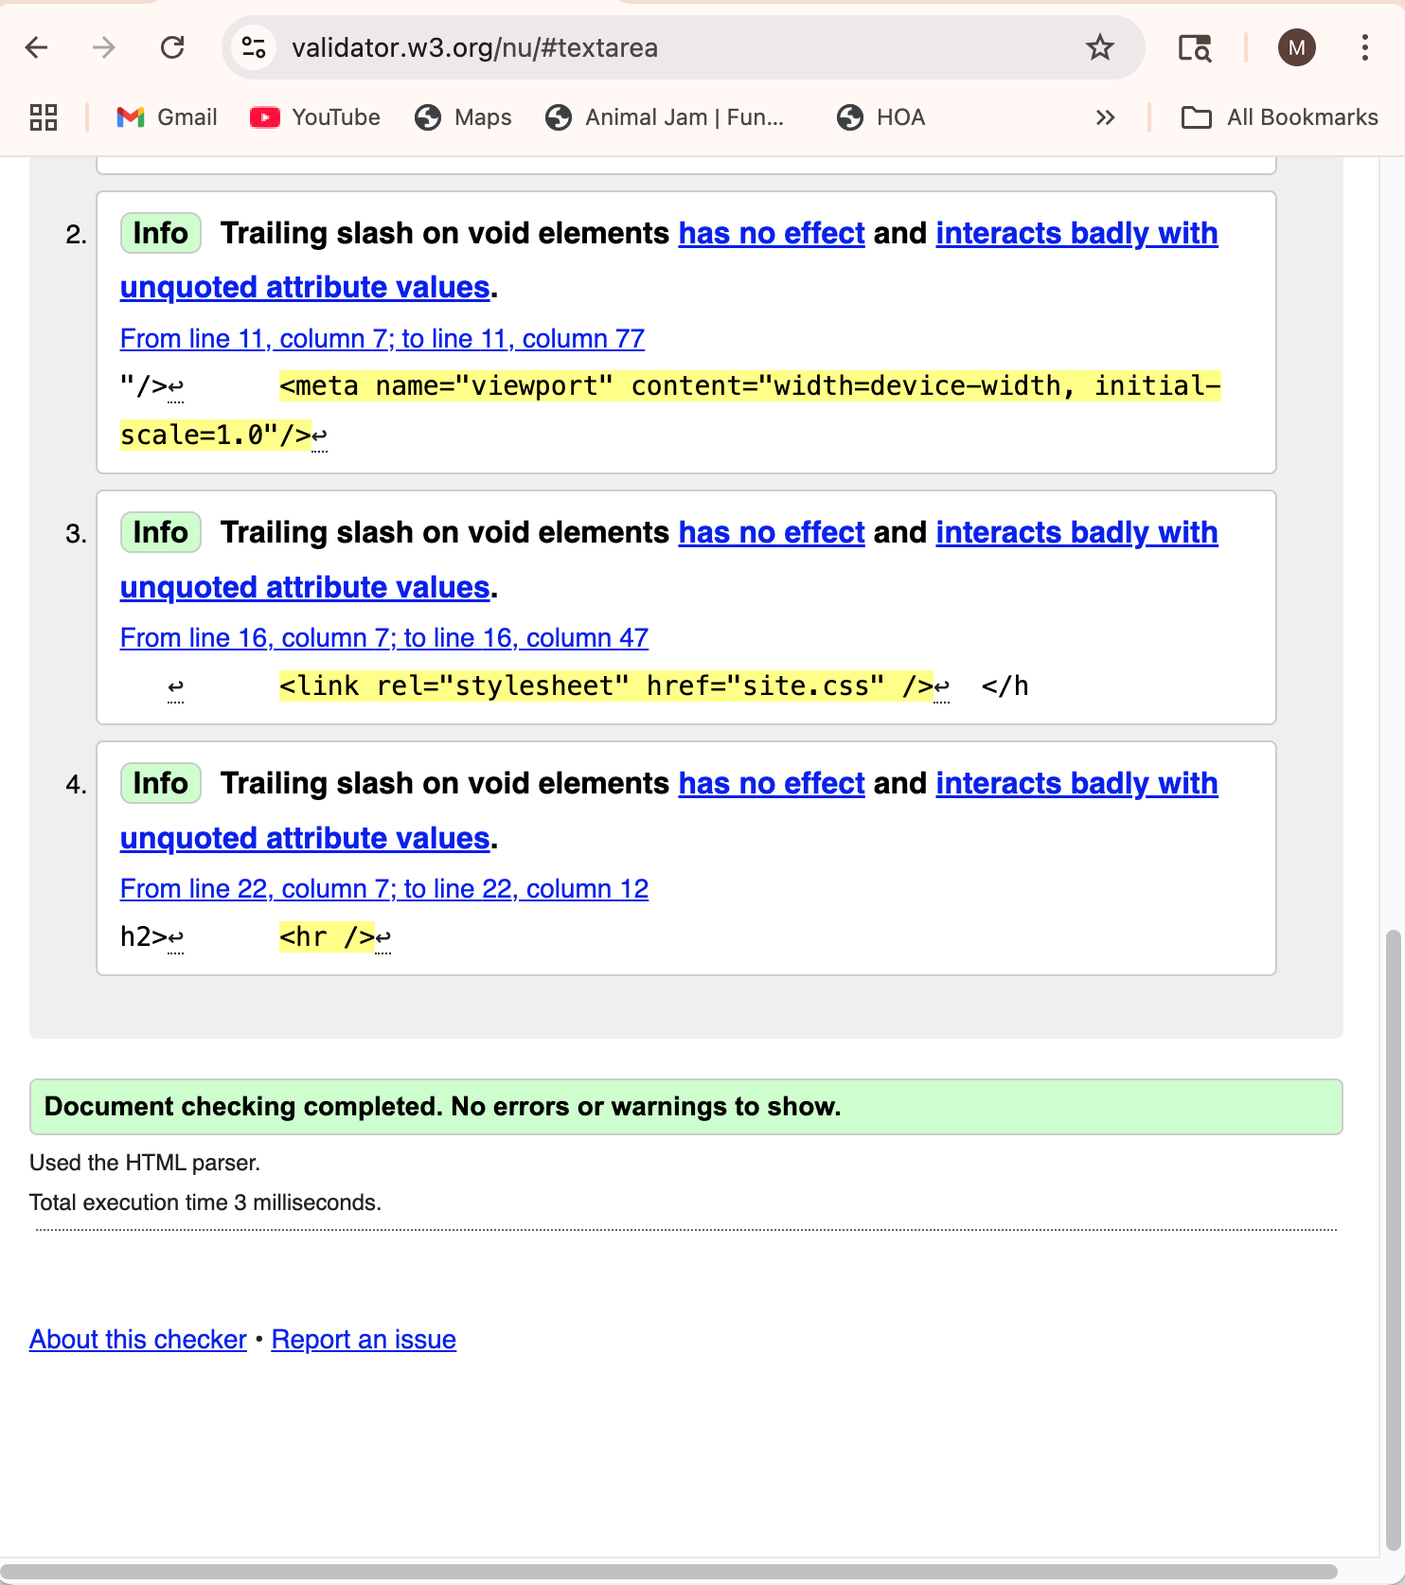
CSS Validator Results:

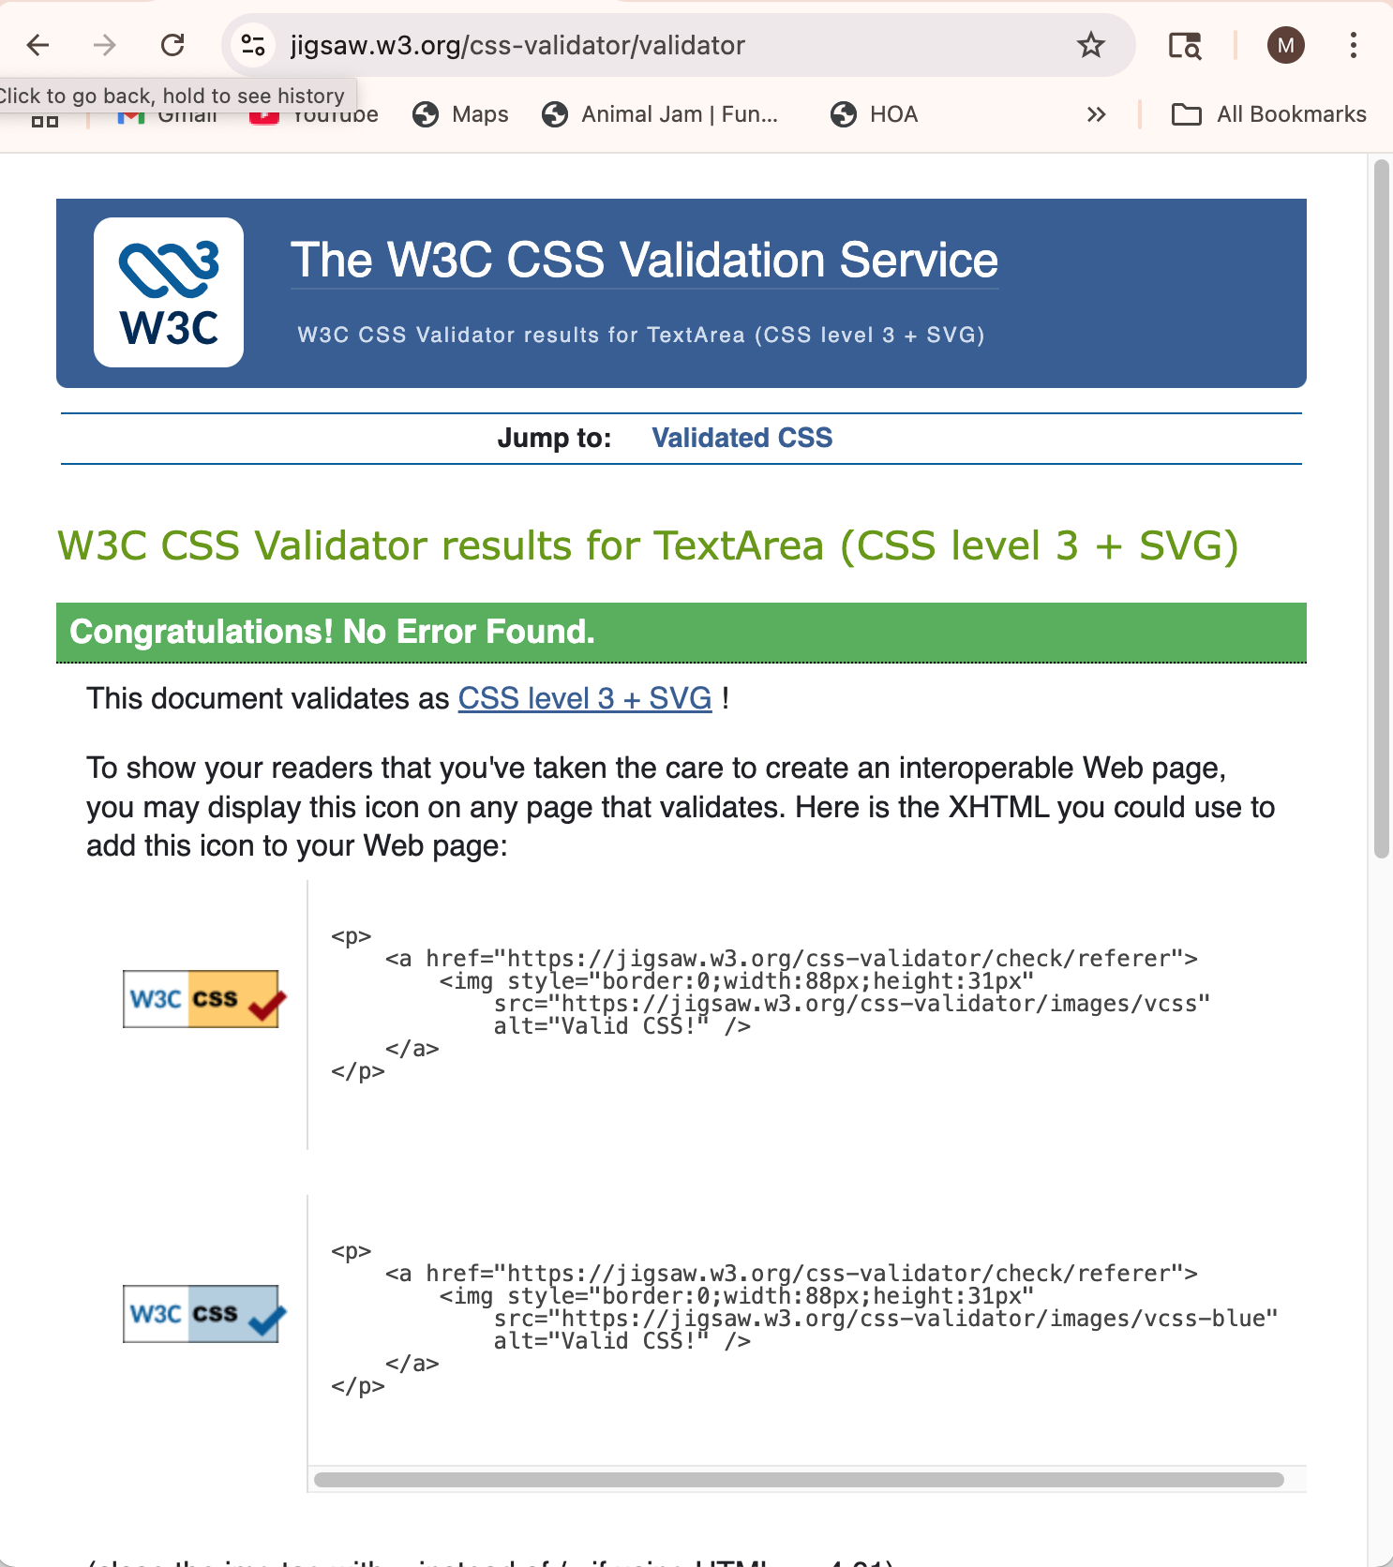

Browser Screenshot of My Page:

