Document: MongoDB

1. Use Spark to load the **/datasets/json-samples/US-Senators.json** into the MongoDB database **labf** under the collection **senators**.  
   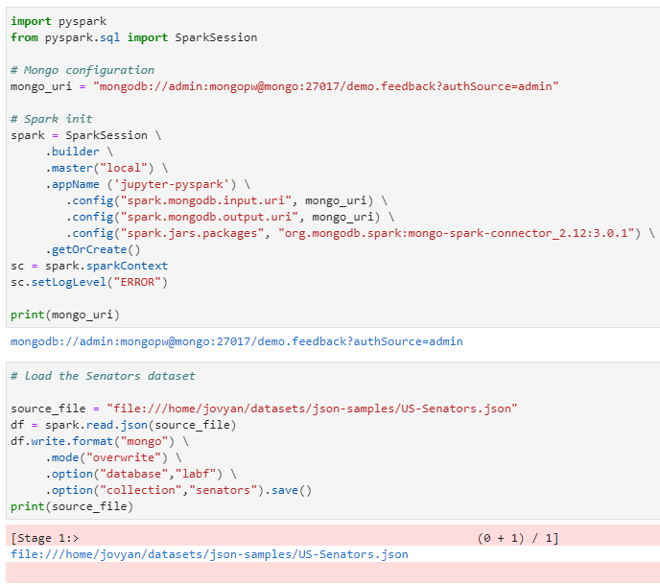

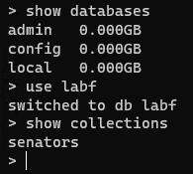

1. From the Mongo client, retrieve the firstname lastname, state, and party for those senators in either the “Republican,” “Democrat,” or “Independent” party.  
   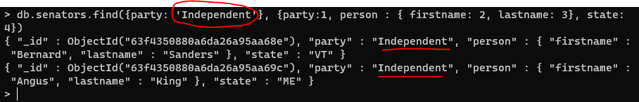
2. From the Mongo client, write an in MQL index to improve the query performance of Question 2. Run the getIndexes() function on the collection to prove you created the index. Then use explain to prove the index is being used.   
   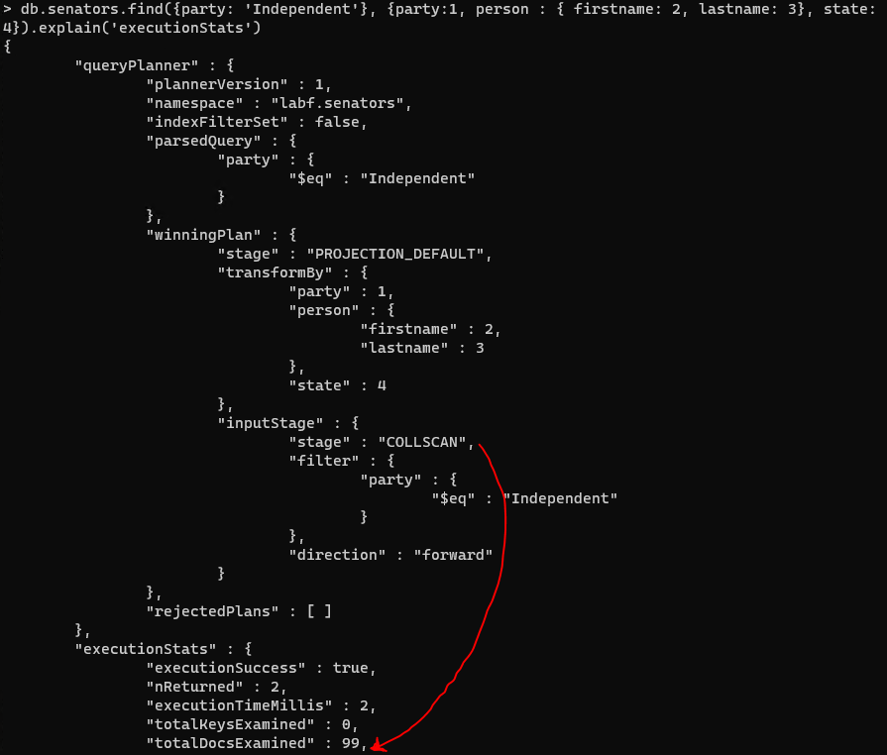

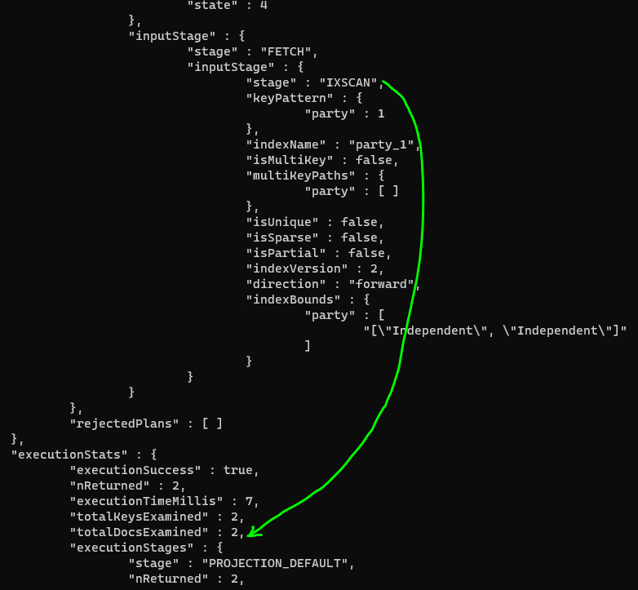

1. Use Spark to load in the **/datasets/netflix-canceled-2021/*.json** into MongoDB database **labf** under the collection **nfcan**.

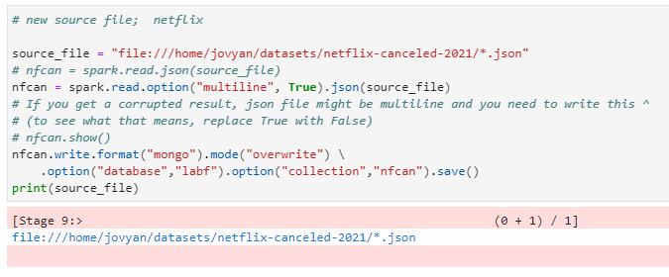

1. Using Drill, write a query to list the name, premier date, and average rating of cancelled Netflix 2021 shows. Limit the shows to those with an average rating under 7.   
   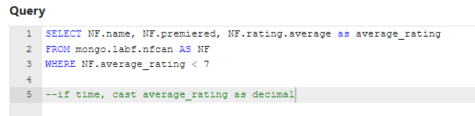

Attempts at getting the full answer:

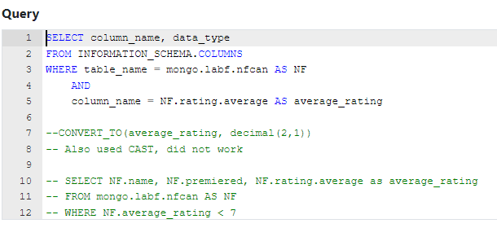

Tried to CAST / CONVERT column data type, couldn’t figure out how to do that so I tried to figure out the data_type.

Would like some feedback on how to do this part.

1. Using Drill, write a query to list the name, premier date, and genre for only those shows in the History or Family genres. Make sure to include a column to display the name of the genre.

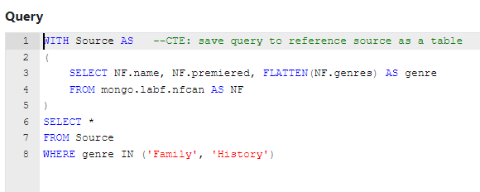

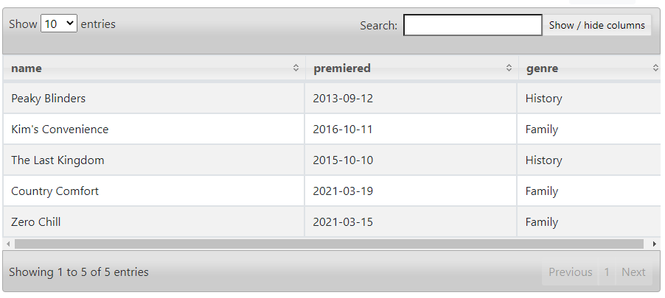

1. Using Spark or Spark SQL, create a DataFrame or view from the Netflix Cancellations MongoDB data, consisting of show name, season number, episode, number, episode name, airdate, and average rating (for the episode).  
   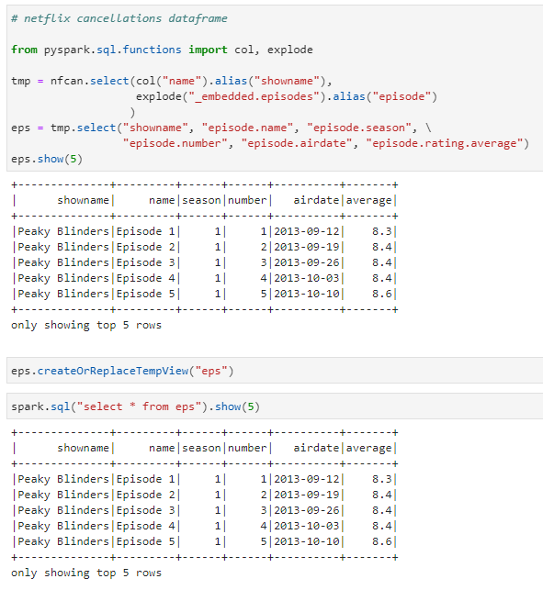
2. Using the query you wrote in Question 7 (if you want), write a Spark or Spark SQL query to get the lowest rated episodes of each season for the cancelled shows. Display show name, season number, episode number, episode name, and rating for that episode.   
   NOTE: Some shows have more than one episode with the lowest rating.   
   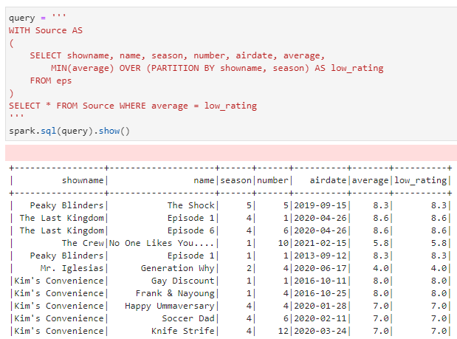
3. CHALLENGE YOURSELF! Display name of show, a picture of the show, and show summary. Make it interactive so you can select the show and see the details.

