Wide Column: Cassandra

Your employer (weather.com) would like you store weather sensor and forecast data. Eventually you will get readings from 2,000 cities worldwide every minute. That's 2.88 million rows each day and 1 billion rows a year! Since the data does not need to be read immediately when written across all nodes, you decide Cassandra is a good choice for this project! This data will be accessible by users so they can get weather information and historical trends for they cities they live in and visit. This should help you figure out how the data will be queried.

**QUESTIONS:   
  
For each question, include a copy of the code required to complete the question along with a screenshot of the code and a screenshot of the output.**

1. InCQL, create a keyspace called **glab** with a replication factor of 1 and a simple replication strategy. Use the keyspace.

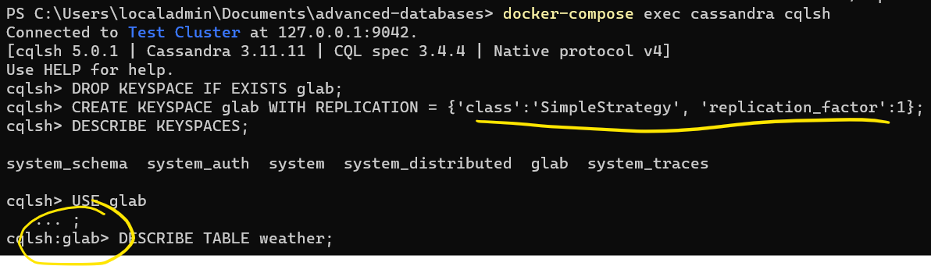

1. In Spark, set up a Spark session that is ready to talk with Cassandra.

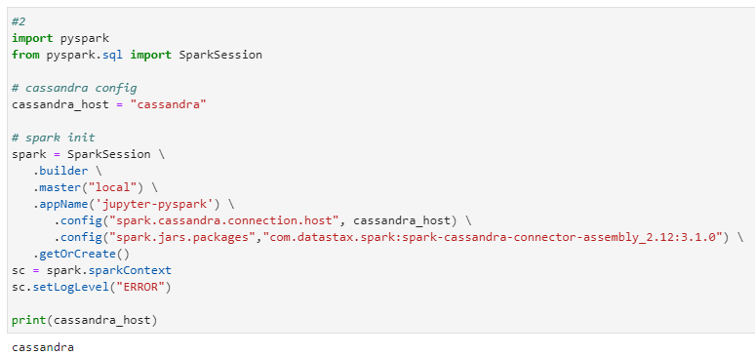

1. To deal with the amount of data associated with the weather.com data set, you decide to start with a smaller sample data set. The data set contains 7 days of weather information for major U.S. cities, with one row being weather information for a single city on a single day. Load the data set located at **/home/jovyan/datasets/weather/weather.json** and use printSchema() to inspect the schema.

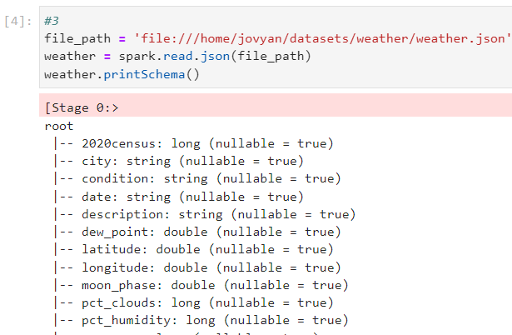

1. Look at rows of data in the sample data set. Profile the data to determine what should be used as the partition and cluster key:
   1. First: Find the minimal candidate key. Which columns serve as a key for each row?   
      NOTE: You canNOT use 2020census as that is a population figure and coincidentally unique.
   2. Next: Prove your key works. In Spark:
      1. Get a count of rows in the entire DataFrame.
      2. Get a count rows when you select your key columns and use distinct() to remove duplicates.
      3. If the row counts are the name, that’s a candidate key. Include the code and output in the screenshot.
   3. A Cassandra row key consists of a partition and cluster key.   
      For this example, use the column that will guarantee to be storing data in increasing order over time (append only) as your cluster key. The other column (or columns) should be the partition key.

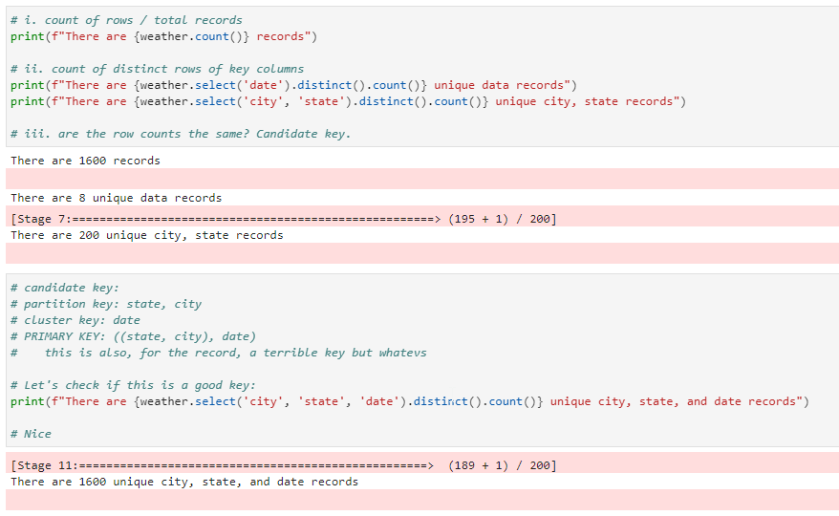

1. With your keys figured out, it’s time to create your table. Using the CQL Shell, write an CQL query to create a table called **daily_city_weather**. Include all columns in the source data set, and make sure to set your partition and cluster keys, as designed. Show the CQL query and the output in the screenshot. Include an additional screenshot of the describe command on this table.  
   ADVICE: Write your create table in a text editor then paste it into CQL, as the command line can be a tad unforgiving.

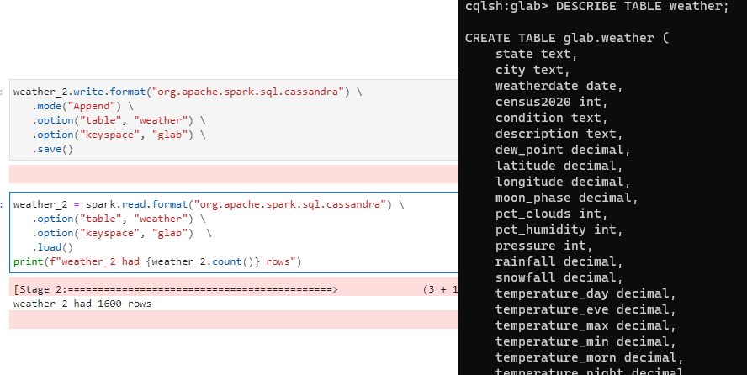

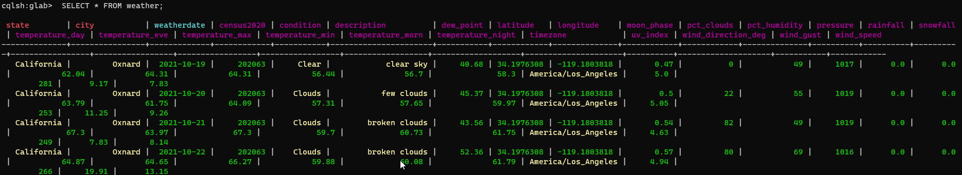

1. Write Spark code to save the JSON DataFrame into your Cassandra table. Make sure the column names are the same. Read the data back out and make sure you have the same number of rows in the DataFrame and in the Cassandra table. This will be further proof that your Cassandra row key is set up correctly. Provide Spark code to save the data to Cassandra and then a screenshot of a select statement and output in the CQL shell.
2. Write a CQL shell query to get the condition, description, and daytime temperatures for "Syracuse, NY"; include all dates.

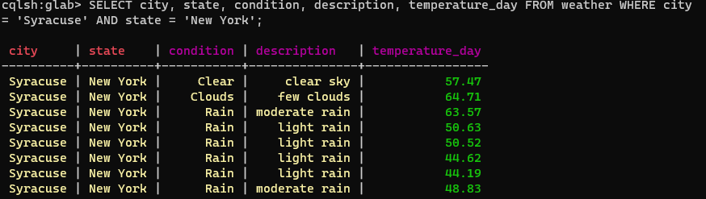

1. Write the same query as Question 7, but using Spark SQL. Register the data from Cassandra as the Temp View **daily_city_weather**, then use Spark SQL to filter on “Syracuse, NY.” Instead of showing the output, **explain()** the Spark query to prove the filter is being passed-through to Cassandra. (The filter should NOT be happening in Spark—Welcome to big data country!)

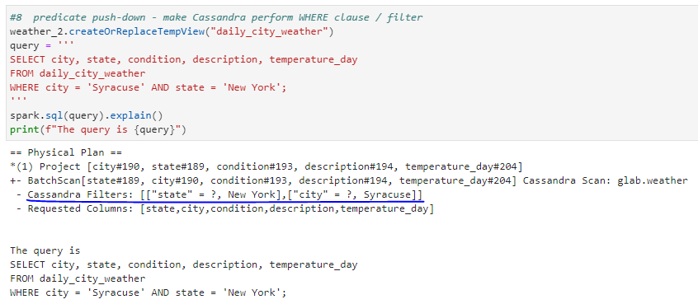

1. Your company would like to now allow users to find cities where it is raining on a specific date. Specifically, they would like a query to show the city and state name, date, condition, and description for only those cities where its not raining on the given date. Write this query in Spark or Spark SQL. Which Cassandra filters are used? Show with explain and highlight in your screenshot.

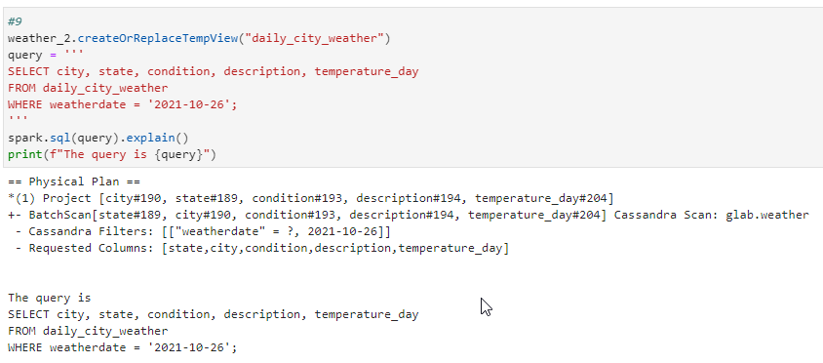

1. Run the same query in Question 9 from the CQL command line; obviously it requires ALLOW FILTERING. Figure out how you can do an index or materialized view to avoid a costly ALLOW FILTERING operation. Include your CQL to create the index or materialized view and then include a query demonstrating it works in CQL.   
   NOTE: Our version of Cassandra and the Spark Connector does not support materialized views.

