Documentation for Visualizing the Magnetic Field in Gate

RFID Research Project

Seyedmorteza MOSTAJABODAVEH

July 31, 2014

|  |  |
| --- | --- |
| Date Performed: | July 31, 2014 |
| Supervisor: | Johannes Lechner |

* **Objective**

In this project, we are going to detect the areas in the gate which the magnetic field strength is not enough to make the RFIDs active. The overall use-case for our system is as follows:

1. **Goals**

First of all, we have to find a way to make the real-world environment con-sistent with the environment which we have in the application because finally user should be able to map what he/she sees in the application to the real-world. Then we should start to collect the pose and magnetic field strength data; and finally, we should find a way to visualize the magnetic field in a specific range. So, the main task is first divided into three main sub-tasks:

**Setting up Scene** In this part we are going to set up the size of the gate, theorigin of the part of the environment which are going to measure the magnetic field in it.

**Collecting Data** First of all we have to define the resolution of the data whichwe are going to achieve. We will make a grid in the area of the interest and we will try to store one value for each element of the grid. The res-olution of the grid, determines how precise do we need to collect data. This task will be done by moving the a dipole in the area of interest and collect the data about the dipole pose and magnetic field strength in each point. The dipole is able to measure the magnetic field which is received

1

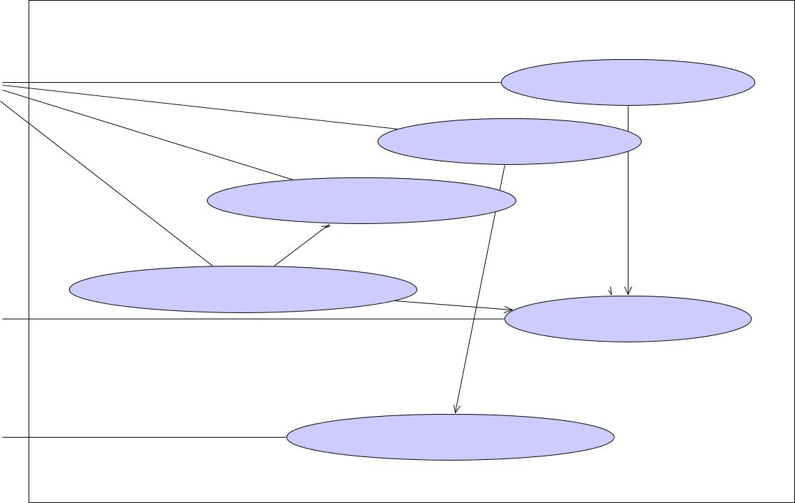

|  |  |  |  |
| --- | --- | --- | --- |
|  | System |  |  |
|  | System |  |  |
|  |  | Setting up the scene |  |
| User | Track Scanned Space | |  |
|  |  |
| Visualize Magnetic Field | | «include» |  |
| «extend» |  | «include» |  |
|  |  |  |
| Focus on low-strength areas | «include» |  |  |
|  | «include» | Locating the dipole |  |
|  |  |  |
| Antenna |  |  |  |
| Measuring Magnetic Field | | |  |
| Tracking System |  |  |  |



Figure 1: The overall system for collecting and visualizing the magnetic field into the gate.

from the antennas and there is tracking system which can measure where the dipole is.

**Visualizing Data** Then, the user wants to visualize the data in the grid in away which the magnetic field in different areas of the gate can be well-presented in classified areas. Areas which their magnetic field strength are in some specific range is displayed and colored based on the user preferences.

2

* **Steps to Do the project**

1. **Setting Up the Scene**

To set up the scene, we have to define the gate dimension and origin, and the area of interest. The area of interest is the area which magnetic field measurements are done there. Additional, to these two main needed specifications, we want to define the antenna position and orien-tation on the gate to make the visualization en-vironment closer to the real world.

1. Finding the 4 inner corners of the gate to determine the gate dimensions and cen-ter. Tip: Why 4 corners? Because calculat-ing the center of the gate is hard to do in real world but putting the dipole’s head in the corners of the gate is pretty simple. Then, finding the center of the gate is easy to calculate.
2. Determining the antenna position and orientation. This step is not necessary but to make the visualization closer to the real world we are trying to include that. To determine the antenna position and orientation, we will put the dipole close to the antenna with almost the same ori-entation of the antenna and then ask the application to store this position as an an-tenna position and orientation.
3. Then we will use the dipole again to de-termine the area of interest for measure-ments. First we put the dipole in one cor-ner of the area of interest and then we will put it in the another corner of the area of the interest. As it is obvious, here we only determine the bounding box of the area of interest. If we want, we can use some other meshes using the application. But this is not our goal. We just want to fill a 3d cube of data.

Using these steps, the scene will be set up. Dur-ing the scene setup the user is able to see the re-sults until now. Additionally, during 3all these set up scene there should be good tutorials to tell the user how to define his/her goals.

Figure 2: Setting up the gate

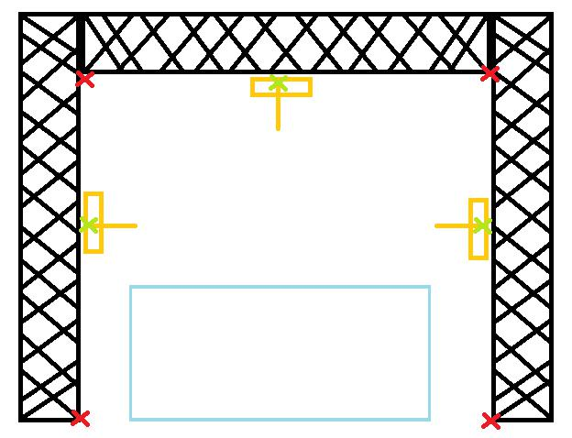

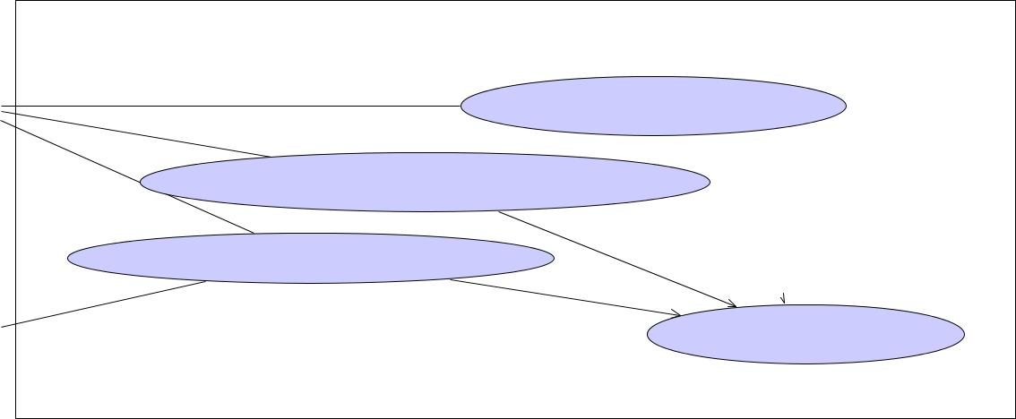

System

System



Gate Dims Specification

User

Antenna Position and Orient setting

«include»

Area of Interest Determination «include»

«include»



Locating the dipole

Tracking System

Figure 3: Setting up the scene use case.

1. **Collecting the data about the magnetic field in the area of interest**

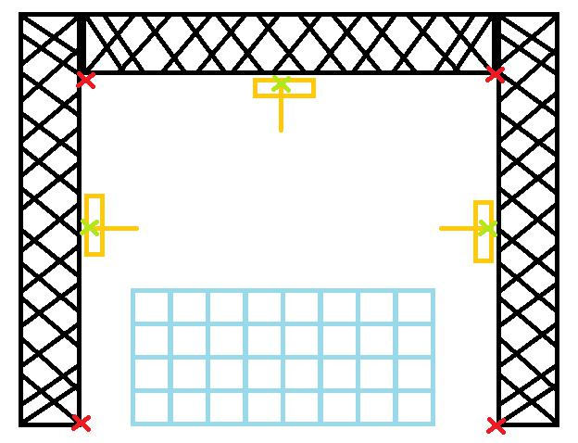

As the first step, we should determine the reso-lution of the box. Possibly, it would be a widget which is opened and user is able to enter the number of segments along length, width and height of the bounding box of the area of inter-est. Then, everything is setup and we are able to scan the area of interest.

While we are measuring the magnetic field, we should determine the position of the dipole, store the measured values, dipole position and orientation to a data structure. During col-lecting the data via scanning, the application should show which part of the area is scanned and which part is not scanned. Also, there should be a mechanism to help the user to find the parts which are not scanned and needed to be scanned to finish the measurements.

Figure 4: Defining the reso-lution of the 3d cube of in-terest

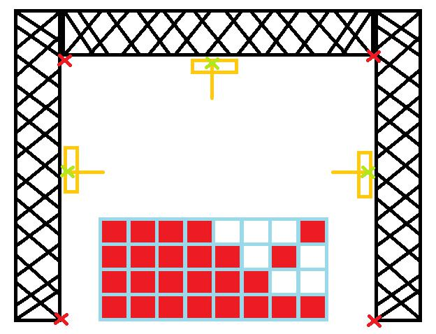

Figure 5: Scanning the cube to collect the data

4

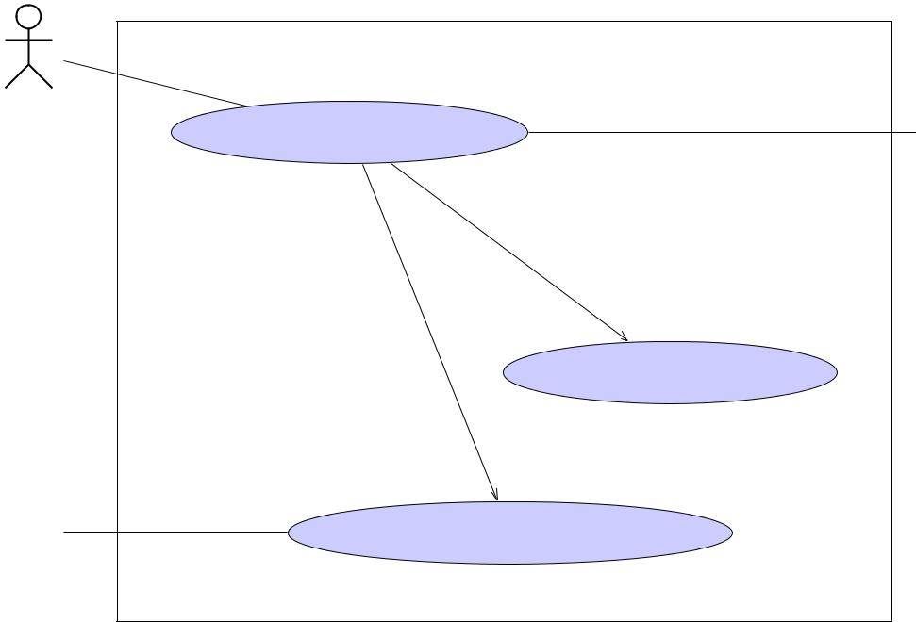

System

System



User

Track Scanned Space

ScanHandler«system»

«include»

«include»



 Locating the dipole Antenna



Measuring Magnetic Field

Tracking System

Figure 6: The collecting data use case.

1. **Visualizing the collected data**

The collected data in previous sections should be used to visualize the data in a good way. For now, the user will define some range of mag-netic field values as critical range. The criti-cal range is the range of values which is con-sidered as low-strength. It is good if we have also some range as the normal range which the user is able to see the normal range beside the critical range. Additionally, the user is able to define a value-color map to represent different values of the magnetic fields with different col-ors, to make them easier to understand.

Figure 7: Visualizing the collected data

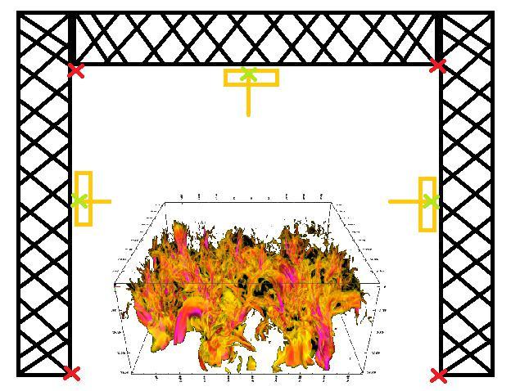

1. **Gantt Chart**

The schedule for doing the project of IDP can be found in the following Gantt Chart:

5

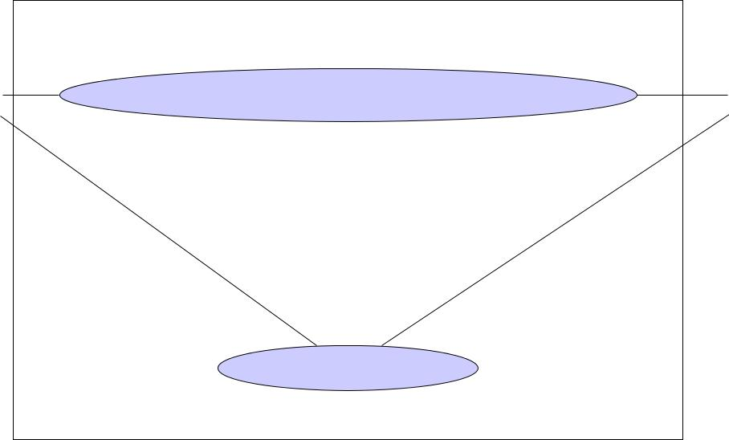

System

System



Determine the visualization values range

|  |  |
| --- | --- |
| User | Data Visualizer«system» |

visualize the data

Figure 8: The visualizing data use case.

* **Known Problems Definition**

In this part, we have to define some simple and planned formation of the an-tennas and the gate and the expected results. This definition will helps us to insure that whether our system is working fine or not.

6

|  |  |  |  |  |  |  |  |  |  |  |  |  |  |  |  |  |  |  |  |  |  |  |  |  |  |  |  |  |  |  |
| --- | --- | --- | --- | --- | --- | --- | --- | --- | --- | --- | --- | --- | --- | --- | --- | --- | --- | --- | --- | --- | --- | --- | --- | --- | --- | --- | --- | --- | --- | --- |
| **WEEKS:** | **1** | | **2** | **3** | **4** | **5** |  | **6** |  | **7** | **8** | | **9** | **10** |  | **11** | **12** | **13** | **14** | | **15** | **16** |  | **17** |  | **18** | **19** |  |  |  |
| **Literature Review** |  |  |  |  |  |  |  |  |  |  |  |  | **20%** | | **complete** | | |  |  |  |  |  |  |  |  |  |  |  |  |  |
|  |  |  |  |  |  |  |  |  |  |  |  |  |  |  |  |  |  |  |  |  |  |  |  |  |
| **Finding** the proper tools |  |  |  |  |  |  |  |  |  |  |  |  |  |  |  |  |  |  |  |  |  |  |  |  |  |  |  |  |  |  |
|  |  |  | 20% | complete | |  |  |  |  |  |  |  |  |  |  |  |  |  |  |  |  |  |  |  |  |  |  |  |  |
|  |  |  |  |  |  |  |  |  |  |  |  |  |  |  |  |  |  |  |  |  |  |  |  |  |  |  |
| **Getting Familiar** with code |  |  |  |  | 40% complete | | | |  |  |  |  |  |  |  |  |  |  |  |  |  |  |  |  |  |  |  |  |  |  |
|  |  |  |  |  |  |  |  |  |  |  |  |  |  |  |  |  |  |  |  |  |  |  |  |  |  |
| **Study** the feasibility of the project |  |  |  |  |  |  |  | 60% | complete | | | |  |  |  |  |  |  |  |  |  |  |  |  |  |  |  |  |  |  |
|  |  |  |  |  |  |  |  |  |  |  |  |  |  |  |  |  |  |  |  |  |  |  |  |  |
| **Implementation**: Initial codes |  |  |  |  |  |  |  |  |  |  | 80% | | complete | |  |  |  |  |  |  |  |  |  |  |  |  |  |  |  |  |
|  |  |  |  |  |  |  |  |  |  |  |  |  |  |  |  |  |  |  |  |  |  |  |  |  |  |
| **Define** the problem and boundaries |  |  |  |  |  |  |  |  |  |  |  |  | 100% | | complete | | |  |  |  |  |  |  |  |  |  |  |  |  |  |
|  |  |  |  |  |  |  |  |  |  |  |  |  |  |  |  |  |  |  |  |  |  |  |  |  |
| **Collecting and Visualizing the Data** |  |  |  |  |  |  |  |  |  |  |  |  |  |  |  |  |  |  |  |  |  |  |  | **70%** | | | **complete** |  |  |  |
|  |  |  |  |  |  |  |  |  |  |  |  |  |  |  |  |  |  |  |  |  |  |  |  |  |  |
| **Setting up** the virtual scene |  |  |  |  |  |  |  |  |  |  |  |  |  |  |  | |  |  |  |  |  |  |  |  |  |  |  |  |  |  |
|  |  |  |  |  |  |  |  |  |  |  |  |  | 20% | complete | | |  |  |  |  |  |  |  |  |  |  |  |  |  |
|  |  |  |  |  |  |  |  |  |  |  |  |  |  |  |  |  |  |  |  |  |  |  |  |  |  |
| **Collecting** Data |  |  |  |  |  |  |  |  |  |  |  |  |  |  |  | 40% complete | | |  |  |  |  |  |  |  |  |  |  |  |  |
|  |  |  |  |  |  |  |  |  |  |  |  |  |  |  |  |  |  |  |  |  |  |  |  |  |  |  |
| **Visualizing** Data |  |  |  |  |  |  |  |  |  |  |  |  |  |  |  |  |  |  | 75% | | complete | |  |  |  |  |  |  |  |  |
|  |  |  |  |  |  |  |  |  |  |  |  |  |  |  |  |  |  |  |  |  |  |  |  |  |  |
| **Guiding** System |  |  |  |  |  |  |  |  |  |  |  |  |  |  |  |  |  |  |  |  | 85% complete | | | | |  |  |  |  |  |
|  |  |  |  |  |  |  |  |  |  |  |  |  |  |  |  |  |  |  |  |  |  |  |  |  |
| **Finalize** the Project |  |  |  |  |  |  |  |  |  |  |  |  |  |  |  |  |  |  |  |  |  | 100% complete | | | | |  |  |  |  |
|  |  |  |  |  |  |  |  |  |  |  |  |  |  |  |  |  |  |  |  |  |  |  |  |  |
| **Adding the new Tracking System** |  |  |  |  |  |  |  |  |  |  |  |  |  |  |  |  |  |  |  |  |  |  |  |  |  |  | **90%** | **complete** | |  |
|  |  |  |  |  |  |  |  |  |  |  |  |  |  |  |  |  |  |  |  |  |  |  |  |  |  |  |
| **Finalizing the documentations** |  |  |  |  |  |  |  |  |  |  |  |  |  |  |  |  |  |  |  |  |  |  |  |  |  |  |  |  | **100% complet** |  |
|  |  |  |  |  |  |  |  |  |  |  |  |  |  |  |  |  |  |  |  |  |  |  |  |  |  |  |  |  |
|  |  |  |  |  |  |  |  |  |  |  |  |  |  |  |  |  |  |  |  |  |  |  |  |  |  |  |  |  |  |  |

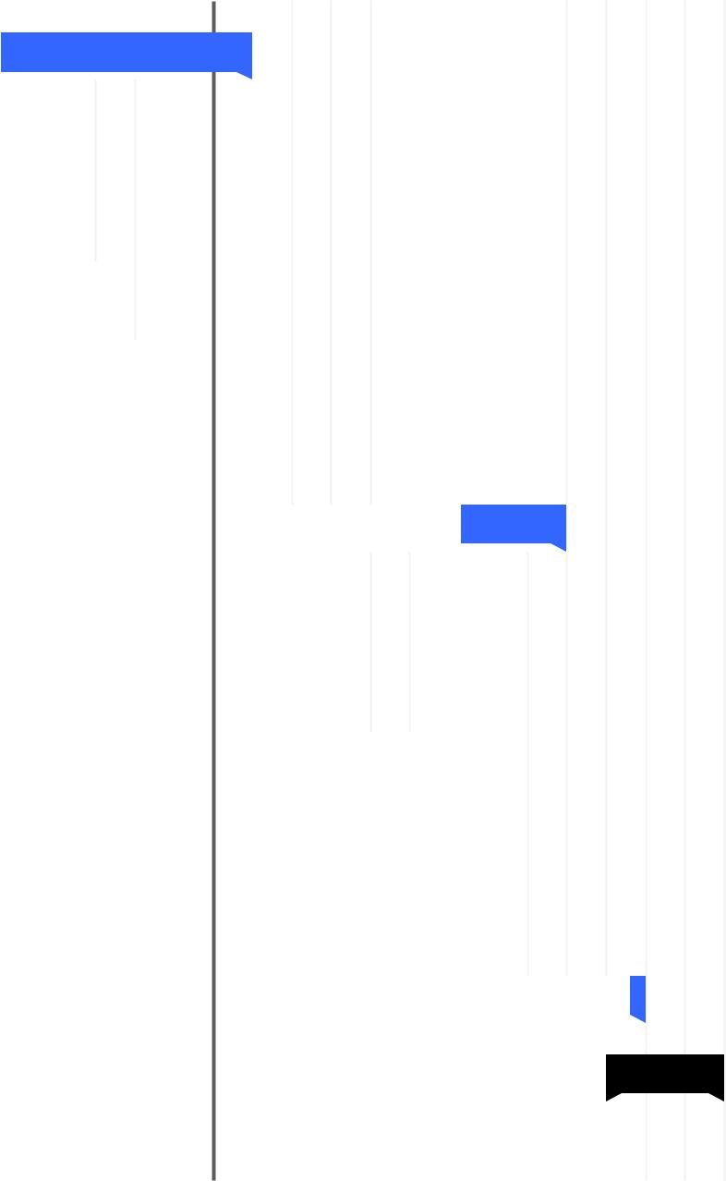

**TODAY**

Figure 9: Gantt chart for the project

7