Documentation for Visualizing the Magnetic Field in Gate

RFID Research Project

Seyedmorteza MOSTAJABODAVEH

August 8, 2014

|  |  |
| --- | --- |
| Date Performed: | August 8, 2014 |
| Supervisor: | Johannes Lechner |

* **Objective**

The project as a whole is going to detect the areas in the gate which the mag-netic field strength is not in a specific domain. The problem is that there can be different gates beside each other that the gates can affect each other if their magnetic field is big outside the gate. As a part of the whole project, I am going to store the store the data in a specific structure and visualize the stored data using some specific algorithm or method.

1. **Goals**

First of all, we have to find a way to map the real-world environment to the world environment in the application; as the user should be able to match what he sees in the application to the real world or vice versa, match what he sees in the real-world to the world environment. It should be possible to map im-portant things in real world to what the user can see in the computer. Then we should start to collect the pose and magnetic field strength data; and finally, we should find a way to store the incoming magnetic field and pose from the dipole in a specific data structure which makes it possible to visualize the data. in a specific range. So, the main task is first divided into three main sub-tasks:

**Setting up Scene** In this part we are going to set up the size of the gate, theorigin of the environment which are going to measure the magnetic field in it and the part of the environment which we are going to measure the magnetic field in it. We call this part of the environment the as Area of Interest.

1

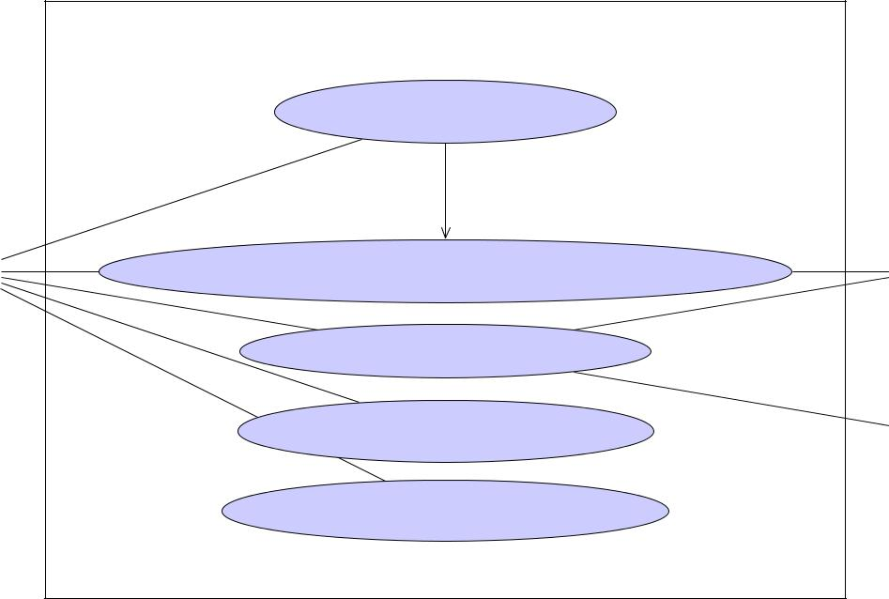

System

System

Setting up the scene

«extend»



Setting up the scene with Tracking System

User Tracking System

Scan the Area of Interest



Visualize Magnetic Field

Focus on Interesting Areas

Antenna

Figure 1: The overall system for collecting and visualizing the magnetic field into the gate.

**Collecting Data** First of all, the resolution of the data which we are going toachieve should be determined by the user. We will make a grid in the area of the interest and the user is going to collect the data using the dipole which he has in his hand. As the dipole is moving, the pose of the dipole and the measured magnetic field is sent received and we are able to store the data in a way to be visualized properly. The dipole is able to measure the magnetic field which is received from the antennas and there is tracking system which can tell us where the dipole is. The resolution of the grid, determines how precise do we need to collect data. This task will be done by moving the a dipole in the area of interest and collect the data about the dipole pose and magnetic field strength in each point.

**Visualizing Data** The most important part of the project is done in this part.Then, the user wants to visualize the data which is collected in the grid in different ways to find out how good is the configuration of the scene. A good way to visualize how good is the current configuration of the an-tennas is to classify the magnetic field in different areas of the gate. It is possible to only show a specific range of data in the areas which their magnetic field strength are in each specific range is displayed in a differ-ent color. It will help the user how good is the antenna configuration but it is not enough to find how to make the antenna configuration better. So, There should be another way to visualize the magnetic field by showing

2

the direction of the magnetic field with a directed arrow in each position in the 3d environment and show the value of the magnetic field by spec-ifying some colors for the directed arrow. Even it can get more advanced if we draw stream lines. Also, the other simpler methods like showing the values in spheres and so can be helpful.

* **Steps to Do the project**

1. **Setting Up the Scene**

To set up the scene, we have to define the gate dimension and origin, and the area of interest. The area of interest is the area which magnetic field measure-ments are done there. Additional, to these two main needed specifications, we want to define the antenna position and orientation on the gate to make the visualization environment closer to the real world.

As it is obvious, the configuration of the scene is more determined by the an-tenna configuration and to modify the final results, the user will move the an-tennas. **So, it is very important to determine the antenna position and orien-**

**tation as best as possible**.

1. There should be two ways to determine the gate dimensions and center: one way is through entering all these numbers via the application. The other way is to find the 3d coordinates of the inner corners of the gate to determine the dimensions and center of the gate. Tip: Why 4 corners? Because calculating the center of the gate is hard to do in real world but putting the dipole’s head in the corners of the gate is pretty simple. Then, finding the center of the gate is easy to calculate.
2. Determining the antenna position and orientation. This step is also should be possible in two ways: one way through the application by itself and other way is determine the antenna position and orientation via putting the dipole in antenna position and orientation.
3. Like the other previous steps, we will have two options: one way to de-termine the area of interest via the application. The other way is to use the dipole to specify the area of interest. It can be determined by putting the dipole in one corner one time and putting the dipole in the other cor-ner, again. As it is obvious, here we only determine the bounding box of the area of interest. If we want, we can use some other meshes using the application. But this is not our goal. We just want to fill a 3d cube of data.

Using these steps, the scene will be set up. During the scene setup the user is able to see the results until now. Additionally, during all these set up scene there should be good tutorials to tell the user how to define his/her goals.

3

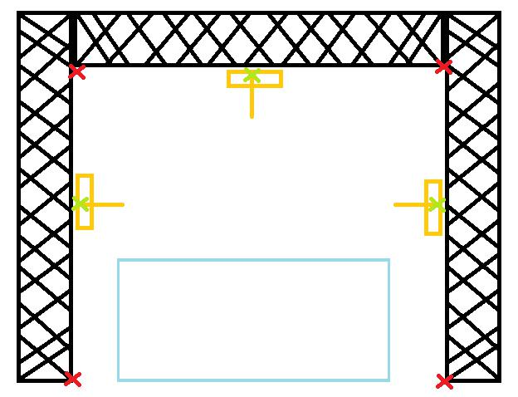

Figure 2: Setting up the gate

1. **Collecting the data about the magnetic field in the area of interest**

As the first step, we should determine the resolution of the box. Possibly, it would be a widget which is opened and user is able to enter the number of segments along length, width and height of the bounding box of the area of interest. Then, everything is setup and we are able to scan the area of interest. While we are measuring the magnetic field, we should determine the position of the dipole, store the measured values, dipole position and orientation to a data structure. During collecting the data via scanning, the application should show which part of the area is scanned and which part is not scanned. Also, there should be a mechanism to help the user to find the parts which are not scanned and needed to be scanned to finish the measurements, if he wants.

Also, there should be a way to visualize the already collected data during the measurements. Because there may be a big mistake in the configuration of the antennas, so the user can understand it very quick and make the required changes.

1. **Visualizing the collected data**

There should be some different ways to visualize the collected data. Each way has its own benefit:

**Simple Bubbles** Visualizing the value in each element of the grid using ansphere with a constant radius and some specific color. The color is deter-

4

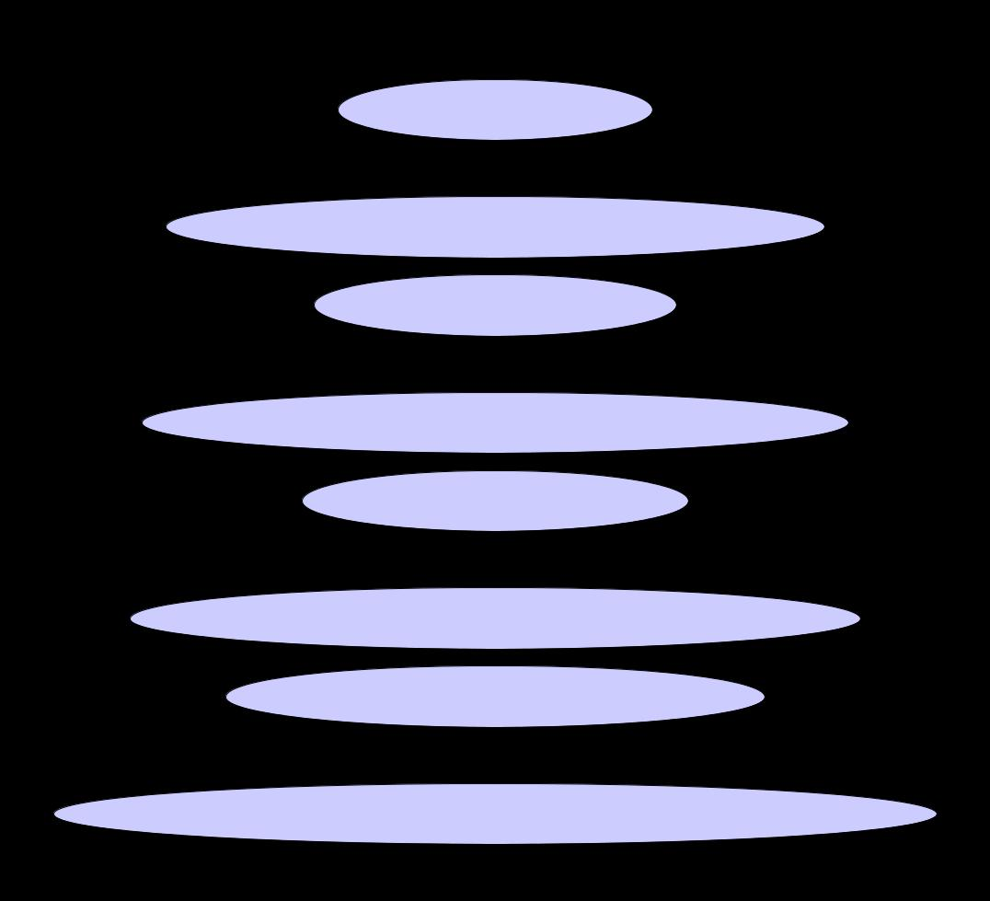

System

System

Specify Gate Specs

«extend»

Specify Gate Specs with Tracking System

Specify Antenna Pose



«extend»

|  |  |
| --- | --- |
| User | Tracking System |
|  | Specify Antenna Pose with Tracking System |

Specify Area of Interest

«extend»

Specify Area of Interest with Tracking System

Adding other objects to the scene «extend»

Adding other objects to the scene with Tracking System

Figure 3: Setting up the scene use case.

mined by the value of the magnetic field in that point.

**Direct Volume Rendering** The user will define some range of magnetic fieldvalues as critical range and some other as the normal range. The critical range is the range of values which is considered as low-strength or high-strength values. It is good if we have also some range as the normal range which the user is able to see the normal range beside the critical range. Additionally, the user is able to define a value-color map to represent different values of the magnetic fields with different colors. It will make visual perception easier. This visualization method helps the user to find the area of interests(Figure 8.

**Arrow Glyph** Visualizing the value of each element in the grid with a 3d ar-row which the direction shows the direction of the magnetic field and the color shows the value of the magnetic field. This method is useful in

5

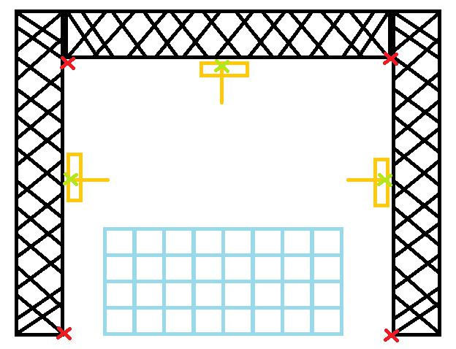

Figure 4: Defining the resolution of the 3d cube of interest

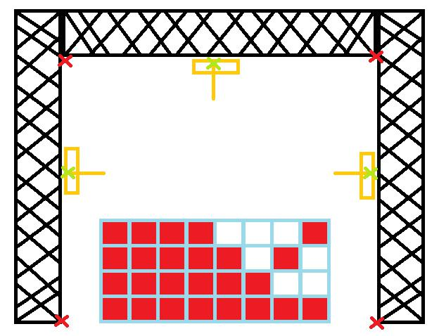

Figure 5: Scanning the cube to collect the data

6

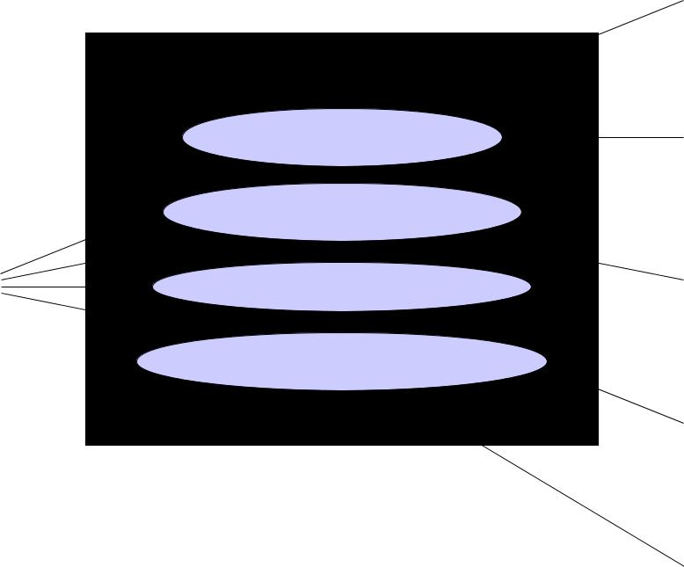

System

System

Update Dipole Pose

Antenna



Storing Scanned Space



Tracking System



Show not scanned areas

User Data Storer

Visualize during scanning



ScanHandler



Data Visualizer

Figure 6: The collecting data use case.

finding how to make the configuration better (Figure 9).

**Stream Lines** are the trajectory of a massless particle in a frozen vector field.We will give the ability to the user, to draw start drawing the stream lines from wherever he wants but it is good to start this lines from the antenna position because they show how magnetic field is going to be distributed into the scene (Figure 10).

**Stream Ribbons** are ribbons which made of by stream lines of two close mas-less particles in a frozen vector field. Sometimes, the ribbon can show how the vector field is changing better (Figure 11).

1. **Gantt Chart**

The schedule for doing the project of IDP can be found in the following Gantt Chart:

7

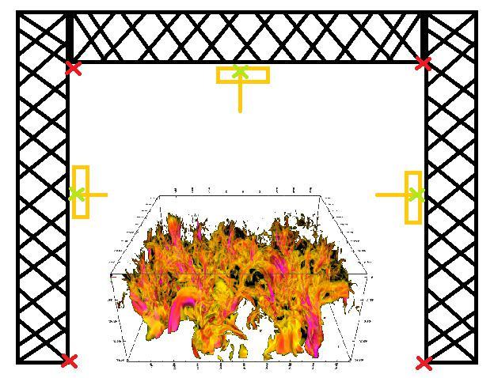

Figure 7: Visualizing the collected data

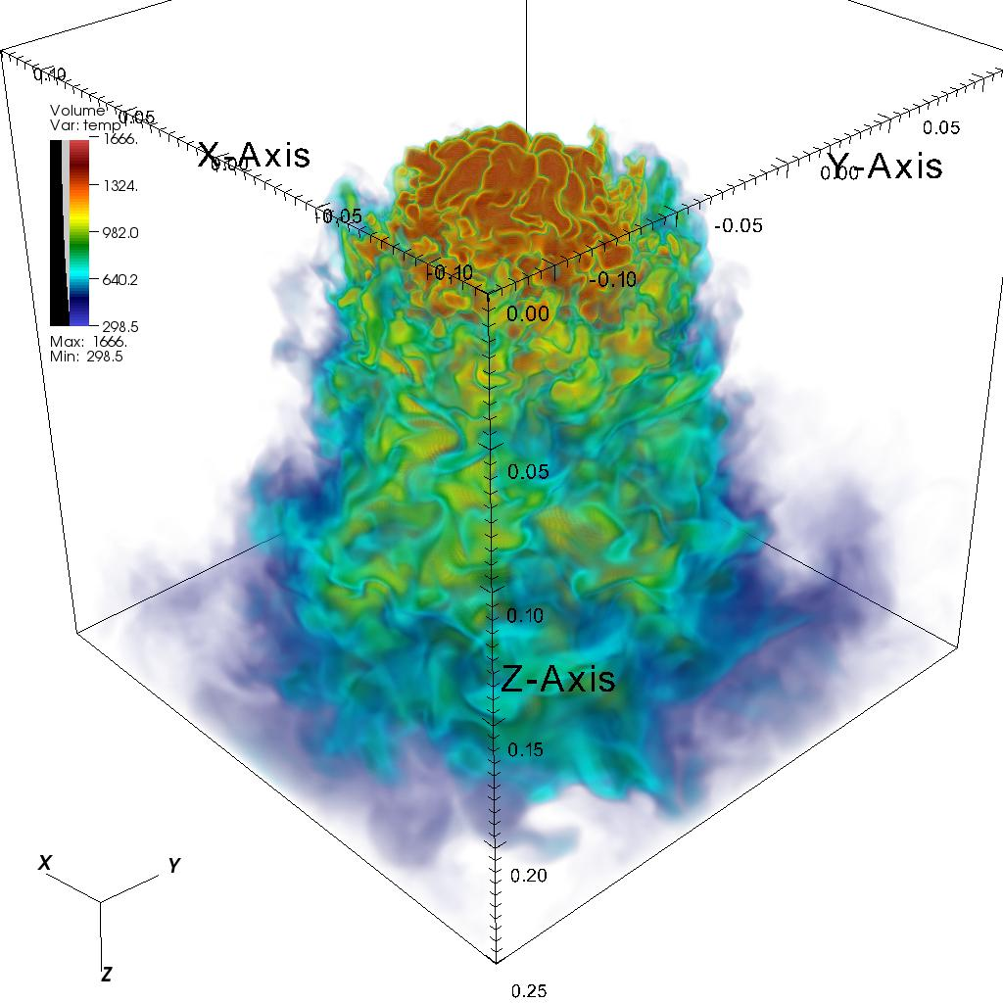

Figure 8: Direct Volume Rendering (DVR) in Action

8

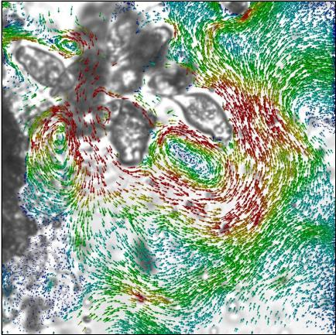

Figure 9: Arrow Glyph in Action

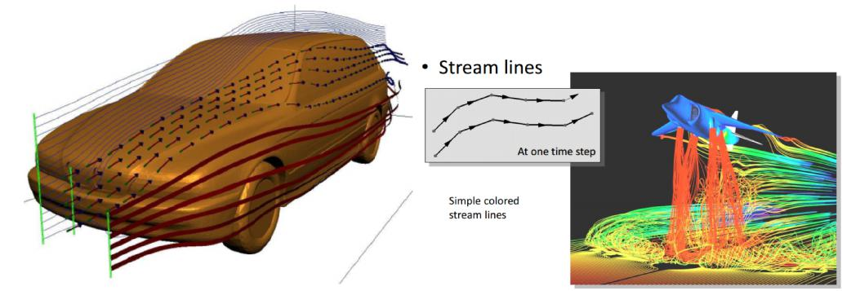

Figure 10: Stream Lines in Visualization

9

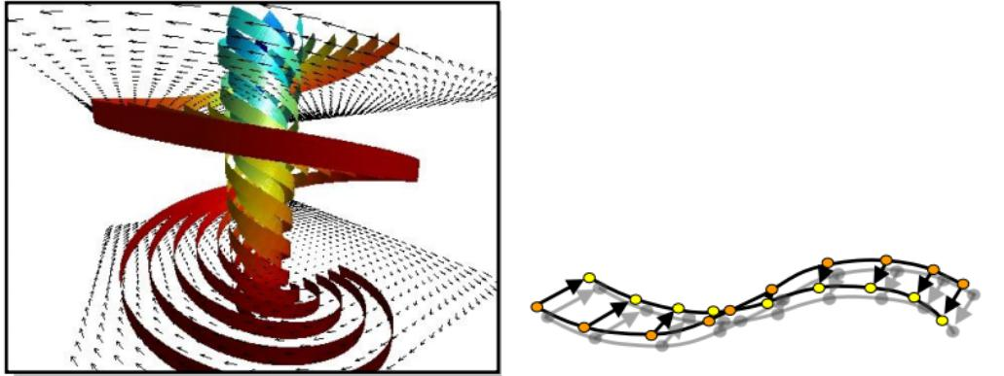

Figure 11: Stream Ribbons in Visualization

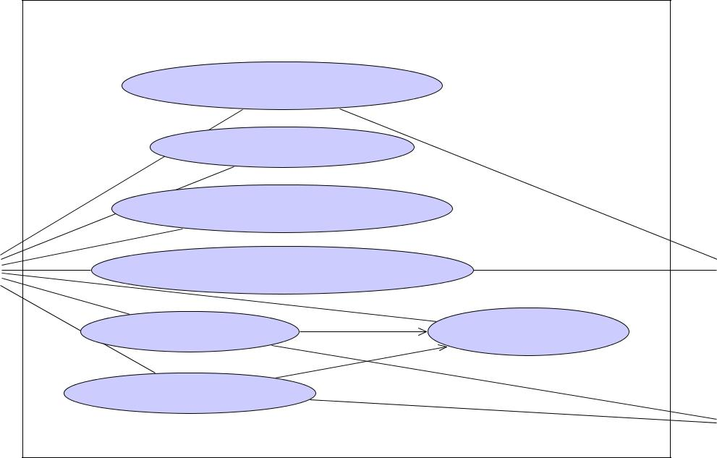

System

System

Determine Value Ranges



Bubble Visualizaton

Rendering «System»

Arrow Glyph Vis. Method



|  |  |  |  |
| --- | --- | --- | --- |
| Direct Volume Rendering Vis. | |  |  |
| User | «include» | DVR «System» |  |
| Stream Line Vis. | Specify origins |  |
|  | «include» |  |  |
| Stream Ribbon Vis. |  |  |  |
|  |  | Particle System «System» |  |



Figure 12: The visualizing data use case.

10

|  |  |  |  |  |  |  |  |  |  |  |  |  |  |  |  |  |  |  |  |  |  |  |  |  |  |
| --- | --- | --- | --- | --- | --- | --- | --- | --- | --- | --- | --- | --- | --- | --- | --- | --- | --- | --- | --- | --- | --- | --- | --- | --- | --- |
| **WEEKS:** | **1** | | **2** | **3** | **4** | **5** |  | **6** |  | **7** | **8** | | **9** | **10** |  | **11** | **12** | **13** | **14** | | **15** | **16** |  |  |  |
| **Literature Review** |  |  |  |  |  |  |  |  |  |  |  |  | **20%** | | **complete** | | |  |  |  |  |  |  |  |  |
|  |  |  |  |  |  |  |  |  |  |  |  |  |  |  |  |  |  |  |  |
| **Finding** the proper tools |  |  |  |  |  |  |  |  |  |  |  |  |  |  |  |  |  |  |  |  |  |  |  |  |  |
|  |  |  | 20% | complete | |  |  |  |  |  |  |  |  |  |  |  |  |  |  |  |  |  |  |  |
|  |  |  |  |  |  |  |  |  |  |  |  |  |  |  |  |  |  |  |  |  |  |
| **Getting Familiar** with code |  |  |  |  | 40% complete | | | |  |  |  |  |  |  |  |  |  |  |  |  |  |  |  |  |  |
|  |  |  |  |  |  |  |  |  |  |  |  |  |  |  |  |  |  |  |  |  |
| **Study** the feasibility of the project |  |  |  |  |  |  |  | 60% | complete | | | |  |  |  |  |  |  |  |  |  |  |  |  |  |
|  |  |  |  |  |  |  |  |  |  |  |  |  |  |  |  |  |  |  |  |
| **Implementation**: Initial codes |  |  |  |  |  |  |  |  |  |  | 80% | | complete | |  |  |  |  |  |  |  |  |  |  |  |
|  |  |  |  |  |  |  |  |  |  |  |  |  |  |  |  |  |  |  |  |  |
| **Define** the problem and boundaries |  |  |  |  |  |  |  |  |  |  |  |  | 100% | | complete | | |  |  |  |  |  |  |  |  |
|  |  |  |  |  |  |  |  |  |  |  |  |  |  |  |  |  |  |  |  |
| **Collecting and Visualizing the Data** |  |  |  |  |  |  |  |  |  |  |  |  |  |  |  |  |  |  |  |  |  |  | **70% complete** | |  |
|  |  |  |  |  |  |  |  |  |  |  |  |  |  |  |  |  |  |  |  |  |  |  |
| **Setting up** the virtual scene |  |  |  |  |  |  |  |  |  |  |  |  |  |  |  | |  |  |  |  |  |  |  |  |  |
|  |  |  |  |  |  |  |  |  |  |  |  |  | 20% | complete | | |  |  |  |  |  |  |  |  |
|  |  |  |  |  |  |  |  |  |  |  |  |  |  |  |  |  |  |  |  |  |
| **Collecting** Data |  |  |  |  |  |  |  |  |  |  |  |  |  |  |  | 40% complete | | |  |  |  |  |  |  |  |
|  |  |  |  |  |  |  |  |  |  |  |  |  |  |  |  |  |  |  |  |  |  |
| **Visualizing** Data |  |  |  |  |  |  |  |  |  |  |  |  |  |  |  |  |  |  | 75% | | complete | |  | |  |
|  |  |  |  |  |  |  |  |  |  |  |  |  |  |  |  |  |  |  | |  |
| **Guiding** System |  |  |  |  |  |  |  |  |  |  |  |  |  |  |  |  |  |  |  |  | 85% complete | | | |  |
|  |  |  |  |  |  |  |  |  |  |  |  |  |  |  |  |  |  |  |  |  |
| **Finalize** the Project |  |  |  |  |  |  |  |  |  |  |  |  |  |  |  |  |  |  |  |  |  | 100% complete | | |  |
|  |  |  |  |  |  |  |  |  |  |  |  |  |  |  |  |  |  |  |  |  |  |
| **Finalizing the documentations** |  |  |  |  |  |  |  |  |  |  |  |  |  |  |  |  |  |  |  |  |  |  |  | **100% complete** |  |
|  |  |  |  |  |  |  |  |  |  |  |  |  |  |  |  |  |  |  |  |  |  |  |  |  |  |

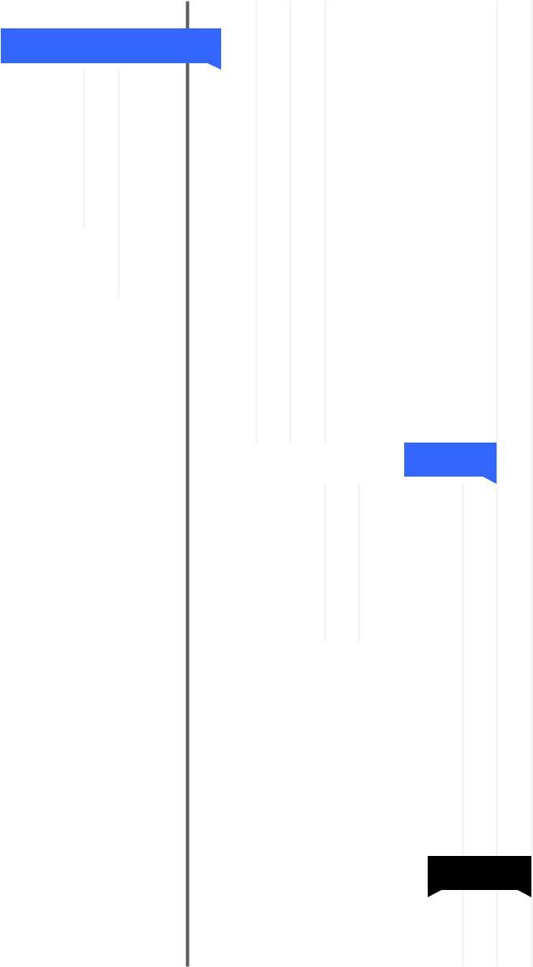

**TODAY**

Figure 13: Gantt chart for the project

11