Creating the Local Mmowgli Database

# Introduction

Getting your database setup will consist of three separate tasks:

1. Installing and executing the MySql database server;
2. Reading/running **mmowgli_bootstrap.sql** to build the tables;
3. Installing one or more user accounts which have rights to read and write to the database.

MySql comes with a command-line interface, but a GUI tool, **MySQL Workbench**, is easy to use for both tasks.

# 1 MySql Server

Complete task 1 following the MySql instructions for your environment and make sure the MySQL database manager is live in the background.

# 2 Mmowgli Database

The initial screen of **MySQL Workbench** is shown below:

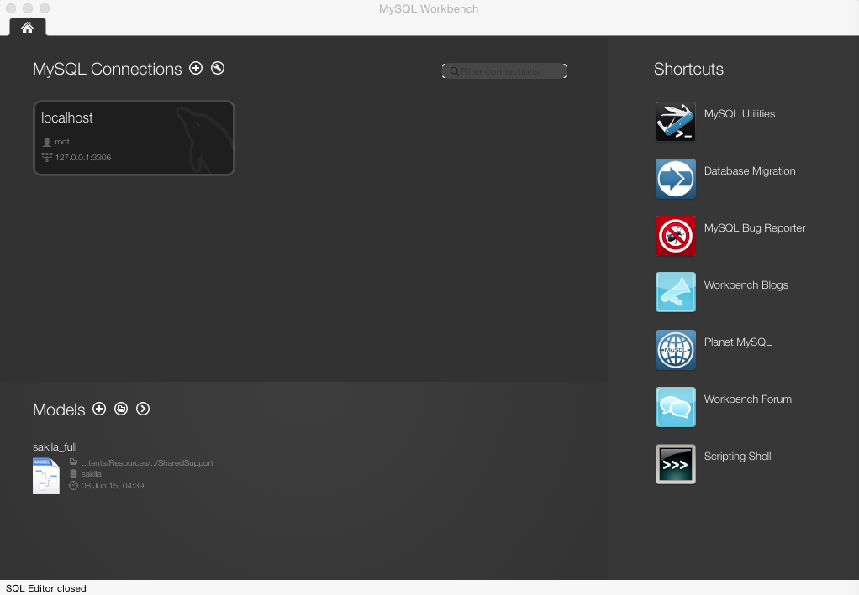

Open the local database manager by choosing from the application menu

**Database->Connect to Database…**

The next dialog will be similar to:

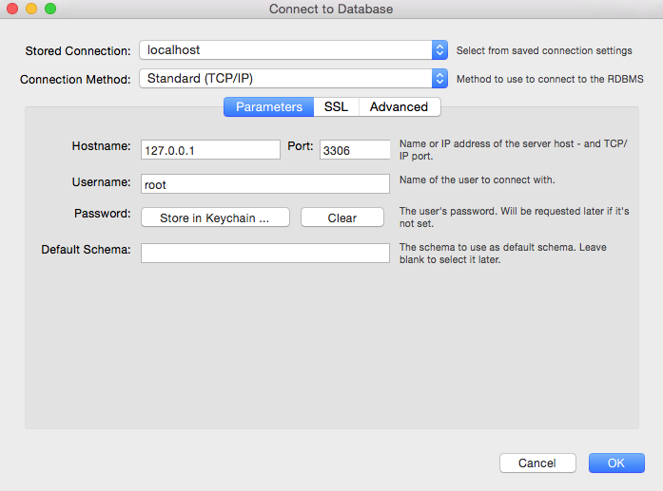

**MySQL Workbench** will then present an interface such as the following (note the new tab):

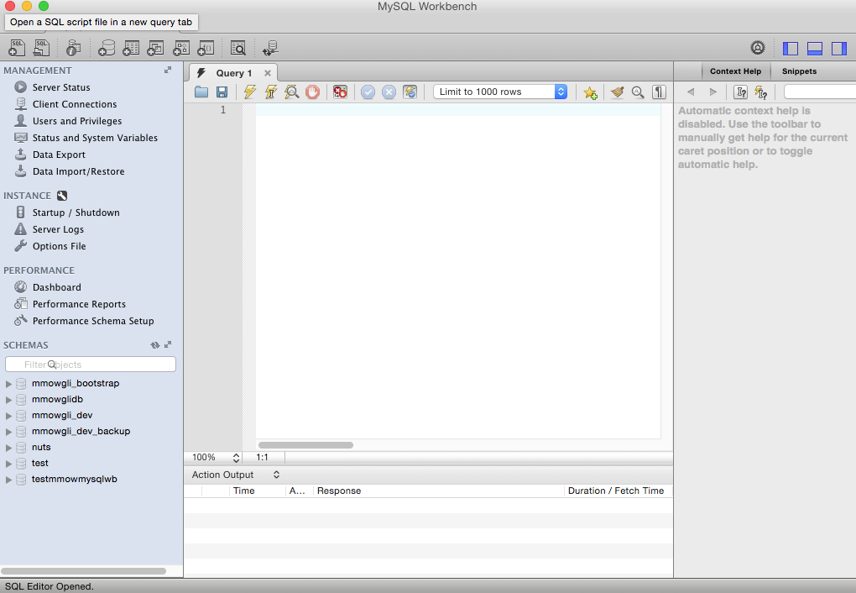

The 7 lines under “SCHEMAS” on the left will not be present on a freshly installed system. They identify separate schemas handled by the local MySql database manager. (In this and other Mmowgli documents, the word “database” will refer to what this tool calls “SCHEMA”.)

Next, the database for use by Mmowgli will be created. In this example, we will name it **mmowgli_dev**, since that matches the default **web.xml**. Click the 4th toolbar button, whose tooltip says “Create a new schema in the connected server”. The following tab will appear:

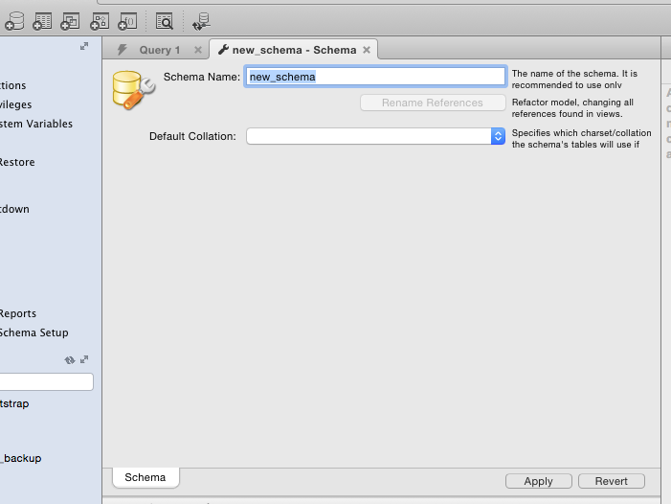

Type “mmowgli_dev” for the **Schema name**, and choose “utf – default collation” for the **Default Collation** field, then click **Apply**. The following dialog appears:

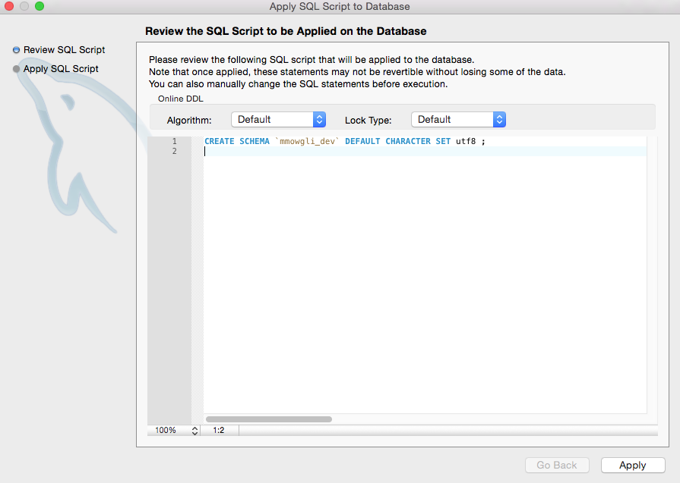

Do 2 things at this point before clicking Apply:

1. Insert the line “USE mmowgli_dev;” as line 2;
2. Copy the entire contents of **mmowgli_bootstrap.sql** from the mmowgli distribution root directory and paste starting at line 3.

The dialog should now be similar to the following:

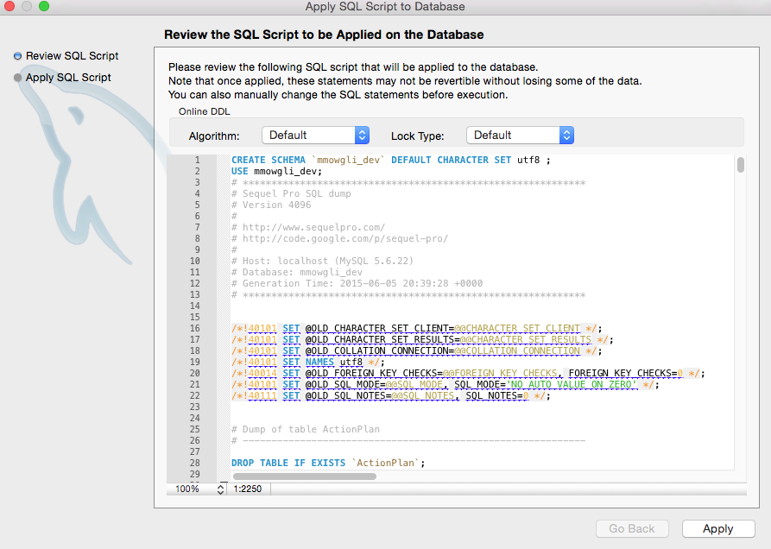

After clicking **Apply**, the **mmowgli_dev** schema (i.e., “database”) should appear in the SCHEMAS list on the left.

# 3 User Accounts

A user name must be entered into the database server to allow the mmowgli application to connect. This name and corresponding password must match entries in **WebContent/WEB-INF/web.xml** (see below). For database novices, it is important to remember that a database user is given different rights within a database server, keyed not only by user name, but also depending on the connection method/address used to reach the database. In the case of local development, the connection method is “localhost”.

From the menu Servers->Users and Privileges, fill in the following dialog with the proper login name, password, and “localhost” connection (“Limit to Hosts Matching:”). The minimal privileges required by the new user will be to CREATE, WRITE, ALTER and DELETE the new database, but it is often quicker in a secure development environment to grant all privileges.

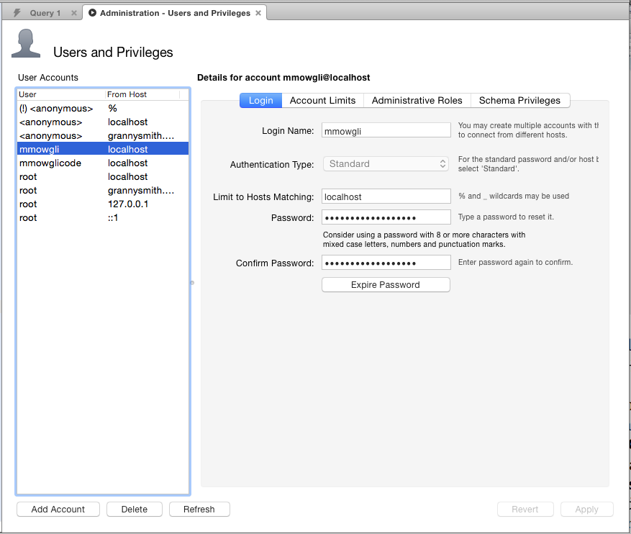

The database name, the user name and the user password used by the running Mmowgli application are passed to the application through fields in the **WebContent/WEB-INF/web.xml** file. There is no limitation on the values of any of the fields, but they must obviously match the corresponding entities installed in the database server. The default port number for the MySQL database manager is 3306. The parameter name which is used by Mmowgli when connecting to the database is **dbUrl**.

The portion of the web.xml file which specifies this configuration follows:

<context-param>

<description>IP location of mmowgli mysql server</description>

<param-name>dbUrl</param-name>

<param-value>jdbc:mysql://localhost:3306/</param-value>

</context-param>

# Troubleshooting

In the interests of reducing the possibility of error, after setting up user accounts and building the database, try using some other tool to access the database through the credentials provided to make sure the database is accessible to Mmowgli code.

When launching Mmowgli through Netbeans for the first time, observe the Console tab for messages. If the app doesn’t launch, there will be exceptions displayed in the console-out area. Scroll to the top (earliest) exception and you should be able to figure out whether it’s the database connection that is giving you trouble.