Revving the Vaadin Version

You will have to check the Vaadin website occasionally to see if an updated version is available. There have been updates in the past which are slightly incompatible with the previous. The differences are typically well described in the release notes on the Vaadin site. The important point is not to blindly update without understanding the implications.

Steps:

1. Change the Vaadin version shown at the top of the ivy.xml file to the desired value.

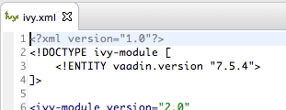

1. Save ivy.xml.
2. Wait for the automatic resolve step to complete by watching the footer bar.

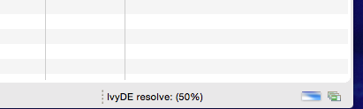

1. Manually perform an Ivy-resolve by right-clicking the project root, Ivy->resolve.
2. Rebuild both widgetsets (main and mobile versions) and the themes by using the gears icon in the toolbar. 

Note: the appropriate widgetset descriptor file must be selected before using the toolbar icon –edu.nps.moves.mmowgli.widgetset.Mmowgli2Widgetset.gwt.xml, then edu.nps.moves.mmowgliMobil.gwt.MmowgliMobileWidgetSet.gwt.xml.