Deployed Contract

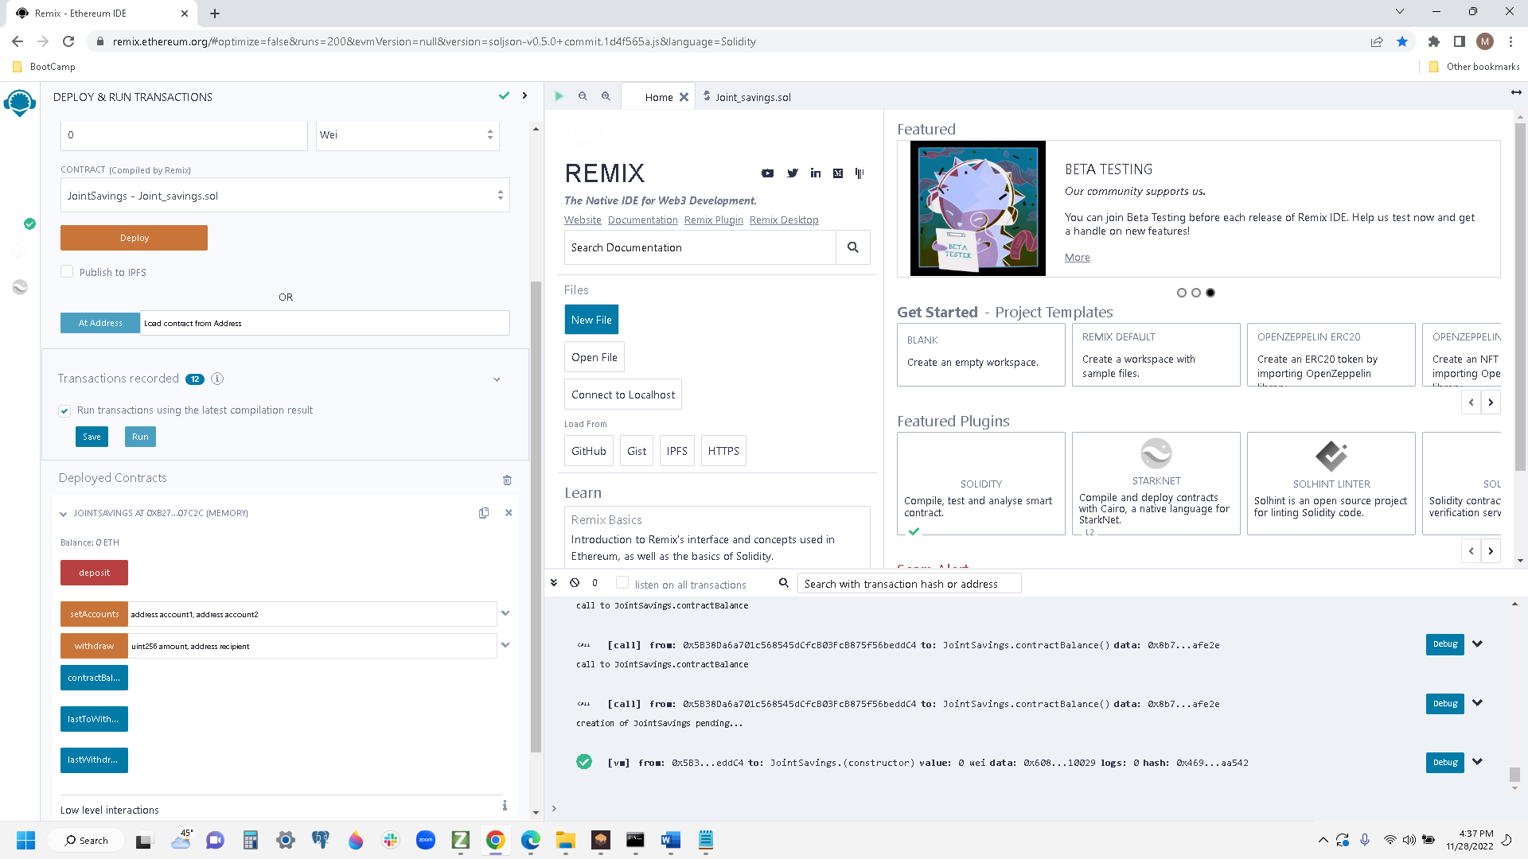

Step 2

Set Accounts

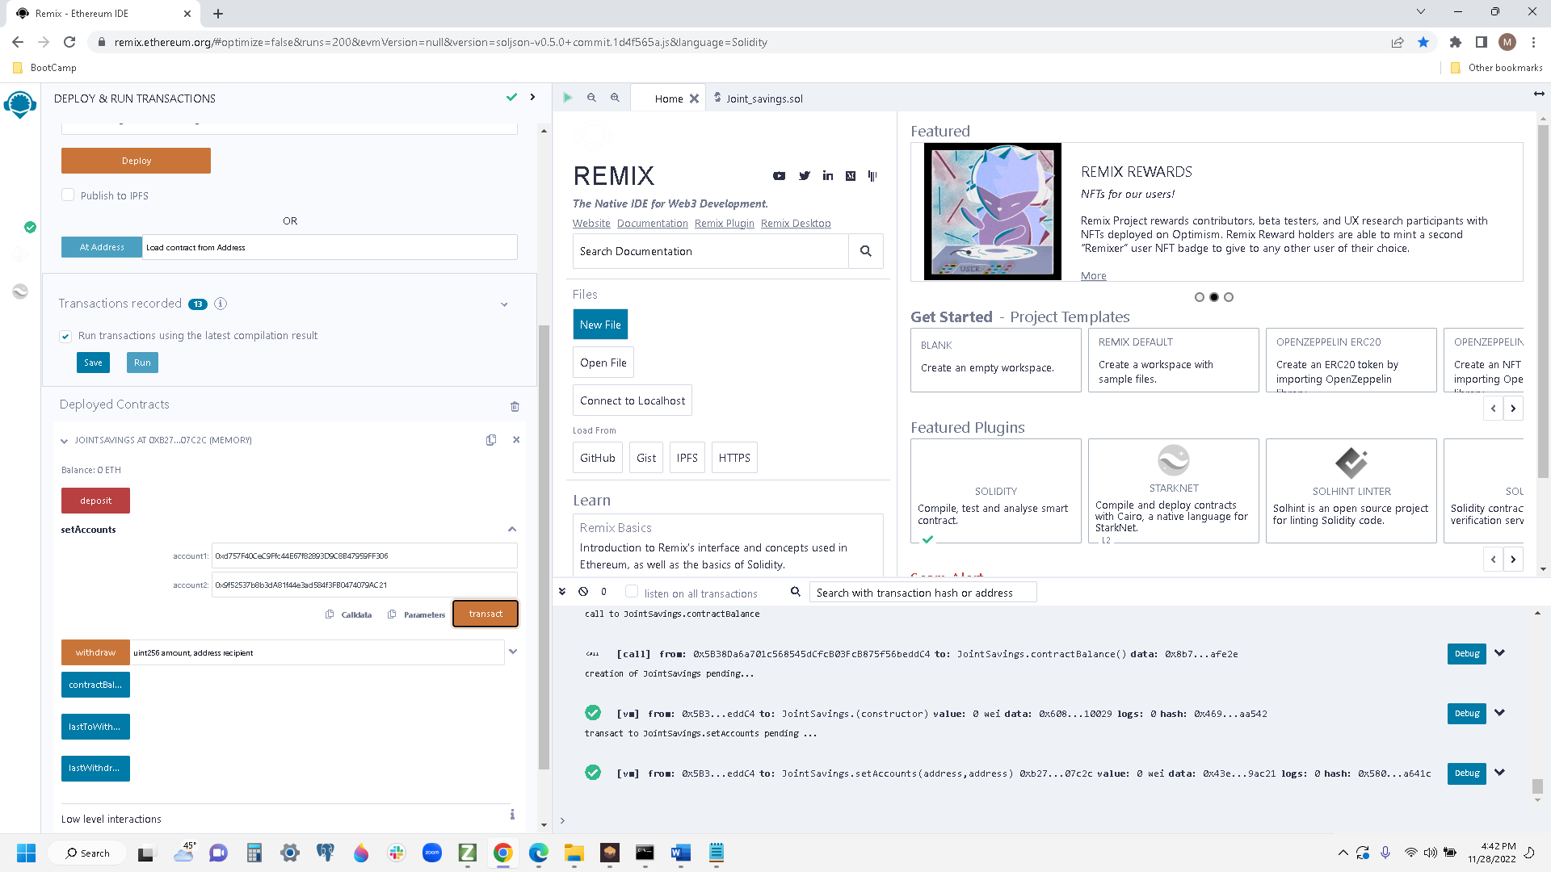

Step 3

Transaction 1 - Deposit 1 ETH as WEI

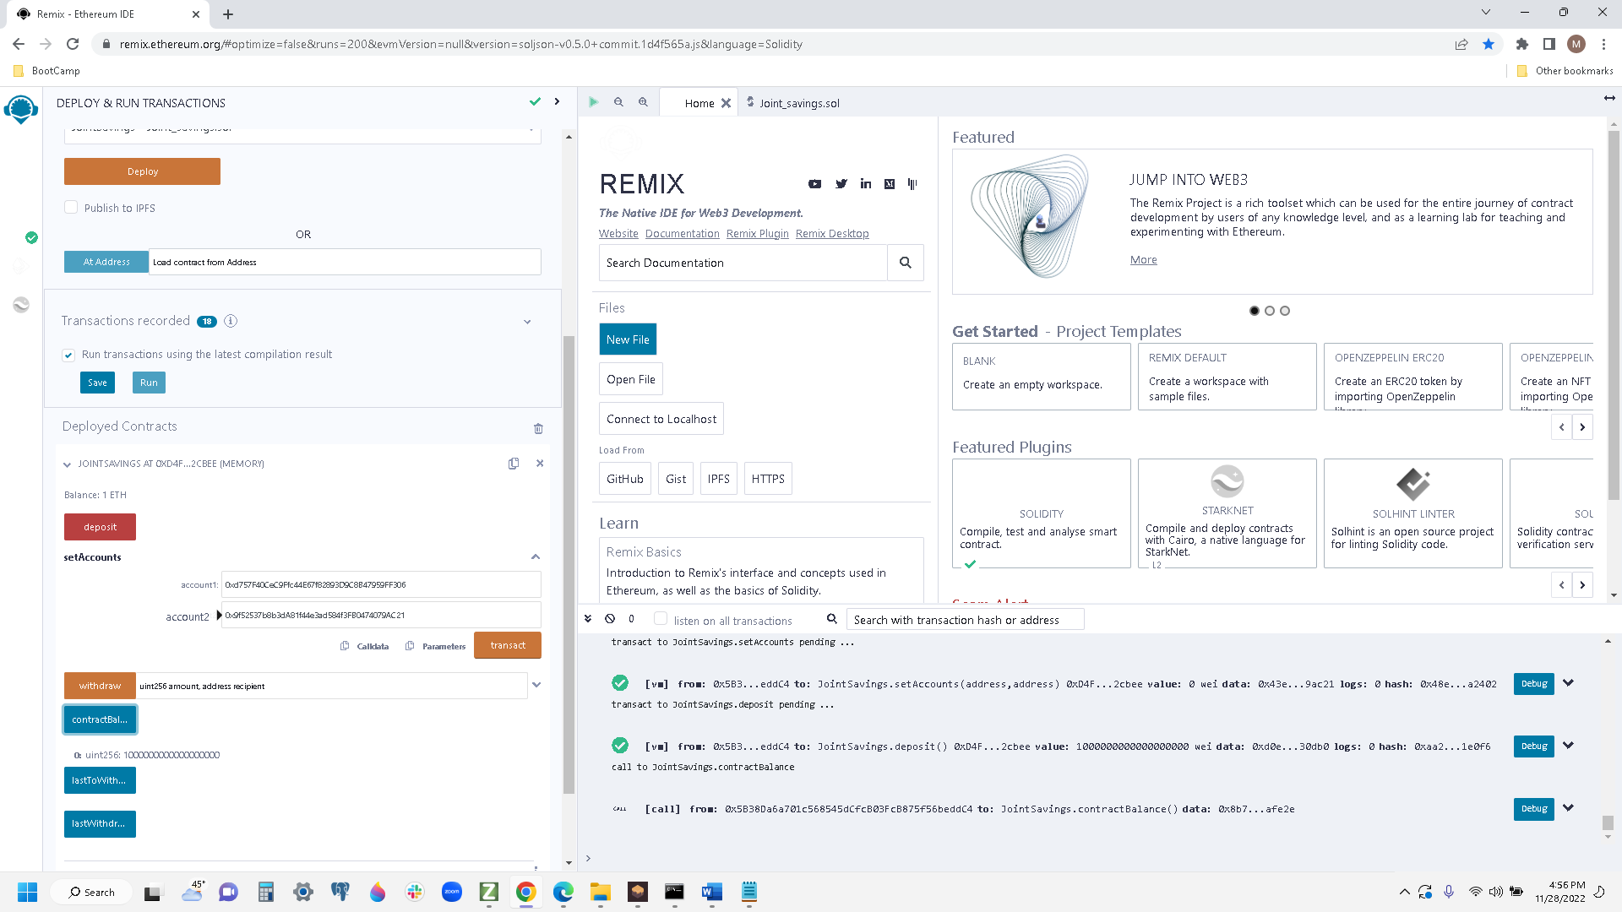

Step 4

Transaction 2 - Deposit 10 ETH

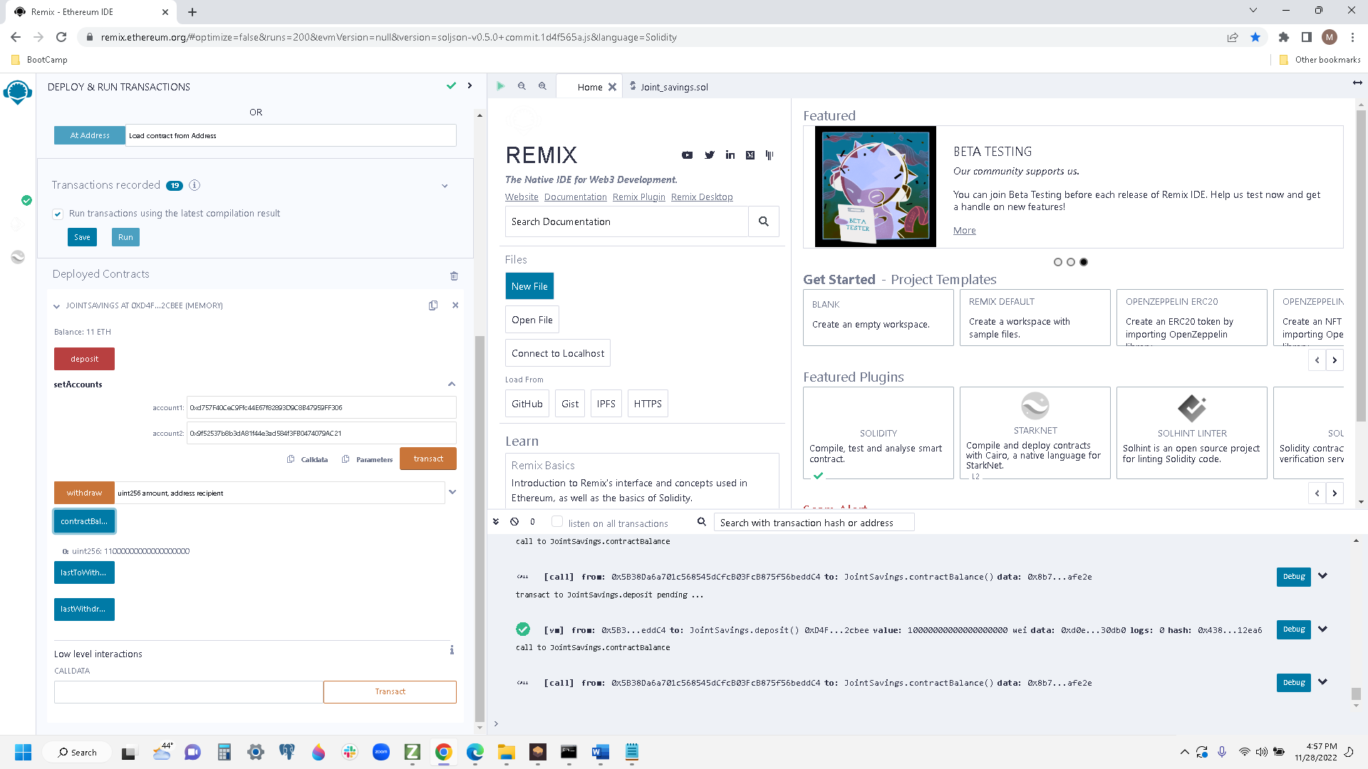

Step 5

Transaction 3 – Deposit 5 ETH

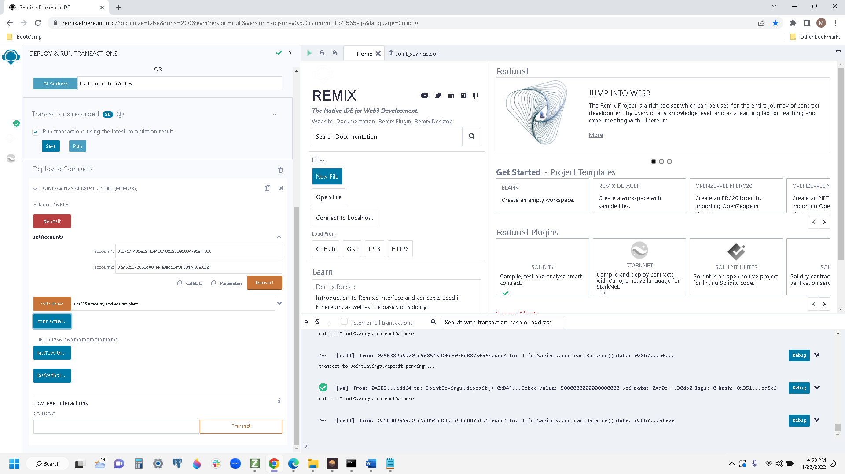

Step 6

Withdraw 5 ETH into AccountOne and show last activity

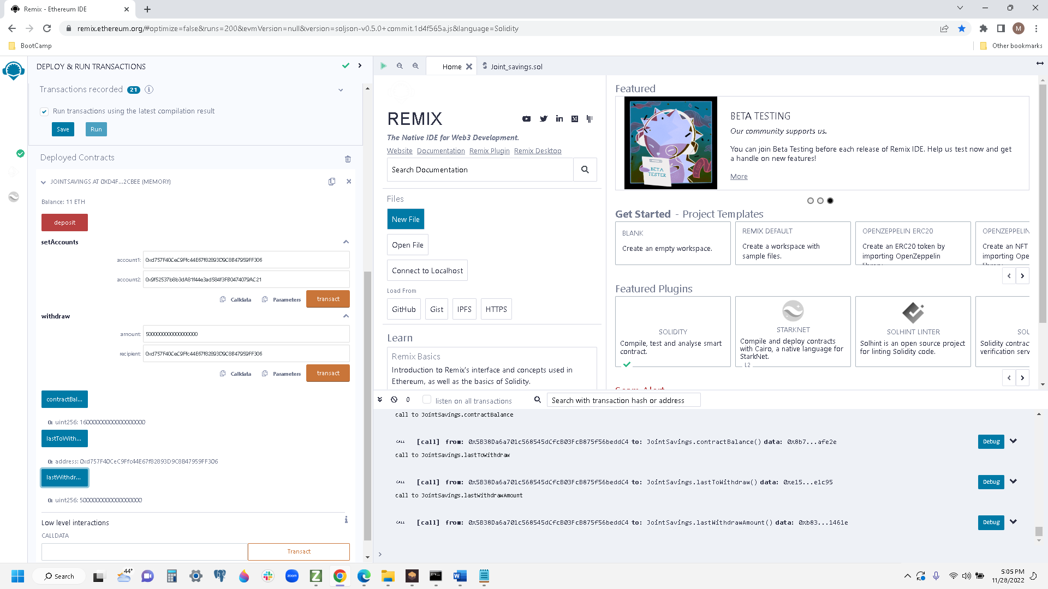

Step 7

Withdraw 10 ETH into AccountTWO and show last withdraw address and amount

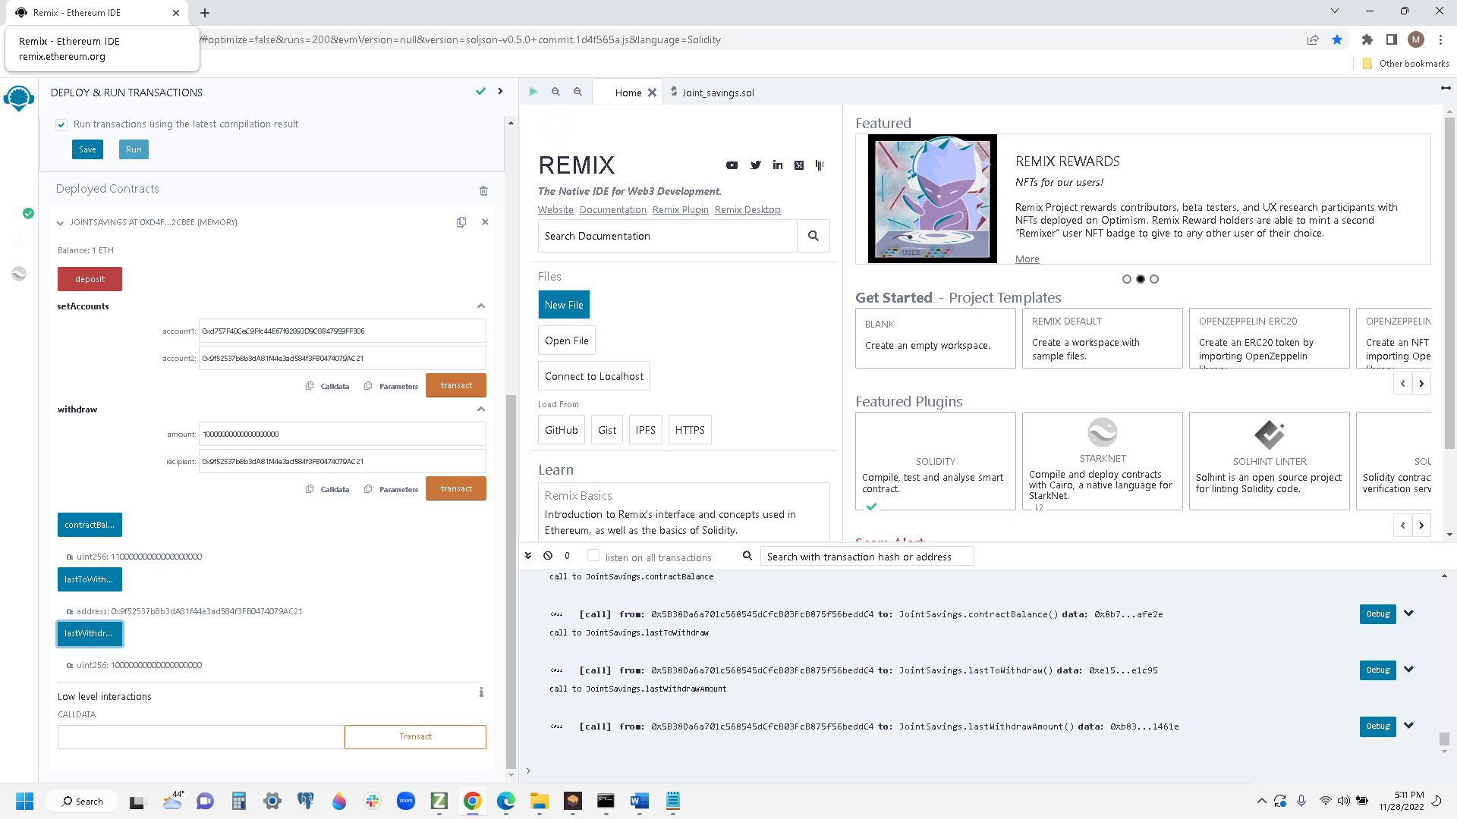

Step 8