Screenshot of Compiled Contract

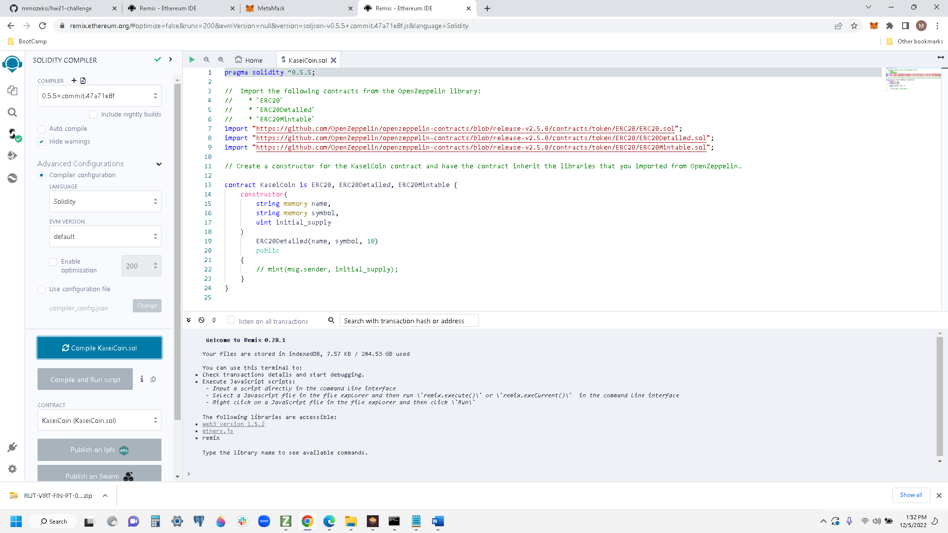

Compiled CrowdSale Code

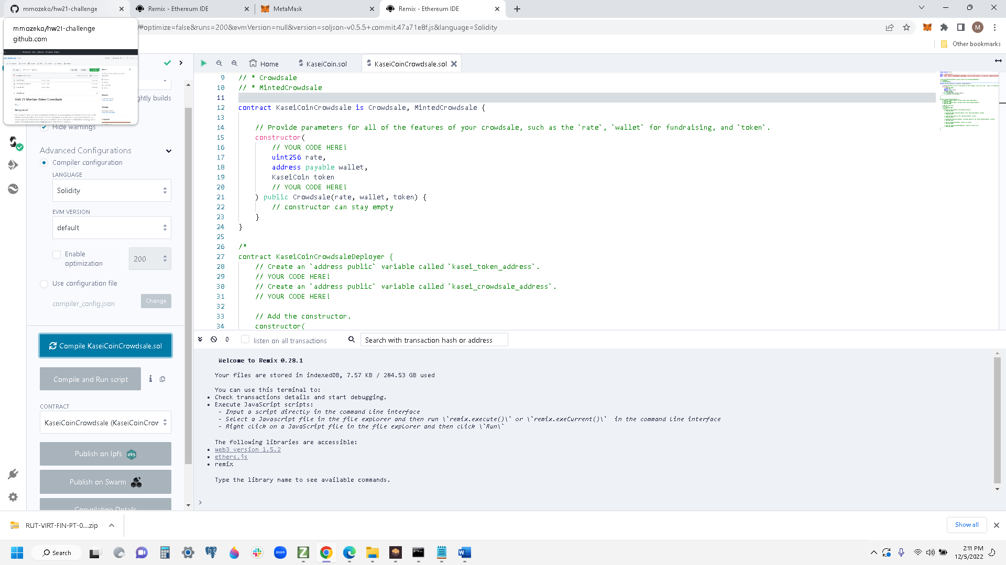

Step 3

Compiled Deployer Contract

DeployDeplaoy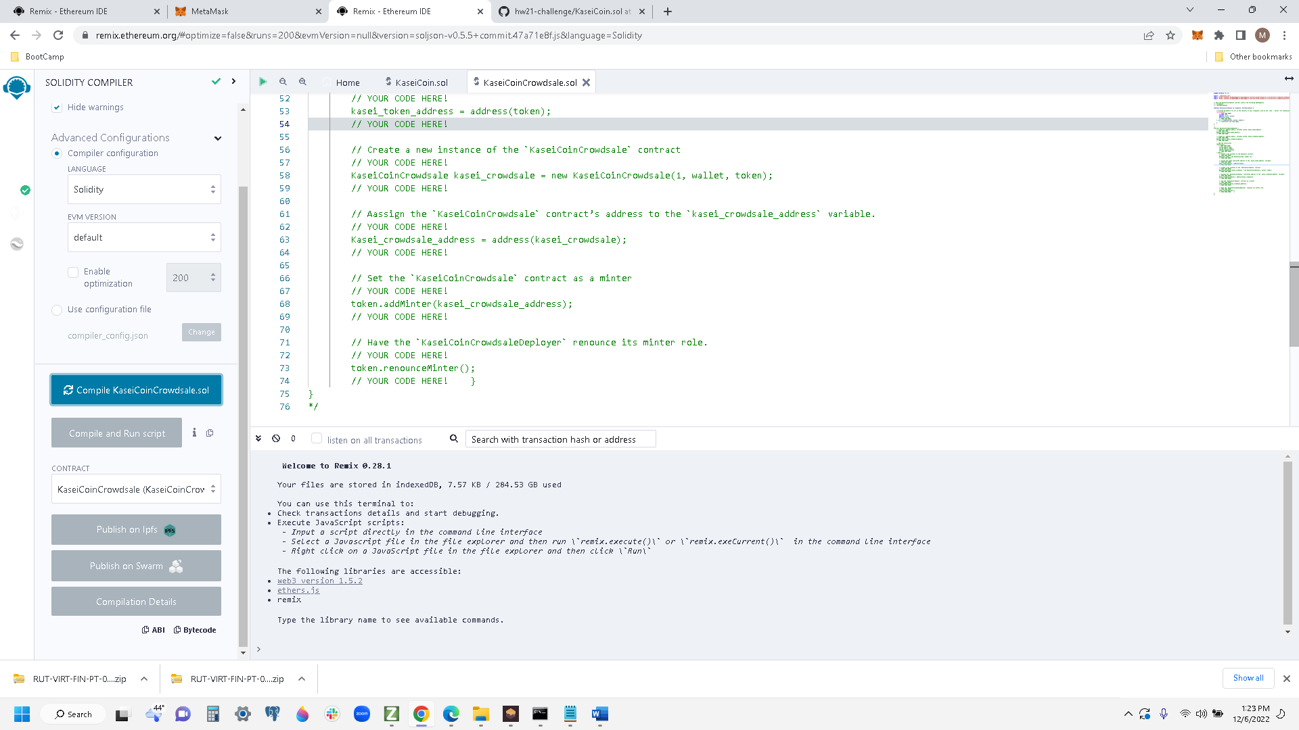

Deploy CrowdSale Contract

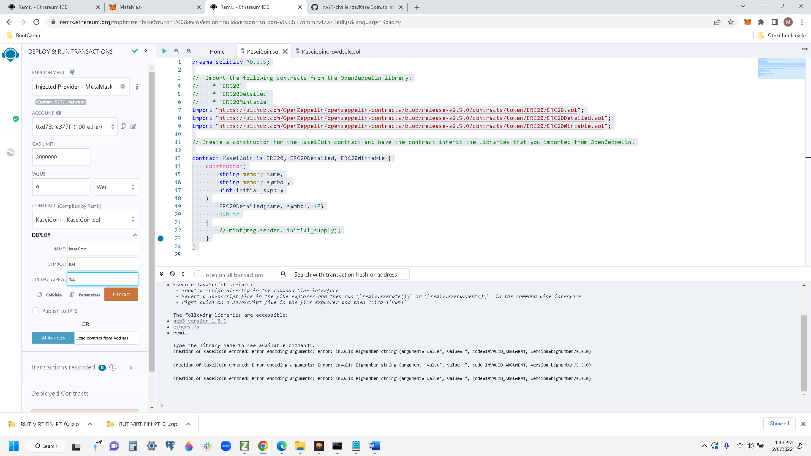

Next Step

Next Step

Next Step