SDMCET Dharwad

Result

Analysis

System

A user manual

*Students: Staff Coordinators:*

A Mahesh Bhat Shiny Rajendrakumar

Anrghya Jantali Rashmi Athanikar

Madhusoodan Pataki

Content

1. What is RAS?
2. HOW TOs?
3. Format of Input Sheets
4. Reporting Bugs

What is RAS?

RAS is a result analysis system built for analysing the student performance for 1-4 years Engineering Result Records in both category and quota-wise.

In order to use RAS you need to have the results and student information in excel sheets in required format.

The required format refers to Format of Input Sheets.

How does RAS work?

RAS reads the excel sheets and stores the data in a database which is created at the time of installation. To know what all database tables are created refer the design document.

Get used with the UI.

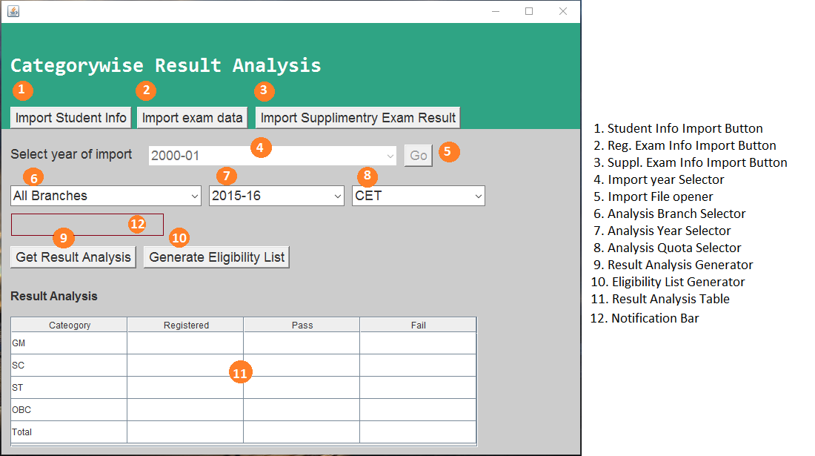

*Different UI Elements in the RAS Window.*

HOW TOs

The next few pages will explain how to

1. Import data from Admin section sheets.
2. Import data from Exam section of
   1. Regular exam sheets
   2. Supplementary exam sheets
3. View Result Analysis for different categories and quotas.
4. Generate an eligibility list for a particular year.

1. Importing Admin data from excel sheets.

Step 1. Click on the “Import Student Info”. A file chooser will open as shown below.

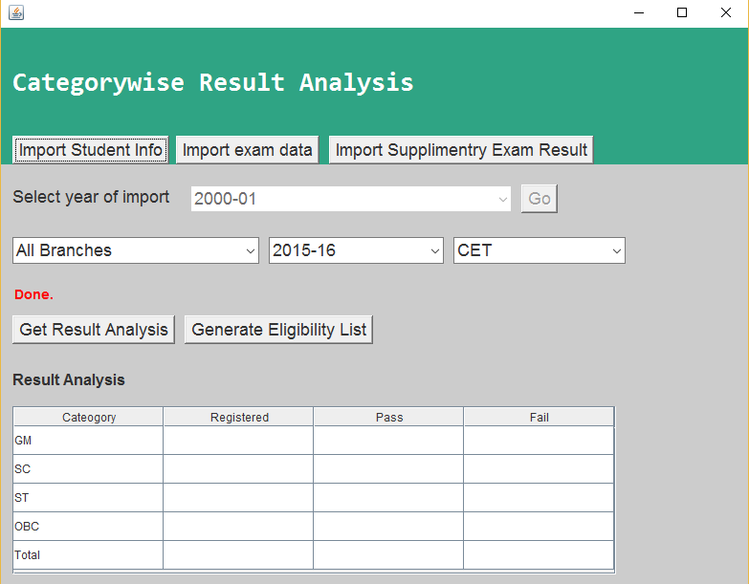

Step 2: Select the excel sheet from the file-chooser which contains student information from Admin section. Hit “Open”. Wait for some time until the notification bar says “Done”.

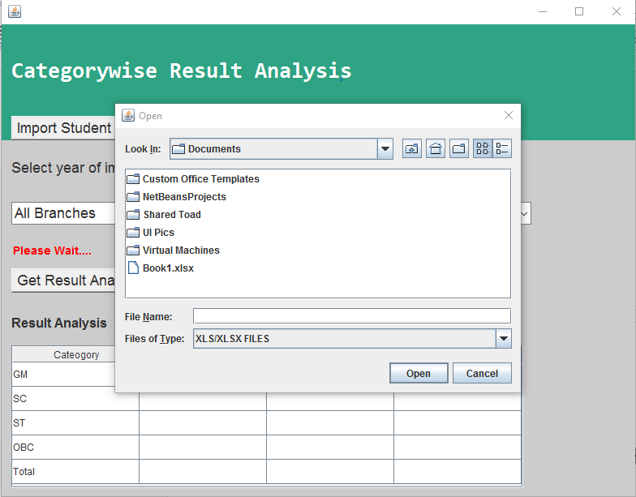

2. Importing Regular Exam data from excel sheets.

Step 1. Click on the “Import Exam data”. A file chooser will open as shown below.



Step 2: Select the excel sheet from the file-chooser which contains Regular Exam Information from Exam section. Hit “Open”. Wait for some time until the notification bar says “Done”.



3. Importing Supplementary Exam data from excel sheets.

Step 1. Click on the “Import Supplementary Exam Info”. A file chooser will open as shown below.



Step 2: Select the excel sheet from the file-chooser which contains Supplementary Exam Information from Exam section. Hit “Open”. Wait for some time until the notification bar says “Done”.



4. Generating Result Analysis

Step 1: Select the branch, year, quota of the analysis you want.

In below picture the selected fields are

a. Branch: Computer Science.

b. Year: 2015-16.

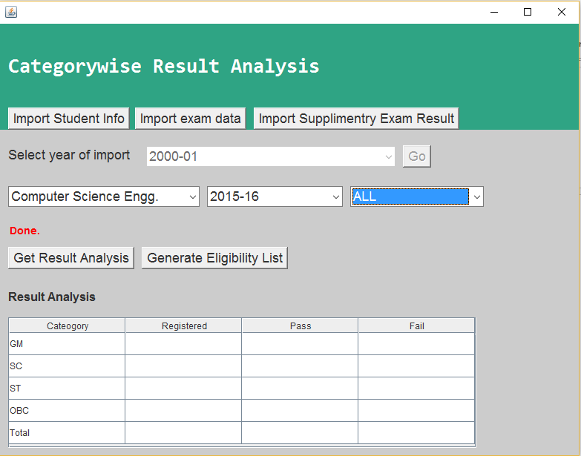 c. Quota: All.

Step 2: Click “Get Result Analysis”. You can view the analysis in the analysis window.

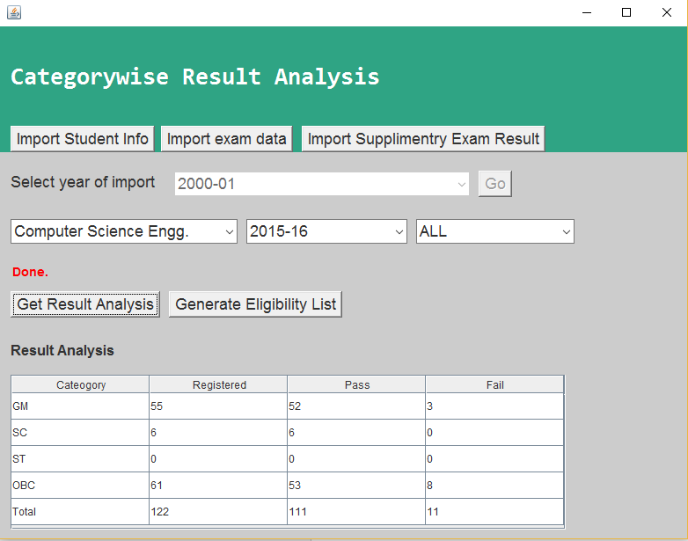

5. Generating Eligibility List.

Step 1: Select the Branch, Year and Quota as described above in Generating Result Analysis.

Click on “Generate Eligibility List”. A file saver dialog will pop up like shown below. Select the path where you want to save the eligibility list file. Click Save. A file will be saved at the path.

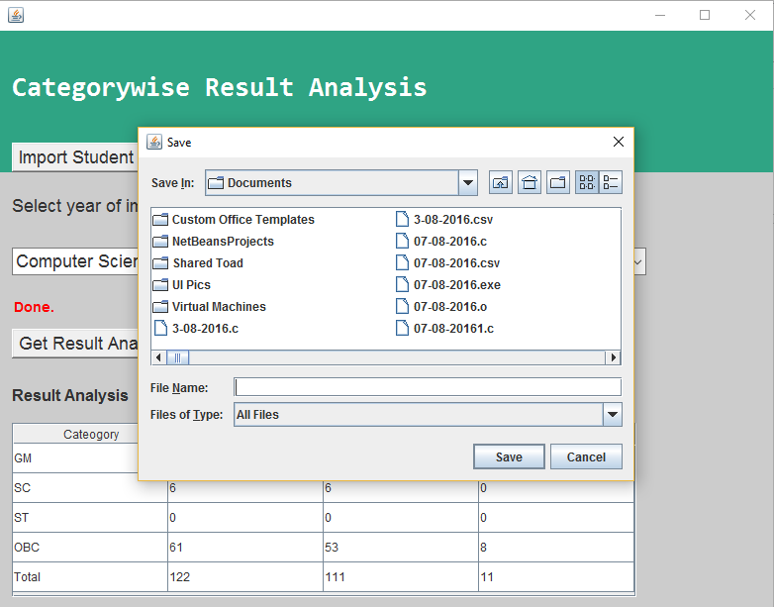

Format of Input Sheets

Refer the samples given along with the software.

Reporting Bugs

To report bugs email to:

*Students:*

[*mbhat24@gmail.com*](mailto:mbhat24@gmail.com)

[*jantalianarghya@gmail.com*](mailto:jantalianarghya@gmail.com)

[*akshayapataki123@gmail.com*](mailto:akshayapataki123@gmail.com)

*Faculty Coordinators:*

[*shiny2010paul@gmail.com*](mailto:shiny2010paul@gmail.com)

[*rathanikar@gmail.com*](mailto:rathanikar@gmail.com)