**AVOCADO TOAST WITH FETA CHEESE AND BALSAMIC GLAZE**

*Avocado Toast – Try this over-the-top Avocado toast, made with chili paste, lime juice, crumbled feta cheese, seeds and balsamic glaze, for a filling and flavor packed breakfast that’ll keep you going all day.*

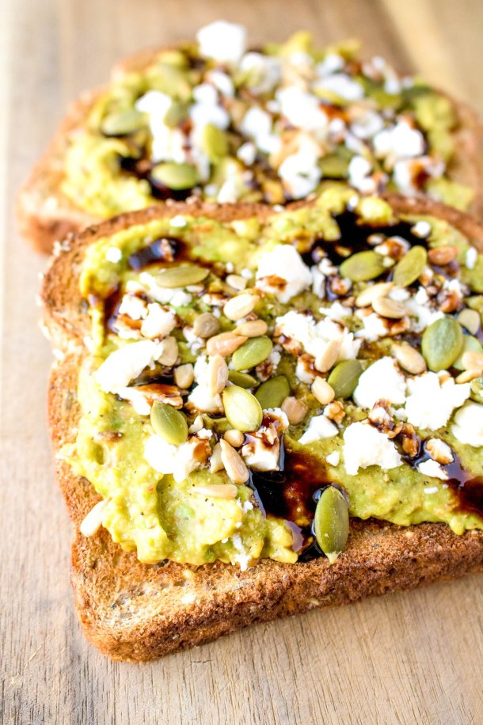

## **Avocado Toast with Feta Cheese and Balsamic Glaze**

Try this over the top Avocado toast, made with chili paste, lime juice, crumbled feta cheese, seeds and balsamic glaze, for a filling and flavor packed breakfast that’ll keep you going all day.

**Prep Time5 mins**

**Cook Time5 mins**

**Total Time10 mins**

**Course: Breakfast**

**Cuisine: American**

**Keyword: avocado, toast**

**Servings: 1**

### **Ingredients:**

* 2 slices bread
* 1 avocado
* squeeze lime juice
* 1-2 tsp chili paste
* salt and pepper, to taste
* 1 tbsp pumpkin seeds
* 1-2 tsp sunflower seeds
* 1-2 tbsp feta cheese, crumbled
* drizzle balsamic glaze

### **Instructions**

* Toast your bread.
* Scoop avocado flesh into a bowl and mash. Add lime juice and chili paste. Mix.  Spread onto the toast.
* Crack fresh salt and pepper onto toast.  Add both seeds.  Crumble feta on top. Drizzle with balsamic glaze. Serve.