**AVOCADO TOAST WITH FETA CHEESE AND BALSAMIC GLAZE**

*Avocado Toast – Try this over-the-top Avocado toast, made with chili paste, lime juice, crumbled feta cheese, seeds and balsamic glaze, for a filling and flavor packed breakfast that’ll keep you going all day.*

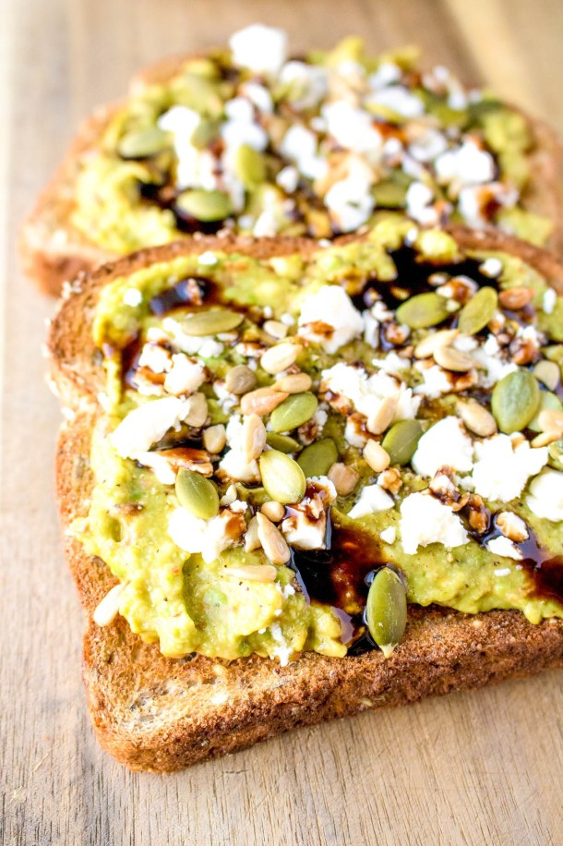

## Avocado Toast with Feta Cheese and Balsamic Glaze

Try this over the top Avocado toast, made with chili paste, lime juice, crumbled feta cheese, seeds and balsamic glaze, for a filling and flavor packed breakfast that’ll keep you going all day.

Prep Time5 mins

Cook Time5 mins

Total Time10 mins

Course: Breakfast

Cuisine: American

Keyword: avocado, toast

Servings: 1

]

### Ingredients

* 2 slices bread
* 1 avocado
* squeeze lime juice
* 1-2 tsp chili paste
* salt and pepper, to taste
* 1 tbsp pumpkin seeds
* 1-2 tsp sunflower seeds
* 1-2 tbsp feta cheese, crumbled
* drizzle balsamic glaze

### Instructions

* Toast your bread.
* Scoop avocado flesh into a bowl and mash. Add lime juice and chili paste. Mix.  Spread onto the toast.
* Crack fresh salt and pepper onto toast.  Add both seeds.  Crumble feta on top. Drizzle with balsamic glaze. Serve.