*6 Ways to Reduce Stress*

March 10, 2019 by Morgan Plackemeier

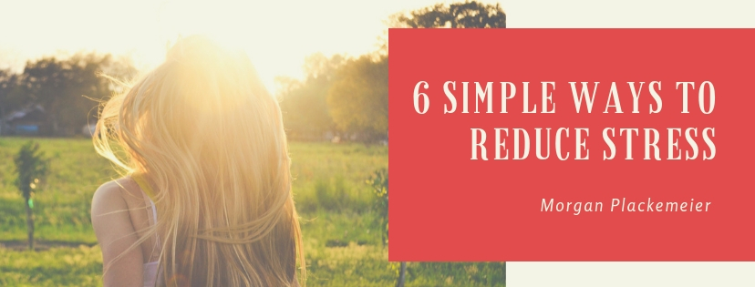

Article was written by Morgan Plackemeier

**Stress is a common issue in today’s society; it can lead to all kinds of problems including high blood pressure, heart disease, emotional and mental health problems, relationship difficulties and even family troubles. Reducing your stress levels positively impacts your life and your health in many ways. Below are 6 ways to reduce stress.**

*6 Ways to Reduce Stress*

1. **Ditch the Caffeine**

Caffeine builds feelings of anxiety and keeps you from having the capacity to completely unwind. Try your best to keep away from beverages containing caffeine, for example, espresso and cola, particularly late at night. Substitute your standard caffeine drinks with home grown teas and natural product juices.

1. **Get some Exercise**

Exercise is known for reducing feelings of anxiety and improving our perspective. Strolling outside in the natural air is a standout amongst the best types of activity; swimming and cycling are likewise superb approaches to assuage pressure.

1. **Learn to Meditate**

Meditation and reflection has been appeared to diminish pressure, strain, and even pulse levels. Locate a peaceful spot where you can put in almost no time multi day simply focusing on your relaxing and breathing. Join a reflection group if you need assistance figuring out how to meditate, or if you prefer the structure offered by a group setting.

1. **Escape for a while**

Everyone feels overpowered by issues here and there; sometimes the most ideal method for managing issues is to get away from them for a sometime so we can gain some perspective on the situation. Read a book, watch a movie, or discover another approach to make tracks in an opposite direction from your issues for some time.

1. **Talk to Someone**

Talking is an highly effective way for reducing feelings of stress and anxiety. This doesn't need to be in a formal setting (for example with an advisor or instructor), it could simply be something as straightforward as having a tattle with your companions or neighbors. The essential thing is to interface with other people.

1. **Take a long hot bath**

A long soak in the hot bath can loosen up your muscles and help you to unwind. Include some treatment oils, for example, lavender or chamomile, and include a couple of teaspoons of sea salt. Put some relaxing music on and place a warm towel over your face.