|  |
| --- |
| egyptianBrackets(){} |
| Software Design Specification |
| Ctrl-P: 3D Printer Depository |
|  |
| **Submitted By: Austin Johnson, Becky Price, Megan Petrillose** |
| **3/7/2014** |

**Prepared for COMP-566 Software Design and Development for Professor Suresh during the spring of 2014**

Table of Contents

1. Introduction 4

**1.1Purpose of this Document** 4

**1.2 Scope of the Development Project** 4

**1.2.1 How to section** 4

**1.2.2 Design collection section** 4

**1.2.3 User profile section** 4

**1.3 Definitions, Acronyms, and Abbreviations** 4

**1.4 References** 4

**1.5 Major software requirements** 4

**1.6 Design constraints, limitations** 5

**1.6.1 Design constraints** 5

**1.6.2 Limitations** 5

**1.7 Changes to Requirements** 5

**1.8 Overview of Document** 6

2. Data Design 6

**2.1 Data Objects and Resultant Data Structures** 6

**2.2 File and database structures** 7

**2.2.1 Database structure** 7

**2.2.2 External file structure** 7

**2.2.3 Global data** 7

**2.2.4 File and data cross reference** 8

3. System Architecture Description 9

**3.1 Overview of Modules / Components** 9

**3.2.1 System Architecture** 10

**3.2.2 Tutorial Architecture** 11

**3.2.3 Catalog Architecture** 11

**3.2.4 User Profile Architecture** 11

4. Detailed description of components 12

**4.1 Component template description** 12

**4.2 Description of Components** 13

**4.2.1 Description of Authentication** 13

**4.2.2 Description of View a Tutorial** 14

**4.2.3 Description of Create a tutorial** 15

**4.2.4 Description of Edit a tutorial** 16

**4.2.5 Description of Rating** 17

**4.2.6 Description of Download a Design** 18

**4.2.7 Description of Upload a Design** 19

**4.2.8 Description of Design Catalog** 20

**4.2.9 Description of Search** 22

**4.2.10 Description of View Profile** 22

**4.2.11 Description of Edit Profile** 23

**4.2.12 Description of Collaborate** 23

**4.2.13 Description of Expand** 24

5. Interface Design 25

**5.1 Homepage** 25

**5.2 Tutorials** 25

**5.3 Catalog** 26

**5.4 User Profile** 26

**Appendix A.1 Definitions** 27

**Appendix A.2 Acronyms** 32

**Appendix A.3 References** 32

**Appendix B.1 ERD Diagram** 33

**Appendix B.2 File Structure Diagram** 35

# 

# 1. Introduction

**1.1 Purpose of this Document**

This document is being used to describe the software design of Ctrl-P. This is a web application that gathers information about 3D printing for beginning and intermediate users. This document will delve deeper into the design behind Ctrl-P and how it displays data for its users. It will give a detailed description of the data design, architecture description, and the interface design.

**1.2 Scope of the Development Project**

Ctrl-P is a web application that is a universal Three Dimensional (3D) printer depository for knowledge and resources to help beginners to intermediate 3D printer users. This web application contains several different sections: a “How to” tutorial section, forum section, Design collection section, and user profiles.

**1.2.1 How to section**

In the “How to…” section the user will be able to access links to helpful videos and information about how to get started on 3D printing. The tutorials will comprise of user created tutorials (internal tutorials) and tutorials that were created and are posted on another website (external tutorials). Information in this section will be limited by research and current documentation that is available on 3D printing.

**1.2.2 Design collection section**

The Design collection section will contain different designs. These designs are uploaded by users so that the designs can be displayed for other users to choose from to download for personal use. The designs that are displayed will be “categorized” to make it easier for users to find the designs that they are looking for. Designs will depend on research and current resources that are available for 3D printing.

**1.2.3 User profile section**

For a user to fully participate in this web application they must be logged in. This means that each user will have a user profile. The user profiles will be similar to user profiles of YouTube in the way that a user will be able to view the designs that they have uploaded.

**1.3 Definitions, Acronyms, and Abbreviations**

Please refer to Appendix A.1 and A.2 for all definitions, acronyms and abbreviations.

**1.4 References**

Please refer to Appendix A.3 for all references.

**1.5 Major software requirements**

|  |  |
| --- | --- |
| **OS** | *Minimum:*  Any OS capable of hosting the below software.  *Recommended:*  Arch Linux |
| **Web Server** | *Minimum:*  Any capable web server app. (Nginx, Apache, etc…)  *Recommended:*  Apache Web Server 2.4.7 |
| **PHP** | *Minimum:*  PHP >= v5.4 |
| **SQL Database** | *Minimum:*  Any capable SQL server (MySQL, Oracle SQL, etc.)  *Recommended:*  MariaDB >= 10.0.8 |

## 1.6 Design constraints, limitations

### 1.6.1 Design constraints

One of the biggest design constraints that Ctrl-P has is time. Ctrl-P had a strict 10 week time constraint to document, design, implement and test.

### 1.6.2 Limitations

### Because PHP is a scripting language and is interpreted, it will be slower than the same program using C++. The time for uploading, downloading, and posting will depend on the server (and the options for storing data - such as the ability to roll back if something went wrong), the internet connection, and the PHP scripts used to gather and transfer information.

## 1.7 Changes to Requirements

|  |  |
| --- | --- |
| **Identification** | **Information** |
| **Crawler** | *Original Requirement:*  To gather information, designs and tutorials into location. Ctrl-P must search and collect information and data from other websites and display it into a centralized location. To facilitate this, Ctrl-P uses a crawler whose function is to comb through websites to find information about 3D printing. When the crawler finds a design, tutorial, or information that it deems relevant, it is posted for other users to view. Ctrl-P primarily uses a crawler to find designs for users to download.  *Change Requirement:*  Ctrl-P will not be using a crawler anymore to gather information to display for users. All information, designs, tutorials, etc. will be found manually and entered by users and administrators.  *Rational:*  The reason that Ctrl-P will not be using a crawler to find information, designs, and tutorials is because of a legal issue surrounding the use of crawlers. Ctrl-P doesn’t want to do anything that is illegal so has opted to not use crawlers to avoid all possibility of illegal actions. |
| **Name change for Followers** | *Original Requirement:*  A user that is following another user is called a Follower.  *Change Requirement:*  Ctrl-P is changing the name of a user that is following another user from a Follower to a Collaborator.  *Rational:*  The reasoning behind this is that users that are following another person will normally use this function so that they can collaborate amongst themselves. By changing the name Ctrl-P is promoting this behavior. |
| **Avatar** | *Original Requirement:*  A user will be able to upload an avatar that will be associated with their user profile.  *Change Requirement:*  Instead of using an avatar users will select from a set of colors which the user will be associated with.  *Rational:*  This is more aesthetically pleasing than the avatar pictures were. |

**1.8 Overview of Document**

The remaining sections of this document will provide an overview of the data design, system architecture, detailed description of components and the interface design. In the data design section this document will provide information about data objects and resultant data structures, file and database structures (i.e. an ERD diagram). This section will also provide information about the external file structure, global data and file and data cross references. In section three this document will discuss the system architecture. Section three will contain the system architecture diagram, and an overview of modules/components. In section four a detailed description of components will be provided. Finally section five contains the interface design which will include rough images of what Ctrl-P’s user interface will look like.

2. Data Design

**2.1 Data Objects and Resultant Data Structures**

|  |  |
| --- | --- |
| **Data Object/Structure Name** | **Brief Description of its Components** |
| **User** | Each User has a username, email, password hash, password salt, last login date, user-online indicator, public text summary, collaborator text summary, and avatar location. Each User has the option to have arrays of Services, Models, Downloads, Tutorials, Tutorial Links, Tutorial Media, Tutorial Edits, Step Edits, Step Photos, Collaborator Chats, and Collaborators. |
| **Tutorial** | A Tutorial belongs to one User, one Tutorial Category, and one Tutorial Link. Each Tutorial has an array of Tutorial Media (title, location), an array of Tutorial Edits, and an array of Steps. |
| **Step** | A Step belongs to one Tutorial. Each step has a step number, title, text, an array of edits, and an array of photos. |
| **Collaborator Chat** | A Collaborator Chat belongs to one User but can be seen as a conversation between two Collaborators (Users who have decided to collaborate). Each Collaborator Chat has a message and a post time. |
| **Model** | A Model object belongs to one User and one Model Category. Each Model has an array of Model STLs, array of Model Pictures, array of Downloads, average rating, title, description, download count, views count, and upload date. |
| **Model STL** | A Model STL object belongs to one Model. Each Model STL has a file location, title, size, upload date, upload size, estimated print time, and comments. |
| **Services** | A Service belongs to one User and one Service Category. Each Service has at least one type of Contact Info (website, email, address, phone), title, comment, postdate, and an array of photos (which can have their own titles and comments). |

**2.2 File and database structures**

Please refer to Appendix B.1 for Entity Relationship Diagrams and File Structure Diagrams.

**2.2.1 Database structure**

Please refer to Appendix B.1 for ERD.

**2.2.2 External file structure**

Please refer to Appendix B.2 for File Structure Diagram.

**2.2.3 Global data**

The global data includes Username, email, pass_hash, pass_salt, user_online, array of tutorials, array of models, array of downloads, array of StepPhotos, array of Tutorials, array of Collaborators, and an array of CollaboratorChats. These can be accessed between tables in the database and referenced by the PHP files.

**2.2.4 File and data cross reference**

|  |  |
| --- | --- |
| **Field Name** | **Use** |
| **idUsers (int)** | A key on the Ctrl-P database used to provide a link between tables. |
| **idServices (int)** | A key on the Ctrl-P database used to provide a link between tables. |
| **idContactInfo (int)** | A key on the Ctrl-P database used to provide a link between tables. |
| **idServicePhotos (int)** | A key on the Ctrl-P database used to provide a link between tables. |
| **idServiceCategories (int)** | A key on the Ctrl-P database used to provide a link between tables. |
| **idModels (int)** | A key on the Ctrl-P database used to provide a link between tables. |
| **idModelCategories (int)** | A key on the Ctrl-P database used to provide a link between tables. |
| **idModelSTLs (int)** | A key on the Ctrl-P database used to provide a link between tables. |
| **idModelPictures (int)** | A key on the Ctrl-P database used to provide a link between tables. |
| **idDownloads (int)** | A key on the Ctrl-P database used to provide a link between tables. |
| **idTutorials (int)** | A key on the Ctrl-P database used to provide a link between tables. |
| **idTutorialCategories (int)** | A key on the Ctrl-P database used to provide a link between tables. |
| **idTutorialEdits (int)** | A key on the Ctrl-P database used to provide a link between tables. |
| **idTutorialLink (int)** | A key on the Ctrl-P database used to provide a link between tables. |
| **idTutorialMedia (int)** | A key on the Ctrl-P database used to provide a link between tables. |
| **idSteps (int)** | A key on the Ctrl-P database used to provide a link between tables. |
| **idStepEdits (int)** | A key on the Ctrl-P database used to provide a link between tables. |
| **idStepPhotos (int)** | A key on the Ctrl-P database used to provide a link between tables. |
| **idCollaborators (int)** | A key on the Ctrl-P database used to provide a link between tables. |
| **idCollaboratorChat (int)** | A key on the Ctrl-P database used to provide a link between tables. |
| **user_name (varchar)** | The name to refer to the user by. |
| **title (varchar)** | The title of an object. |
| **post_date (datetime)** | The date and time an object was posted or uploaded. |
| **rating (int)** | A number (1-5) which represents a user’s satisfaction of an object. |
| **views (int)** | The number of times a user has viewed an object. |
| **comment (varchar)** | A comment or description written by the user about an object. |
| **location (varchar)** | The location of a file to be downloaded. |

3. System Architecture Description

**3.1 Overview of Modules / Components**

|  |  |
| --- | --- |
| **Module/Component Name** | **Brief description of its Functionality** |
| **View External Tutorials** | On the tutorial page the user will have the ability to select view external tutorials. After selecting this it will display external based tutorials that the user may select from. |
| **View Internal Tutorials** | On the tutorial page the user will have the ability to select view external tutorials. After selecting this it will display internal based tutorials that the user may select from. |
| **Edit a Tutorial** | This allows a user to edit tutorials that have been submitted. |
| **Create a Tutorial** | This allows the user to create tutorials for other users and guests to use. The user will accomplish this by entering information into a form that when submitted creates a tutorial for other users to view. |
| **Rate** | This enables the user or guest to rate tutorials that they have used. To use this functionality the user or guest must be viewing the tutorial that they wish to rate. |
| **Search** | This enables users to be able to search various parts of the website based on user-selected search limitations. |
| **Authentication** | This enables a user to log in or out of Ctrl-P. Logging in to Ctrl-P gives users access to certain functionality. |
| **View Catalog** | This allows the user or guest to view all Designs that have been uploaded by other users. After selecting this it will display designs that the user may select from. |
| **View Design** | This allows the user or guest to view more details about the design (such as images and descriptions) and gives the user the option to download it. |
| **Upload Design** | This allows the user to upload Design files for other users and guests to download and print. The user will accomplish this by entering information into a form that when submitted creates a Design page for other users and guests to view. |
| **View Print Locations** | On the Catalog page the user will have the ability to select View Print Locations. After selecting this it will display print locations with contact information. |
| **Post Print Location** | This allows the user to upload Print Locations for other users and guests to view. The user will accomplish this by entering information into a form that when submitted creates a Print Location information post that gets displayed along with other posts on the View Print Locations page. |
| **View Tools and Materials Locations** | On the Catalog page the user will have the ability to select View Tools and Materials Locations. After selecting this it will display tools and materials locations with contact information. |
| **Post Tools and Materials Locations** | This allows the user to upload Tools and Materials Locations for other users and guests to view. The user will accomplish this by entering information into a form that when submitted creates a Tools and Materials Location information post that gets displayed along with other posts on the View Tools and Materials Locations page. |

**3.2 Structure and relationships**

**3.2.1 System Architecture**

The following is a diagram showing a top level view of the system architecture. Several components (e.g. KVM, IPTables, etc.) could be replaced with alternate software if necessary.

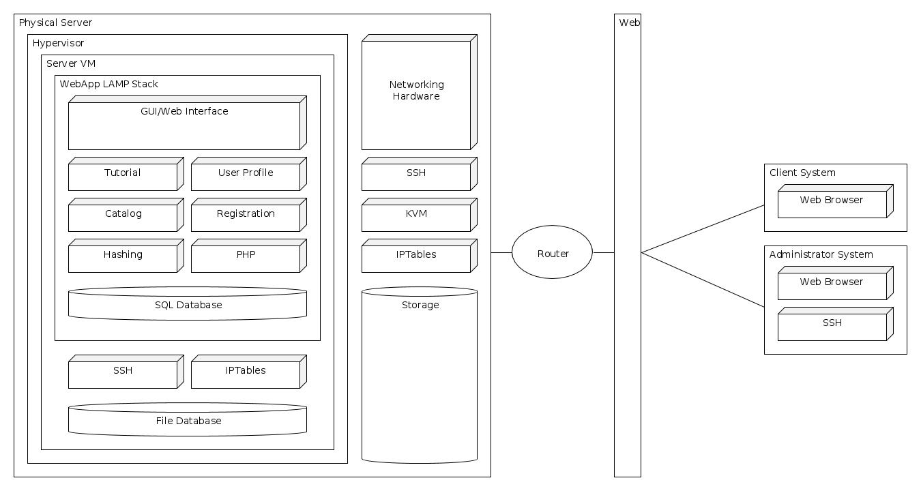

**3.2.2 Tutorial Architecture**

The diagram below depicts a more detailed version of the architecture of the tutorial section. It shows the major component that the tutorial section contains.

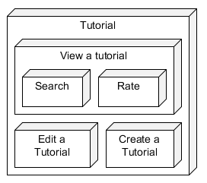

**3.2.3 Catalog Architecture**

This diagram shows a more detailed view of the catalog section’s architecture.

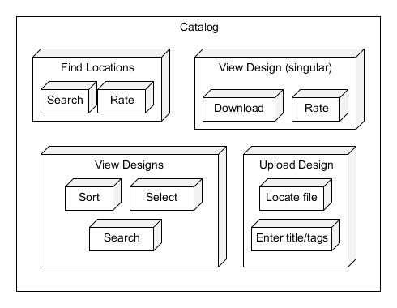

**3.2.4 User Profile Architecture**

The architecture of the User Profile section is illustrated below. The User Profile is made up of individual sections which work independently apart from the “Edit” and “Search” functions which rely upon data from the other modules in order to function. All modules are dependent upon the underlying SQL database.

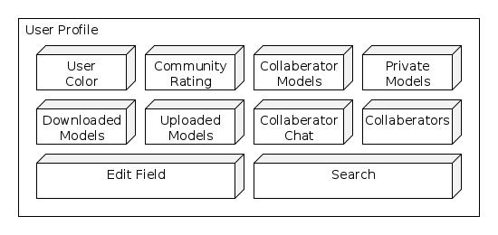

4. Detailed description of components

**4.1 Component template description**

|  |  |
| --- | --- |
| **Identification** | **Information** |
| **NAME** | *Purpose:*  Function and performance requirements implemented by the design component, including derived requirements. Derived requirements are not explicitly stated in the SRS, but are implied or adjunct to formally stated SDS requirements. This is where you explain the connection of this component to some requirement(s) as specified in the SRS.  *Function:*  What the component does, the transformation process, the specific inputs that are processed, the algorithms that are used, the outputs that are produced, where the data items are stored, and which data items are modified.  *Database Tables:*  The internal structure of the component, the constituents of the component, and the functional requirements satisfied by each part.  *Dependencies:*  How the component Include the other components that use this component. Interaction details such as timing, interaction conditions (such as order of execution and data sharing), and responsibility for creation, duplication, use, storage, and elimination of components.  *Resources:*  A complete description of all resources (hardware or software) external to the component but required to carry out its functions. Some examples are CPU execution time, memory (primary, secondary, or archival), buffers, I/O channels, plotters, printers, math libraries, hardware registers, interrupt structures, and system services.  *Processing:*  The full description of the functions presented in the Function subsection. Pseudo-code may be used to document algorithms, equations, and logic.  *Data:*  For the data internal to the component, describes the representation method, initial values, use, semantics, and format. This information will probably be recorded in the data dictionary. |

**4.2 Description of Components**

**4.2.1 Description of Authentication**

|  |  |
| --- | --- |
| **Authentication** | *Purpose:*  This component provides users the ability to login to Ctrl-P which allows them to perform actions (e.g. upload models) which are only available to authenticated users.  *Function:*  Users provide a username and password, the correct combination of logs the user into the site giving the user elevated access to the site.  *Database Tables:*  Users  *Dependencies:*  Users must first have an account on the site.  *Resources:*  SQL database, hashing mechanism  *Processing:*  Username is used to look up user’s hashed password and salt. The user’s password is hashed together with the user’s salt and is compared against the stored password hash.  *Data:*  N/A |

## 4.2.2 Description of View a Tutorial

|  |  |
| --- | --- |
| **Identification** | **Information** |
| **View a Tutorial** | *Purpose:*  Ctrl-P provides a place for users to post tutorials. Tutorials can either be internal tutorials (ones that the user has created on their own) or external tutorials (ones from external sources). On the tutorial page the user has the option to choose which type of tutorials they would like to view. When the user finds a tutorial that they would like to look at in more detail the user may select the tutorial and view its detailed view.  *Function:*  View an external Tutorial:  When the user selects external tutorials on the main tutorial page the user will be directed to the external tutorials page which consists of a list of external tutorials that the user has the option to select to see more details about.  View an Internal Tutorial:  When the user selects Internal tutorials on the main tutorial page the user will be directed to the internal tutorials page which consists of a list of internal tutorials that the use will have the option to select from to see more details.  *Database Tables:*  This component requires access to several database tables to display the tutorials to the user. These tables include Tutorials, TutorialCategories, TutorialMedia, TutorialLink, TutorialEdits, Step, StepPhotos.  *Dependencies:*  For a user to edit or rate a tutorial they must first view the tutorial in its detailed view. A user can also search for tutorials. When the search results are shown the user can then select the tutorial to view it.  *Resources:*  To view a tutorial Ctrl-P must access its database to display the tutorials.  *Processing:*  To view the external or the internal tutorials section Ctrl-p will have to query the database for tutorials that are relevant for those sections. When a user selects a specific tutorial to view in more detail then Ctrl-P will have to query the database for additional material.  *Data:*  N/A |

**4.2.3 Description of Create a tutorial**

|  |  |
| --- | --- |
| **Identification** | **Information** |
| **Create a tutorial** | *Purpose:*  Ctrl-P allows its users to post tutorials that other users or guests can view. When a user creates a tutorial they have the option to create an internal or external tutorial.  *Function:*  When a user decides to create a tutorial they will be directed to the “create a tutorial” page. The user will be asked if they are creating an external or an internal tutorial and will be directed to the correct page for whichever one the user selects.  Create an external tutorial  When a user selects “create an external tutorial,” the user will be directed to the external tutorial form. After the user fills out this form and submits it, the tutorial will be created and other users and guests will be able to view it.  Create an internal tutorial  When a user selects “create an internal tutorial,” the user will be directed to the internal tutorial form. After the user fills out this form and submits it, the tutorial will be created and other users and guest will be able to view it.  *Database Tables:*  This component requires access to several database tables to create the tutorials. When a tutorial is created Ctrl-P adds the tutorial to the database so that it can be pulled and displayed later. The tables it accesses can be any of the following: Tutorial, TutorialCategories, TutorialMedia, TutorialLink, Step, or StepPhotos.  *Dependencies:*  When a user creates a tutorial, the tutorial needs to be added to the database. So the creation of a tutorial depends on a database being available for an entry to be added to it. The user must be logged in to create a tutorial.  *Resources:*  To create a tutorial, access to the database is necessary so that the entry can be added to it.  *Processing:*  When the user opens the “create a tutorial” page the user will select which type of tutorial they would like to create. Depending on the user’s entry the appropriate form will be displayed for the user to enter the tutorial information. When the user submits the tutorial, it will be processed to make sure that the basic needs (i.e. the title, description, and link or written steps) are met before the tutorial is added to the database. After the tutorial is added to the database other users will be able to view it.  *Data:*  External Tutorial:  When an External tutorial is created the user will be required to enter the title of the tutorial, a brief description, and the link to the tutorial. Also the author (current user logged in) and the date that the tutorial was created on will be added automatically to the entry.  Internal Tutorial  When an internal tutorial is created the user will be required to enter the title of the tutorial, a brief description, and at least three steps for the users to follow. The user has the option to add more steps and media to their tutorial. Additionally the author (the current user logged in) and the date that the tutorial was created on will be added to the entry. |

**4.2.4 Description of Edit a tutorial**

|  |  |
| --- | --- |
| **Identification** | **Information** |
| **Edit a tutorial** | *Purpose:*  Ctrl-P gives it users the option to edit tutorials that were previously created.  *Function:*  To edit a tutorial the user must be viewing the tutorial that they wish to edit.  Edit an External Tutorial:  A user will select the edit a tutorial button when the user is viewing the tutorial that they wish to change. That button will redirect them to the edit a tutorial page. This is the” create an external tutorial” form just with the form filled out with the current data. The user will then be able to edit the tutorial with the new values and submit the changes.  Edit an Internal Tutorial:  A user will select the edit a tutorial button when the user is viewing the tutorial that they wish to change. That button will redirect them to the edit a tutorial page. This page is the “create an internal tutorial” form just with the form filled out with the current data. The user will then be able to edit the tutorial with the new values and submit the changes.  *Database Tables:*  To edit a tutorial Ctrl-p will access any of the following tables, Tutorial, TutorialCategories, TutorialMedia, tutorialLink, tutorialEdits, StepEdits, Step, StepPhotos.  *Dependencies:*  Editing a tutorial is dependent on tutorials being created. Users can not edit tutorials if there aren’t any tutorials to edit. A user must be logged in to edit a tutorial.  *Resources:*  To edit a tutorial Ctrl-P must access the database to populate the form initially and then to update the entry in the database.  *Processing:*  Ctrl-P queries the SQL database for the information that was originally entered as the initial items in the tutorial and puts them into the form and shows it to the user. The user then can edit the information when they select submit the information is saved in the database.  *Data:*  The initial data will be the data that is contained in the entry on the database. The new data will be the updated information that the user changed. The updated values will be updated on the database then. Also every change that is done to a tutorial is tracked. In the table TutorialEdits Ctrl-P tracks the changes that are made, the user that made the change and the date that the change was made on. |

**4.2.5 Description of Rating**

|  |  |
| --- | --- |
| **Identification** | **Information** |
| **Rating** | *Purpose:*  Ctrl-P allows users and guests to rate tutorials and designs that they are viewing.  The reason behind this is so that other users will know how useful or well written a tutorial was when a user or guest is thinking about viewing a tutorial.  *Function:*  The user will have the option to choose from one to five stars. After the user enters the desired rating for the tutorial or design the rating that the user has selected will get averaged with the current rating for that page. Then the averaged score is entered into the database as the new rating for that design or tutorial.  *Database Tables:*  The Tutorials table and the Models table needs to be accessed so that the ratings for the designs and tutorials ratings can be updated.  *Dependencies:*  To rate a tutorial the user or guest must be viewing the tutorial. To rate a design the user or guest must be viewing the design.  *Resources:*  For a user or guest to rate a tutorial or design there must be access to the database so that the rating can be updated.  *Processing:*  The user will select a rating from one star to five stars and then the rating that the user has chosen will be averaged with the current score. The only deviation from this is when the tutorial or design has never been rated. In this case the rating that the user inputted will be the tutorial’s or design’s rating.  *Data:*  The initial value of a tutorial/design if no users/guests have rated it will be null. If null is present then the tutorial’s/design’s new rating will be the user’s/guest’s rating. However if the tutorial/design has been rated before then the initial value will be whatever the average rating was. The new value will be the current averaged rating averaged with the new rating. |

**4.2.6 Description of Download a Design**

|  |  |
| --- | --- |
| **Identification** | **Information** |
| **Download Design** | *Purpose:*  Ctrl-P gives users and guests the opportunity to download a design (Model STL files) they are viewing.  *Function:*  To download a design, the user must be viewing the design that they wish to download. The user will choose where to save the files to and the files will be downloaded.  *Database Tables:*  To download a design, the Models table and ModelSTLs table needs to be accessed to be able to retrieve the files. The Models table will also need to be accessed to increment the download count. A record of the download will need to be added to the Downloads table.  *Dependencies:*  The user or guest must be viewing the design to download it.  *Resources:*  For a user or guest to download a design there must be access to the database so that the STL files can be located and downloaded. And there must be access to the database so that the download records can be updated.  *Processing:*  The user will choose the save location for the design files. The download count associated with that design will be incremented. If the user is logged in (not a guest), a record of this download will be added to the list of models that user has downloaded.  *Data:*  The initial value of a Model’s download count will be 0. This will be incremented by 1 each time any user or guest downloads it. The initial value of a User’s Downloads will be null. Each time a design is downloaded when the user is logged in, a new record of it will be added in connection with that user. |

## 4.2.7 Description of Upload a Design

|  |  |
| --- | --- |
| **Identification** | **Information** |
| **Upload Design** | *Purpose:*  Ctrl-P allows its users to upload designs that other users or guests can view.  *Function:*  When a user decides to upload a design they will be directed to the Upload Design page which will have a form for the user to fill out. After the form is filled out and submitted, the design will be uploaded and other users and guests will be able to view it.  *Database Tables:*  This component requires access to the Models, ModelCategories, ModelSTLs, and ModelPictures tables for storing the design data and the User table to connect the design to the user who is uploading it.  *Dependencies:*  The user must be logged in to upload a design. When a user uploads a design, the design needs to be added to the database. The uploading of a design depends on a database being available for an entry to be added to it.  *Resources:*  To upload a design, access to the database is necessary so that the entry can be added to it.  *Processing:*  When the user opens the Upload Design page a form will be displayed for the user to enter the design information. When the user submits the design, it will be processed to make sure that the basic needs (i.e. the title, description, STL files, and images) are met before the design is added to the database. After the design is added to the database other users will be able to view it.  *Data:*  When a design is uploaded the user will be required to enter the title of the design, a brief description, the STL files, and at least one image of the printed design. The author (current user logged in) and the date that the design was uploaded on will be added to the entry. Additionally the download count and view count associated with this design will be set to 0. |

## 4.2.8 Description of Design Catalog

|  |  |
| --- | --- |
| **Identification** | **Information** |
| **Design Catalog** | *Purpose:*  Ctrl-P provides a place for designs to be displayed, users to upload designs, and services (such as Find Print Locations and Find Tools and Materials Locations) to be found. When a user or guest finds a design that they would like to look at in more detail or download, the user or guest may select the design and view its detailed view. When a user or guest wants to find or post a service, the user or guest can navigate to those selections within the Catalog page.  *Function:*  View Designs:  This is the main Catalog page which consists of design images with links to their individual design pages as well as links to view services.  Upload a Design:  If the user is logged in, there will be a link to upload designs. When clicked, this will take the user to a page with a form to fill out.  View a Service:  When the user or guest selects a service the user or guest will be directed to either the View Print Locations page or the View Tools and Materials page. These pages consist of information posted by other users.  Post a Service:  If the user is logged in, there will be a link to post a service. When clicked, this will take the user to a page with a form to fill out.  *Database Tables:*  This component requires access to several database tables to display the tutorials to the user. These tables include Users, Services, ContactInfo, ServicePhotos, ServiceCategories, Models, ModelCategories, and ModelPictures.  *Dependencies:*  For a user or guest to view individual designs in detailed view they must click a design on the main design page. For a user or guest to view services they must click the link to the desired type of service. The user must be logged in to upload a design or post a service. When a user uploads a design or posts a service, the design or service needs to be added to the database. The uploading of a design or service depends on a database being available for an entry to be added to it.  *Resources:*  To view the main design page, individual designs, or services Ctrl-P must access its database to display the tutorials. To upload a design or post a service Ctrl-P must also access its database to save all the information for future use.  *Processing:*  To view the main design page, individual designs, or services Ctrl-P will have to query the database for information relevant to each specific section. When the user opens the Upload Design page or Post Service page a form will be displayed for the user to enter the design or service information. When the user submits the design or service, it will be processed to make sure that the basic needs (i.e. the title, description, STL files, and images or the title, description, and contact info) are met before the design or service is added to the database. After the design or service is added to the database other users will be able to view it.  *Data:*  When a design is uploaded the user will be required to enter the title of the design, a brief description, the STL files, and at least one image of the printed design. When a service is posted the user will be required to enter the title of the service, a brief description, and at least one form of contact information (such as website, address, email address, or phone number). The author (current user logged in) and the date that the design or service was posted will be added to the entry. Additionally the download count and view count associated with the design will be set to 0 and the rating will be set to null. |

**4.2.9 Description of Search**

|  |  |
| --- | --- |
| **Identification** | **Information** |
| **Search** | *Purpose:*  Ctrl-P allows users and guests to have the ability to search various parts of the website based on the users/guests inputted search criteria.  *Function:*  The user/guest enters a search criterion (which is a set of words) in the search box and depending on the section the user/guest is in the search will output items that meet the criteria.  *Database Tables:*  Depending on the section that is being searched all tables in the database could be searched.  *Dependencies:*  Searching is dependent on the user/guest inputted criteria.  *Resources:*  SQL database  *Processing:*  SQL database is querying for the users/guests search criteria. Then the appropriate information will be displayed to the user/guest.  *Data:*  N/A |

**4.2.10 Description of View Profile**

|  |  |
| --- | --- |
| **Identification** | **Information** |
| **View Profile** | *Purpose:*  This allows user to view the User Profile page of a user. The amount of information display depends upon the authentication level of the user.  *Function:*  Users view the profile information provided by the owner of the User Profile as well as dynamically provided information related to that user’s interaction with the site.  *Database Tables:*  Users, Colors, Collaborators, Models, Downloads, Tutorials  *Dependencies:*  N/A  *Resources:*  SQL database, file database  *Processing:*  The page for the user is dynamically generated from data stored in the SQL database based on the authentication level of the user viewing the user profile.  *Data:*  N/A |

**4.2.11 Description of Edit Profile**

|  |  |
| --- | --- |
| **Identification** | **Information** |
| **Edit Profile** | *Purpose:*  Allows user to edit certain information on the profile.  *Function:*  Provides an edit option available on certain parts of a user’s profile.  *Database Tables:*  Users, ContactInfo  *Dependencies:*  User must be logged in and viewing that profile.  *Resources:*  SQL database  *Processing:*  Appropriate SQL tables are update based on the input data provided by the user.  *Data:*  N/A |

### 4.2.12 Description of Collaborate

|  |  |
| --- | --- |
| **Identification** | **Information** |
| **Collaborate** | *Purpose:*  User can choose to collaborate with one another providing them a more direct means of communication and the ability to semi-privately share models.  *Function:*  User can choose to collaborate with other users when viewing that other user’s profile.  *Database Tables:*  Collaborators, Users, Models, CollaboratorChat  *Dependencies:*  Users must both choose to collaborate with one another.  *Resources:*  SQL database, file database  *Processing:*  The information of a user’s profile is generated dynamically based on whether the users are collaborators or not.  *Data:*  N/A |

**4.2.13 Description of Expand**

|  |  |
| --- | --- |
| **Identification** | **Information** |
| **Expand** | *Purpose:*  Allows a user to expand certain sections of the User Profile section.  *Function:*  Sections such as Downloaded and Uploaded can contain more information that can be displayed constantly. Users can choose to display this information.  *Database Tables:*  Downloads, Models, Collaborators, Users  *Dependencies:*  User must have a greater number of items to display than is displayed before expanding.  *Resources:*  SQL database, file database  *Processing:*  SQL database is queried for more information related to the user and the appropriate information is then display in the expanded section.  *Data:*  N/A |

5. Interface Design

## 5.1 Homepage

## Homepage2.jpgThe image below is a mockup of what the Home Page of Ctrl-P should look like. This will be the page that greets all users upon navigating to the site. The top navigation bar provides the user the ability to browse the major sections of the site as well as offering the user the option to Login or Join the site. There is a section near the top of the page that is administratively configured to should Models and/or Tutorials chosen by an administrator of the site. Below this there are two boxes which are dynamically configured to show the most popular Models and Tutorials for the week.

## 5.2 Tutorials

The image below is a mockup of what the Tutorial section of Ctrl-P should look like. This will be the landing page for the tutorial section. When the user runs their mouse over the tutorial button at the top of the page the user will have additional options that they can choose from. These extra options include creating a tutorial, viewing internal or external tutorials, etc.

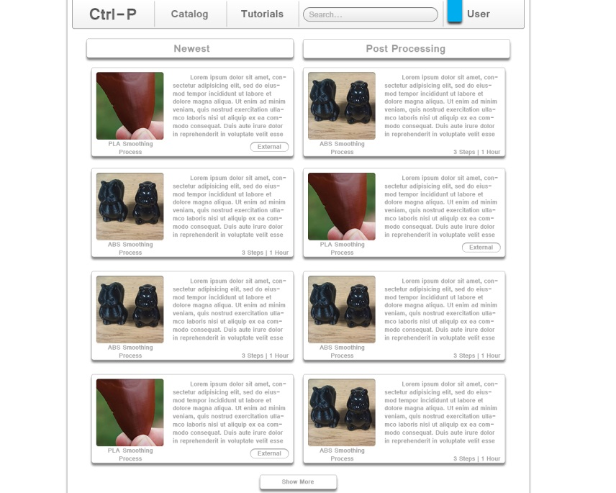

## 5.3 Catalog

## The image below is a mockup of what the Catalog section of Ctrl-P should look like. This will be the landing page for the catalog section. The user will be able to click individual designs and this will take them to another page with more details about the selected design and an option to download the design. On the catalog landing page, when the user runs their mouse over the catalog button at the top of the page the user will see more options that they can choose from. These extra options include uploading a design (if the user is logged in), finding print locations, posting print locations (if the user is logged in), finding tools and materials locations, and posting tools and materials locations (if the user is logged in).

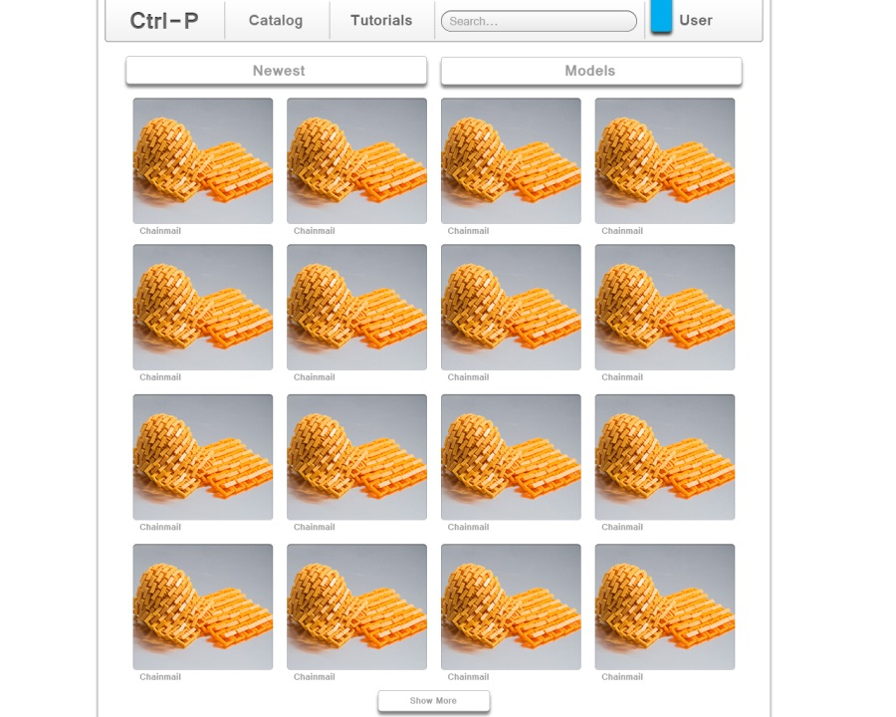

## 5.4 User Profile

The image below is a mockup of what the User Profile section should look like. The top section of the profile page displays the color with which the user has chosen to associate along with those users Community Rating which is the cumulative tally of all ratings given to that user’s submitted content. Below this section are two sections which are configured by the user at the users own discretion. The Summary section contains a description about the user. The Contact Info section contains contact information provided by that user. Below these two sections are several dynamically configured sections. The Downloaded section contains models downloaded by the user. The Uploaded section contains models uploaded by the user. There are two other sections (not shown) which optionally exist: Collaborator Models and Private Models. Collaborator Models contain models which are only visible to the user and Collaborators of that user. Private Models are models which are only visible to that user.

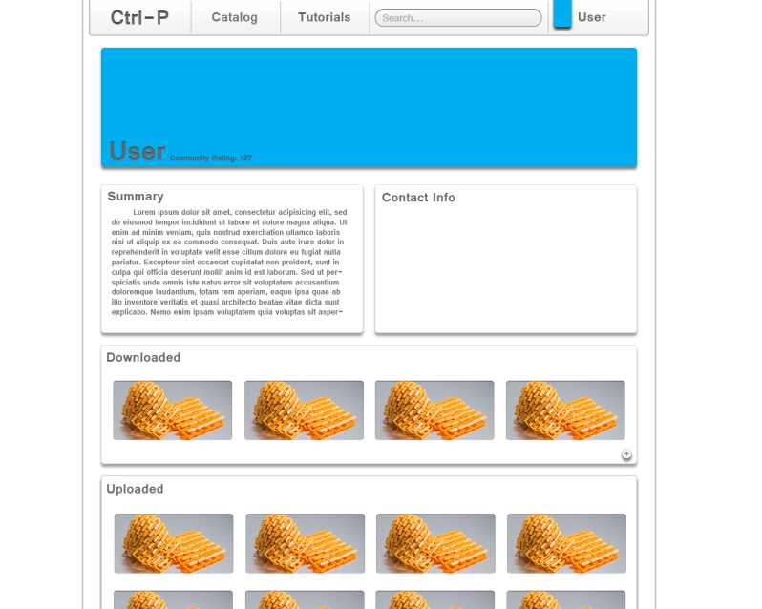

Appendix A.1 Definitions

|  |  |
| --- | --- |
| **Term** | **Definition** |
| **About** | In reference to; relating to; concerned with |
| **Apache** | Is a Unix-based Web server from the Apache Software Foundation ([www.apache.org](http://www.apache.org)). It is a widely-used HTTP server on the internet.  Apache is distributed under an “open source” license. |
| **Authentication** | Verifying the identity of a user logging into a network, computer or account. Passwords, digital certificates, etc., can be used to prove a user’s identity. |
| **Author** | Is considered the user that has written something or who has created something. In the case of 3D printing “something” could be a tutorial or a 3D printing design. |
| **Avatar** | A graphic identity that a user selects to represent themselves in a chat, or website. An avatar is generally a caricature, rather than a realistic photo and can be anything from a simple cartoon to a fantasy figure or a real object. |
| **Button** | This is an icon on a screen that is “pressed” by clicking it with the mouse or, if on a touch screen, tapping it with a finger. |
| **Cancel** | To cause (something) to end or no longer produce a certain effect. In the case of Ctrl-P cancel would mean to end a user's subscription to Ctrl-P’s services. |
| **Catalog** | A directory of disk files or files used in an application. |
| **Chat** | A real-time communication via keyboard between two or more users on a local network (LAN) or over the Internet. |
| **Classifieds** | A small advertisement that is grouped with others that are like it in a special section of a newspaper, magazine or Website. |
| **Clicking** | The act of selecting an object by pressing the mouse button when the cursor is pointing on the required menu option, icon, or hypertext link. |
| **Crawler** | Also known as a “spider”, “robot” and “intelligent agent”. A crawler is a program that searches for information on the web. |
| **Database** | Collection of all the information monitored by this system. |
| **Design software** | The user must use a design program to create a digital model. Some examples of design programs are Auto Computer aided Design(CAD),Blender, 3D tin, Sculptris, etc. |
| **Digital model** | This is the process of creating a computer model of an object that exactly replicates the form of the object. |
| **Download** | This is the process of transmitting files over a network from one computer system to another computer or device. |
| **Edit** | To make a change to data or alter the content of a file. The terms edit and “update” are used synonymously. |
| **Entity** | An entity is a piece of data, an object or concept about which data is stored. |
| **Entity- Relationship Model** | Is a graphical representation of entities and their relationships to each other, typically used in computing in regards to the organization of data within a database. |
| **External** | Coming or derived from a source outside the subject affected. In this case it would refer to content such as tutorials or videos that come from an outside source (i.e. not internally created). |
| **Frequently Asked Questions** | Also referred to as FAQ is a group of commonly asked questions about a subject along with the answers. Vendors often display them on their websites for use as troubleshooting guidelines. |
| **Follower** | A follower is an individual that has selected to watch a user’s page. A follower typically chooses to follow a user so that they can get updates on what the individual they are following is doing/creating. |
| **Gigabyte** | Is one billion bytes. |
| **Host** | A computer that acts as a source of information or signals. In a network, clients and servers are hosts because they are both sources of information. |
| **Hyper Text Markup Language** | Also known as HTML. This is the standard document format for a web page. It is defined by the Internet Engineering Task Force (IETF). Every web page contains HTML tags embedded in the text that define the page layout, fonts and hypertext links. |
| **Hypervisor** | A system program that provides a virtual machine environment. |
| **Internal** | Existing or located on the inside of something. In Ctrl-P’s case it could refer to tutorials or videos that were created by Ctrl-P’s user base or administrators. |
| **JavaScript** | A widely used programming language that is embedded in most web pages. It is supported by all web browsers, and enables interactive functions that can be added to web pages, which are otherwise static. |
| **Kilobyte** | One thousand bytes. |
| **Layers** | To print off an object the digital model that is created must be sliced into very thin cross-sections. |
| **Linux** | An Open source Operating system that runs on all major hardware platforms. Linux is licensed under the General Public License (GPL). |
| **Login** | Also known as Signing in is the process of gaining access to a network server, web server or computer. |
| **Logout** | Also known as Signing Out is the process of exiting a system. |
| **MariaDB** | Is a community-developed fork of the MySQL relational database management system. Maria is licensed under the GPL. |
| **Megabytes** | One million bytes. |
| **Megabytes per second** | Also known as Mbps. Mbps is the measurement of peripheral data transfer or network transmission speed. |
| **Menu bar** | A row of menu titles typically located at the top of the application’s window on screen. It contains a list of available actions that a user can perform in the application. |
| **Model** | A graphical representation of an object. |
| **PHP: Hypertext preprocessor** | Also known as PHP is a scripting language used to create dynamic web pages. PHP code is embedded within HTML pages for server side execution. It is commonly used to extract data out of a database on the web server and present it on the web page. It is supported by all web servers and is widely used. |
| **Post** | To place an entry on a blog, a social networking site, or a tutorial submission site. These entries are user written. |
| **Private** | Belonging to or for the use of one particular person or group of people only. This means essentially that only one person can access or view “xyz.” |
| **Public** | Of or concerning the people as a whole. This means essentially that everyone as a whole can access or view “xyz.” |
| **Rating** | The classification or ranking of someone or something based on a comparative assessment of their quality, standard or performance. In this case the Rating of someone or something is user based. |
| **Registration** | This is the process of identifying oneself online. Websites often offer free news, information or services but require users to answer questions in return. Registration helps a site to tailor the site to the user. |
| **Resolution** | The degree of sharpness of a displayed or printed image. Resolution is defined as a matrix of “pixels” per inch. |
| **Screen** | The display area of a computer monitor or TV set. The term “screen”, “terminal” and “monitor” used synonymously. |
| **Search** | The act of looking for specific data in a file, or website. A search implies either scanning content sequentially or using algorithms to compare multiple indexes to find a match. |
| **Server** | A computer or program that supplies data or resources to other machines on a network. |
| **Structured Query language** | Also known as SQL is a language used to interrogate and process data in a relational database. SQL commands can be used to interactively work with a database or can be embedded within a script or programming language to interface to a database. |
| **Storage Capacity** | The amount of data a storage device such as a disk or tape can hold. Storage Capacity is measured in Kilobytes (KB), Megabytes (MB), Gigabytes (GB) and Terabytes (TB). |
| **Submit** | To give to someone so that it can be considered or approved. |
| **Tags** | A word that a user has selected to describe a design. A tag can be used to help a user search for relevant designs. |
| **Text editor** | Software used to create and edit files that contain only text. |
| **Three Dimensional** | Having or appearing to have height width and depth. |
| **Three Dimensional Printer** | A 3D printer is unlike a common printer. On a 3D printer the user can print a 3D object. A 3D model is built up layer by layer until a 3D solid object is created. The 3D printer starts at the bottom of the design and builds up successive layers of material until the object is finished. |
| **Three Dimensional Printing(additive Manufacturing)** | Is a process of making a three-dimensional (3D) solid object of virtually any shape from a digital model. It can form any material that a user can obtain as a powder (such as plaster, bio-plastic, polyester, metal, etc.) into a 3D object. |
| **Tutorial** | Is a method of teaching that helps people learn new skills by using a step by step process that ensures that the user is following along and comprehending the material. An example would be video tutorials that lead by example or printed out instructions with illustrations. |
| **Upload** | To send data from a user’s machine to a server. |
| **User** | Someone who interacts with this web application. |
| **User Account** | It is a relationship between a user and a computer, network or information service. User Accounts are assigned a Username. Passwords are optional for computers and networks but mandatory for registrations and subscriptions to online services. |
| **Username** | Also referred to as a login name, it is a unique sequence of characters used to identify a user and allows access to a computer system, computer network or online account. |
| **Web Browser** | Is an application program that serves as the primary method for accessing the World Wide Web (WWW). With user input it is able to display websites for users to view. The most popular web browsers are Internet Explorer (IE), Firefox, Chrome, Safari and Opera. |
| **Web Site** | A presence on the World Wide web. To qualify as a bona fide web site, it must be available over the internet around the clock. A website is a collection of Web pages, which are documents coded in HTML that are linked to each other and very often to pages on other web sites. |
| **YouTube** | The largest video sharing site on the Web. YouTube lets anyone upload short videos for private or public viewing. Founded in 2005 by Chad Hurley, Steve Chen, and Jawed Karim and acquired by Google in 2006. |
| **Zipped Folder** | A digital folder that has been compressed to a smaller size to save disk space. |

**Appendix A.2 Acronyms**

|  |  |
| --- | --- |
| **Acronym** | **Term** |
| **3D** | Three Dimensions |
| **CAD** | Computer aided Design |
| **ERD** | Entity Relationship Diagram |
| **FAQ** | Frequently Asked Questions |
| **GB** | Gigabytes |
| **GPL** | General Public License |
| **HTML** | Hyper Text Markup Language |
| **IE** | Internet Explorer |
| **KB** | Kilobytes |
| **MB** | Megabytes |
| **MBPS** | Megabytes per second |
| **PHP** | PHP: Hypertext Preprocessor |
| **SQL** | Structure Query Language |
| **SRS** | Software Requirements Specification |
| **TB** | Terabytes |
| **WWW** | World Wide Web |

**Appendix A.3 References**

1. Benchoff, Brian. *Smoothing PLA printed parts.* June 7, 2013.

http://hackaday.com/2013/06/07/smoothing-pla-printed-parts/ (accessed March 4, 2014).

1. *Bld3r.* n.d. http://www.bld3r.com/ (accessed March 1, 2014).
2. Collins, Barry. *3D Printing: Undeniably cool, but lacks a killer app.* January 12, 2012.

http://www.pcpro.co.uk/blogs/2012/01/12/3d-printing-undeniably-cool-but-lacks-a-killer-app/ (accessed March 2, 2014).

1. *CubeHero.* 2014. https://cubehero.com/ (accessed Feburary 28, 2014).
2. *Fabster.* 2013. http://www.fabster.com/ (accessed Feburary 27, 2014).
3. Flaherty, Joseph. *Slick trick adds much-needed shine to 3-D printed parts.* March 2, 2013.

http://www.wired.com/design/2013/03/3d-print-smoothing/ (accessed March 2, 2014).

1. Johnson, Austin, Megan Petrillose, and Becky Price. "Software Requirements Specificaiton, Ctrl

P: 3D Printer Depository." Boston, MA, Feburary 10, 2014.

1. Jonas. *My First More Conplex 3D-Print: Yoda.* August 9, 2012. http://toxinlabs.net/2012/first-

more-complex-3d-print-yoda/ (accessed March 1, 2014).

1. *MakerBot Thingiverse.* 2014. http://www.thingiverse.com/ (accessed March 3, 2014).
2. *Shapeways.* 2014. http://www.shapeways.com/ (accessed Feburary 28, 2014).
3. Walter. *Chaninmail.* January 29, 2013. http://www.thingiverse.com/thing:45203 (accessed

March 5, 2014).

1. Weinberg, Michael. *Stratasys Sues Afinia: Ramifications for the Desktop 3D Printering Industry.*

November 27, 2013. http://makezine.com/2013/11/27/stratasys-sues-afinia-ramifications-for-the-desktop-3d-printing-industry/ (accessed March 3, 2014).

1. *YOUMAGINE.* 2014. https://www.youmagine.com/ (accessed Feburary 27, 2014).

**Appendix B.1 ERD Diagram**

Below is the ERD diagram which depicts graphically the entities and relationships of the database that is being used for Ctrl-P.

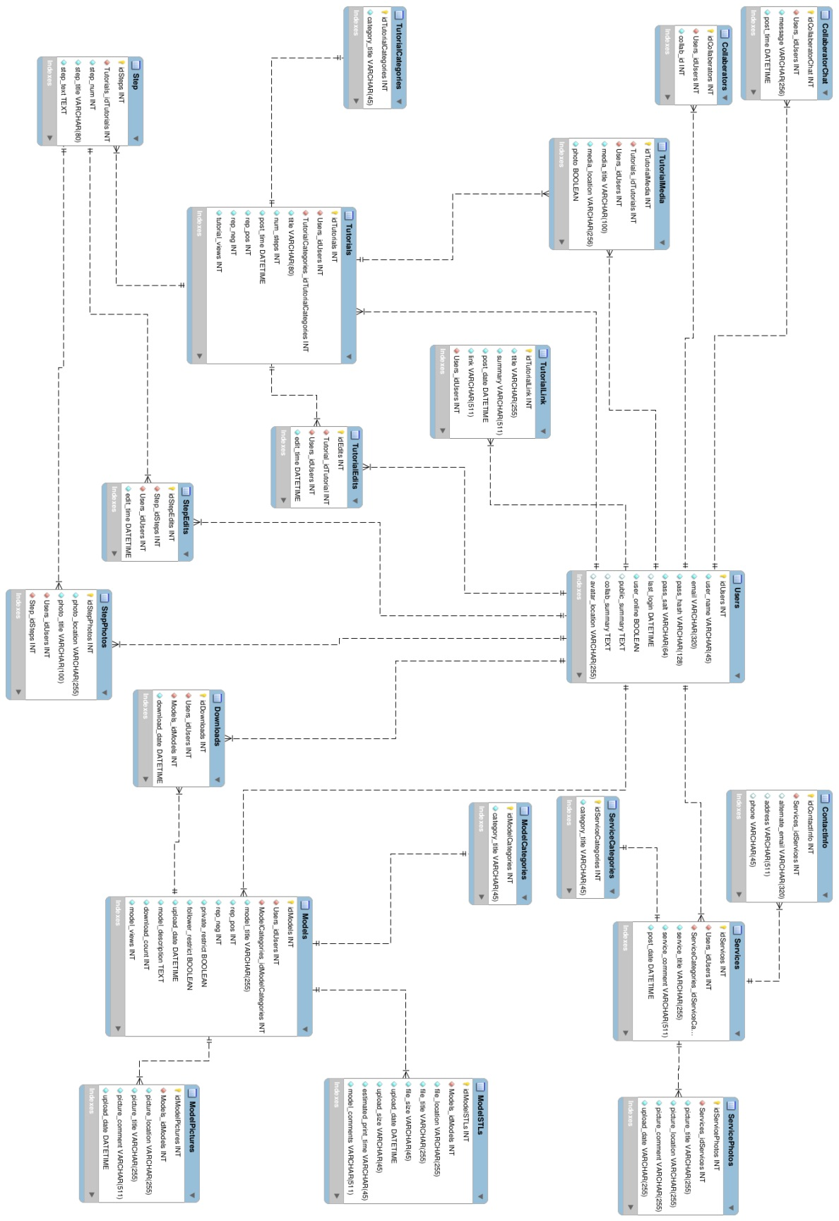

**Appendix B.2 File Structure Diagram**

Below is a diagram which displays the file structure which is used to store user submitted content.

