|  |
| --- |
| egyptianBrackets(){} |
| Software Requirements Specification |
| Ctrl-P: 3D Printer Depository |
|  |
| **Submitted By: Austin Johnson, Becky Price, Megan Petrillose** |
| **2/10/2014** |
|  |

Table of Contents

1. INTRODUCTION 4

**1.1 Purpose of this Document** 4

**1.2 Scope of the Development Project** 4

**1.2.1 How to section** 4

**1.2.2 Design collection section** 4

**1.2.3 User profile section** 5

**1.3 Definitions, Acronyms, and Abbreviations** 5

**1.4 References** 5

**1.5 Overview of Document** 5

2. GENERAL DESCRIPTION 6

**2.1 User Characteristics** 6

**2.2 Product Perspective** 6

**2.3 Overview of Functional Requirements** 6

**2.4 Overview of Data Requirements** 6

**2.4.1 User Profiles** 6

**2.4.2 Tutorial Section:** 7

**2.4.3 Catalog Section:** 8

**2.5 General Constraints, Assumptions, Dependencies, Guidelines** 9

**2.5.1 User Profiles** 9

**2.5.2 Assumptions:** 9

**2.5.3 Dependencies:** 9

**2.5.4 Guidelines:** 9

**2.6 User View of Product Use** 9

**2.6.1 General User View** 9

3. SPECIFIC REQUIREMENTS 12

**3.1 External Interface Requirements** 12

**3.1.1 User Interface Requirements** 12

**3.1.2 Software Interface Requirements** 16

**3.1.3 Hardware Interface Requirements** 17

**3.2 Detailed Description of Functional Requirements** 17

**3.2.1 General Functionality** 17

**3.2.2 Tutorial Section** 19

**3.2.3 Catalog Section** 21

**3.2.4 User Profile Section** 23

**3.3 Performance Requirements** 26

**Class Project Scope** 26

**3.4 Quality Attributes** 26

4. Other requirements 27

5. Diagrams 27

**5.1 General Diagrams** 27

**5.2 Tutorial Section** 28

5.2.1 Component Diagram 29

5.2.2 Interaction Diagram 30

5.2.3 Sequence Diagram 31

5.2.4 Use Case Diagrams 32

**5.3 Catalog Section** 34

5.3.1 Component Diagram 34

5.3.2 Interaction Diagram 35

5.3.3 Sequence Diagram 36

5.3.4 Use Case Diagrams 37

**5.4 User Profile Section** 40

5.4.1 Component Diagram 40

5.4.2 Interaction Diagram 41

5.4.3 Sequence Diagram 42

5.4.4 Use Case Diagrams 43

**Appendix A.2 Acronyms** 49

Appendix B: Changes Made to Ctrl-P 49

**Appendix B.1: Removing Forum Section** 49

1. INTRODUCTION

**1.1 Purpose of this Document**

The purpose of this document is to present a detailed description of Ctrl-P. Ctrl-P is a web application that is a universal 3D printer depository for knowledge and resources. This document will explain the purpose, and features of this system. It will also illustrate what this system will do, as well as the performance requirements allocated and the constraints under which it must operate and how the system will react to external stimuli. The aim of this document is to gather, analyze and give in-depth insight of Ctrl-P by outlining all of the above and more to gain a better understanding of this project.

**1.2 Scope of the Development Project**

Ctrl-P is a web application that is a universal Three Dimensional (3D) printer depository for knowledge and resources to help beginners to intermediate 3D printer users. This web application contains several different sections: a “How to” tutorial section, forum section, Design collection section, and user profiles.

**1.2.1 How to section**

The “How to…” section the user will be able to access links to helpful videos and information about how to get started on 3D printing. For example, the user will be able to access information on software packages (design software) used for modeling (information in this section will be limited by research and current documentation that is available on 3D printing). In this section the user will also be able to find common FAQ’s new users may have on 3D printing.

**1.2.2 Design collection section**

The Design collection section will contain different designs (these design can either be uploaded by users or from other websites) that users can choose from to download for personal use. The designs that are displayed will be “categorized” to make it easier for users to find the designs that they are looking for. Designs will depend on research and current resources that are available for 3D printing. This section will also contain information about places to print user’s designs and places where the user can get tools and materials.

**1.2.3 User profile section**

For a user to fully participate in this web application they must be logged in. This means that each user will have a user profile. The user profiles will be similar to user profiles of YouTube in the way that a user will be able to view the designs that they have uploaded.

**1.3 Definitions, Acronyms, and Abbreviations**

Please refer to Appendix A for all definitions, acronyms and Abbreviations.

**1.4 References**

1. *bld3r.* Retrieved February 9, 2014, from<http://www.bld3r.com/>
2. *Encyclopedia.* Retrieved February 13, 2014, from

[http://www.pcmag.com/encyclopedia/index/a](%20http://www.pcmag.com/encyclopedia/index/a)

1. *Fabster.* Retrieved February 11, 2014, from<http://www.fabster.com/>
2. *MakerBot thingiverse.* (2014). Retrieved February 4, 2014, from [http://www.thingiverse.com/](http://www.shapeways.com/)
3. *Merriam-Webster.* Retrieved February 13, 2014, from<http://www.merriam-webster.com/>
4. *Shapeways.* Retrieved January 28, 2014, from<http://www.shapeways.com/>
5. *Share your imagination.* Retrieved February 11, 2014, from<https://www.youmagine.com/>
6. Weinberg Michael. (11/27/2013). *Stratasys sues afinia: Ramifications for the desktop 3D*

*printing industry.* Retrieved February 8, 2014, from [http://makezine.com/2013/11/27/stratasys-sues-afinia-ramifications-for-the-desktop-3d-printing-industry/](%20http://makezine.com/2013/11/27/stratasys-sues-afinia-ramifications-for-the-desktop-3d-printing-industry/)

1. *Work with others on 3D printing.* Retrieved February 10, 2014, from<https://cubehero.com/>

**1.5 Overview of Document**

The remaining sections of this document will provide a general description which includes the user characteristics, product perspective, functional and data requirements, as well as general constraints, guidelines, and a user view of Ctrl-P.  The functional requirements can be found in section three. The functional requirements include external and internal interface requirements, including software and hardware requirements. Section three also contains all the specific requirements of this project. Section four and five contain supporting information and use cases. The Appendix at the end of this document includes reasoning behind changes from the proposal.

2. GENERAL DESCRIPTION

**2.1 User Characteristics**

The user of this website is an individual who has novice to intermediate understanding of 3D printing technology. The user is either seeking to learn more about 3D printing by looking at the Tutorial Section, or is looking to upload, download, or browse 3D printable models from the websites Model Catalog. The user may also be seeking to make connections with other users on the website by following the models that that users contributes to the website.

**2.2 Product Perspective**

Ctrl-P is a new system that is filling a gap in the market. There is a lot of information about 3D printing scattered through the Web. Ctrl-P strives to become a 3D printing depository for knowledge. This web application is looking to collect and display information, designs and tutorials on a plethora of 3D printing topics.

This product is a knowledge base for other resources. The idea is to gather information, designs, and tutorials into one location. This means that Ctrl-P must search and collect information and data from other websites and display it in a centralized location. To facilitate this, Ctrl-P uses a crawler, which combs through websites to find information about 3D printing.  When the crawler finds a design, tutorial, or information that it deems relevant, it is posted for other users to view. Ctrl-P primarily uses a crawler to find designs for users to download.

**2.3 Overview of Functional Requirements**

The website is broken into several sections providing different functions to the user. The user is first greeted with a homepage displaying recent and popular model additions and tutorials. The user is able to navigate to the other sections of the website by using a navigation panel that is universal to every page on the site. The user also has the option to login, register, or logout of the website on every page.

There is a user Profile section which contains the profile for each registered user. Each user owns a profile page and can edit the information that is displayed on that page. When viewing another user profile, only certain information is visible depending upon authentication of the viewing user.

There is a tutorial section which contains user contributed resources related to 3D printing technology. Tutorials are organized by topics which the user is able to browse manually. There are featured tutorials which are tutorials which have been rated as being valuable by other users. Tutorial pages are searchable.

There is a catalog section which contains 3D printable models and user posted Classifieds. The user is able to download or upload 3D printable models to/from the catalog. The user can search through the catalog and find model or classifieds. User posted Classifieds are offers for either 3D Printing Services or Material Supplies posted by registered users of the site.

**2.4 Overview of Data Requirements**

**2.4.1 User Profiles**

Login

Registering:

If a user has not registered before, the user must first register before using certain functionality. The user must enter some basic information when first logging in.  The required fields are email, first name, last name, birthday,  username, state/basic location, level of expertise, and  finally the user will have to create a password that will meet certain standards(i.e. uppercase and lowercase letters and number combination). After entering that information the user will receive an email stating that they have completed the registration process.

Returning user:

Returning users already have an account with Ctrl-P. Because of this they will only have to enter their email address/username and their password.

Forgot Password:

As a returning user that has an account with Ctrl-P, if the user forgets their password the Returning user can enter in their username/email address that is registered to their account and an email will be sent to their account email address with a temporary password. Once the user logs in the next time using the temporary password the user can then change their password.

**2.4.2 Tutorial Section:**

Create tutorial:

A user has the option to create a tutorial. If the user chooses to create a tutorial, the user will be transferred to the tutorial creation page. This page gives users an outline (using a form) that they must fill in. This will include optional sections such as a text editor for the instructions for the tutorial and a text box for a link to a web site. This form will also include mandatory input such as a tutorial heading, a description, and required materials. After the user submits a completed tutorial the user will get either an error message letting the user know that something must be changed, or a confirmation page.

Edit a tutorial:

A user will have the option to edit tutorials that they have submitted. If the user chooses to edit the tutorial the user will be transferred to the tutorial editing page (which is the same layout as the creation page with current values filled into the different fields). When the user reaches this page there will be the option to edit any piece of the tutorial. After the user submits a completed tutorial the user will get either an error message letting the user know that something must be changed, or a confirmation page.

Rate:

A user or guest has the option to rate tutorials that are displayed in the internal and external tutorials pages. The user and guest will choose the rating that the user/guest believes is appropriate for that page. The user or guest will have the rating options of one to five stars. After the user or guest submits their rating it will be averaged with the current rating for that tutorial.

Search:

By entering keywords into the search bar the user or guest will have the ability to search the tutorial section to find relevant tutorials.

Submit a link:

A user will have the ability to submit outside tutorials. When a user wishes to submit an outside tutorial they will be directed to an external tutorial creation page. On this page the user will be required to enter the title of the tutorial and the description of the tutorial as well as the link to the external source.

**2.4.3 Catalog Section:**

Designs

Download:

When looking at already-uploaded Designs, a user or guest can click download. A download window will pop up, letting the user/guest decide where to save the file to.

Search:

A user or guest will have the option to search through the designs using keywords. The keywords should correspond to a design’s title or tags.

Sort:

A user or guest can choose to view designs organized by title, popularity, or postdate.

Upload:

A user will have the ability to upload a design. An upload window will pop up where the user can select the file from their computer to upload. After selecting the file to upload, the user will have the option to add tags to correspond to the design. Tags will help other users to find specific or related designs.

Print Locations:

Find Print Locations:

A user or guest will have the ability to find other users who are willing to print the user’s or guest’s designs. The user or guest will have the ability to view print location posts organized by date posted, username, or location.

Post Print Location:

A user will have the ability to post print locations. A post print location page will open and will contain a form asking for Description and Contact Information (website, email, and phone number).

Tools and Materials:

Find Tools and Materials:

A user or guest will have the ability to find other users who are selling 3D printing tools and materials. The user or guest will have the ability to view tools and materials posts organized by date posted, username, or location.

Post Tools and Materials:

A user will have the ability to post tools and materials locations. A post tools and materials location page will open and will contain a form asking for Description and Contact Information (website, email, and phone number).

**2.5 General Constraints, Assumptions, Dependencies, Guidelines**

**2.5.1 User Profiles**

A user must be logged in as a registered user (not guest) to do the following:

* Create Tutorials
* Edit Tutorials
* Rate Tutorials
* Submit Links (to external tutorials)
* Upload Designs
* Post Print Locations
* Post Tools and Materials Locations

**2.5.2 Assumptions:**

Users:

Users of Ctrl-P will be beginners or have some knowledge of 3D printing (they do not need to be experts). Users must be connected to the internet.

Software:

The Ctrl-P applications are web-based.

**2.5.3 Dependencies:**

The Ctrl-P website is dependent on SQL server. The application is web-based. The web application is dependent upon a virtualized server environment.

**2.5.4 Guidelines:**

The website should be simple, fluid, intuitive, and easy to use.

**2.6 User View of Product Use**

**2.6.1 General User View**

At the top of the page there will be a button that the user will be able to click on that will always give the user the option to login/ register. If the user is logged in to the system this button will change into the logout button and will give the user the option to logout at anytime

Login:

When the user selects the login button a pop up dialog box will appear. In the box the user will have the option to enter their email/username and their password. After the user enters that information they will be able to select the button labeled submit that is located in the dialog box too. If the user forgets their password in that dialog box they will have a link that they can select that will bring them to a page where the user must enter their email and a temporary password will be emailed to them.

Registering:

If a user has not registered yet they will have the option to register. It will be a button that is sitting next to the login button at the top of the page. Like the Login button it will always be available so long as you are not logged into the system. When the user selects the register button they will be directed to a registration page. On this page they will be asked so information. Such as Name, email, username, password, general location, gender, age, etc.  When the user has entered this information it will be verified and entered into the database so that this user can sign in next time without having to register again. If any information such as their password or username is either used already or is not valid it will let the user know so that they can correct it.

Logging out:

When the user is logged in at the top of the page they will always have a button that says logout. If the user clicks on this button it will log the user out of the system.

**2.6.2 User View of Tutorial Section**

Internal Tutorial:

View Tutorials:

Displays a list of all internal tutorials, for each tutorial that is displayed it the user will be able to view the Title of the tutorial the quick description of the tutorial and the author.

Create Tutorial:

A form will be displayed for the user to see. The form will contain certain sections some of them will be mandatory (title, description, materials needed), and some will be optional (text box for a web link, text box for the body of the tutorial).

Edit Tutorial:

This section will look the same as the “create a tutorial” section described above but the fields will be filled in with the data that is associated with the tutorial being edited.

External Tutorial

View Tutorials:

Displays a list of all external tutorials, for each tutorial that is displayed it the user will be able to view the Title of the tutorial the quick description of the tutorial and the author.

Submit a Link (external tutorial):

A form will be displayed for the user to see. The form will contain certain sections that are mandatory such as title, description and a text box for the web link

Edit Tutorial:

This section will look the same as the “create a tutorial” section described above but the fields will be filled in with the data that is associated with the tutorial being edited.

Rating:

At the bottom of each tutorial the user will have the option to rate the tutorial that they just used. The user will be given the option of one to five stars. After the user chooses their rating it will be averaged with the current rating.

Search:

Users will be able to enter keywords into a search bar that will be provided. The results of the keyword search will display a list of tutorials that included similar words in their title.

**2.6.3 User View of Catalog Section**

View Designs:

Download:

When a user views a design there will be a button that will say “download”. When the user clicks on this button the design will start downloading for the user and will be added to the users downloaded designs on their profile.

Search:

Designs will come up in the results for searches that include to the tags or are similar to the title.

Sort:

Designs can be sorted by Title, Popularity, or Post Date.

Upload Designs:

Stored data:

Each Design will have a user who uploaded it, a 3-D Design File or Zipped Folder containing 3-D Design Files, a Title, and Popularity. Optionally, Designs can have a Description, an Image, and Tags.

Print Locations:

Find Print Locations:

Print Locations can be searched by Title and Location and sorted by Title, Date Posted, or Username (of the user who posted it).

Post Print Location:

The form for uploading an each Print Location will ask for a Title, Location, and Contact Information (website, email, and phone number). Only 1 form of Contact Information is necessary, but all are accepted.

Tools and Materials:

Find Tools and Materials:

Tools and Materials Locations can be searched by Title and Location and sorted by Title, Date Posted, or Username (of the user who posted it).

Post Tools and Materials:

The form for uploading an each Tools and Materials Location will ask for a Title, Location, and Contact Information (website, email, and phone number). Only 1 form of Contact Information is necessary, but all are accepted.

**2.6.4 User View of User Profile Section**

Public Profile View:

User Information:

Information about the user account including username, number of positive ratings user submitted content has received, and any publicly available contact information.

Downloaded Models:

Models which have been downloaded by the user.

Uploaded Models:

Models which have been uploaded by the user.

Follower Profile View:

Public Profile View:

All information available in the Public Profile View.

Follower Models:

Models uploaded by the user that are only visible to Followers of the user.

Follower Chat:

Chat window used by Followers of the user.

Private Profile View:

Edit:

An edit option for all aspects of the profile.

3. SPECIFIC REQUIREMENTS

**3.1 External Interface Requirements**

**3.1.1 User Interface Requirements**

|  |  |
| --- | --- |
| **Minimum Screen Resolution** | 900 *x* 500 |
| **Browser Requirements** | Firefox 26.0, Chrome, IE |
| **Network Connection** | Minimum: 512 kbps ; Recommended: 1.5Mbps |

General Interface Features:

Navigation Menu

A universal navigation menu is available on all pages. The menu is actuated via a button at the top right of the screen independent of the users location on any particular page. Actuating the button slides out a menu containing various navigation options. The menu is altered depending on the access level of the user. The following features are found universality to all users and visitors:

*Search Bar*

The search bar is used to search the site universally. There is a mechanism for limiting searches to the catalog, tutorial.

*Catalog*

This is a link that brings the user/visitor to the Catalog section of the website.

*Tutorial*

This is a link that brings the user/visitor to the Tutorial section of the website.

Account Management

An account management link is always available at the top right of the screen independent of the users location on any particular page. This section changes depending on access level of the user/visitor. These are the following possible configurations for this feature:

*Login/Registration*

This is a link which will bring up a Login Dialog Box in the center of the screen independent of the user’s location on any given page. This option is only available when a user is not yet logged into the site. The login dialog box contains a form which accepts a username and password. At the bottom of the box is a Registration Link which when clicked alters the login dialog box to display the Registration Dialog Box. The registration dialog box contains a form which takes accepts information from the user necessary for user registration.

On both the Login and Registration there are Submit and Cancel buttons. Clicking the submit button submits the form data entered by the user. Clicking the cancel button closes the Dialog Box and returns the user to the page on which the box was initially displayed.

*User Account/Logout*

This will display the logged in users username and associated avatar along with a link to the logout option. Clicking on the username or avatar directs the user to that user public/follower profile page. Clicking on the logout option causes and the user to immediately log out of the website altering the navigation menu and account management sections appropriately.

Emergency Footer

This section is always visible along the bottom of the screen independent of the user’s location on any given page. This bar contains the following links:

*About*

Clicking this link directs the user to the about page which contains information about the site, its developer, and the sites mission statement.

*Contact Us*

Clicking this link opens up a contact information box in the center of the screen independent of the users location on any given page. This contact information box contains pertinent contact information for the site.

*Help*

Clicking this link directs the user to the help page which contains help information pertaining to a user’s interaction with the site.

Page/Section Interfaces:

Tutorial Section

This section contains tutorials that users can use to learn about 3D printing, modeling, and designing. This section combines internal and external resources for tutorials. The user can sort tutorials by type, subject, popularity, rating, and postdate. The following are possible tutorial types:

*External Resource*

This is a tutorial submitted by a user that links other users to third party resources.

External resource tutorials are labeled as such in the tutorial section.

*User (internal) Tutorial*

This is a tutorial written by one or more users that is viewable by other users and guests. User tutorials are Cc-edited to the tutorial’s original author and have editor credits for any user that has change a certain percentage of that tutorial. User tutorials contain textual and educational information. User tutorials can optionally contain educational images and YouTube media. User tutorials contain at least three sections:

Purpose (description):

This subsection describes the purpose of the tutorial and a brief overview of what will be accomplished during the tutorial. This section also contains any references to related tutorials.

Required Materials:

This section is a bulleted list containing the required materials needed to undergo the tutorial. This section also contains a time estimation of how long the tutorial will take to accomplish.

Process:

This section contains the processes are to be followed in order to complete the tutorial. The process section is broken up into numbered steps of which there is a minimum of three.

*Featured Tutorial*

This is a tutorial submitted by one or more users that have reach a certain level of popularity and has been rated highly a certain number of times. A Featured Tutorial contains the three mandatory sections of a user tutorial but also contains educational images and contains a YouTube media section.

Catalog Section

This section displays the design collection (for downloading and uploading designs), the print locations locator (for finding places that will print designs for the user), and the tools and materials locator (for finding places that sell tools and materials needed for 3D printing). The designs can be displayed by type, popularity, rating, and postdate. Designs can be searched by title or tags.

*Download Design*

Designs can be downloaded to designated locations on a user’s or guest’s computer. There will be a window that pops up and lets the user or guest specify the download location.

*Upload Design*

On the upload design page, there will be fields for the user to give the design a unique title and tags and to navigate to the desired file to upload. The title and tags will give the design a better chance of coming up in searches.

*Find Print Locations*

This page displays a list of 3D printing locations. Each location will be listed with contact information and a description of materials that can be used.

*Post Print Locations*

There will be a form on this page with the following fields: description, website, email, and phone. Only one form of contact Information will be required, but more is encouraged.

*Find Tools and Materials*

This page displays a list of users, websites, or stores that sell tools or materials. Each seller will be displayed with contact information and a description.

*Post Tools and Materials Locations*

There will be a form on this page with the following fields: description, website, email, and phone number. Only one form of contact information will be required, but more is encouraged.

About Page

This page contains the mission statement of the website and describes the goals of the project.

Help Page

This page contains various help topics that aid users in their interactions with the web site. Topics are broken down by the aforementioned sections and contain information which is pertinent to those sections.

User Profiles:

Public Profile

This is the profile which is visible to all users of the website regardless of the level authentication. The public profile displays:

*User Info*

This area contains information about the user including: username, avatar, and publically presented contact information. This information is display at the left corner of the page.

*Uploaded Models*

This area displays the models which the user has contributed to the website.

This section initially only shows recently contributed models. There is a button at the bottom right corner of this section which expands the section to show all models that have been contributed by the user. Once the section is expanded the user can again collapse the section by navigating to the bottom of the section and clicking the collapse button.

*Liked Models*

This area displays the models of which the user has given a positive rating. This section initially only shows models which were recently given a positive rating. There is a button at the bottom right corner of this section which expands the section to show all liked models. Once the section is expanded the user can again collapse the section by navigating to the bottom of the section and clicking the collapse button.

*Downloaded Models*

This area displays the models which the user has downloaded from the website. This section initially only shows recently downloaded models. There is a button at the bottom right corner of this section which expands the section to show all models that the user has downloaded since the date of their joining. Once the section is expanded the user can again collapse the section by navigating to the bottom of the section and clicking the collapse button.

Follower Profile

This area contains all the information found in the public profile section but contains additional information that is only visible to authenticate users that are followers of that user’s profile. The Follower can contain the following sections:

*Follower Models*

This optional section contains models which are uploaded by the user that have been designated as only being visible to followers of that user. This section initially only shows recently contributed follower models. There is a button at the bottom right corner of this section which expands the section to show all follower models that have been contributed by the user. Once the section is expanded the user can again collapse the section by navigating to the bottom of the section and clicking the collapse button.

*Follower Chat*

This optional section contains a messages submitted by either the user owning the profile or by followers of that user. This section is limited to ten messages each of 255 characters or less.

Private Profile

This area contains all the information found in both the public profile and follower profile but contains additional features and the ability for the user to edit the other profile sections. Editing is done via an edit button that is found adjacent to each section in the profile. This area also includes:

*Private Models*

This optional section contains models which are uploaded by the user that have been designated as only being visible to user owning that profile. The number of possible Private Models that a user can have is limited by the number of public models the user has contributed. This section initially only shows recently contributed private models. There is a button at the bottom right corner of this section which expands the section to show all private models that have been contributed by the user. Once the section is expanded the user can again collapse the section by navigating to the bottom of the section and clicking the collapse button.

**3.1.2 Software Interface Requirements**

Web Portal

The site runs on a Linux based server employing Apache as the Web service. The website makes use of PHP, JavaScript, and HTML5 as mechanisms for building pages dynamically as informations is added to the site by users. The website makes use of a MariaDB (SQL Server) as a mechanism for storing information that is added to the site by users.

Site Crawler

This is a mechanism which is employed when a user makes a search on the website. The Site Crawler will examine other 3D printing model sites and display any applicable links which may match that users search criteria.

Authentication

The authentication mechanism is used ensure that a user is who the claim to be while using the site. Authentication is used as a mechanism for display the appropriate information to a user based on their form of authentication.

Hypervisor

This is the system on which the virtualized server runs.

**3.1.3 Hardware Interface Requirements**

Server Host(s)

This is the physical machine(s) on which the Hypervisor runs and provides the structure on which the web application is able to run.

**3.2 Detailed Description of Functional Requirements**

**3.2.1 General Functionality**

|  |  |
| --- | --- |
| **Function Name** | **Information** |
| **Login** | *Purpose:*  Method which authenticates registered users.  *Input(s):*  Username, Password  *Processing:*  Evaluate Username/Password combination against stored hashed value stored on system database. Session Token is created.  *Output:*  Login Screen |
| **Register** | *Purpose:*  Method for allowing a new user to register an account on the website.  *Input(s):*  Desired Username/Password, valid Email, optional Personal Information  *Processing:*  Check if email address is already registered in the system, create an account in the system, hash username/password  *Output:*  Confirmation Email |
| **Logout** | *Purpose:*  Method which allows a session to end and a user to logout of the website.  *Input(s):*  Click logout button.  *Processing:*  Disable Session Token registered to the user that clicks the Logout link.  *Output:*  Disabled session token, Redirected to the home page. |

|  |  |
| --- | --- |
| **Function Name** | **Information** |
| **Search** | *Purpose:*  Method for search various part of the website based on user selected search limitations.  *Input(s):*  Enter search term in textbox at top of the screen.  *Processing:*  Query website SQL database for matching terms in sections/tables that are applicable to the search term and limitations.  *Output:*  List of links containing the Search term |

**3.2.2 Tutorial Section**

|  |  |
| --- | --- |
| **Function Name** | **Information** |
| **View External Tutorials** | *Purpose:*  Tutorial page that contains External tutorials. The data that is displayed is determined by the input of users and administrators and the current tutorials that are available on the Web.  *Input(s):*  Click on the tab for external tutorials.  *Processing:*  Queries the SQL database for tutorials that are from external sources.  *Output:*  Displays a formatted page that lists the external tutorials that were found. |

|  |  |
| --- | --- |
| **Function Name** | **Information** |
| **View Internal Tutorials** | *Purpose:*  Tutorial page that contains Internal tutorials. The data that is displayed is determined by the input of users and administrators.  *Input(s):*  Click on the tab for the internal tutorials.  *Processing:*  Queries the SQL database for tutorials that are from internal sources.  *Output:*  Displays a formatted page that lists the internal tutorials that were found. |
| **Create Tutorial** | *Purpose:*  Method that allows the user to create tutorials for other users and guests to use.  *Input(s):*  Desired tutorial material (text, links, etc.)  *Processing:*  Evaluates the tutorial material that was submitted and determines if it is in the right format and is added it the database.  *Output:*  Confirmation page or Error message. |
| **Edit a tutorial** | *Purpose:*  Method that allows a user to edit tutorials that they submitted.  *Input(s):*  Enter desired edits to the tutorial in the editing form and presses submit.  *Processing:*  Evaluates the tutorial material that was submitted and determines if it is in the right format and is added it the database.  *Output:*  Confirmation page or Error message. |

|  |  |
| --- | --- |
| **Function Name** | **Information** |
| **Rate** | *Purpose:*  Method that allows a user or guest to Rate tutorials that they have used.  *Input(s):*  Enter desired Rating  *Processing:*  Determines the tutorial that is currently being viewed and updates the rating of the current tutorial.  *Output:*  Modified Rating. |
| **Submit Link** | *Purpose:*  Method that allows the user to submit an external Tutorial link for other users and guests to use.  *Input(s):*  Desired External tutorial link  *Processing:*  Evaluates the tutorial material that was submitted and determines if it is in the right format and is added it the database.  *Output:*  Confirmation page or Error message. |

**3.2.3 Catalog Section**

|  |  |
| --- | --- |
| **Function Name** | **Information** |
| **View Designs** | *Purpose:*  Design page that contains uploaded designs. The designs displayed are determined by the input of users.  *Input(s):*  Click on the link for the design page.  *Processing:*  Queries the SQL database for uploaded designs.  *Output:*  Displays a formatted page that lists the uploaded designs. |
| **Download Design** | *Purpose:*  Method that allows the user or guest to download a Design file.  *Input(s):*  Desired Design link, location to save Design to  *Processing:*  Finds the Design in the database and downloads it to the specified location.  *Output:*  File is downloaded. |
| **Upload Design** | *Purpose:*  Method that allows the user to upload a Design for other users and guests to download.  *Input(s):*  Desired Design material (file, title, tags)  *Processing:*  Evaluates the Design material that was submitted and determines if it is in the right format and adds it to the database.  *Output:*  Confirmation page or Error message. |

|  |  |
| --- | --- |
| **Function Name** | **Information** |
| **Find Print Locations** | *Purpose:*  Find Print Locations page that contains locations or people who will print designs. The locations and people displayed are determined by the input of users.  *Input(s):*  Clicks on the link for the page “Find print locations”.  *Processing:*  Queries the SQL database for print locations.  *Output:*  Displays a formatted page that lists the print locations that were found. |
| **Find Tools and Materials** | *Purpose:*  Find Tools and Materials Locations page that contains locations or people who sell tools and materials for 3D printing. The locations and people displayed are determined by the input of users.  *Input(s):*  Clicks on the link for the page “Find tools and materials”.  *Processing:*  Queries the SQL database for tools and materials locations.  *Output:*  Displays a formatted page that lists the tools and materials locations that were found. |

**3.2.4 User Profile Section**

|  |  |
| --- | --- |
| **Function Name** | **Information** |
| **View Profile** | *Purpose:*  Profile page that is visible to guests and Users of the website containing information about the user owning the profile. Amount of information displayed is based on the authentication of the user viewing the profile  *Input(s):*  Must be logged in and have a session token. Click on the link “View profile”.  *Processing:*  Assess the Session Token of the user and display information that is applicable to that Session Token.  *Output:*  Formatted Profile Page |
| **Edit Profile** | *Purpose:*  Method that allows a user to edit what information is visible on their profile page and which users are able to view it.  *Input(s):*  Profile Information  *Processing:*  Insert, Update, or Delete information for the users profile depending on the specified input.  *Output:*  Updated Profile Page |
| **Follow** | *Purpose:*  Method that allows a user to request to Follow another Registered user.  *Input(s):*  Must be logged in. Click on the follow button.  *Processing:*  Assess the Session Token and submit a request to the appropriate user for their approval.  *Output:*  Follow Request |
| **Function Name** | **Information** |
| **Accept Follower** | *Purpose:*  Method that allows a user to accept a new follower based on a request sent by another user.  *Input(s):*  Follower Request, Must be logged in.  *Processing:*  Assess the Session Token of the user and modify the database to add follower to that user.  *Output:*  Modified Follower List |
| **Ignore Request** | *Purpose:*  Method that allows a user to ignore a new follower based on a request sent by another user.  *Input(s):*  Follower Request, User must be logged in.  *Processing:*  Follower Request is removed from the database.  *Output:*  N/A |
| **Expand** | *Purpose:*  Method for expanding several profile subsections when applicable.  *Input(s):*  Click on the plus sign in the corner of the section.  *Processing:*  Modify profile page to include all information found within a given subsection.  *Output:*  Formatted Profile Page |

|  |  |
| --- | --- |
| **Function Name** | **Information** |
| **Collapse** | *Purpose:*  Method for collapsing several profile subsections when the subsection has already been expanded.  *Input(s):*  Click on the minus sign in the corner of the section  *Processing:*  Modify profile page to exclude the majority of information found within a given subsection.  *Output:*  Formatted Profile Page |
| **Chat** | *Purpose:*  Method for posting a message to a user of which the posting user is a follower.  *Input(s):*  Message Text, must be logged in.  *Processing:*  Evaluate message text validity and update the database to contain that message.  *Output:*  Updated Chat Display |
|  |

**3.3 Performance Requirements**

**Class Project Scope**

|  |  |
| --- | --- |
| **Simultaneous Connections** | ~ 60 Connections |
| **Simultaneous Users** | ~ 30 users |
| **Response Time** | < 3 seconds |
| **Database Capacity** | ~ 100 GB |
| **Max Model Size** | ~ 50 MB |
| **Models per User** | ~ 100 Models |
| **Interactions per Day** | ~ 4000 Interactions |

**3.4 Quality Attributes**

Security Attributes:

Users will be required to log into Ctrl-P for all pages that are considered restricted to registered users. The system will only permit users that have been registered and are listed in the database table for users, to login and interact with sections of Ctrl-P that are restricted to registered users. The system will allow a user to view only their private personal information, not other user’s private personal information.

Availability Attributes:

Ctrl-P shall be available to users on the internet 99.9% of the time from 5:00am and midnight local time and 95% of the time between midnight and 5:00am local time.

4. Other requirements

N/A

5. Diagrams

**5.1 General Diagrams**

5.1.1 Top View Diagram

The table below is the system diagram. It represents the top view of Ctrl-P.

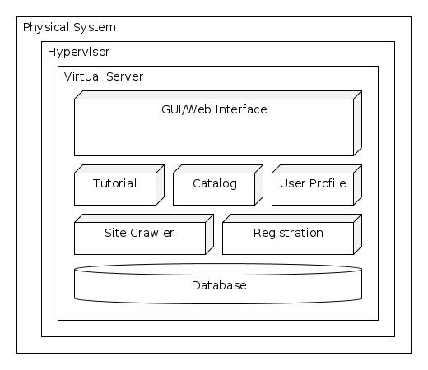

5.1.2 General Use Case Diagrams

Authentication

The diagram below represents the authentication process for when a user logs into Ctrl-P.

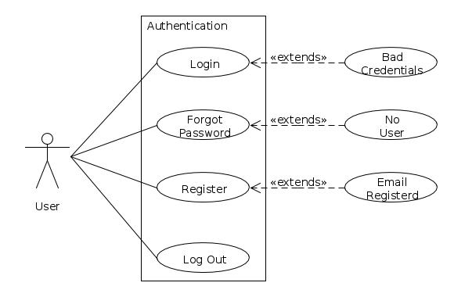

Rating

The diagram below represents the rating process for Ctrl-P. A user can rate either positively or negatively.

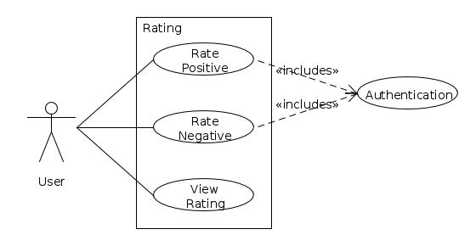

**5.2 Tutorial Section**

## 5.2.1 Component Diagram

## 5.2.2 Interaction Diagramhttps://lh6.googleusercontent.com/QiieArv4rsSnqgcZDSgG4WzkDVxi-XXB_wJlTaFbfIux7T7HEyIqvyG1DWPegpNrViFn2U8oqdUTxm4lL_7SmOwP2tFRgVqChDM_UO-L8pS4UPgVoBcNI6L03Q

## 5.2.3 Sequence Diagram

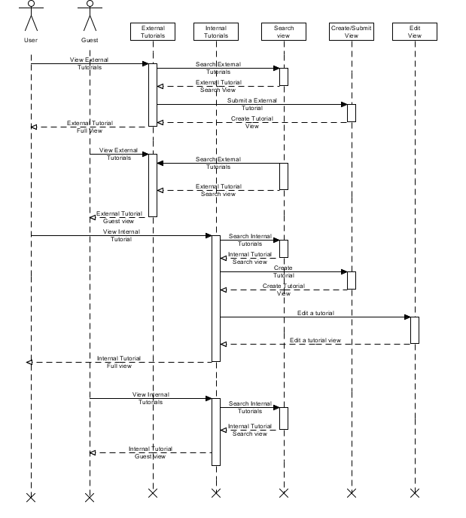

## 5.2.4 Use Case Diagrams

Internal Tutorial for User

The diagram below represents the use case for the internal tutorials section showing the processes that a user may complete

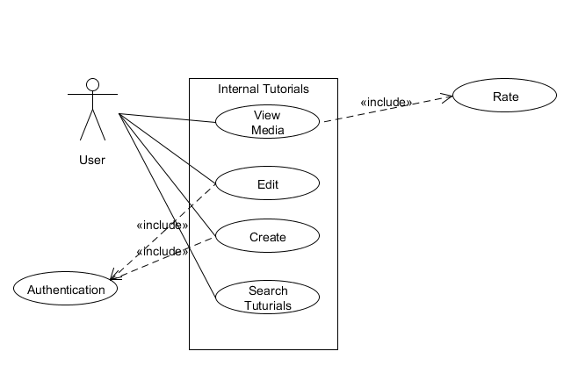

Internal Tutorial for Guest

The diagram below represents the use case for the internal tutorials section showing the processes that a guest may complete

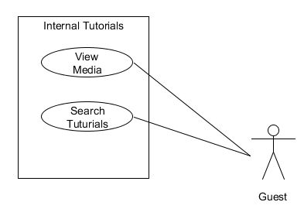

External Tutorial for User

The diagram below represent the use cases for the external tutorial section showing process that a user may complete.

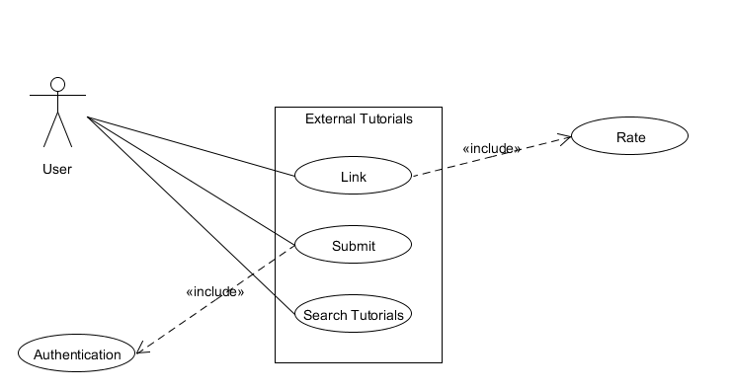

External Tutorial for Guest

The diagram below represent the use cases for the external tutorial section showing process that a user/guest may complete.

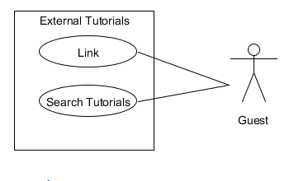

**5.3 Catalog Section**

## 5.3.1 Component Diagram

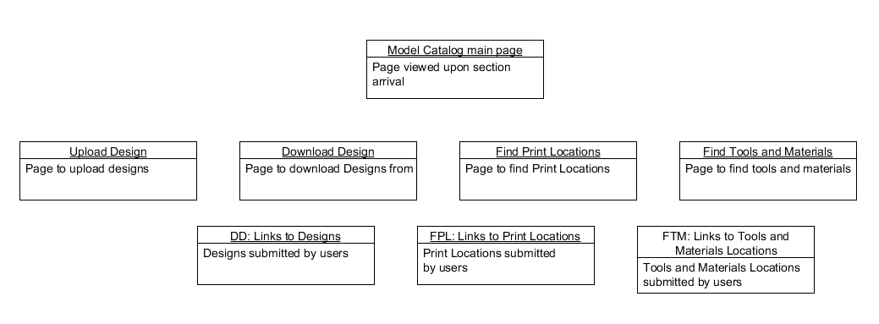

## 5.3.2 Interaction Diagram

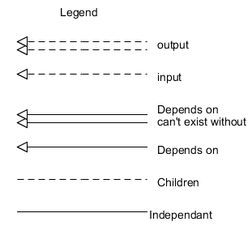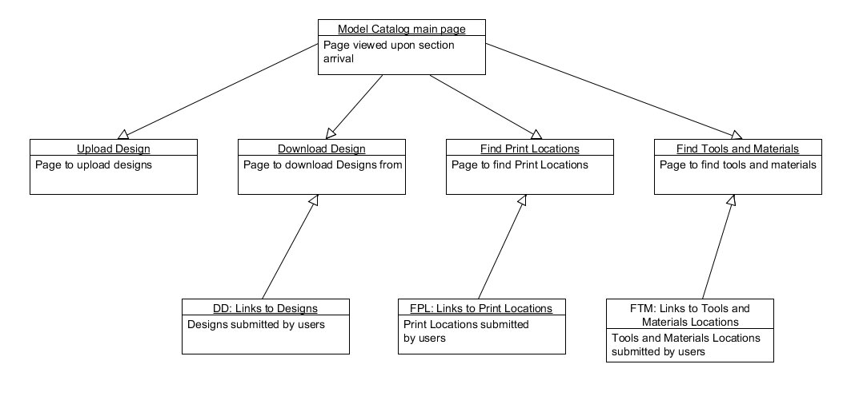

## 5.3.3 Sequence Diagram

## https://lh6.googleusercontent.com/qMgjd7E1FxqmxYvZFVlvijfRuDu9_ql1uQmK1pvq8BH5Ri03KI4vIrgFZyQKOekFpBc9Zt7396F9SfaLMaSJE1HTWVCKiBsT8QAzG5xSCMBEjs_Csj0bRr4Yww

## 5.3.4 Use Case Diagrams

Download Design

The diagram below represents the use cases for when a user (authenticated or guest) downloads a design.

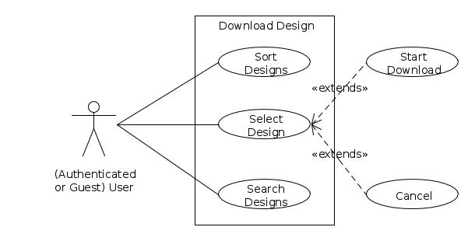

Model Catalog for Authenticated User

The diagram below represents the use cases what processes an authenticated user can complete in the model catalog.

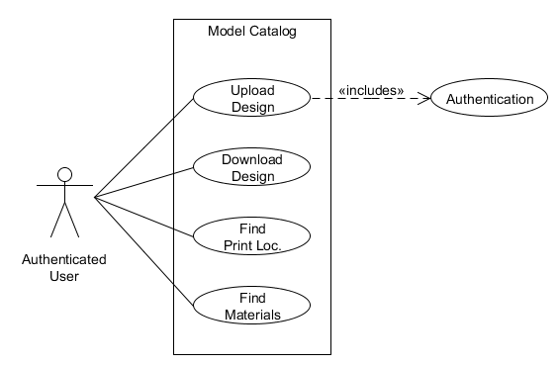

Model Catalog for User

The diagram below represents the use cases what processes an authenticated user can complete in the model catalog.

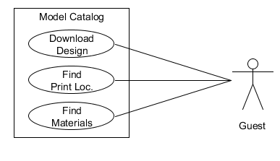

Upload Catalog for Authenticated User

The diagram below represents the use cases what processes an authenticated user can complete while uploading a design.

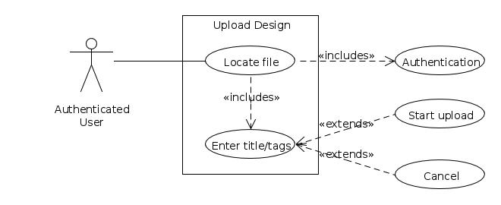

Find Tools and Materials for Authenticated User

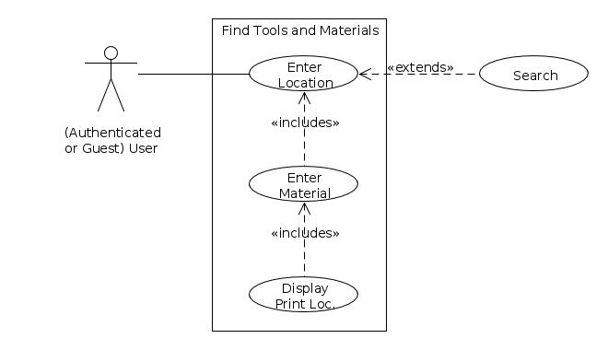The diagram below represents the use cases for a user (authenticated or guest) wants find tools or materials.

Find Print Locations

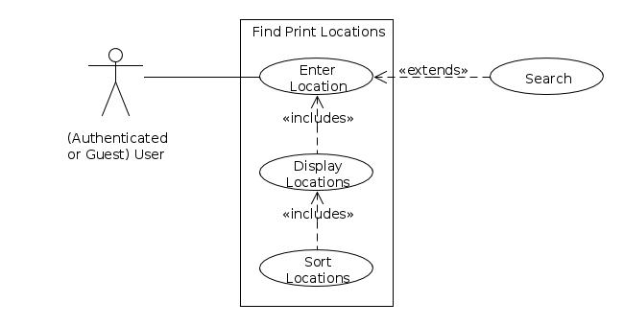The diagram below represents the use cases for a user (authenticated or guest) wants find a print location close to them.

**5.4 User Profile Section**

## 5.4.1 Component Diagram

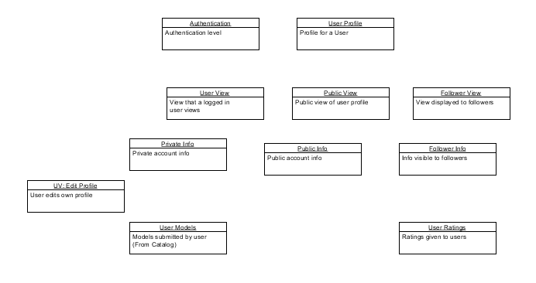

## 5.4.2 Interaction Diagram

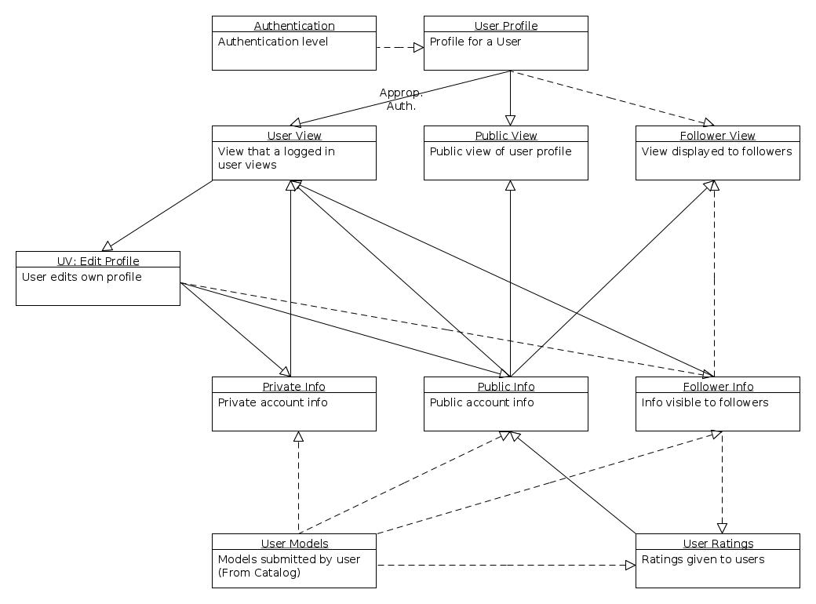

## https://lh5.googleusercontent.com/pAwdsILqxRRIZSLyBUYU0PyuVKJ_8tPvQFtwmdq0fYhHMMPCJMC-mcrY3FJxLAA_HEIiJt8Gi-p2THxTqWGSJLjp_2lkphy_DQxnfOJboUmeKLoIOqH2u_0ChA5.4.3 Sequence Diagram

## 5.4.4 Use Case Diagrams

Authenticated Users Profile

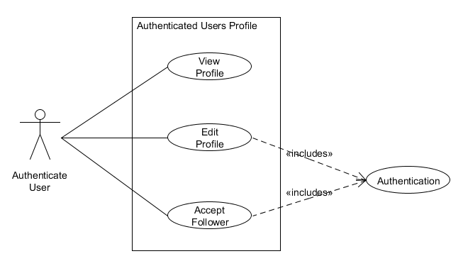The diagram below represents the use cases for a authenticated user and the processes that they can’t complete in their user profile.

Authenticated Users Profile

The diagram below represents the use cases for a authenticated user and the processes that they can’t complete in their user profile.

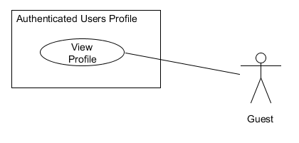

Another Users Profile

The diagram below represents the use cases for the processes that any user can complete in another users profile.

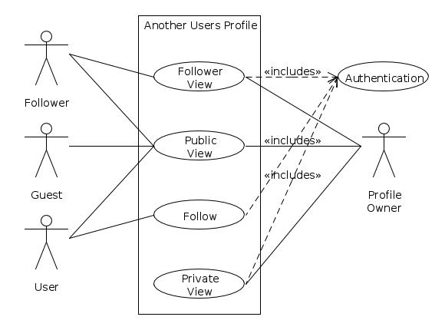

Appendix A: Glossary

**Appendix A.1 Definitions**

|  |  |
| --- | --- |
| **Term** | **Definition** |
| **About** | In reference to; relating to; concerned with |
| **Apache** | Is a Unix-based Web server from the Apache Software Foundation ([www.apache.org](http://www.apache.org)). It is a widely used HTTP server on the internet.  Apache is distributed under an “open source” license. |
| **Authentication** | Verifying the identity of a user logging into a network, computer or account. Passwords, digital certificates, etc., can be used to prove a user’s identity. |
| **Author** | Is considered the user that has written something or who has created something. In the case of 3D printing “something” could be a tutorial or a 3D printing design. |
| **Avatar** | A graphic identity that a user selects to represent themselves in a chat, or website. An avatar is generally a caricature, rather than a realistic photo and can be anything from a simple cartoon to a fantasy figure or a real object. |
| **Button** | This is an icon on a screen that is “pressed” by clicking it with the mouse or, if on a touch screen, tapping it with a finger. |
| **Cancel** | To cause (something) to end or no longer produce a certain effect. In the case of Ctrl-P cancel would mean to end a user's subscription to Ctrl-P’s services. |
| **Catalog** | A directory of disk files or files used in an application. |
| **Chat** | A real-time communication via keyboard between two or more users on a local network (LAN) or over the Internet. |
| **Classifieds** | A small advertisement that is grouped with others that are like it in a special section of a newspaper, magazine or Website. |
| **Clicking** | The act of selecting an object by pressing the mouse button when the cursor is pointing on the required menu option, icon, or hypertext link. |
| **Crawler** | Also known as a “spider”, “robot” and “intelligent agent”. A crawler is a program that searches for information on the web. |
| **Database** | Collection of all the information monitored by this system. |
| **Design software** | The user must use a design program to create a digital model. Some examples of design programs are Auto Computer aided Design(CAD),Blender, 3D tin, Sculptris, etc. |
| **Digital model** | This is the process of creating a computer model of a n object that exactly replicates the form of the object. |
| **Download** | This is the process of transmitting files over a network from one computer system to another computer or device. |
| **Edit** | To make a change to data or alter the content of a file. The terms edit and “update” are used synonymously. |
| **External** | Coming or derived from a source outside the subject affected. In this case it would refer to content such as tutorials or videos that come from an outside source (i.e. not internally created). |
| **Frequently Asked Questions** | Also referred to as FAQ is a group of commonly asked questions about a subject along with the answers. Vendors often display them on their websites for use as troubleshooting guidelines. |
| **Follower** | A follower is an individual that has selected to watch a user’s page. A follower typically chooses to follow a user so that they can get updates on what the individual they are following is doing/creating. |
| **Gigabyte** | Is one billion bytes. |
| **Host** | A computer that acts as a source of information or signals. In a network, clients and servers are hosts because they are both sources of information. |
| **Hyper Text Markup Language** | Also known as HTML. This is the standard document format for a web page. It is defined by the Internet Engineering task Force (IETF). Every web page contains HTML tags embedded in the text that define the page layout, fonts and hypertext links. |
| **Hypervisor** | A system program that provides a virtual machine environment. |
| **Internal** | Existing or located on the inside of something. In Ctrl-P’s case it could refer to tutorials or videos that were created by Ctrl-P’s user base or administrators. |
| **JavaScript** | A widely used programming language that is embedded in most web pages. It is supported by all web browsers, and enables interactive functions that can be added to web pages, which are otherwise static. |
| **Kilobyte** | One thousand bytes. |
| **Layers** | To print off an object the digital model that is created must be sliced into very thin cross-sections. |
| **Linux** | An Open source Operating system that runs on all major hardware platforms. Linux is licensed under the General Public License (GPL). |
| **Login** | Also known as Signing in is the process of gaining access to a network server, web server or computer. |
| **Logout** | Also known as Signing out is the process of exiting a system |
| **MariaDB** | Is a community-developed fork of the MySQL relational database management system. Maria is licensed under the GPL. |
| **Megabytes** | One million bytes. |
| **Megabytes per second** | Also known as Mbps. Mbps is the measurement of peripheral data transfer or network transmission speed. |
| **Menu bar** | A row of menu titles typically located at the top of the application’s window on screen. It contains a list of available actions that a user can perform in the application. |
| **Model** | A graphical representation of an object. |
| **PHP: Hypertext preprocessor** | Also known as PHP is a scripting language used to create dynamic web pages. PHP code is embedded within HTML pages for server side execution. It is commonly used to extract data out of a database on the web server and present it on the web page. It is supported by all web servers and is widely used. |
| **Post** | To place an entry on a blog, social networking site, a tutorial submission site. These entries are user written. |
| **Private** | Belonging to or for the use of one particular person or group of people only. This means essentially that only one person can access or view “xyz” |
| **Public** | Of or concerning the people as a whole. This means essentially that everyone as a whole can access or view “xyz” |
| **Rating** | The classification or ranking of someone or something based on a comparative assessment of their quality, standard or performance. In this case the Rating of someone or something is user based. |
| **Registration** | This is the process of identifying oneself online. Websites often offer free news, information or services but require users to answer question in return. Registration helps a site to tailor the site to the user. |
| **Resolution** | The degree of sharpness of a displayed or printed image. Resolution is defined as a matrix of “pixels” per inch. |
| **Screen** | The display area of a computer monitor or TV set. The term “screen”, “terminal” and “monitor” used synonymously. |
| **Search** | The act of looking for specific data in a file, or website. A search implies either scanning content sequentially or using algorithms to compare multiple indexes to find a match. |
| **Server** | A computer or program that supplies data or resources to other machines on a network. |
| **Structured Query language** | Also known as SQL is a language used to interrogate and process data in a relational database. SQL commands can be used to interactively work with a database or can be embedded within a script or programming language to interface to a database. |
| **Storage Capacity** | The amount of data a storage device such as a disk or tape can hold. Storage Capacity is measured in Kilobytes (KB), Megabytes (MB), gigabytes (GB) and terabytes (TB). |
| **Submit** | To give to someone so that it can be considered or approved. |
| **Tags** | A word that a user has selected to describe a design. A tag can be used to help a user search for relevant designs. |
| **Text editor** | Software used to create and edit files that contain only text. |
| **Three Dimensional** | Having or appearing to have height width and depth. |
| **Three Dimensional Printer** | A 3D printer is unlike a common printer. On a 3D printer the user can print a 3D object. A 3D model is built up layer by layer until a 3D solid object is created. The 3D printer starts at the bottom of the design and builds up successive layers of material until the object is finished. |
| **Three Dimensional Printing(additive Manufacturing)** | Is a process of making a three-dimensional (3D) solid object of virtually any shape from a digital model. It can form any material that a user can obtain as a powder (such as plaster, bio-plastic, polyester, metal, etc.) into a 3D object. |
| **Tutorial** | Is a method of teaching that helps people learn new skills by using a step by step process that ensures that the user is following along and comprehending the material. An example would by video tutorials that lead by example or printed out instructions will illustrations. |
| **Upload** | To send data from a user’s machine to a server. |
| **User** | Someone who interacts with this web application. |
| **User Account** | It is a relationship between a user and a computer, network or information service. User Accounts are assigned a Username. Passwords are optional for computers and networks but mandatory for registrations and subscriptions to online services. |
| **Username** | Also referred to as a login name, it is a unique sequence of characters used to identify a user and allows access to a computer system, computer network or online account. |
| **Web Browser** | Is an application program that serves as the primary method for accessing the World Wide Web (WWW). With user input it is able to display websites for users to view. The most popular web browsers are Internet Explorer (IE), Firefox, Chrome, Safari and Opera. |
| **Web Site** | A presence on the World Wide web. To qualify as a bona fide web site, it must be available over the internet around the clock. A website is a collection of Web pages, which are documents coded in HTML that are linked to each other and very often to pages on other web sites. |
| **YouTube** | The largest video sharing site on the Web. YouTube lets anyone upload short videos for private or public viewing. Founded in 2005 by Chad Hurley, Steve Chen, and Jawed Karim and acquired by Google in 2006. |
| **Zipped Folder** | A digital folder that has been compressed to a smaller size to save disk space. |

**Appendix A.2 Acronyms**

|  |  |
| --- | --- |
| **Acronym** | **Term** |
| **3D** | Three Dimensions |
| **CAD** | Computer aided Design |
| **FAQ** | Frequently Asked Questions |
| **GB** | Gigabytes |
| **GPL** | General Public License |
| **HTML** | Hyper Text Markup Language |
| **IE** | Internet Explorer |
| **KB** | Kilobytes |
| **MB** | Megabytes |
| **MBPS** | Megabytes per second |
| **PHP** | PHP: Hypertext Preprocessor |
| **SQL** | Structure Query Language |
| **SRS** | Software Requirements Specification |
| **TB** | Terabytes |
| **WWW** | World Wide Web |

Appendix B: Changes Made to Ctrl-P

**Appendix B.1: Removing Forum Section**

The forum section of Ctrl-P that was first proposed in the Proposal last month is being removed from the requirements. The reason that the Forum section is being removed from the requirements is because of time restraints. There is not enough time to complete all the initially proposed sections. The reason that the forum section is being removed from the requirements instead of a different section was based on the content of the sections. To meet Ctrl-P’s goal to become a repository for all information about 3D printing for beginning and intermediate users, there had to be careful consideration on which sections would be most beneficial to that goal. Both the Tutorial section and the Collection section could not be cut because of the value that each brought to Ctrl-P. Because of that, it was decided that the Forum section was the least important section to Ctrl-P’s future.