<https://www.facebook.com/maymyintmo.mm/posts/3023748491188767>  
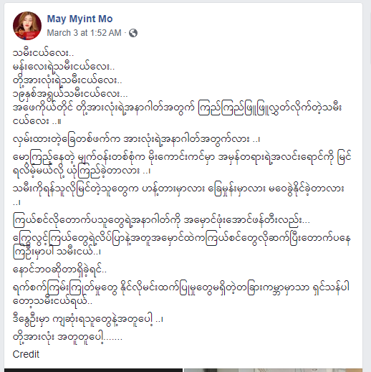

[**https://www.facebook.com/7daynews/posts/4114181548643448**](https://www.facebook.com/7daynews/posts/4114181548643448)

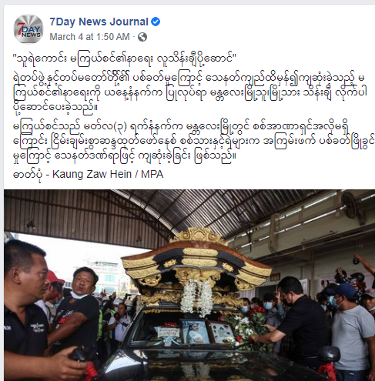

[**https://www.youtube.com/watch?v=9tB3XPoWCBo**](https://www.youtube.com/watch?v=9tB3XPoWCBo)

