A Local 9B Coding Agent
Passed 92 Verified
Terminal-Bench Attempts
Villani Code drove Qwen3.5-9B through the complete Terminal-Bench 2.0 suite and landed accepted work across real terminal environments. The local-agent era has started.
92 verifier-accepted completions. Eight tasks conquered on every run. Thirty-one tasks breached successfully. This is a local 9B model executing work and passing hard verification.

89  Terminal-Bench tasks | 445  Clean scored attempts | 92  Accepted completions
20.67%  Full-suite success rate | 31  Tasks successfully breached | 8  Tasks conquered 5/5

1. The result
Villani Code was evaluated with a local Qwen3.5-9B backend across all 89 Terminal-Bench 2.0 tasks. Each task received five scored attempts. The clean evaluation contains 445 attempts and 92 verifier-accepted completions.
A nine-billion-parameter local model completed hard terminal work at scale under objective verification.
The fixed protocol uses five attempts per task. One duplicated extra five-attempt qemu-startup record was removed from the raw archive, leaving the clean 445-attempt result.

2. Leaderboard position
At 20.67%, Villani Code + Qwen3.5-9B slots into #126 on the current Terminal-Bench 2.0 leaderboard, above Gemini CLI + Gemini 2.5 Pro and Bash Agent + TermiGen-32B.
The public little-coder + Qwen3.5-9B entry scores 9.2%. Villani reaches 20.67% on the same model class: 2.25x the score.
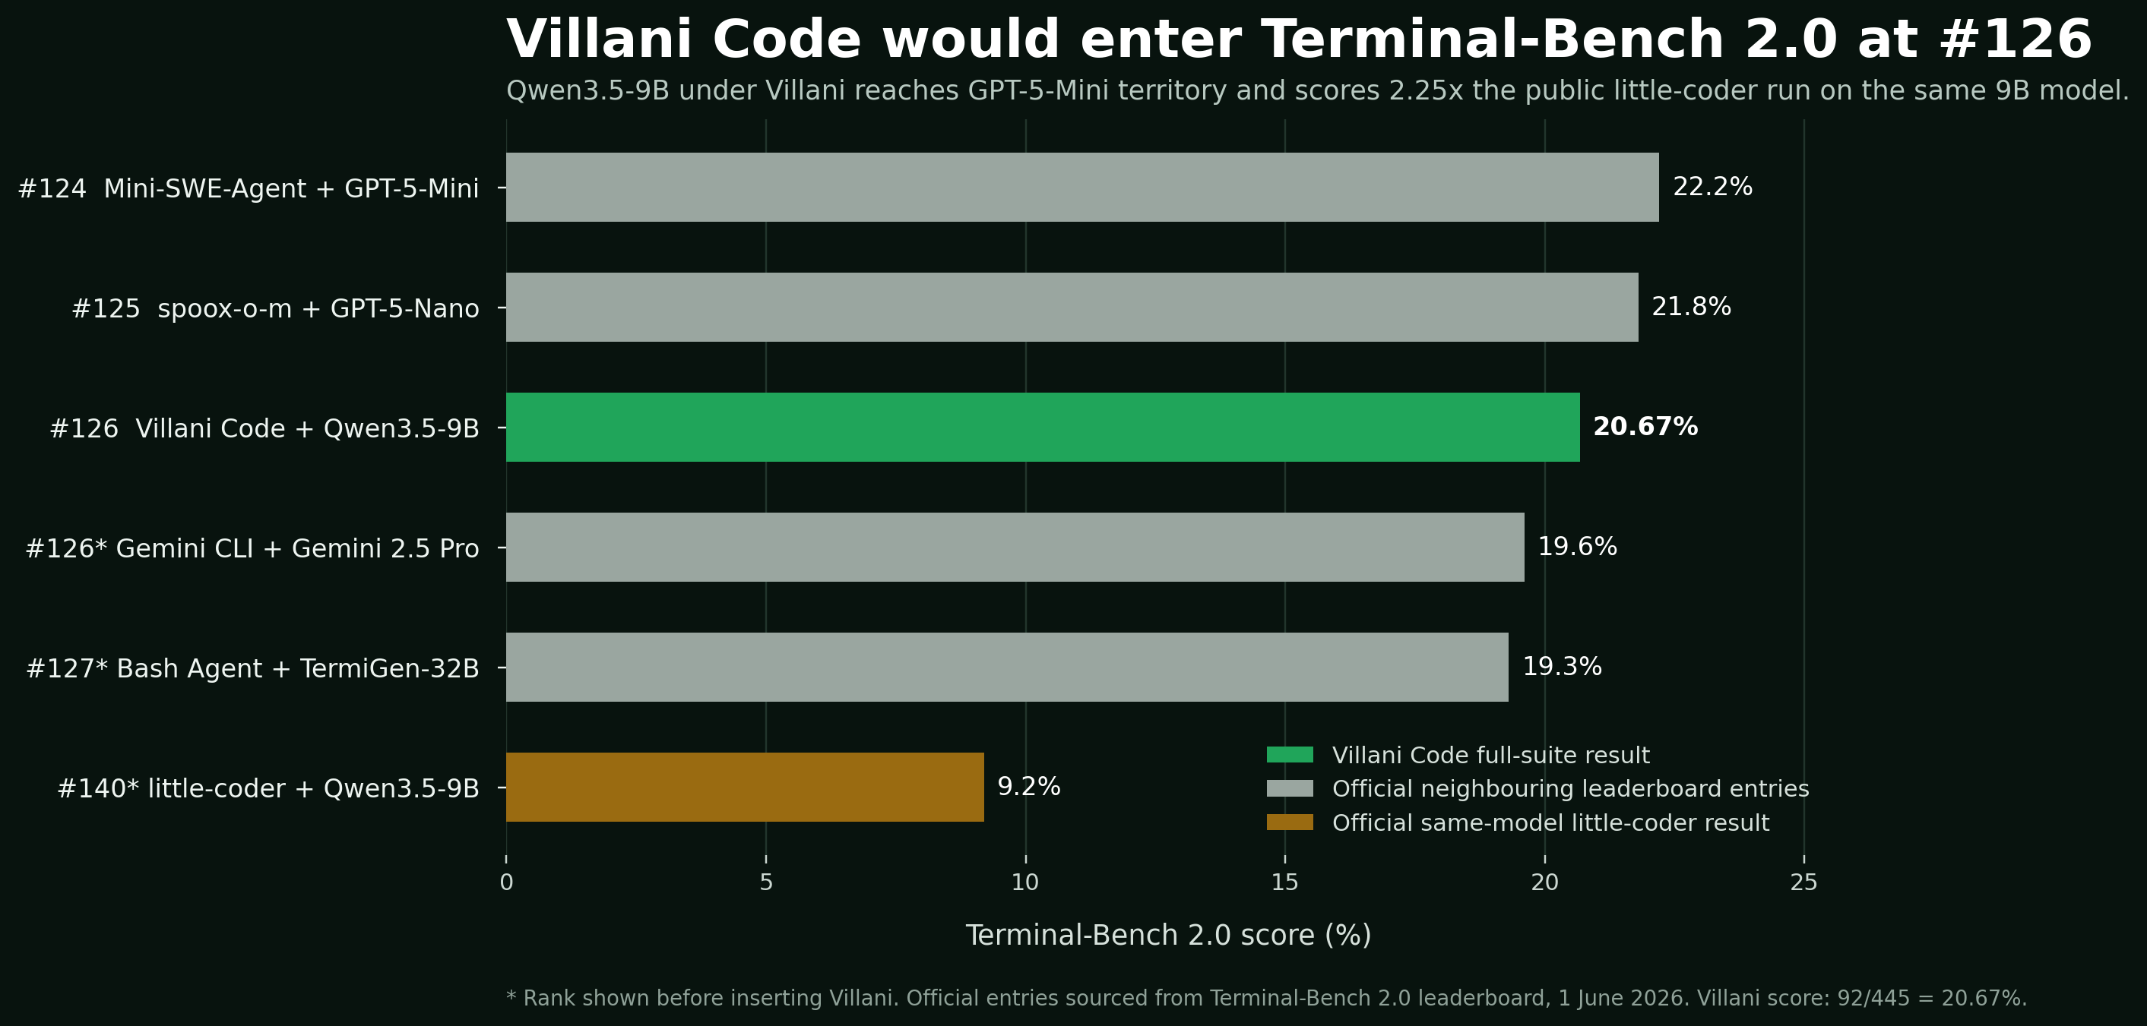
Figure 1. Villani Code inserted into the current Terminal-Bench 2.0 ranking beside its nearest official entries and the public same-model little-coder result.
Position | Agent + model | Score
#124 | Mini-SWE-Agent + GPT-5-Mini | 22.2%
#125 | spoox-o-m + GPT-5-Nano | 21.8%
#126 | Villani Code + Qwen3.5-9B | 20.67%
#126 before insertion | Gemini CLI + Gemini 2.5 Pro | 19.6%
#127 before insertion | Bash Agent + TermiGen-32B | 19.3%
#140 before insertion | little-coder + Qwen3.5-9B | 9.2%
Official leaderboard entries sourced from Terminal-Bench 2.0 on 1 June 2026. Villani position is calculated by inserting its 92/445 full-suite score into the published ranking.

3. Proven repeatable wins
Villani established a real repeatable capability zone. Eight tasks were solved on all five attempts. Ten more were solved on three or four attempts. These are repeated verifier passes.

Conquered on every attempt
Task | Passes | Rate
cobol-modernization | 5/5 | 100%
fix-git | 5/5 | 100%
git-leak-recovery | 5/5 | 100%
merge-diff-arc-agi-task | 5/5 | 100%
modernize-scientific-stack | 5/5 | 100%
openssl-selfsigned-cert | 5/5 | 100%
portfolio-optimization | 5/5 | 100%
prove-plus-comm | 5/5 | 100%

Majority-success tasks
Task | Passes | Rate
configure-git-webserver | 4/5 | 80%
multi-source-data-merger | 4/5 | 80%
build-pmars | 3/5 | 60%
cancel-async-tasks | 3/5 | 60%
count-dataset-tokens | 3/5 | 60%
fix-ocaml-gc | 3/5 | 60%
log-summary-date-ranges | 3/5 | 60%
nginx-request-logging | 3/5 | 60%
tune-mjcf | 3/5 | 60%
vulnerable-secret | 3/5 | 60%

The success pattern is clear: compact local agents can already finish bounded repo repair, modernization, concrete terminal configuration and exact verifier-driven work.
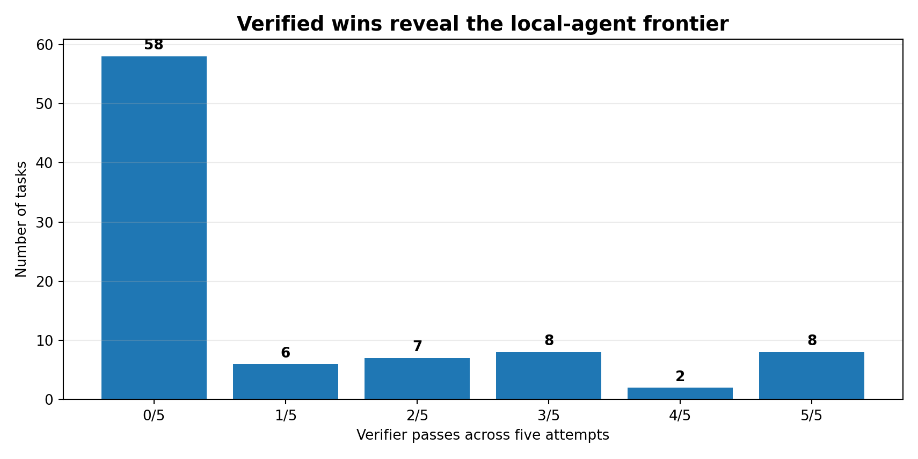
Figure 2. Villani's verified frontier across the complete task set.

4. The next attack surface
Fifty-eight tasks were unbeaten in this run. Thirteen were breached once or twice. This is the next attack surface: systems work, complex builds, data and model operations, long-horizon environment control, and tasks where one execution error kills the entire run.
The path forward is direct. Instrument the failed runs, identify the recurring execution collapses, and turn the first frontier breaches into repeated verifier passes. Every converted task expands the area where local models can replace heavier systems.

The engineering campaign should target command wandering, incomplete patch trajectories, missed artifacts, weak verification recovery and strategy changes for tasks that defeat the current execution loop.

5. What Villani Code is building
Villani Code is a local-first terminal agent runtime built to make compact models finish real software engineering work. Its standard is deliberately unforgiving: a run only counts when the benchmark verifier accepts it.
- Local-first execution: the model and code stay under operator control.
- Terminal-native action: files, commands, diffs, tests and repository state drive the loop.
- Verifier-led iteration: results are measured in accepted completions.
- Failure-driven progress: every unbeaten task creates a concrete engineering target.
Villani Code is building the runtime layer that makes local coding agents formidable.

6. Protocol
Item | Value
Benchmark | Terminal-Bench 2.0
Backend model | Qwen3.5-9B
Agent runtime | Villani Code
Task count | 89
Attempts per task | 5
Acceptance rule | Benchmark verifier pass
Clean score | 92/445 accepted completions (20.67%)

Appendix: complete task-level outcome map
Five clean scored attempts per task. The duplicated extra qemu-startup records are excluded from the fixed-protocol result.

Conquered: 5/5
Task | Passes | Rate
cobol-modernization | 5/5 | 100%
fix-git | 5/5 | 100%
git-leak-recovery | 5/5 | 100%
merge-diff-arc-agi-task | 5/5 | 100%
modernize-scientific-stack | 5/5 | 100%
openssl-selfsigned-cert | 5/5 | 100%
portfolio-optimization | 5/5 | 100%
prove-plus-comm | 5/5 | 100%

Majority successes: 3/5 to 4/5
Task | Passes | Rate
configure-git-webserver | 4/5 | 80%
multi-source-data-merger | 4/5 | 80%
build-pmars | 3/5 | 60%
cancel-async-tasks | 3/5 | 60%
count-dataset-tokens | 3/5 | 60%
fix-ocaml-gc | 3/5 | 60%
log-summary-date-ranges | 3/5 | 60%
nginx-request-logging | 3/5 | 60%
tune-mjcf | 3/5 | 60%
vulnerable-secret | 3/5 | 60%

Frontier breaches: 1/5 to 2/5
Task | Passes | Rate
constraints-scheduling | 2/5 | 40%
hf-model-inference | 2/5 | 40%
mcmc-sampling-stan | 2/5 | 40%
overfull-hbox | 2/5 | 40%
pypi-server | 2/5 | 40%
query-optimize | 2/5 | 40%
sqlite-with-gcov | 2/5 | 40%
fix-code-vulnerability | 1/5 | 20%
git-multibranch | 1/5 | 20%
largest-eigenval | 1/5 | 20%
pytorch-model-cli | 1/5 | 20%
rstan-to-pystan | 1/5 | 20%
sanitize-git-repo | 1/5 | 20%

Next attack surface: 0/5
Task | Passes | Task | Passes
adaptive-rejection-sampler | 0/5 | mailman | 0/5
bn-fit-modify | 0/5 | make-doom-for-mips | 0/5
break-filter-js-from-html | 0/5 | make-mips-interpreter | 0/5
build-cython-ext | 0/5 | model-extraction-relu-logits | 0/5
build-pov-ray | 0/5 | mteb-leaderboard | 0/5
caffe-cifar-10 | 0/5 | mteb-retrieve | 0/5
chess-best-move | 0/5 | password-recovery | 0/5
circuit-fibsqrt | 0/5 | path-tracing | 0/5
code-from-image | 0/5 | path-tracing-reverse | 0/5
compile-compcert | 0/5 | polyglot-c-py | 0/5
crack-7z-hash | 0/5 | polyglot-rust-c | 0/5
custom-memory-heap-crash | 0/5 | protein-assembly | 0/5
db-wal-recovery | 0/5 | pytorch-model-recovery | 0/5
distribution-search | 0/5 | qemu-alpine-ssh | 0/5
dna-assembly | 0/5 | qemu-startup | 0/5
dna-insert | 0/5 | raman-fitting | 0/5
extract-elf | 0/5 | regex-chess | 0/5
extract-moves-from-video | 0/5 | regex-log | 0/5
feal-differential-cryptanalysis | 0/5 | reshard-c4-data | 0/5
feal-linear-cryptanalysis | 0/5 | sam-cell-seg | 0/5
filter-js-from-html | 0/5 | schemelike-metacircular-eval | 0/5
financial-document-processor | 0/5 | sparql-university | 0/5
gcode-to-text | 0/5 | sqlite-db-truncate | 0/5
gpt2-codegolf | 0/5 | torch-pipeline-parallelism | 0/5
headless-terminal | 0/5 | torch-tensor-parallelism | 0/5
install-windows-3-11 | 0/5 | train-fasttext | 0/5
kv-store-grpc | 0/5 | video-processing | 0/5
large-scale-text-editing | 0/5 | winning-avg-corewars | 0/5
llm-inference-batching-scheduler | 0/5 | write-compressor | 0/5

Evidence and protocol
System: Villani Code. Backend: Qwen3.5-9B through a local endpoint. Benchmark: Terminal-Bench 2.0. Tasks: 89. Attempts: 5 per task. Acceptance: benchmark verifier pass. Clean score: 92 accepted attempts out of 445.

