**Hive Interview Questions And Answers**

1. Difference between Data warehouse and database?

Data Warehouses and Databases are both important components of data management, but they serve different purposes and have distinct characteristics. Here are the key differences between them:

Purpose:

Database: Databases are designed for efficient data storage, retrieval, and management. They are used for transactional processing, which involves adding, updating, and deleting data. Databases are typically used for day-to-day operations of an organisation.

Data Warehouse: Data Warehouses are designed for collecting, organising, and storing large volumes of historical data from various sources. They are used for analytical processing, reporting, and data analysis to support business intelligence and decision-making.

Data Structure:

Database: Databases are typically designed to store structured data, which has a well-defined schema and is optimised for quick retrieval of specific pieces of information.

Data Warehouse: Data Warehouses store structured, semi-structured, and unstructured data. They often incorporate data from multiple sources and transform it into a common format for analysis.

Schema:

Database: Databases use a schema that defines the structure and relationships of the data. Changes to the schema can be complex and may require downtime.

Data Warehouse: Data Warehouses often use a dimensional or star schema, which is optimised for query performance and reporting. The schema can evolve more easily to accommodate changing business needs.

Query and Reporting:

Database: Databases are designed for transactional processing and provide fast access to individual records. They are not optimised for complex analytical queries.

Data Warehouse: Data Warehouses are optimised for complex analytical queries and reporting. They allow aggregations, filtering, and transformation of data to generate insights.

Data Volume:

Database: Databases are suitable for handling relatively small to moderate amounts of data, suitable for day-to-day operational needs.

Data Warehouse: Data Warehouses are designed to handle large volumes of historical data, often containing years of data from multiple sources.

Latency:

Database: Databases prioritise low-latency access to data and real-time processing.

Data Warehouse: Data Warehouses prioritise batch processing and might have higher query latency, as the emphasis is on analysing historical data.

Data Integration:

Database: Databases are typically isolated and not designed to integrate data from multiple sources.

Data Warehouse: Data Warehouses integrate data from various sources, including databases, external systems, and data streams.

Storage:

Database: Databases use efficient storage mechanisms like B-trees to store data, which is optimised for read and write operations.

Data Warehouse: Data Warehouses use columnar storage to optimise queries and compress data, which reduces storage costs.

Usage:

Database: Databases are used for OLTP (Online Transaction Processing) systems, which involve daily business operations.

Data Warehouse: Data Warehouses are used for OLAP (Online Analytical Processing) systems, which support decision-making and reporting.

In summary, while databases are focused on real-time transactional processing and efficient data retrieval, data warehouses are designed for historical data storage, analysis, and reporting. They are complementary and serve different roles in an organisation's data ecosystem. Many organisations use both databases and data warehouses to meet their various data management needs.

2. Difference between Data warehouse and data mart?

Data Warehouses and Data Marts are both data storage and management solutions, but they serve different purposes and have distinct characteristics. Here are the key differences between them:

* Scope:
  + Data Warehouse: A Data Warehouse is a central repository that stores and manages large volumes of historical data from various sources across an entire organisation. It serves as a comprehensive and integrated store of data for various purposes, including reporting and analytics.
  + Data Mart: A Data Mart is a subset of a Data Warehouse. It focuses on a specific department, business unit, or functional area within an organisation. Data Marts are designed to meet the needs of a particular group of users, making them more specialised and targeted.
* Data Focus:
  + Data Warehouse: Data Warehouses typically contain data from multiple areas and functions of the organisation. They consolidate and integrate data from various sources to support enterprise-wide reporting and analysis.
  + Data Mart: Data Marts are tailored to the specific needs of a department or team. They store data relevant to a particular business function, making it easier for that department to access and analyse their data.
* Schema:
  + Data Warehouse: Data Warehouses often use a centralised and unified data model, such as a star or snowflake schema. These schemas facilitate cross-functional analysis by providing a common structure for all data.
  + Data Mart: Data Marts may use a schema that is specific to the needs of the department or group it serves. The schema can be designed to optimise performance for the types of queries that are common within that area.
* Data Integration:
  + Data Warehouse: Data Warehouses integrate data from various sources across the entire organisation. They ensure data consistency, quality, and uniformity.
  + Data Mart: Data Marts are focused on a specific business function, and they may integrate a subset of the data from the Data Warehouse. This can lead to quicker deployment and reduced complexity.
* Data Volume:
  + Data Warehouse: Data Warehouses handle large volumes of historical data from all areas of the organisation.
  + Data Mart: Data Marts store a smaller subset of data, which is relevant to a particular department's needs. They may contain less data than the Data Warehouse.
* User Access:
  + Data Warehouse: Data Warehouses are used by users from various departments and functions for enterprise-wide analysis and reporting.
  + Data Mart: Data Marts are typically designed for the specific users within a department or business unit. They cater to the unique needs of those users.
* Performance:
  + Data Warehouse: Data Warehouses are optimised for overall performance and support complex cross-functional queries. They may have higher storage and processing capabilities.
  + Data Mart: Data Marts are optimised for the specific queries and reporting needs of a particular group. They may have smaller data volumes, which can lead to faster query performance.

In summary, Data Warehouses are comprehensive data storage solutions that serve the entire organisation, while Data Marts are smaller, specialised subsets of data focused on meeting the needs of specific departments or business units. Data Warehouses provide a centralised view of the data, while Data Marts provide decentralised, department-specific views. Many organisations use a combination of both to balance enterprise-wide data needs with departmental requirements.

3. Why is hive metadata stored in SQL?

Hive, a data warehousing and SQL-like query language tool for Hadoop, uses a relational database, often referred to as the Hive Metastore, to store its metadata. There are several reasons for storing Hive metadata in an SQL-based database:

* **Efficient Query Planning:** Storing metadata in an SQL database enables efficient query planning. When you submit a Hive query, the metadata is consulted to optimise the query execution plan. This includes determining the location of data, how data is partitioned, and which files need to be read. SQL databases are well-suited for indexing and querying metadata efficiently.
* **Standardisation:** By using SQL for metadata storage, Hive adheres to a widely adopted and standardised query language. This makes it easier to interact with and manage metadata using standard SQL commands and tools.
* **Scalability:** SQL databases are known for their scalability and ability to handle a large number of records efficiently. Hive is often used for processing vast amounts of data, and an SQL database can manage the associated metadata effectively.
* **Security and Access Control:** SQL databases provide robust security and access control mechanisms. Hive can leverage these features to ensure that only authorised users and services can access and modify the metadata.
* Concurrency and Locking: SQL databases offer built-in support for concurrency control, transactions, and locking mechanisms. This is crucial in a multi-user environment like Hive, where multiple users may be concurrently running queries or modifying metadata.
* **Metadata Consistency:** SQL databases are ACID-compliant (Atomicity, Consistency, Isolation, Durability), which ensures that metadata updates are transactionally consistent. This consistency is vital to maintain the integrity of metadata in Hive.
* **Compatibility with Ecosystem:** The choice of using an SQL database for metadata storage aligns well with other components in the Hadoop ecosystem. Hive metadata can be easily integrated with tools like Apache Ranger, Apache Sentry, and Apache Atlas, which provide security and governance capabilities for Hadoop-based systems.
* **Data Independence:** Storing metadata in a separate SQL database allows for data independence. You can manage and maintain metadata separately from the data files, making it easier to perform tasks like metadata backups and recovery.

While SQL databases are commonly used for Hive metadata storage, it's worth noting that Hive also supports multiple storage backends for its metadata. You can configure Hive to use different databases like Apache Derby, MySQL, PostgreSQL, or Oracle as the Hive Metastore depending on your organisation's requirements and preferences.

4. Which SQL is the default database for hive?

The default database for storing metadata in Hive is Apache Derby. When you set up Hive without specifying a different database for the Hive Metastore, it typically uses Apache Derby as the embedded database for managing metadata. Apache Derby is a lightweight, Java-based relational database that comes bundled with Hive.

While Apache Derby is the default choice, you have the flexibility to configure Hive to use other relational databases like MySQL, PostgreSQL, Oracle, or Microsoft SQL Server for the Hive Metastore, depending on your organisation's requirements and preferences. The choice of the database can be influenced by factors such as scalability, performance, and compatibility with your existing data infrastructure.

5. What is a managed table?

In the context of Apache Hive or other similar data warehouse systems, a managed table is a type of table that is associated with a managed schema and storage. Here are the key characteristics of a managed table:

* **Storage Location:** Managed tables have their data stored in a location managed by the data warehouse system itself. This means the system takes care of storing and organising the data files on your behalf. The storage location is typically in a directory or a specific file system within the data warehouse.
* **Schema Management:** The schema (structure) of a managed table is managed by the data warehouse system. When you create a managed table, the system creates metadata to describe the table's structure, including column names, data types, and constraints. This metadata is stored in the data warehouse's catalogue or metastore.
* **Ease of Use:** Managed tables are designed for ease of use. They are ideal for users who want a simple way to create, query, and manage data without needing to handle low-level storage details or write custom data management scripts.
* **Data Integrity:** Data integrity and consistency are often better maintained in managed tables because the data warehouse system enforces schema constraints, such as data types and column constraints.
* **Backup and Recovery:** Managed tables are typically easier to back up and recover because the data and metadata are stored in a controlled and known location.
* Data Lifecycle Management: Managed tables often have better support for data lifecycle management, including features like automatic data retention policies and data purging.

Managed tables are well-suited for scenarios where you want a simplified data management experience and are willing to rely on the data warehouse system to handle storage, schema management, and some aspects of data governance. They are commonly used for operational and analytical workloads where data consistency, ease of use, and integrated data management are important.

In contrast to managed tables, there are also "external tables" in Hive and similar systems. External tables do not manage the storage location, and users are responsible for specifying the storage path and managing the data files themselves. External tables provide more flexibility but require users to handle more aspects of data management.

6. What is an external table?

An external table, in the context of data management systems like Apache Hive, is a table that is associated with data stored in an external location, typically outside of the system's control or management. Here are the key characteristics of an external table:

* **External Data Location:** The data for an external table is not stored in a location managed by the data management system itself. Instead, it resides in an external location, such as a directory in a distributed file system (e.g., HDFS), a cloud storage service (e.g., AWS S3, Azure Blob Storage), or an external database.
* **No Data Movement:** Unlike managed tables, where data is physically moved and managed by the system, external tables do not physically move or copy the data into the system. The data remains in its original location, and the table's metadata references the external data.
* **Schema Management:** The schema (structure) of an external table is managed by the data management system, similar to managed tables. Users define the schema, including column names, data types, and constraints, and this metadata is stored in the system's catalogue or metastore.
* **Data Independence:** External tables provide data independence. Users can query and manipulate the data without worrying about the underlying storage details. This is particularly useful when you have data stored in various external sources, and you want to query it without moving or duplicating it.
* **Flexibility:** External tables are often used in scenarios where data may change frequently in the external location or when you want to integrate data from different sources. They offer flexibility in terms of data sources and locations.
* **Data Control:** Since the data is not under the system's control, users are responsible for ensuring the data's quality, access control, and organisation in the external location.
* **Data Format:** External tables can work with various data formats, including text, Parquet, ORC, Avro, and more, depending on the system's capabilities.

External tables are commonly used in situations where you want to query or analyse data without needing to move or replicate it into the system's storage. They are especially useful when dealing with data that originates from different systems or when you need to analyse data residing in distributed storage, cloud platforms, or other external data sources.

It's important to note that while external tables provide flexibility, they require users to manage the data's location, access permissions, and organisation. They are often used for scenarios where data governance and control are the responsibility of the data owner or source system.

7. When do we use an external table?

An external table, in the context of data management systems like Apache Hive, is a table that is associated with data stored in an external location, typically outside of the system's control or management. Here are the key characteristics of an external table:

* **External Data Location:** The data for an external table is not stored in a location managed by the data management system itself. Instead, it resides in an external location, such as a directory in a distributed file system (e.g., HDFS), a cloud storage service (e.g., AWS S3, Azure Blob Storage), or an external database.
* No Data Movement: Unlike managed tables, where data is physically moved and managed by the system, external tables do not physically move or copy the data into the system. The data remains in its original location, and the table's metadata references the external data.
* **Schema Management:** The schema (structure) of an external table is managed by the data management system, similar to managed tables. Users define the schema, including column names, data types, and constraints, and this metadata is stored in the system's catalogue or metastore.
* **Data Independence:** External tables provide data independence. Users can query and manipulate the data without worrying about the underlying storage details. This is particularly useful when you have data stored in various external sources, and you want to query it without moving or duplicating it.
* **Flexibility:** External tables are often used in scenarios where data may change frequently in the external location or when you want to integrate data from different sources. They offer flexibility in terms of data sources and locations.
* Data Control: Since the data is not under the system's control, users are responsible for ensuring the data's quality, access control, and organisation in the external location.
* **Data Format:** External tables can work with various data formats, including text, Parquet, ORC, Avro, and more, depending on the system's capabilities.

External tables are commonly used in situations where you want to query or analyse data without needing to move or replicate it into the system's storage. They are especially useful when dealing with data that originates from different systems or when you nee

It's important to note that while external tables provide flexibility, they require users to manage the data's location, access permissions, and organisation. They are often used for scenarios where data governance and control are the responsibility of the data owner or source system.d to analyse data residing in distributed storage, cloud platforms, or other external data sources.

8. Diff between managed and external tables?

Managed tables and external tables are two different approaches to managing data in a data management system like Apache Hive. Here are the key differences between managed tables and external tables:

**Managed Tables:**

* **Data Storage:** Managed tables store data in a location controlled and managed by the data management system itself. The system is responsible for physically storing and organising the data in a location defined by the system.
* **Data Movement:** When data is loaded into a managed table, it is often copied or moved into the system's storage location. The system takes care of data ingestion, storage, and organisation.
* **Schema Management:** The schema (structure) of a managed table is managed by the data management system. Users define the schema, including column names, data types, and constraints, and the system enforces it.
* **Data Independence:** Managed tables offer data independence. Users interact with the data without needing to worry about its physical location or storage format.
* **Data Governance:** Managed tables provide a higher level of data governance and control as the system manages and enforces schema and data consistency.
* **Backup and Recovery:** Data backup and recovery are typically easier for managed tables since the data and metadata are within the system's control.
* **Performance Optimization:** Managed tables are optimised for performance as the system can control the data layout and organisation.

**External Tables:**

* **Data Storage:** External tables reference data stored in an external location, often outside the control of the data management system. The data remains in its original external location.
* **Data Movement:** Data is not moved or copied into the data management system when using external tables. It stays in the original location.
* **Schema Management:** The schema of an external table is managed by the data management system. Users define the schema, including column names, data types, and constraints, and the system enforces it.
* **Data Independence:** External tables provide data independence, allowing users to interact with data without having to manage its physical location.
* **Data Governance:** Data governance and control are often the responsibility of the data owner or the source system since the data remains external.
* **Data Backup and Recovery:** Backup and recovery for external tables may require separate mechanisms for the external data location. The system manages the metadata but not the data files.
* **Data Performance:** External tables might have slightly different performance characteristics, as the system does not control the organisation of the external data. Query performance can vary based on the external data format and location.

The choice between managed tables and external tables depends on your specific use case and requirements. Managed tables provide more control, performance optimization, and data governance but often require data movement into the system. External tables offer flexibility and data independence, making them suitable for scenarios where data is distributed across different sources or locations.

9. What happens if you don’t provide a location to an external table?

When you create an external table and do not provide a specific location for the table, the behaviour can vary depending on the data management system you are using (e.g., Hive, Spark SQL, or another system). However, in many systems, if you don't specify a location for an external table, the system will assume a default location or use a location provided during system configuration. Here are some possible outcomes:

* **Use of Default Location:** The system may use a default location for external tables, which is predefined in its configuration. This default location is typically a system-defined directory or storage location.
* **Use of Current Working Directory:** In some systems, if a location is not specified, the table might default to using the current working directory of the user or process that creates the table.
* **Configuration-Based Default:** The system may rely on configuration settings to determine the default location. The default location could be specified in system configuration files.
* **Error or Rejection:** Some systems may require a location to be explicitly specified, and if you don't provide a location, it might result in an error or rejection of the table creation request.

It's essential to consult the documentation or guidelines specific to the data management system you are using to understand how it handles the absence of a location when creating an external table. Providing an explicit location is often a best practice to ensure that the data is stored in the intended location and to avoid any unexpected behaviour.

10. Performance optimization in hive?

Performance optimization in Apache Hive, a data warehousing and SQL-like query tool for big data, is essential to ensure that queries and data processing tasks are executed efficiently. Here are some best practices and strategies for optimising performance in Hive:

* **Table Design:**
  + **Use Appropriate Storage Formats:** Choose storage formats like Parquet, ORC, or Avro, which are columnar and offer better compression and query performance.
  + **Partitioning:** Partition tables based on columns frequently used in WHERE clauses. This reduces the amount of data scanned during queries.
  + **Bucketing:** Bucketing divides data into smaller, evenly distributed files, improving query performance on join operations.
* **Data Cleansing and Transformation:**
  + Clean and transform data during the ETL (Extract, Transform, Load) process to reduce the need for complex transformations during query execution.
* Statistics:
  + Gather statistics on tables to help the query optimizer make better execution plans. Use the ANALYZE TABLE command to collect statistics.
* Caching and Indexing:
  + Enable query caching to store intermediate results and avoid re-computation of the same query.
  + Use index tables to speed up lookups on frequently filtered columns. Hive supports bitmap indexes for this purpose.
* Vectorization:
  + Enable vectorized query execution, which processes data in batches (vectors) and can significantly improve query performance. You can set hive.vectorized.execution.enabled to true.
* Predicate Pushdown:
  + Hive supports predicate pushdown, where filters are pushed down to storage files. Ensure that predicate pushdown is enabled for the storage format you are using.
* Cost-Based Optimization:
  + Enable cost-based optimization by setting hive.cbo.enable to true. Cost-based optimization can lead to better query plans.
* Parallel Execution:
  + Configure the level of parallelism for query execution by setting parameters like mapreduce.job.reduces or hive.exec.reducers.bytes.per.reducer. This depends on the size of your data and cluster resources.
* Cluster Sizing:
  + Scale your cluster resources according to your data volume and query workload. Ensure that you have enough resources to handle the query load efficiently.
* Tez and LLAP:
  + Consider using execution engines like Tez or Hive's LLAP (Live Long and Process) for faster query execution, especially for complex queries.
* **Optimised Joins:**
  + Use appropriate join types (e.g., broadcast join for small tables, map join) and use the DISTRIBUTE BY clause when joining to reduce data shuffling.
* **Memory Management:**
  + Adjust the memory allocation for Tez or MapReduce tasks, taking into account the available cluster resources.
* **Dynamic Partition Pruning:**
  + Leverage dynamic partition pruning for partitioned tables to eliminate unnecessary partitions during query execution.
* **Connection Pools:**
  + Use connection pools to manage the number of concurrent JDBC connections for metastore access.
* **Data Compression:**
  + Choose appropriate data compression methods for your storage format to reduce storage space and improve I/O performance.
* **Data Skew Handling:**
  + Address data skew issues by distributing data evenly, using custom scripts, or using the DISTRIBUTE BY clause.
* **Cache Lookup Tables:**
  + Cache small lookup tables in memory to avoid redundant table scans during query execution.
* **Sessionization and Vectorization:**
  + Use sessionization and vectorization techniques for specific use cases, such as time-series data analysis.
* **Monitoring and Tuning:**
  + Continuously monitor query performance using tools like Ambari, Hue, or external monitoring solutions. Use query profiling to identify bottlenecks and make adjustments as needed.
* **Data Pruning and Archiving:**
  + Implement data pruning and archiving strategies to remove or move outdated data, reducing the volume of data to be processed.

Performance optimization in Hive is an ongoing process that involves a combination of best practices, cluster tuning, query optimization, and the selection of appropriate storage formats and execution engines. Regular monitoring and analysis of query performance are essential to maintain optimal performance in a changing data environment.

11. Explain the partition table. Give example

A partitioned table is a database table that is divided into smaller, more manageable segments called partitions based on the values in one or more columns. This organisation helps improve query performance and makes it easier to manage and maintain large datasets. Partitioning is commonly used in data warehousing systems, like Hive, to efficiently handle vast amounts of data.

Let's explore the concept of a partitioned table with an example:

Suppose you have a table called "sales_data" that stores information about sales transactions. The table has columns for "order_date," "product," and "sales_amount." It might look like this:

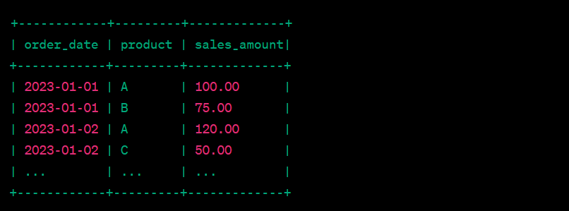

To optimise query performance and manage this data more efficiently, you can create a partitioned table based on the "order_date" column. Here's how it works:

* Partitioning Key: In this case, "order_date" is the partitioning key, and each unique date value will become a partition. Partitioning can be done on a single column or a combination of columns.
* Directory Structure: The data is physically organised into separate directories or subfolders based on the partitioning key. Each partition contains records with the same "order_date."
* Example Directory Structure:

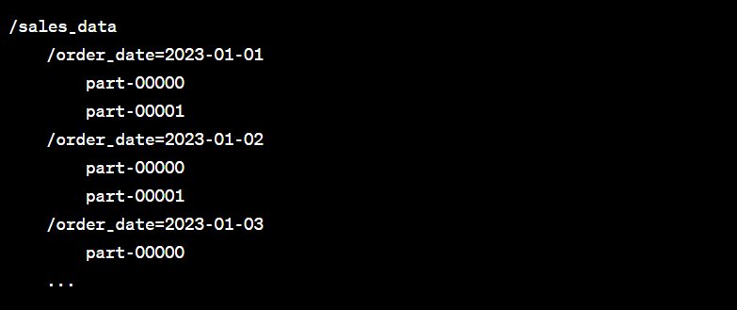

Now, when you run queries on this partitioned table, the database system can intelligently access only the partitions that are relevant to the query, reducing the amount of data that needs to be scanned. This significantly improves query performance, especially when working with large datasets.

With partitioning, you can easily perform tasks like:

* Retrieving all sales data for a specific date or date range.
* Aggregating sales data for a specific date range.
* Filtering data for a particular product within a specific date range.

Partitioning is a powerful technique for managing and querying large datasets, and it is particularly useful when dealing with time-series data, such as daily, monthly, or yearly records, as shown in this example.

12. Explain bucket table. Give example

A bucketed table is a type of table in a database system, such as Hive, where the data is organised into a fixed number of buckets or partitions based on a specific column's hash value. Bucketing is a technique used to improve query performance, especially when dealing with large datasets. It's particularly beneficial when you need to optimise join operations.

Here's how a bucketed table works with an example:

Suppose you have two tables: "sales_data" and "products." "sales_data" contains sales transactions, including the "order_date," "product_id," and "sales_amount," while "products" contains product information, including "product_id" and "product_name."

sales_data table:

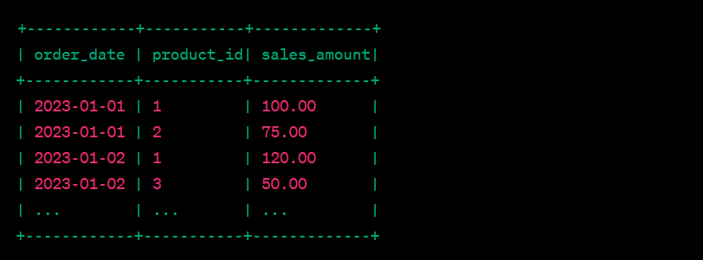

products table:

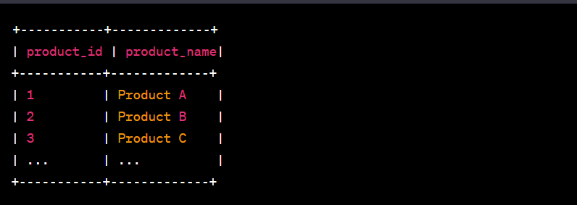

Now, you want to join these two tables on the "product_id" column to get sales data along with product names. If both tables are large, joining them can be a time-consuming operation.

To optimise this join, you can create a bucketed table for both "sales_data" and "products" based on the "product_id" column. Here's how it works:

* Bucketing Key: The "product_id" column serves as the bucketing key. It is used to determine which bucket each row belongs to.
* Bucketing Process: The data is hashed using the values in the "product_id" column to determine which bucket each row should go into. Each bucket contains a subset of data based on the hash value.
* Fixed Number of Buckets: You specify a fixed number of buckets (e.g., 8, 16, or any number) that the data should be distributed into. The goal is to evenly distribute the data across the specified number of buckets.
* Directory Structure: The data is physically stored in files within these buckets.

The directory structure for a bucketed table might look like this:

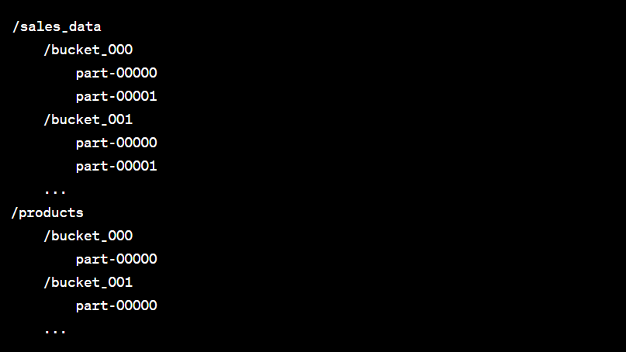

Now, when you perform a join between these bucketed tables on the "product_id" column, the database system can perform the join more efficiently. Each bucket contains a subset of data, and the hash values ensure that matching rows are in the same bucket, reducing the amount of data shuffling and scanning required during the join operation.

Bucketing is a powerful technique for optimising join operations and improving query performance, especially when dealing with large datasets. It's commonly used in data warehousing systems like Hive and can significantly speed up query execution.

13. Diff between partition and bucketed table.

Partitioned tables and bucketed tables are both techniques used in database systems like Hive to optimise data organisation and query performance. However, they serve different purposes and work differently. Here are the key differences between partitioned tables and bucketed tables:

Partitioned Tables:

* **Data Organization:**
  + In a partitioned table, data is divided into separate physical directories or subfolders based on specific column values (the partition key).
* **Partition Key:**
  + A partition key is one or more columns that determine how data is partitioned. Each unique value in the partition key creates a separate partition.
* Data Scanning:
  + Partitions are used to reduce data scanning during query execution. When querying, the database system knows which partition to access based on the query's filter conditions.
* **Data Distribution:**
  + Partitions are ideal for situations where data is naturally divided into categories, such as time-series data, and where you frequently filter data based on the partitioning column.
* **Common Use Cases:**
  + Time-based data partitioning (e.g., by date).
  + Geographic data partitioning (e.g., by country or region).
  + Categorical data partitioning (e.g., by product category).

**Bucketed Tables:**

* **Data Organization:**
  + In a bucketed table, data is divided into a fixed number of buckets or partitions based on a hash of one or more columns (the bucketing key).
* **Bucketing Key:**
  + The bucketing key is typically a single column or a combination of columns used to distribute data evenly across the specified number of buckets.
* **Data Scanning:**
  + Bucketing improves data locality, especially in join operations. Rows with the same hash value for the bucketing key end up in the same bucket, reducing the need for data shuffling during joins.
* **Data Distribution:**
  + Bucketing is useful for optimising join operations and evenly distributing data across a fixed number of partitions.
* **Common Use Cases:**
  + Join-heavy workloads where data shuffling can be a performance bottleneck.
  + Reducing data skew in distributed data processing.

In summary, partitioned tables are used for dividing data into separate directories or subfolders based on specific column values, which is particularly useful for data that naturally falls into distinct categories, like time-based or geographical data. On the other hand, bucketed tables are used for distributing data into a fixed number of buckets based on a hash of one or more columns, which is ideal for optimising join operations and reducing data shuffling. The choice between partitioning and bucketing depends on your specific data and query requirements.

14. How is data distributed among buckets?

Data distribution among buckets in a bucketed table is determined by the hash values of the data in the bucketing column (or columns). Here's how data is distributed among buckets in a bucketed table:

* **Select the Bucketing Key:** You specify one or more columns as the bucketing key when creating a bucketed table. The data in these columns is used to determine the hash value for each row.
* **Hashing Algorithm:** A hashing algorithm is applied to the values in the bucketing key to generate a hash code. This hash code is a numeric value that represents the row's bucket assignment.
* **Number of Buckets:** When creating the bucketed table, you specify the number of buckets you want to use. The hash code is then modulo-divided by the number of buckets, and the remainder determines the bucket assignment. For example, if you have 8 buckets, the remainder of the hash code divided by 8 determines the bucket number (0 to 7).
* **Data Assignment:** Each row in the table is assigned to one of the buckets based on its hash code. Rows with the same hash code will be assigned to the same bucket. The goal is to distribute the data as evenly as possible across the specified number of buckets.
* **Bucket Directory:** The data for each bucket is physically stored in a separate directory or subfolder within the table's location. The directory structure for a bucketed table will have subdirectories corresponding to each bucket, and the data files for each bucket are stored within those subdirectories.
* Efficient Join Operations: When performing join operations between two or more bucketed tables on the same bucketing key, the data distribution ensures that matching rows are likely to be in the same bucket. This reduces the need for data shuffling during join operations and improves query performance.

It's important to note that the even distribution of data among buckets is not always perfect, and there may be some variance in the number of rows in each bucket. However, the goal is to minimise data skew and ensure that the majority of the data is evenly distributed for efficient query processing.

Bucketing is a powerful technique for optimising query performance, particularly in join-heavy workloads where data shuffling can be a performance bottleneck. It's commonly used in data warehousing systems like Apache Hive to speed up query execution.