**Week 1:**

**Assignment 1: Git and Github**

1. How do you initialise a new Git repository named "project1" on your local machine?

Answer: Create a folder on your local machine then open git bash at the location of folder/directory. initialise a new Git repository named "project1" run the command:

git init

“

**mmqas@ITC_Workbook_MQ MINGW64 /i/Solution_Assignments/Project1**

**$ git init**

**Initialized empty Git repository in I:/Solution_Assignments/Project1/.git/**

“

2. How do you add a new file named "index.html" to the "project1" repository?

To add a new file named “index.html”, run the command:

touch index.html

And to check the new created file, run the command:

ls

The final output of both commands is:

“

**mmqas@ITC_Workbook_MQ MINGW64 /i/Solution_Assignments/Project1 (master)**

**$ touch index.html**

**mmqas@ITC_Workbook_MQ MINGW64 /i/Solution_Assignments/Project1 (master)**

**$ ls**

**index.html**

“

3. How do you stage the changes made to "index.html" for committing?

To stage the changes we have to add the file “index.html”. To add run the command:

git add index.html

“

**mmqas@ITC_Workbook_MQ MINGW64 /i/Solution_Assignments/Project1 (master)**

**$ git add index.html**

”

To check the status run command:

git status

“

**$ git status**

**On branch master**

**No commits yet**

**Changes to be committed:**

**(use "git rm --cached <file>..." to unstage)**

**new file: index.html**

“

4. How do you commit the changes made to "index.html" with a commit message of "Add index.html"?

First add some text or some changes in “index.html”. Run the command:

echo “working on week 1 assignment 1” >> index.html

To see the changes run command:

cat index.html

To commit the changes with the commit message “Add index.html” run the command:

git commit -m “Add index.html”

Note: Git bash command line is case sensitive

The final output with git status:

“

**mmqas@ITC_Workbook_MQ MINGW64 /i/Solution_Assignments/Project1 (master)**

**$ git add index.html**

**warning: in the working copy of 'index.html', LF will be replaced by CRLF the next time Git touches it**

**mmqas@ITC_Workbook_MQ MINGW64 /i/Solution_Assignments/Project1 (master)**

**$ git commit -m "Add index.html"**

**[master 9b37cde] Add index.html**

**1 file changed, 1 insertion(+)**

**mmqas@ITC_Workbook_MQ MINGW64 /i/Solution_Assignments/Project1 (master)**

**$ git status**

**On branch master**

**nothing to commit, working tree clean**

”

Before committing any change first add/stage it.

5. How do you view the commit history of the "project1" repository?

To see the commit history run the command:

git log

This command will show all the history of commits done in project.

Output:

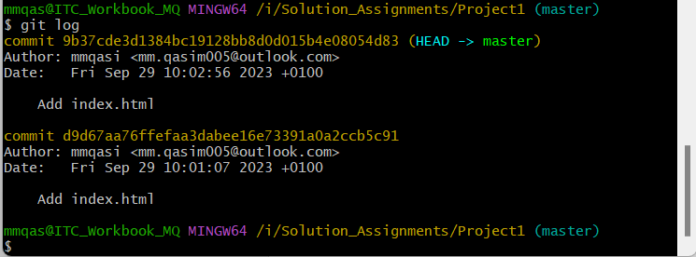

6. How do you create a new branch named "feature-branch" in the "project1" repository?

To create a “Feature branch” run the command:

git branch Feature_branch

To see the new branch created and all available branches run the command:

git branch

Output:

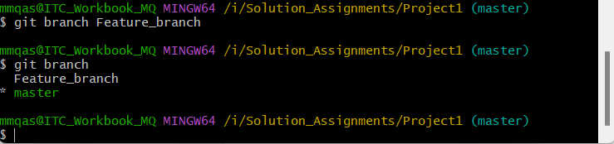

7. How do you switch to the "feature-branch" in the "project1" repository?

To switch to the feature branch run the command:

git checkout Feature_branch

Output:

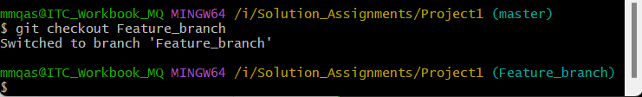

Branch switched to Feature_branch

8. How do you make changes to "index.html" in the "feature-branch"?

To make changes in “index.html”. First change something in the file. Run the command:

echo “Changing in branch Feature_branch” >> index.html

To see the changes in “index.html” run the command:

cat index.html

Output:

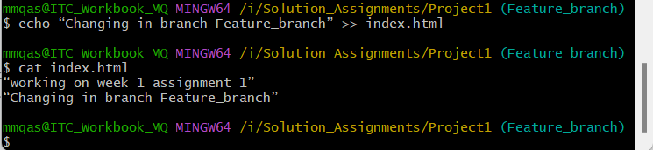

9. How do you stage and commit the changes made in the "feature-branch" with a commit message of "Update index.html in feature branch"?

To commit changes first stage the file/changes. Run the command:

git add index.html

To commit the changes in “Feature_branch”. Run the command:

git commit -m “Update index.html in feature branch”

Output:

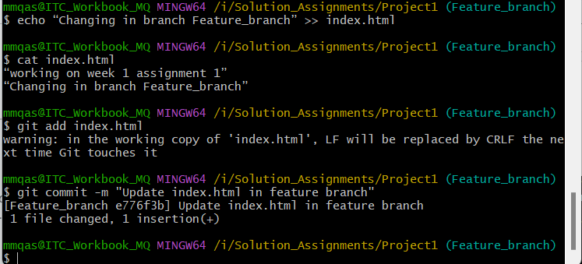

10. How do you switch back to the main branch in the "project1" repository?

To switch to the main branch run the command:

git checkout master

Output:

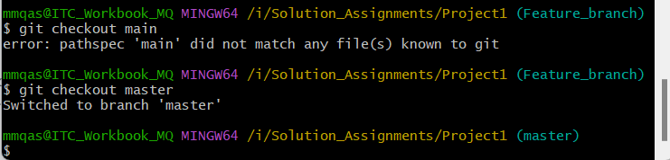

Main branch is master write the branch name “master”

11. How do you merge the changes from the "feature-branch" into the main branch?

To merge the “Feature_branch” to the main branch, run the command:

git merge Feature_branch

Output:

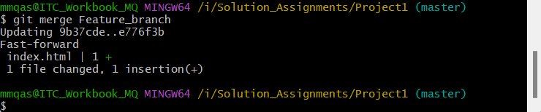

12. How do you resolve any merge conflicts that occur during the merge process?

If the same part of the same file is updated or modified in two different branches then basic merge conflicts do occur. First run the command:

git status

To check the status of merging and mainly the conflicts.

#Copied

Anything that has merge conflicts and hasn’t been resolved is listed as unmerged. Git adds standard conflict-resolution markers to the files that have conflicts, so you can open them manually and resolve those conflicts.

In order to resolve the conflict, you have to either choose one side or the other or merge the contents yourself. For instance, you might resolve this conflict by replacing the entire block with this:

<div id="footer">

please contact us at email.support@github.com

</div>

This resolution has a little of each section, and the <<<<<<<, =======, and >>>>>>> lines have been completely removed. After you’ve resolved each of these sections in each conflicted file, run git add on each file to mark it as resolved. Staging the file marks it as resolved in Git.

If you want to use a graphical tool to resolve these issues, you can run git mergetool, which fires up an appropriate visual merge tool and walks you through the conflicts.

13. How do you view the changes introduced by the merge commit?

Run the command:

git log

Output:

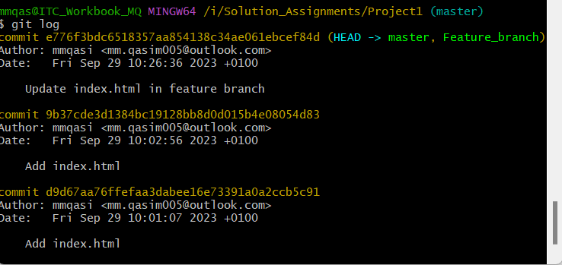

14. How do you create a new tag named "v1.0" for the current commit in the "project1" repository?

To tag the current commit in the “project1” run the command:

git tag v1.0

Output:

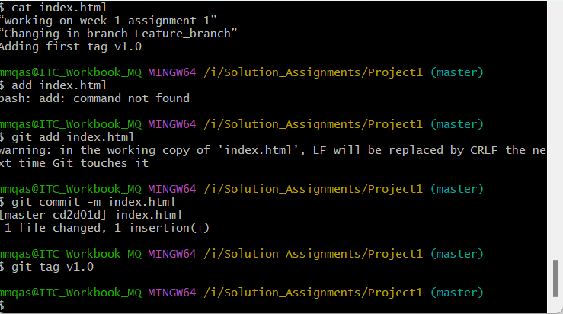

To see the list of tags in git, run the command:

git tag

Output:

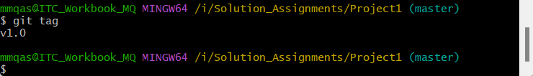

15. How do you push the "project1" repository to a remote repository named "origin"?

To push the “project1” repository to a remote repository named "origin" first create a repository in Github. Then run these two commands:

git remote add origin https://github.com/mmqasi/Origin.git

git push -u origin main

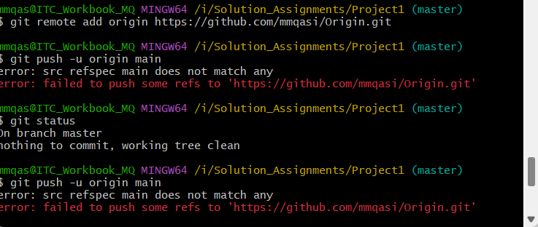

Always first run this command $ git branch -M main before git push -u origin main.

16. How do you clone the "project1" repository from a remote repository to another machine?

To clone a project first go to repository where you want to clone the run the following command:

$ git clone <https://github.com/mmqasi/Origin>

The name of remote repository is “Origin”

Output:

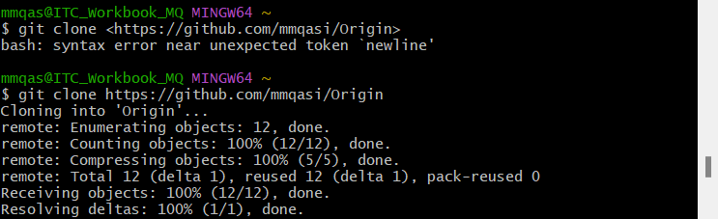

17. How do you fetch the latest changes from the remote repository to your local "project1" repository?

To fetch the latest changes from the remote repository, run the command:

git fetch

Output:

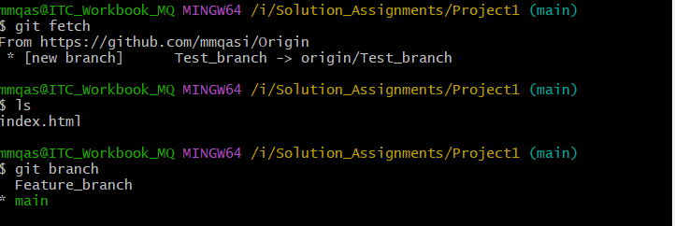

Test branch is not shown in list of branches?

18. How do you pull the latest changes from the remote repository into your current branch in the "project1" repository?

For this run the command:

git pull

Output:

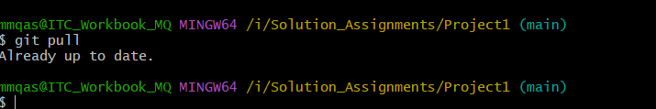

19. How do you create a new branch named "bug-fix" in the "project1" repository based on a specific commit?

For this run the command:

$ git branch bug-fix d9d67aa76ffefaa3dabee16e73391a0a2ccb5c91

Commit hash value that is used for reference of commit is :

D9d67aa76ffefaa3dabee16e73391a0a2ccb5c91

Output:

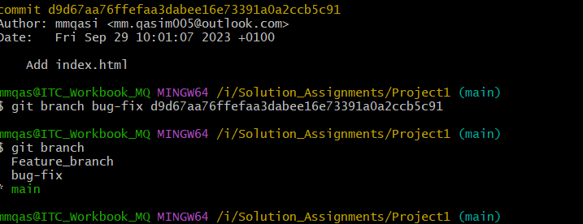

20. How do you revert the last commit made in the "project1" repository?

Use the command:

git revert HEAD

To push the changes that are created at the end then run the following commands.

git push origin main

