Class 7: **class, Properties, Fields Classes 1**

1. Class e always Public Property rakhbo,
2. Private field tokhon e rakhbo jokhon amra kono property customize or logic add korbo.
3. Fild Should Be Private and Property Should be Public, Logic should be implemented in class not in object: MS recommended

Class 8: **Constructor, Constructor Overloading, Method Overloading, Constructor Chaining, Static class, Stacic Method, Non-Static Method**

1. Constructor: Class er Value jokkhon instance banabo, jeta ekta object hobe, oi object er kichu initial value set korai Constructor er kaj. Student class er Name, address, Date of birth
2. Constructor e Obijec inintialze korar pore, Method updates hoi but field update hoi nah.

Code: Program.CS : 40

1. Static Method: Tokhon e use korbo jokhon kono Field er Proyojon Hobe nah.

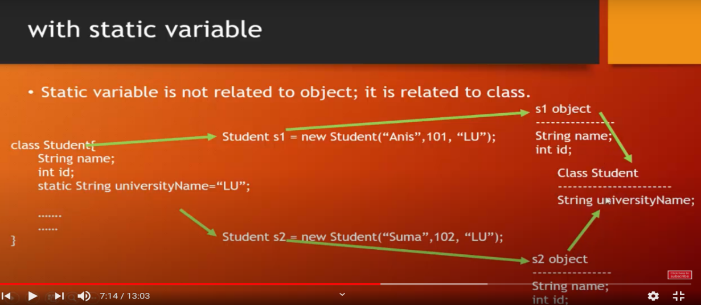

Class 9: **Constructor Real Example, Inheritance, All Type of Access Modifiers, Reference adds one project to another project (Class library reference add), Abstract Class**

* Private – Only Own Class // Default variable
* Protected- Own class + Child Class
* Internal – Own Class + Same Project (Onno Project e use kora jabe nah) // Default class
* Protected Internal: Combination
* Public- All Open

2. Class library DLL create kore and console app exe create kore

3. Abstract Class: Method Overload korar jonno abstract or virtual use korte hobe at BASE CLASS, and child class override likhte hobe

Extra:

Branch: OOP Example

Project: UpdownCasting ,

Down casting e jawat shomoi Direction dia dite hoi left or right e jabe

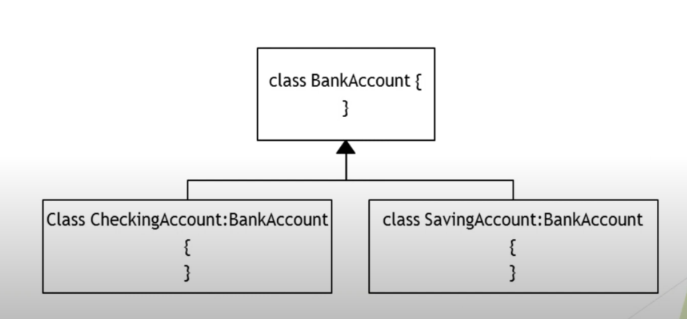

1. Child class e object create korar shate shate base class er constructor must call hobey.
2. Override: Run Time, Overload= Compile Time
3. **Summary:**

* **Virtual Method**- Basic Code thakbe, Pore override kore ni
* Abstract class e No Obeject, Because Base class e abstract method e body nai. Jodi
* Abstract class e abstract likhe method likhte hobe, Virtual likha jabe nah, pore sheta implement korte hobe

Class 10: **No Class, Exam**

Class 11: **Interface,etc etca**

**Abstract VS Interface**

**1** Student: IInformation, IPriter (Ekhane Right side e jeta thakbe oita Base Class

2 IInformation reference er moddhe implemented object rakhte pari;

**3** Fully Abstract in interface, can be fully or partially abstract

Details: <https://www.geeksforgeeks.org/difference-between-abstract-class-and-interface-in-c-sharp/>

**4 Explicit interfaces:** Multiple Interface same method thakle then Explicit(Specific kore bole dewa) Interface use korbo.