A closed-form water-quality compatibility threshold governs where AI data-centre expansion binds an urban water system
Target journal: *Water Research* (Research Paper)
Word budget: ≤ 8,000 words including references (official limit); operating target 7,700.
Source of numbers: the authoritative master document (03_ file, v2) is the single source for every number quoted here; no number in this file may change without changing it there first.

Nomenclature
Symbol | Meaning | Unit
$r$ | Reclaimed-water substitution ratio of the data-centre cooling make-up (facility level) | –
$r^{*}$ | Critical substitution ratio above which raising $r$ raises total make-up demand | –
$L$ | Maximum allowable TDS in the cooling loop (scaling/corrosion limit) | mg L⁻¹
$CoC$ | Cycles of concentration, $CoC=M/B$ | –
${CoC}_{d}$ | Design (equipment) cycles of concentration | –
$C_{p}, C_{r}$ | TDS of potable and reclaimed water; $C_{mix}(r)=rC_{r}+(1-r)C_{p}$ | mg L⁻¹
$C^{*}$ | $L/{CoC}_{d}$, the highest make-up TDS tolerable at design CoC | mg L⁻¹
$E, B, M$ | Evaporation, blowdown and make-up flow of the cooling tower | ML d⁻¹
$k$ | City-level ratio of total potable to total reclaimed water use | –
$k^{*}$ | Critical $k$ below which the data-centre mix necessarily exceeds $r^{*}$ | –
CAWCC | Carrying-capacity-constrained AI capacity (max feasible AI load under a given constraint set and time aggregation) | MW
$u$ | City-wide reclaimed-water utilisation rate, $u=(reclaimed used)/(wastewater treated)$ | –
$W/D$ | Ratio of city wastewater throughput to campus cooling make-up demand | –
All abbreviations are spelt out at first occurrence in the text. Supplementary sections are cited as SI.

Abstract
Cooling AI data centres with reclaimed water is promoted as a water-saving measure, yet the substitution ratio has been treated as a free policy variable whose cost was never tested. Cooling-tower salt balance and the design limit bound the cycles of concentration by make-up salinity, giving a closed-form threshold $r^{*}=(L/{CoC}_{d}-C_{p})/(C_{r}-C_{p})$; written as a minimum over limiting constituents it is structural rather than TDS-specific, placing $C^{*}=L/{CoC}_{d}$ against the two source salinities partitions cities into four regimes, and the controlling constituent switches with the ratio. In a daily urban water metabolism model with ten constraints at 41 capacity points and two synthetic endpoints, the mechanism yields $r^{*}=0.5532$ and matches model output to $8.9×10^{-16}$. The response is threshold-typed: the penalty is exactly zero for $r≤r^{*}$ and independent of capacity beyond it (+6.47 to +6.48%). Under a purely physical constraint set the water-scarce endpoint loses about 100 MW as $r$ rises from 0.5 to 0.9 while its grid constraint holds; the cool endpoint loses nothing under the baseline climate, but its loss doubles under a summer +4 °C scenario. Both a water-quality penalty and a water-side bottleneck are required, and the second condition is climate-conditional. Bottleneck identity is separable on a phase diagram whose frontier is set by the grid connection ratio alone: the two domains' frontiers lie at 1256.25 and 1631.25 MW, so the cool endpoint's grid setting sits 131.25 MW below its own, which is why its bottleneck is electrical. Current policy ranges produce no capacity consequence, a falsifiable prediction. The criterion reduces to two numbers: with data centres taking 6% and 26% of potable and reclaimed supply, cities whose ratio falls below 3.50 exceed $r^{*}$ (13.6% of 169 California systems), and with equal shares the boundary falls to 0.81. The capacity effects are deterministic scenario differences: the nominal CAWCC sits at P70–P73 across 1024 samples and the sampling band exceeds the effect.
Keywords: reclaimed water; data centre cooling; cycles of concentration; water-quality compatibility; urban water metabolism; bottleneck migration

1. Introduction
Data-centre water use has become a new variable in urban water management. Most assessments operate at the facility scale: water use effectiveness per unit of information-technology power, comparisons between evaporative and dry cooling, and site-level water-risk scoring [1,9,13]. Such accounting answers how much water a facility withdraws, but not the planning question a city faces. When compute capacity grows from 100 MW to 1000 MW, does water quantity, treatment capacity, wastewater capacity or grid connection fail first, and which investment would genuinely raise the feasible scale? Neither answer follows from facility size; both follow from the city's residual-margin structure. A water-rich city with a thin grid and a water-scarce city with a generous grid fail in entirely different places.
The reclaimed-water substitution ratio, defined here as the share of reclaimed water in the cooling make-up stream of a data-centre campus, is treated throughout this literature as a free policy variable. The implicit argument for reclaimed-water cooling is that a higher substitution ratio is always better: it displaces potable water one-for-one and therefore saves water. This step is where the reasoning becomes incomplete. The cycles of concentration of a cooling tower are bounded by the salinity of the blended make-up stream. Because reclaimed water is more saline than potable water, raising the substitution ratio raises make-up salinity, which depresses the permissible cycles of concentration; and the cycles of concentration determine make-up demand per unit of heat rejected. Raising the substitution ratio can therefore increase total make-up demand while decreasing potable abstraction. Two strands of work gesture at this possibility. Field measurements on a reclaimed-water-cooled tower report that raising the cycles of concentration improves water efficiency [3], and a recent perspective argues that the volumetric paradigm is exhausted and that the frontier is water-quality compatibility [11]. Neither provides a computable criterion. The literature has not answered how high the substitution ratio must rise before the penalty begins, nor tested whether that penalty relocates the system bottleneck.
Three further gaps follow. First, facility-scale metrics do not map onto system bottlenecks: a technology that halves water use per unit of power may add zero feasible capacity where the binding constraint is the grid. Second, distinct estimands are reported as one number; the physical boundary, the policy threshold, the annual and daily boundaries and the hourly proxy are five quantities, and conflating them invites a policy target to be read as a physical limit [2,7,15]. Third, interventions are rarely tested counterfactually: where the pool is committed, the effect depends on whether a data centre takes new supply or reallocated stock, and those have opposite signs in the city ledger [14].
We take the position of a mechanism study. Because calibration data for a real city are unavailable, we claim no city's carrying capacity and no city's threshold value; what we deliver is a criterion, the ordering and migration structure of constraints, and the conditions under which the mechanism binds. Our contributions are five. (i) We derive a closed-form water-quality compatibility threshold, $r^{*}=(L/{CoC}_{d}-C_{p})/(C_{r}-C_{p})$, which states how high the substitution ratio may rise before the penalty begins, given the loop salinity limit, the design cycles of concentration, and the salinities of the two sources; it agrees with model output to machine precision. (ii) We show that the response is threshold-typed rather than gradual: for $r≤r^{*}$ the carrying capacity and total withdrawal are exactly unchanged, and deterioration begins only beyond $r^{*}$. This is not a small effect; it is an effect that is zero and then kinks. (iii) We show that the bottleneck location is an endogenous function of the policy variable: under a purely physical constraint set the water-scarce endpoint loses about 100 MW as $r$ rises, its first-failing constraint moves forward, and its water-side ratios deteriorate while the grid constraint does not move at all. (iv) We state the two conditions under which the penalty changes carrying capacity, namely a water-quality penalty and a water-side bottleneck, and confirm the second condition by a negative result at the cool endpoint, where the penalty occurs but has no capacity consequence. (v) We separate three levers that are routinely conflated: expanding reclaimed-water treatment capacity is ineffective, raising reclaimed-water production is effective and migrates the bottleneck, and raising the substitution ratio is harmful beyond $r^{*}$.
Two scope statements belong here rather than in the limitations. We claim no capacity loss under current policy. In the range $r≤0.35$, which contains current Chinese reclaimed-water utilisation targets, the carrying capacity of both endpoints does not vary with $r$ at all, and this exact zero is identical on all three capacity grids tested. A linear mechanism cannot produce an exact zero; a threshold mechanism can, and that zero is falsifiable by any non-zero observation. The criterion's policy value therefore lies in delimiting a safe interval rather than forecasting any city's present condition. Second, the ratio used here is the campus substitution ratio, not the city-wide utilisation rate whose denominator is municipal wastewater throughput; the bridge between them is $r_{max}=u (W/D)$.

2. Material and methods

2.1 Model structure and closure
We built a daily urban water metabolism model with six component classes: source water (RES1), water treatment works (WTW1), distribution mains (DM1), wastewater treatment works (WWTW1), a central reclaimed-water facility (CENTRAL_REUSE) and the artificial-intelligence data centre (AI_DC1), following the urban-water-metabolism framework of [4,10]. Every daily step is checked against two closure identities, a storage balance and a delivery balance; across 45 scenarios and both identities all checks pass, with a maximum relative error of $3.45×10^{-13}\%$. The magnitude of both residuals and their stability along the capacity axis are shown in SI Figure S8; its x-axis reads the scientific-notation residual column rather than the rounded percentage column, which is flattened to zero.
The data-centre component resolves information-technology load, cooling (evaporative, dry and hybrid), make-up demand and blowdown. Potable and reclaimed water are blended to a target substitution ratio $r$, and water quality is tracked for two species, total dissolved solids (TDS) and chloride, both configured with limits and source concentrations: TDS at 2200 and chloride at 500 mg L$-1$. The cooling constraint is the tighter.
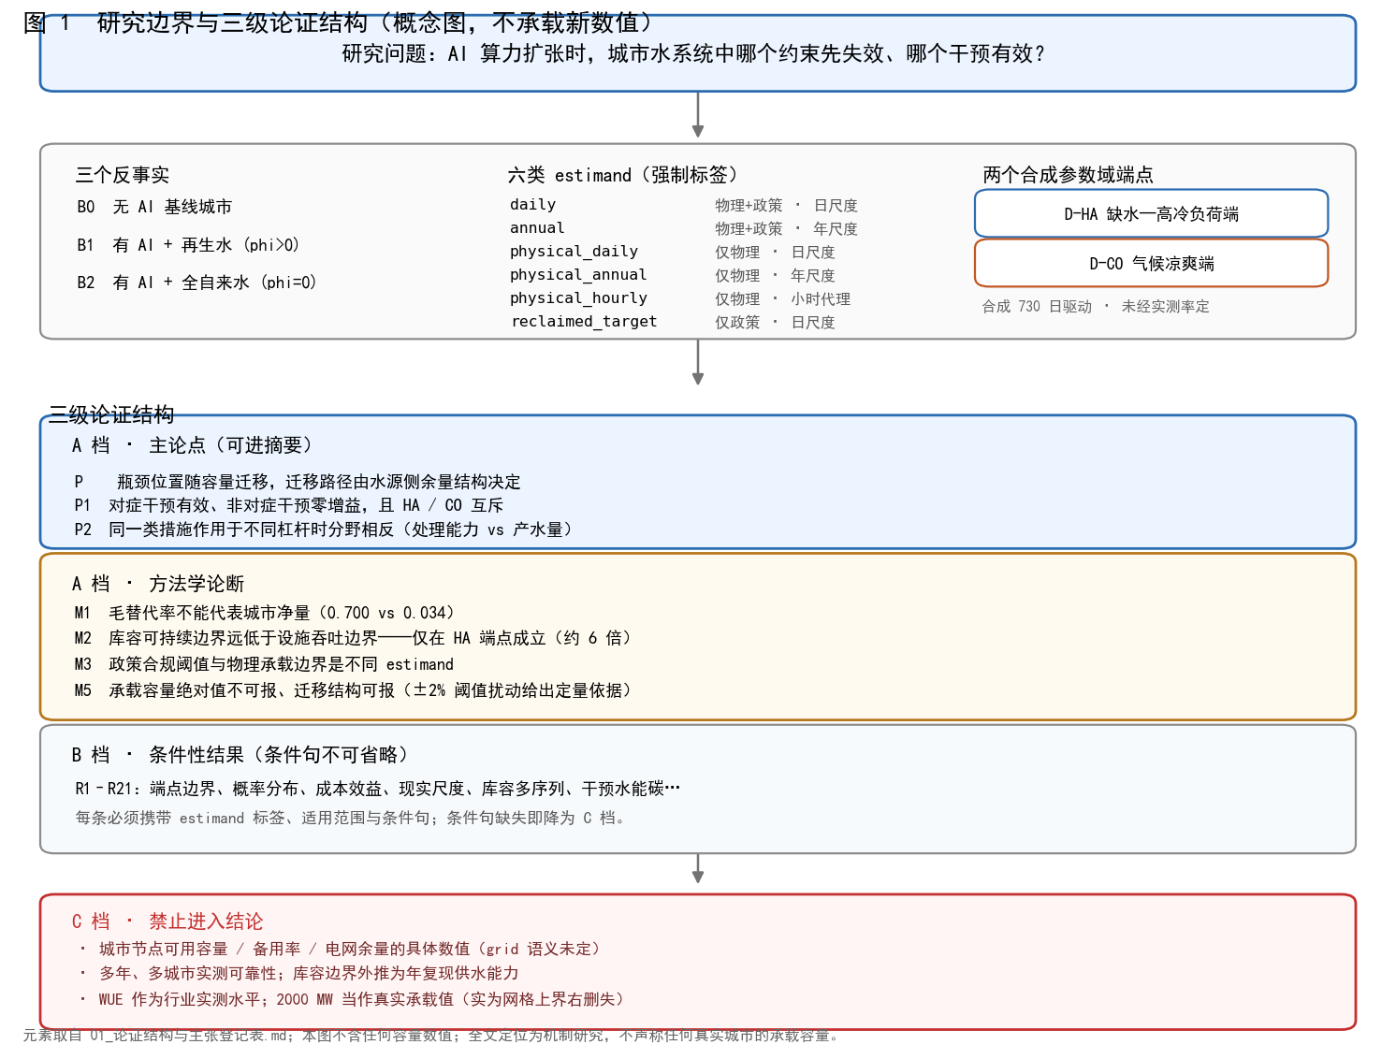
Figure 1. Research boundary and the three-tier argument structure. Panel (a) relates the three counterfactuals B0/B1/B2; panel (b) lays out the six estimands as a constraint-set by time-aggregation table; panel (c) gives the three-tier argument structure, separating the main claim from methodological assertions, conditional results and explicit prohibitions. The figure carries no new numbers, and states on its face that both endpoints are synthetic parameter-domain corners and that nothing here is calibrated to an observed city.

2.2 Parameter-domain endpoints
Two endpoints represent corners of the parameter domain, not real cities. The water-scarce, high-cooling-load endpoint (D-HA) combines a high wet-bulb climate with a tight abstraction cap, treatment works of 370 ML d$-1$, wastewater works of 270 ML d$-1$ and a reclaimed facility of 40 ML d$-1$. The cool-climate endpoint (D-CO) combines a low cooling load with a generous cap and 380, 270 and 36 ML d$-1$ respectively. Their policy substitution targets differ (0.65 and 0.40), a property of the city rather than of the model, and this is why the joint and purely physical constraint sets diverge at the two endpoints.

2.3 Constraint sets and estimands
Ten constraints are evaluated at every capacity point (Table 1). Capacity-type constraints use a planning-margin threshold of 0.95 rather than 1.0, because the engine hard-truncates treatment utilisation and a threshold of 1.0 would be vacuously true; 0.95 asks how much margin remains. One candidate indicator, the reclaimed-plant utilisation ratio, is excluded: a 300 ML storage pond, roughly seven to nine days of production, makes nameplate treatment rate on a daily step normal buffering rather than failure, and the indicator is identically 1.0 across the capacity range.
Table 1. The ten carrying-capacity constraints and their thresholds.
# | Constraint | Operator | Threshold
1 | System reliability fraction | $≥$ | 0.99
2 | Domestic unmet demand | $≤$ | 0
3 | Cooling water unmet | $≤$ | 0
4 | Maximum WTW utilisation | $≤$ | 0.95
5 | Maximum WWTW utilisation | $≤$ | 0.95
6 | Maximum source abstraction ratio | $≤$ | 0.95
7 | Reclaimed substitution ratio | $≥$ | 0.65 / 0.40
8 | Peak capacity ratio | $≤$ | 1.0
9 | Maximum local connection ratio | $≤$ | 1.0
10 | Maximum daily-average grid connection ratio | $≤$ | 1.0
Constraint 7 is the policy constraint. We therefore report two constraint sets throughout: a joint set that includes it, and a purely physical set that excludes it. The distinction is a premise, not a detail. Our independent variable is the substitution target $r$; leaving the condition that delivered ratio must meet target ratio inside the criterion set would make raising $r$ necessarily raise the chance of failure, which is self-reference rather than physical evidence. All conclusions about whether $r$ changes carrying capacity therefore rest on the purely physical set; the joint set appears only as a contrast, and the gap at $r=0.9$ reaches 300 MW at the water-scarce endpoint and 700 MW at the cool endpoint. The ordering is the opposite of what one might expect from the endpoints' policy targets alone, and the reason is where each endpoint's physical bottleneck sits: at the water-scarce endpoint it is source abstraction at 1200 MW, close to where the policy constraint fails (850 MW at $r=0.9$), so the policy constraint can hardly take over; at the cool endpoint the physical bottleneck is electrical (grid connection at 1500 MW up to $r=0.8$, local connection at 1400 MW at $r=0.9$), far later than the policy constraint's failure point, so the policy constraint readily does. Without the separation the cool endpoint would be misreported as losing 750 MW of capacity when the physical loss is 50 MW.
Because the same model yields several boundary values, every capacity number is tagged with its estimand: daily or annual aggregation, joint or purely physical constraint set, and a separate hourly proxy. These are not stricter and looser versions of one number; they answer different questions. Definitions of all six estimands and the three counterfactuals they serve are in SI Section S1.

2.4 Scan protocol and bottleneck attribution
Capacity is scanned from 0 to 2000 MW in 50 MW steps, 41 points, with the full 730-day model re-run at every point. The first-failure capacity is the first point at which any constraint is violated; the maximum safe capacity is the last point before it. The 0 MW point is the no-AI baseline for counterfactual differencing.
When several constraints fail at the same point, the dominant one has the largest dimensionless violation, violation divided by the absolute target, ties broken by name. The scale-free measure is required because constraints carry different units: the domestic-unmet constraint first fails at 1850 MW with a margin of 167.78 ML, whereas the abstraction ratio first fails at 1200 MW with a margin of 0.00495 in dimensionless terms, so ranking by raw margin would place domestic supply ahead of the true bottleneck. The rule also makes the result independent of the insertion order of the constraint dictionary.
Two decisions must be stated. Intervention counterfactuals originally used a 100 MW grid while the main results use 50 MW, so a gain may only be differenced against a same-grid baseline; we therefore re-ran every intervention on the 50 MW grid. Second, capacity grids introduce quantisation, so we re-ran the decisive comparisons at 25 and 10 MW resolution.
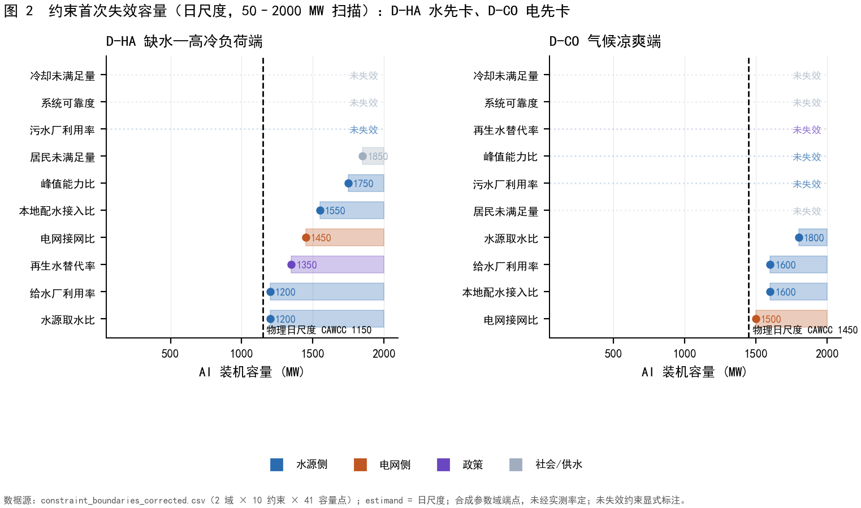
Figure 2. Bottleneck migration at the two endpoints. Panel (a) is the water-scarce endpoint and panel (b) the cool endpoint; within each, the ten constraints are drawn as horizontal bands ordered by the capacity at which each first fails, with the physical daily carrying capacity marked as a vertical dashed line. Constraints never failing within 2000 MW are labelled as such rather than dropped. Every capacity value carries its estimand label; the boundaries come from a deterministic single scan with no sampling-error estimate; and the thresholds are engineering conventions rather than city-calibrated values.

2.5 Parameter anchoring and what is not calibrated
External anchoring covers parameter ranges and orders of magnitude only, never calibration. Of 54 model parameters, 10 fall inside a documented envelope, 10 sit on a boundary, 32 carry no anchor and 2 fall outside; the anchors come from a convenience sample of the local literature library, not a systematic review. None of the four threshold parameters carries a measured anchor: the design cycles of concentration is listed without one, and the three water-quality parameters — the loop salinity limit and the two source salinities — are absent from the envelope table entirely. Drivers are synthetic, and no threshold has been calibrated against any city.
Three supporting cross-checks are placed in the SI. First, the position of each parameter within its literature envelope (SI Figure S5): of the 11 anchored parameters five sit inside the envelope, five exactly on a boundary and one falls outside (industrial return coefficient 0.8 against 0.85–0.95). Second, the site WUE of seven cooling technologies against disclosed and benchmark ranges (SI Figure S4): the tier ordering and magnitude agree with the literature, and the evaporative tier's 2.205 L kWh⁻¹ falls inside the conventional 2–4 range. Third, the water–energy trade-off and the grid water intensity at which dry cooling stops saving (SI Figure S7): at the 750 MW IT slice the fully dry tier drives site water to zero at a facility energy penalty of 15.41%, and its whole-system saving is 79.65%, 43.37% and 18.34% under the three grid intensities considered (the project value, GreenGrid 1.8 and LBNL 4.52), against 81.22%, 47.74% and 24.65% for the liquid-to-air tier at a 6.50% penalty. The reversal thresholds of the dry-cooled tiers lie between 11.5 and 36.3 L kWh⁻¹, all above the disclosed upper bound of 4.52, so within this parameter domain the direction of dry-cooling savings is not overturned by indirect grid water use. None of the three changes a conclusion, but together they convert "are the parameters reasonable" from assertion into a checkable position.

3. Results

3.1 Where the system binds, and how the binding point migrates
The two endpoints fail in different places, and the ordering of their failures carries the argument. At the water-scarce endpoint the first constraint to fail on a daily step is source abstraction, at 1200 MW, with treatment-works utilisation failing at the same point; grid connection does not fail until 1450 MW. At the cool endpoint the order is reversed: grid connection fails first at 1500 MW and source abstraction is not reached until 1800 MW. The model skeleton, the constraint set and the scan protocol are identical at the two endpoints; only the climate driver and the facility parameters differ. The difference in starting point must therefore be attributed to residual-margin structure rather than to facility scale.
That attribution must first exclude an alternative: both endpoints set the grid connection capacity to 1500 MW, and the cool endpoint's 1450 MW sits right against it. One endpoint binding on water and the other on electricity could therefore be a direct consequence of where the setting was placed rather than a property of the margin structure. To turn a comparison of two scenarios into a mechanism that can be discriminated, we scanned a $9×9$ grid over (source abstraction capacity as a multiple $a$ of each endpoint's own baseline, grid connection capacity $G$), with a 41-point capacity scan in each cell, and bisected each abstraction capacity under the purely physical set to locate the frontier between water-side and grid-side dominance (SI Figures S9–S11).
Three results follow. First, the frontier is horizontal: at D-HA the critical grid capacity $G^{*}=1256.25$ MW with a slope of $1.9×10^{-13}$ against $a$, that is, independent of abstraction capacity; it is fixed by the grid connection ratio threshold alone. Second, the two endpoints lie on opposite sides but with very different margins: the water-scarce endpoint's 1500 MW setting sits 243.75 MW above its frontier, a robust water-side dominance, whereas the cool endpoint's setting sits 131.25 MW below its own frontier ($G^{*}=1631.25$ MW for $a≥1.00$). Third, D-CO's $G^{*}$ falls with abstraction capacity only when $a<1.00$ (1068.75 MW at $a=0.90$), because the water side itself collapses earlier there.
The third point makes the earlier qualitative statement concrete. The cool endpoint's bottleneck is electrical not because "cool cities are power-limited" by inference, but because its grid capacity is set 131 MW below its own critical value. Conversely, raising D-CO's grid capacity above 1631 MW would flip its bottleneck to the water side, and the water-quality penalty would then produce a capacity consequence there. The frontier is thus an operational threshold: given a city's abstraction capacity and grid connection capacity, which side it falls on decides whether the quality mechanism has a capacity consequence, with no need to re-run the model (SI Figure S10).
Capacity does not respond continuously to the grid setting. Sweeping $G$ at fixed abstraction capacity, D-HA saturates at 1150 MW once $G$ exceeds about 1200 MW, whereas D-CO rises monotonically and plateaus at 1350 and 1550 MW, the two plateaus corresponding to the local connection ratio and the grid connection ratio as the binding constraint (SI Figure S11). The plateaus show that bottleneck identity is a discrete quantity, and they explain why the capacity difference between the endpoints cannot be extrapolated linearly in $G$.
Table 2. First-failure capacity of each constraint, daily step, joint constraint set (MW).
Constraint | D-HA | D-CO
Maximum source abstraction ratio | 1200 | 1800
Maximum WTW utilisation | 1200 | 1600
Reclaimed substitution ratio (policy) | 1350 | never
Maximum daily-average grid connection ratio | 1450 | 1500
Maximum local connection ratio | 1550 | 1600
Peak capacity ratio | 1750 | never
Domestic unmet demand | 1850 | never
Maximum WWTW utilisation | never | never
System reliability fraction | never | never
Cooling water unmet | never | never
Migration differs beyond its start. The water-scarce endpoint passes through six failure capacities spanning 650 MW, moving from water to grid and ending at peak capacity and domestic supply; the cool endpoint passes through three spanning 300 MW, from grid to source abstraction. Because the endpoints share everything except climate and facility parameters, this divergence is what a residual-margin explanation predicts and a scale explanation cannot produce.
Six constraints never carry information at the cool endpoint and three at the water-scarce one within the 0–2000 MW scan. A non-informative constraint is not evidence of safety: the scan never reached it. Doubling the scan ceiling to 4000 MW shows how range-dependent that statement is — only max_wwtw_utilization then remains non-informative at either endpoint, reaching just 0.8992 and 0.8755 against a 0.95 threshold, while the other five first fail between 1350 and 3000 MW. This both strengthens and weakens a negative result. It strengthens the counter-intuitive claim that wastewater capacity is not a bottleneck, since that survives a scan ceiling more than twice the main result. It weakens the remaining non-informative statements, which hold only inside the original range. Two of the negative results therefore matter. Wastewater treatment utilisation never fails, peaking at 0.892 and 0.860 against 0.95, so wastewater capacity is not a bottleneck here, contrary to the intuition that data-centre demand overwhelms sewerage. Domestic unmet demand is zero and never informative at the cool endpoint, which is why we claim nothing about domestic supply there.
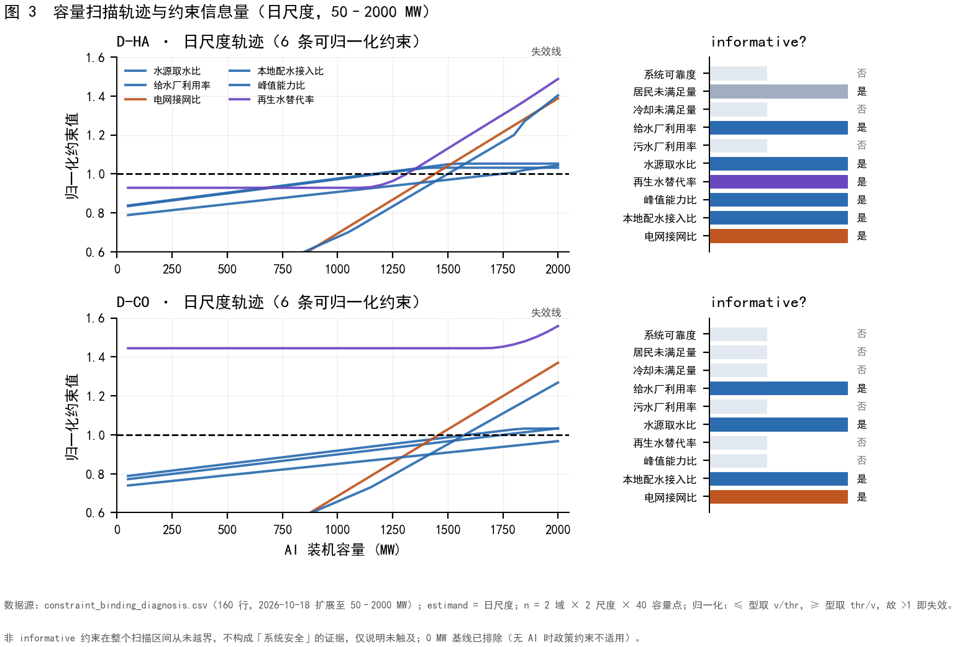
Figure 3. Constraint trajectories and informativeness across the capacity scan. Panel (a) plots every constraint normalised by its own threshold against capacity, in two rows for the two endpoints; panel (b) records which constraints are informative and where each first fails. Separating the panels keeps "never binds" distinct from "binds late": a non-informative constraint is one the scan never reached, which describes the scanned range and is not a statement of system safety.
Interventions confirm the binding constraint, not the label, decides whether investment works. Of the nine one-to-one interventions at the water-scarce endpoint, only 30% leakage reduction yields a gain (the combined upgrade, which already contains that leakage reduction, reproduces the same 150 MW and is therefore redundant rather than additional), raising capacity from 1150 to 1300 MW by relaxing the water side (a joint-caliber figure, where the policy constraint reclaimed_water_substitution_ratio is the binding one; under the pure-physical caliber used for the main results the same intervention yields +250 MW, 1150 to 1400); 50% grid expansion yields exactly zero, at a median investment of 44,921 ten-thousand yuan. At the cool endpoint the pattern inverts: grid expansion yields 100 MW, from 1450 to 1550, while leakage reduction yields zero at a median investment of 2718.8 ten-thousand yuan. Cross-application is ineffective both ways. Zero gain is not zero cost. The unit costs differ 24.4-fold, but as only one input has an official source we read that ratio as an order of magnitude only. Placing investment against gain in one plane, the Pareto-efficient set holds exactly one intervention per endpoint: 30% leakage reduction at the water-scarce endpoint and 50% grid expansion at the cool one; the combined upgrade matches the leakage gain at 8.6 times the investment and therefore lies off the front (SI Figure S6). The gain distribution is highly degenerate — seven of nine interventions at one endpoint and eight of nine at the other are exactly zero — so SI Figure S27 presents it as jittered points and horizontal bars rather than a violin plot, which would manufacture a spurious peak.
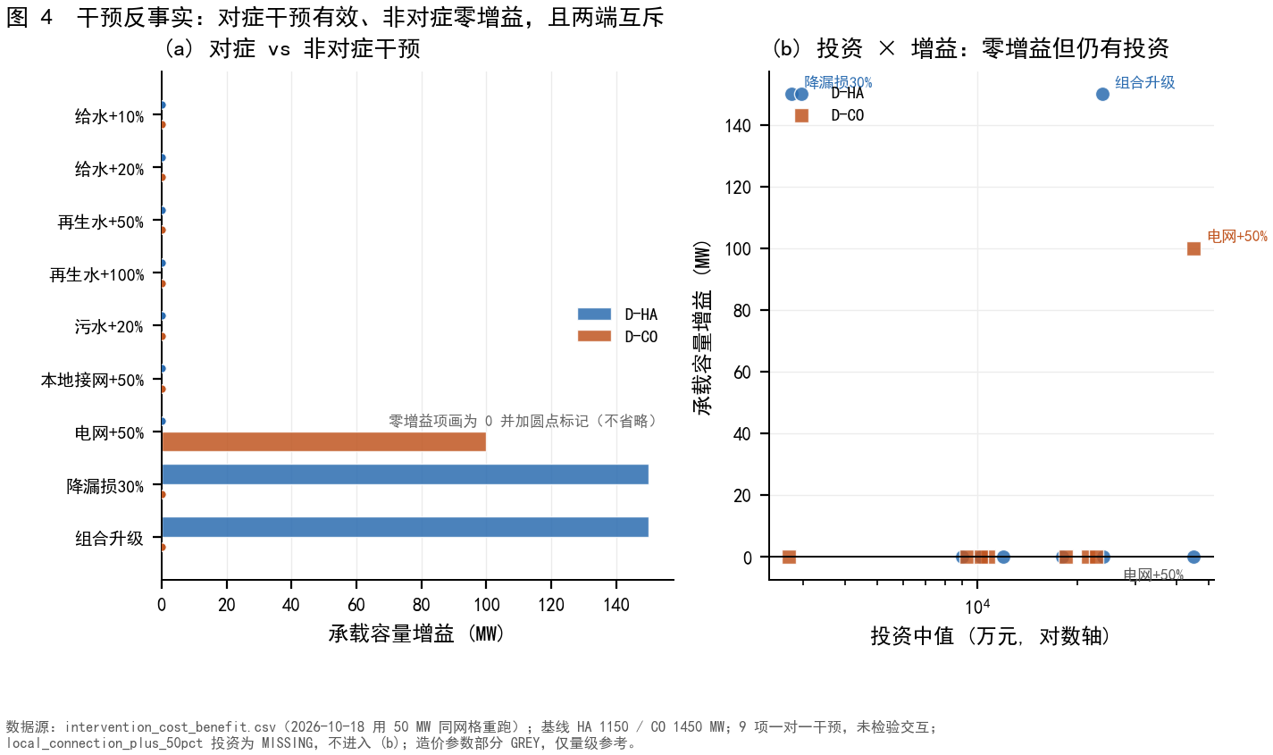
Figure 4. Intervention counterfactuals. Panel (a) gives the capacity gain of each of the nine interventions at both endpoints, drawing zero-gain interventions as zero-height bars rather than omitting them; panel (b) plots median investment against gain and marks the Pareto-efficient set. local_connection_plus_50pct is absent from panel (b) because its investment figure is missing rather than small. All nine interventions have been re-run on the 50 MW grid, so these gains share a baseline with the main results (1150 and 1450 MW); the leakage_minus_30pct gain of 150 MW at the water-scarce endpoint is the joint-set figure, in which the policy constraint binds, whereas the purely physical set gives 250 MW. The two calibers must not be subtracted from one another.

3.2 A closed-form threshold on the substitution ratio
Everything above was obtained at a fixed substitution target, 0.70 at the water-scarce endpoint and 0.45 at the cool endpoint, treated as an attribute of the city. It is in fact a policy variable, and the question is whether raising it relocates the carrying capacity. The intuitive answer is that it cannot, because the ratio is only a source mix and total source volume is conserved. This intuition holds below a threshold and fails above it.
For a cooling tower in steady state, neglecting drift, with evaporation $E$, blowdown $B$, make-up $M$ and cycles of concentration $CoC=M/B$: salts do not evaporate, so $M C_{mix}=B C_{loop}$, giving $C_{loop}=CoC C_{mix}$. A scaling and corrosion limit $C_{loop}≤L$ then gives $CoC≤L/C_{mix}$, and make-up blended at ratio $r$ gives $C_{mix}(r)=rC_{r}+(1-r)C_{p}$. The model takes the tighter bound,
$CoC(r)=min({CoC}_{d}, L/C_{mix}(r)).$
Setting the water-quality bound equal to the design value gives the critical substitution ratio:
$r^{*}=(L/{CoC}_{d}-C_{p})/(C_{r}-C_{p}).$
With endpoint parameters ($L=2200$ mg L$-1$, ${CoC}_{d}=5.0$, $C_{p}=180$ mg L$-1$, $C_{r}=650$ mg L$-1$) this gives $r^{*}=(440-180)/470=0.5532$. Because the model tracks two species, we also computed the chloride threshold, $(500/5-35)/(130-35)=0.6842$, and took the tighter of the two. TDS is the binding species, so the reported value needs no correction; and because the parameter set configures exactly these two species, this tightening is complete rather than partial. The general form is $r^{*}=\min_{s}[(L_{s}/{CoC}_{d}-C_{p,s})/(C_{r,s}-C_{p,s})]$.
That minimum is not a cosmetic generalisation; it changes what the criterion is. If the criterion held only for TDS by coincidence, it would be a numerical accident; only as a minimum is it structural. To test this we added a third limiting constituent beyond the two configured species — hardness, with $L=1200$, $C_{p}=120$ and $C_{r}=350$ mg L$-1$ as CaCO$3$, taken from common engineering ranges for recirculating cooling water as a stress test rather than a project setting — and ran three analyses (SI Figures S15–S17).
The first is the per-constituent threshold. The three values are 0.5532 (TDS), 0.6842 (chloride) and 0.5217 (hardness). With all three in play the system threshold is set by hardness at 0.5217, 3.2 percentage points below the TDS value.
The second is how control moves with the substitution ratio. Evaluating the allowable cycles ceiling $L_{s}/C_{mix,s}(r)$ for each constituent across $r∈[0,1]$ and taking the minimum, the controlling constituent switches twice: for $r<0.53$ the design cycles bind and CoC stays at 5.0; for $0.53≤r<0.83$ hardness controls; for $r≥0.83$ TDS controls (SI Figure S16). The same city is thus governed by a different water-quality indicator at different substitution ratios — the controlling constituent is not a fixed property of the city.
The third asks whether TDS is naturally the tightest. Taking five levels each for $L$ and $C_{r}$ of the three constituents with $C_{p}$ fixed at the project values gives 15,565 combinations: hardness is tightest in 42.7%, chloride in 29.6% and TDS in only 27.7% (SI Figure S17). The TDS result at this model's parameters is therefore a property of these two parameter sets, not a general rule; the criterion must be written and reported as a minimum, and populated with whatever constituent actually controls when data permit. This is simultaneously a support and a limitation: it supports generalisation to an arbitrary number of constituents, and it limits the reported 0.5532 to the TDS constituent.
Regimes differ qualitatively. For $r≤r^{*}$ the cycles equal the design value, make-up demand is constant, and the effect is pure gain: potable abstraction falls by the substituted volume and total withdrawal does not move. For $r>r^{*}$ the cycles fall with $r$, make-up demand per unit of heat rejected rises through $M=E CoC/(CoC-1)$, and the gain is partly eroded: the penalty is $+1.27\%$ at $r=0.60$, $+4.08\%$ at $r=0.70$, $+7.06\%$ at $r=0.80$ and $+10.21\%$ at $r=0.90$.
Because $r^{*}$ is easily mistaken for a city constant, its sign and magnitude are themselves classificatory. Writing $C^{*}≡L/{CoC}_{d}$ for the highest make-up salinity tolerable at the design cycles, four regimes follow (Table 3). Regime I, $C^{*}≤C_{p}$: the tolerable salinity is below that of potable water itself, so any substitution costs and no pure-gain interval exists. Regime II, $C_{p}<C^{*}<C_{r}$: the only regime with a genuine policy trade-off, and the one containing both endpoints. Regime III, $C^{*}≥C_{r}$: substitution is never costly. Regime IV, $C_{r}≤C_{p}$: reclaimed water is cleaner than potable and the problem disappears.
Table 3. Four regimes defined by the position of $C^{*}=L/{CoC}_{d}$ relative to the two source salinities.
Regime | Criterion | Position of $C^{*}$ | Policy meaning
I | $r^{*}≤0$ | $C^{*}≤C_{p}$ | Every substitution costs; no pure-gain interval
II | $0<r^{*}<1$ | $C_{p}<C^{*}<C_{r}$ | A real threshold exists; the only trade-off regime
III | $r^{*}≥1$ | $C^{*}≥C_{r}$ | Substitution is never costly
IV | — | $C_{r}≤C_{p}$ | Reclaimed water is cleaner; problem disappears
Both endpoints fall in Regime II, since $C^{*}=2200/5=440$ lies between 180 and 650; their difference is one mechanism under two policy targets, the water-scarce 0.70 exceeding $r^{*}$ while the cool 0.45 does not. We verified behavioural distinctness by holding the endpoint at 800 MW and varying only ${CoC}_{d}$. The nominal case (${CoC}_{d}=5.0$, $r^{*}=0.5532$) is flat to the threshold and rises $6.48\%$ from $r=0$ to $r=0.8$. Regime I (${CoC}_{d}=15.0$, $r^{*}=-0.0709$) starts with a CoC of 12.2222 rather than the design value of 15, the signature of a design value unreachable because the quality constraint binds from the outset, and is already $4.43\%$ above baseline at $r=0.2$ and $20.74\%$ by $r=0.8$. Regime III (${CoC}_{d}=2.5$, $r^{*}=1.4894$) holds CoC at 2.5 across all five points and shows exactly $0.00×10^{0}\%$ change. Regimes I and II coincide exactly once the quality bound falls below both design values, total withdrawal matching to the digit at $r=0.8$ (23,840.93 ML), whereas Regime III never merges because its design value stays under the quality bound.
The threshold's form is structural and its value conditional. It is worth separating two kinds of analytic reach here. The threshold location is exactly analytic: $r^{*}$ matches the model to machine precision. The effect size is not. Writing the binding abstraction ratio as a constant plus a term proportional to $MW f(r)$ with $f=CoC/(CoC-1)$ suggests $CAWCC(r)=A/f(r)$, but this only approximates the model: it agrees to within one grid step at 50 and 25 MW, fails at 10 MW (2.11 steps at $r=0.9$), and a 1 MW scan puts the true value at 1111.76 MW against a predicted 1088.9 MW, a 22.9 MW discrepancy that grid quantisation cannot explain since the tolerance there is ±1 MW. The bias grows monotonically with $r$ (about +5 MW at $r=0.6$ to +23 MW at $r=0.9$), so the closed form is missing a term that rises with $r$. The consequence for how this paper should be read is direct: the −100 MW figure is a model output, never an analytic prediction. The residual has a specific cause, which we report because it constrains the high-$r$ results. Raising the target ratio beyond about 0.70 exhausts the reclaimed supply: at 1100 MW the delivered fraction stays at 0.700000 with no shortfall days up to $r=0.70$, but falls to 0.740 and 0.744 with 620 and 724 of 730 days short at $r=0.80$ and $0.90$. The model nevertheless computes the cycles of concentration from the *target* mix rather than the delivered one — its output matches the target-based closed form to 1e-15 while differing from the delivered-based value by 0.505 at $r=0.9$ (3.6484 against 4.1535). Because a shortfall makes the real blend fresher than the target, the true cycles would be higher and the penalty smaller, so the model understates CoC and overstates the water-quality penalty above $r≈0.70$. The declines reported at $r=0.8$ and $0.9$ are therefore upper bounds under this modelling convention, not point estimates. The threshold itself is unaffected: $r^{*}=0.5532$ lies where delivery is complete. Tracing that residual one level further exposes a model-path setting that must be declared. Neither endpoint project sets quality_state_enabled, whose default is false, so all 730 days run the legacy volume-only path in which CoC follows the closed form directly with no day-by-day salt balance. Enabling the dynamic path gives the same direction at about half the magnitude: at 1100 MW the CoC falls to 4.3709, 4.1490 and 4.1364 at $r$ = 0.7, 0.8 and 0.9 (against 4.3222, 3.9568 and 3.6484 under the legacy path), and annual make-up rises 5.012% from $r$ = 0.5 to 0.9 against 9.373% under the legacy path. An earlier version of this section reported the dynamic path as locking its CoC at 5.0 with make-up essentially invariant, and attributed that to a physical mechanism. That reading was wrong twice over. The proximal cause was an implementation defect: neither endpoint project declares a TDS or chloride load for municipal wastewater, so the salt ledger is effectively empty, and _reuse_output_quality overrode the declared reclaimed concentration of 650 mg L$-1$ with the ledger's mass-to-volume ratio, giving 8.27 mg L$-1$ (1.3% of the declared value). Two code paths produced this. First, the ledger concentration was trusted even when it fell below the potable concentration, which is physically impossible for treated effluent; it is now rejected as incomplete in that case. Second, and decisively, data_center.py treated the quality override as a wholesale *replacement* rather than a merge, so species absent from the override (TDS) dropped out of the mixed concentration entirely, leaving only the potable contribution ($0.3×180=54$ mg L$-1$); $L/C_{mix}$ then exceeded the design cycles and min() clamped CoC to 5.0. The override is now merged, so declared species are retained unless the ledger supplies a physical value for them. With both defects fixed the dynamic path reproduces the backlash rather than cancelling it. A 2 × 2 design at 1100 MW separates the path from the question of whether the municipal TDS load is declared: under the legacy path the make-up rises 9.373% from $r$ = 0.5 to 0.9 in both cells, because it never consults the ledger; under dynamic tracking it rises 5.011% when the load is absent and 7.363% once the ledger is calibrated so that the reclaimed concentration returns to 650 mg L$-1$. The lesson is methodological: a claim that an effect vanishes on one implementation path must first establish that both paths receive the same inputs, and only then discuss mechanism. Re-running the capacity scan with the water-quality inputs thus aligned, legacy CAWCC falls 1200 → 1150 → 1100 MW across $r$ = 0, 0.7 and 0.9 while the dynamic path falls 1200 → 1150 → 1150. The effect is halved, not eliminated: 100 MW against 50 MW. We accordingly withdraw the claim that the 100 MW effect vanishes under dynamic tracking, and with it the bracket framing that made the legacy path an upper bound and dynamic tracking a lower bound near zero. The correct statement is narrower and still useful. The direction of the backlash is the same on both paths, so raising the target ratio always increases withdrawal and lowers CAWCC; only its magnitude depends on the path, and the −100 MW and +6.48% reported here are legacy-path values, an upper-end estimate under this modelling convention rather than a robust point estimate. The criterion itself is untouched in either case: $r^{*}$ says where a quality ceiling begins to bind, which is an algebraic property of the four water-quality parameters independent of the model path, so the derivation, the four-regime taxonomy and the elasticities all stand. We retain the legacy path as the main scenario because it uses the same CoC expression as the analytic derivation, matching it to 1e-15, and because the dynamic path can only be run once the missing wastewater salt load is back-calibrated from the declared $C_{r}$; the price of that choice is the upper-end magnitude reported here, which we state explicitly. The closed form tells us where the threshold is; it does not tell us how much is lost beyond it. Elasticities are $+1.6923$ for $L$, $-1.6921$ for ${CoC}_{d}$, $-1.3828$ for $C_{r}$ and $-0.3093$ for $C_{p}$; the near-equality of the first two reflects that both enter only through $C^{*}$. A 10% change in one parameter moves $r^{*}$ by 0.018 ($C_{p}$), 0.089 ($C_{r}$), 0.094 ($L$) or 0.104 (${CoC}_{d}$), with a span reaching 0.19 — enough to cross the case city's value. Across 320 full-factorial parameter combinations, Regime II occupies 48.8%, Regime I 25.3%, Regime III 19.7% and Regime IV 6.2%, with $r^{*}$ inside Regime II ranging from 0.0196 to 0.9167. A threshold-typed response is therefore robust, fixed by the min structure of the CoC expression, whereas the value of $r^{*}$ and any city's regime assignment are not.
Three empirical checks support the derivation. First, the cycles of concentration are a response variable, not an input constant: across 40 sampling points (two endpoints, five ratios, four capacities) the maximum deviation between model and analytic expression is $8.882×10^{-16}$, at machine precision, and CoC falls from 5.0 at $r≤0.5$ to 3.648 at $r=0.9$, a decline of 27%.
Second, the penalty is measurable and independent of capacity: raising $r$ from 0.5 to 0.8 raises total withdrawal by $+6.47\%$ at 200 MW and $+6.48\%$ at 800, 1200 and 1600 MW, a range of 0.012 percentage points. A penalty from load growth would scale with capacity; one from blend chemistry does not. Attribution follows from back-calculating evaporation at the water-scarce endpoint and 1600 MW: evaporation is essentially constant (35,815.7 to 35,544.1 ML, $-0.76\%$) while total withdrawal rises $9.37\%$, so the increment can only come from the water-quality term.
Third, the penalty contribution is exactly zero for $r≤r^{*}$: actual withdrawal minus withdrawal at $r=0$ for the same capacity gives $0.000×10^{0}$ ML at the water-scarce endpoint and 1200 MW, and $7.276×10^{-12}$ ML at the other three sampled combinations, against 1257.9 to 3146.5 ML once $r≥0.7$. A supporting falsification tests the obvious alternative: at 1200 MW, raising $r$ from 0 to 0.5 raises reclaimed use from 0 to 16,790 ML, half of total withdrawal, while total withdrawal, the abstraction ratio and treatment utilisation do not move by a single digit. Raised reclaimed use alone therefore does not load the system; only blend chemistry does.

3.3 The bottleneck is an endogenous function of the policy variable
The carrying-capacity question is separate from total withdrawal and can only be answered under the purely physical constraint set, because leaving the policy constraint in place makes the answer self-referential. Under that set the water-scarce endpoint's capacity is 1200 MW for $r≤0.5$, 1150 MW at $r=0.6$ and 0.7, and 1100 MW at $r=0.8$ and 0.9, with source abstraction first-failing throughout. The cool endpoint stays at 1450 MW until $r=0.9$, where it falls to 1400 MW and local connection binds. The effect is therefore about 100 MW at the water-scarce endpoint and essentially nothing at the cool endpoint.
That "essentially nothing" needs a climate condition. All the values above are obtained under the baseline climate driver; raising summer dry-bulb temperature by 4 °C (G1) and additionally cutting wet-season inflow to 0.65 and abstraction capacity to 0.85 (G2, drought) makes the two domains respond differently (SI Figures S12–S14 and S24). Under G1 the water-scarce endpoint's capacity falls from 1200 to 1050 MW (a 150 MW loss against baseline) but its decline across $r=0.5$ to 0.9 stays at 100 MW, whereas the cool endpoint falls from 1450 to 1400 MW and its decline over the same ratio interval doubles from 50 MW to 100 MW. Warmth raises the cooling load and compresses the water-side margin, so a bottleneck that sat on the electrical side is more easily pushed onto the water side by the quality penalty.
Drought (G2) produces a different response. The water-scarce endpoint's capacity collapses to 100 MW (a 1100 MW loss) and the cool endpoint to 550 MW (900 MW lost); the bottleneck in both domains flips to the water side, while the absolute size of the quality effect shrinks (−50 MW at the water-scarce endpoint, 0 MW at the cool one) — in a regime close to physical collapse, capacity is set by absolute water volume rather than by blend chemistry. The compound scenario G3, applying heat, drought and a 12% demand increase together, has no feasible point at either endpoint: even 0 MW (no AI) violates the domestic unmet-demand constraint. That is a meaningful boundary result rather than a gap. Treating each scenario's six substitution-ratio points as a distribution, drought not only lowers the median but narrows the within-endpoint spread: at the water-scarce endpoint the interquartile range contracts from 75 MW at baseline to 50 MW under heat and 0 MW under drought (the full range compressing from 1100–1200 MW to 50–100 MW; SI Figure S24). The two endpoints' constraint-pressure profiles consequently take different shapes — D-HA approaches the failure line on peak capacity ratio and source abstraction, D-CO on the grid connection ratio (SI Figure S26) — a structural rather than a scale difference.
The second condition — the bottleneck lies on the water side — should therefore be stated as a climate-conditional one: the cool endpoint loses almost nothing under the baseline climate but doubles its loss under warming. The quality mechanism thus strengthens rather than weakens under climate change, consistent with the intuition that warming simultaneously raises cooling demand.
Quantisation constrains what may be cited. Because the effect is roughly two grid steps and the first-failure boundary need not fall on a grid point, we recomputed at 25 and 10 MW. The zero-effect region is identical on all three grids — the strongest form of the result, and the one our falsifiability claim rests on. At the endpoint ($r=0.9$) the decline is $-100$, $-100$ and $-90$ MW, a range of 10 MW, so the figure may be cited as approximately 100 MW with a $±25$ MW caveat. In the intermediate range ($r=0.6$ and $0.8$) the ranges are 30 to 40 MW and precise declines must not be cited: the 50 MW grid reports $-50$ and $-100$ where 25 MW reports $-25$ and $-75$ and 10 MW reports $-10$ and $-70$. The cause is the subtraction of two rounding errors, not instability, since a true boundary of 1187 MW would be reported as 1150, 1175 and 1180. Absolute values approach the upper bound monotonically as the grid is refined (1150, 1175, 1190 at $r=0.6$), so the 50 MW grid underestimates capacity by 0 to 25 MW, an inherent property of defining a maximum feasible point on a discrete grid rather than a model error.
The confound control is the hardest evidence: capacity, climate and city load are fixed and only the blend varies. At the water-scarce endpoint and 1200 MW the abstraction ratio is 0.9497 for $r≤0.5$, compliant against 0.95, and 0.9513 at $r=0.6$, non-compliant: raising the reclaimed target from 0.5 to 0.6 alone pushes a compliant city across the threshold. Treatment utilisation moves the same way, from 0.9463 to 0.9479 at $r=0.6$ and past 0.95 by $r=0.7$. Meanwhile the grid constraint stays at 0.8326 with a change of exactly 0.0000 across the entire range. The penalty strikes the water side, not the electricity side. The pattern reproduces at the cool endpoint and 1600 MW, where the abstraction ratio rises from 0.9306 to 0.9472 and treatment utilisation from 0.9503 to 0.9674 while the grid ratio remains at 1.0959.
The response is a step, not a gradient. Constraint margins at a carrying boundary are small by construction: the first-failing abstraction ratio sits 0.00028 above threshold one grid step earlier at $r=0.5$ and 0.00543 and 0.00541 at $r=0.6$ and 0.8, whereas the penalty increment is 0.013 to 0.017. The penalty therefore exceeds the boundary margin by a factor of 2 to 50, which is why crossing $r^{*}$ must push the boundary forward by at least one grid step, and why a penalty percentage cannot be converted into a megawatt decline: the decline is fixed jointly by grid resolution and local margin, a threshold-crossing problem rather than a continuous response.
Why the water-scarce endpoint loses capacity but the cool one does not requires a second condition. The penalty occurs at both, which share identical water-quality parameters and hence the same $r^{*}=0.5532$, but changes capacity only where the first-failing constraint is on the water side: true at the water-scarce endpoint, false at the cool endpoint where the grid fails first. The mechanism is thus stated completely as two conditions, $r>r^{*}$ and a water-side bottleneck. Cooling-technology sensitivity tests this. Switching the water-scarce endpoint among four tiers while holding everything else fixed gives make-up increases of +6.478% (evaporative), +6.472% (hybrid) and +7.851% (dry_first) for $r$ rising from 0.5 to 0.8, so the threshold-typed response survives every tier that has cooling water at all; the dry tier draws none and the mechanism simply does not apply there. The capacity response varies with technology, but neither its exact magnitude nor the ordering of the tiers survives grid refinement: across 50, 25 and 10 MW grids the drop is 100/75/70 MW for evaporative, 50/50/60 for hybrid, 50/75/90 for dry_first and 0/0/0 for dry. At 50 MW evaporative leads, whereas at 10 MW dry_first overtakes it, because the two depend on the grid in opposite ways — evaporative has a grid-invariant baseline with a rising endpoint, so its drop converges downward, while dry_first has a grid-invariant endpoint with a rising baseline, so its drop diverges upward. What can be claimed is only that the three tiers that use cooling water all fall in the 50–90 MW range, the same order as the −100 MW main result, and that dry is identically zero on all grids because it draws no external water — the criterion is inapplicable there rather than robust. We therefore do not claim that evaporative modelling bounds the effect from above (SI S7.14). The dry_first tier's larger increase is explained by its design cycles of concentration of 6.0, which lowers $r^{*}$ to 0.3972 and so crosses the threshold earlier (SI S7.14). It is not a claim that water saving is harmful; the cool endpoint is the negative result establishing the second condition.

3.4 Operationalising the criterion: a two-number city screen
The criterion becomes usable in quantities cities publish. With potable use $P$ and reclaimed use $R$; if data centres take share $α$ of potable and $β$ of reclaimed, campus make-up is $D=αP+βR$, so
$r=βR/(αP+βR)=1/(1+(α/β) k), k≡P/R.$
Setting $r=r^{*}$ gives the critical city ratio $k^{*}=(1/r^{*}-1)/ρ$, where $ρ≡α/β$ is the ratio of the data-centre shares in the two supplies. For the shares documented in Santa Clara, California — 6% of city potable water and 26% of city reclaimed water, so $ρ=6/26=0.2308$ — this gives $k^{*}=3.50$: a city whose ratio of potable to reclaimed use falls below 3.50 has a data-centre substitution ratio that necessarily exceeds $r^{*}$. The two shares calibrating $ρ$ are transcribed, not first-hand: the originating City report (File 26-1037) is not in our possession, and the figures reach us through an independent community report whose page 53 reproduces them in text, warning itself that the denominators are not additive and the period undisclosed (SI S7.2). The mechanism's premise — that campus cooling make-up is a blend whose constraint sits on the salinity side — also has first-hand documentary support we had not previously used: the city's statutory water plan states that cooling towers receiving groundwater "could also receive a blend of multiple water sources ... with slight variations in water quality", describes recycled water as advantageous for cooling towers through "a much lower level of salinity", and records that TDS "is not a concern for the City". These support the premise and the direction of the parameter choice, but the plan contains no numerical TDS, conductivity, chloride or hardness values, so they cannot anchor $C_{p}$ or $C_{r}$ (SI S7.12). A separate external check supports the water-side implementation. The city's community report reproduces a project-level environmental design estimate — rooftop air-cooled chillers with adiabatic assistance, cooling water at most 0.5 acre-feet per year, or 616.7 m³ — which corresponds to a WUE between 0.001 and 0.07 L/kWh across any IT capacity from 1 to 72 MW. That range sits between the model's dry tier (0.000 L/kWh) and its dry_first tier (0.398 L/kWh), matching the air-cooled design the document describes, while the model's evaporative tier reaches 2.205 L/kWh, inside the conventional 2–4 band. The tier ordering is therefore monotone and of the right magnitude, and modelling every facility as evaporative biases the water side upward rather than downward (SI S7.13). This is a transferable screening procedure, not an assessment of one city; the case below demonstrates it.
The value 3.50 must be reported with $ρ$: $k^{*}$ is strongly sensitive to it, and the screen is only as sharp as the shares it is fed. Holding $r^{*}$ nominal, $ρ=0.10$ gives $k^{*}=8.08$ and $ρ=1.0$ gives $k^{*}=0.81$; across that range the Californian population below the boundary falls from 57 to 3 systems. $k^{*}$ is equally sensitive to $r^{*}$, which carries the $±10\%$ uncertainty noted below: at $ρ=0.2308$, moving $r^{*}$ from 0.50 to 0.61 moves $k^{*}$ from 4.33 to 2.77. We therefore report a conservative boundary too: $ρ=1$, assuming equal data-centre shares in both supplies and least favourable to crossing, yields $k^{*}=0.81$, with 3 of 169 systems still below it. The claim surviving every assumption we examined is narrower than the Santa-Clara figure; we state both.
For Santa Clara the 2025 Urban Water Management Plan gives two calibers. On supply capacity it gives SFPUC 5041, Valley Water 4560, groundwater 23,048 and recycled 6017 acre-feet per year, described as "about 38,700" in total; the 38,666 used here and the potable subtotal 32,649 are our summations, not quoted figures. They give $k=5.43$ and $r=0.444$, 10.9 points below $r^{*}$. On 2025 actual use potable is 16,857 and reclaimed 3871, giving $k=4.35$ and $r=0.499$, 5.4 points below. Both agree the threshold is not crossed, but the actual-use margin is only 9.8%. An independent source corroborates the ratio: the California Electronic Annual Report for 2022 gives potable 16,913 and recycled 3450 acre-feet, hence $k=4.90$, differing 0.3% on potable and 11% on recycled. The actual-use caliber sits closer because the city is lightly loaded overall, using 20,728 of 38,666 acre-feet per year or 53.6% of capacity, while its recycled subsystem is heavily loaded at 3871 of 6017, or 64.3%: when water is abundant, what constrains the blend is the tightness of the recycled subsystem rather than total volume.
Applied across a state, the screen identifies a non-trivial population. From the full 2022 California Electronic Annual Report we extracted every public water system reporting both potable and recycled production and computed $k$, retaining systems with potable production of at least 100 acre-feet per year, $k≥0.2$ and a recycled share no greater than 90%. That leaves 169 systems with a median $k$ of 13.54, of which 13.6% (23) fall below $k^{*}=3.50$; among the 93 large systems serving 50,000 or more the share is 8.6%. About one recycled-water system in seven would cross it given Santa Clara's 6%/26% shares. The conditional is essential: shares are city-specific and we hold documented shares for one city only, so this distribution bounds the criterion's reach and does not assert that any of these cities has crossed. The sample is also selected: California has more than 7,000 systems reporting recycled production, but most are wholesalers reporting no potable production and cannot yield a $k$. The cumulative curve of this distribution against the two thresholds appears in SI Figure S25.
Three limits travel with this section. It is an application, not a verification: we have not observed make-up demand rising after a city's ratio crossed $r^{*}$, which would need facility-level time series we do not hold. The 6% and 26% shares have different denominators, cannot be summed to 32%, and have an undisclosed reporting period. And $r=0.499$ averages over 56 data centres rather than describing any one. Because $r^{*}$ carries $±10\%$ uncertainty, a true value near 0.51 would put Santa Clara at or beyond the threshold, so "not crossed" holds under nominal parameters only.
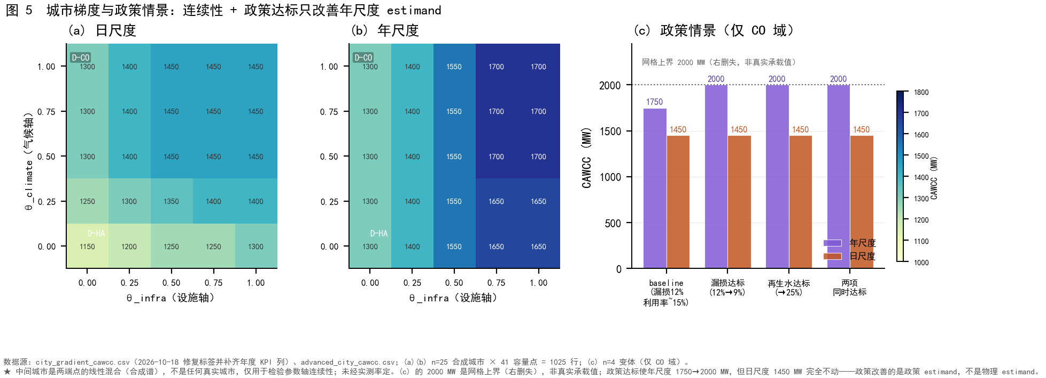
Figure 5. City-gradient scan and policy scenarios. Its two ends reproduce the main results one-for-one (1150 MW with source abstraction, 1450 MW with grid connection), which is what a continuity check should do; the interior points are linear mixtures of the endpoints and are not independent cities. The figure thus demonstrates that the mechanism varies continuously across the parameter domain, not that any interior point corresponds to an observed city.

4. Discussion

4.1 Relation to prior work on rebound in water reuse
The mechanism here is distinct from three established mechanisms that also produce adverse outcomes in water reuse, and the distinction matters because they are frequently conflated. Schwabe et al. describe supply-side self-consumption: indoor conservation reduces wastewater collection and shrinks the reclaimed pool downstream. Tran et al. describe quality-side deterioration: drought combined with conservation raises influent concentration and degrades effluent quality. Ours is a blend-side penalty: both sources meet their standards, the pool is large enough, and yet raising the blending ratio alone reduces the cycles of concentration and raises make-up demand. The three can occur independently, and only the third is invisible to volume-based accounting.
Against global assessments of data–water symbiosis [14] our result is complementary, not corrective. That assessment quantified, across 4775 data centres and 57,547 wastewater plants, savings of roughly 1.3 billion m³ of water and 84 million tonnes of CO₂-equivalent per year plus bidirectional heat recovery. We do not dispute it; we identify the ratio at which its marginal saving begins to erode. Their question is how much can be saved, ours when saving stops being saving. Two asymmetries must be stated. Their evidence base, a global inventory with life-cycle assessment and optimisation, is stronger than ours, so nothing here corrects it. And they return data-centre waste heat to sludge drying and anaerobic digestion, a coupling our model omits by treating that heat as waste.
Against facility-scale accounting the relation is one of level, not disagreement. Reviews of data-centre water use conclude that no single formula applies [8], and national inventories have established the magnitude of the demand, including the concentration of Chinese compute in water-scarce regions [2,5,15]. Those studies answer how much water is used; ours which constraint fails first and how raising the reclaimed ratio reorders that sequence. The value added lies in a mechanism facility accounting cannot express: footprint accounting treats water as homogeneous, so the effect of blend salinity on the cycles of concentration is summed away. Field measurements on a 4.2 MW tower report that raising the cycles of concentration improves water efficiency [3], the same mechanism at a different scale; we therefore claim directional agreement and not agreement with measurement.
The model's material flow separates how much water is withdrawn from where that water ends up, a distinction that matters for environmental assessment. Aggregating 730 daily steps along the topology declared in supply_paths and wastewater_connections, and checking conservation component by component (all intermediate nodes agree to better than 1%; SI Figures S21–S23), yields two quantitative facts not previously stated. First, 78.7% (water-scarce endpoint) and 81.6% (cool endpoint) of AI withdrawal becomes evaporative consumption and does not return to the urban water body; only the blowdown fraction rejoins the wastewater system. About four-fifths of the facility's withdrawal is therefore consumptive use that leaves the basin, not water that can be returned — a substantive difference from treating withdrawal as the sole indicator. Second, flow to the receiving water body falls as AI capacity grows (89,042 ML yr⁻¹ at 0 MW against 80,365 ML yr⁻¹ at 1200 MW, a 9.7% decrease), because more reclaimed water is retained within the city. This must be read separately from the total: total withdrawal rises with AI capacity, and only the discharge falls. The three calibers — facility make-up, urban potable abstraction and urban carrying capacity — are related but not interchangeable; the result here belongs to the first.

4.2 Three levers that must not be conflated
A corollary follows from separating the substitution ratio from capacity and production, all three described as expanding reclaimed-water use yet pointing in different directions. Expanding treatment capacity while leaving production unchanged is ineffective: capacity is not the binding quantity, and the marginal capacity gain is identically zero at every scanned point at both endpoints. Raising reclaimed-water production, by increasing the wastewater diversion fraction from 0.16 to 0.25, is effective and relocates the bottleneck from source abstraction to grid connection at the water-scarce endpoint, a gain of 250 MW on the same grid as the main results. Raising the substitution ratio is harmful once $r>r^{*}$, because it amplifies demand through the quality side. Capacity expansion does not change available production, production expansion adds supply, and ratio expansion inflates demand; conflating them yields planning conclusions of the opposite sign.
Each lever had previously been scanned only along its own axis, which cannot answer how they interact. We therefore ran a $5×5$ scan over (wastewater diversion fraction $f$, substitution ratio $r$) with treatment capacity set at 1.25 × production (SI Figures S18–S20). Three results. First, the two levers differ by an order of magnitude: the production effect is +400 MW at D-HA and +350 MW at D-CO for $r≤0.8$ (the D-CO value is +300 MW at $r=0.8$), against −50 to −100 MW for the ratio effect. Second, raising production does not offset the ratio penalty: at the water-scarce endpoint the penalty is −50 MW at the lowest production ($f=0.16$) and grows to −100 MW at the highest ($f=0.60$). That runs counter to the intuition that producing more water makes a higher ratio safe, and the mechanism is coherent — production lifts the supply side while the penalty acts on the demand side through blend chemistry, so the two do not cancel.
The third is a negative result that must be reported. The preceding paragraph states that raising production relocates the bottleneck from source abstraction to grid connection; that finding comes from the one-dimensional production scan. In the present two-dimensional grid under the purely physical set, the identity of the first-failing constraint does not change at all: source abstraction controls throughout at D-HA and treatment-works utilisation throughout at D-CO (SI Figure S20). The two statements are not contradictory but their conditions differ: the one-dimensional scan observed migration when the diversion fraction rose from 0.16 to 0.25, whereas the two-dimensional grid extends to 0.60 and finds no change of identity. Relocating the bottleneck is therefore not a general property of the production lever but holds in a specific interval under a specific caliber. We accordingly restrict the claim: migration is observed at the water-scarce endpoint when the diversion fraction rises from 0.16 to 0.25, and we do not claim it as a general effect of the production lever.
Two mechanisms can make the policy constraint fail. The reclaimed pool may be capacity-limited, so reclaimed use saturates against a hard supply ceiling. Or the water-quality penalty may dilute the denominator, so the same pool corresponds to a larger make-up demand: at the water-scarce endpoint and 1600 MW reclaimed use rises only from 25,157 to 25,567, or 1.6%, while total withdrawal rises 5.4%. Both operate and neither can be neglected; treating the first as the whole story would misplace the conclusion. We do not claim which dominates at the margin, because the two figures are not decomposable into separate contributions — one is a reclaimed-use volume, the other a total-withdrawal volume, measured on different calibers — and a decomposition would require holding the capacity ceiling fixed while varying water chemistry alone, which we have not done.

4.3 What the criterion is good for
A reviewer may ask what policy value a mechanism has when it does not operate in current policy ranges. The criterion forecasts no city's present state; it delimits an interval, useful at every stage. Far below $r^{*}$ it supplies an executable planning ceiling: the ratio can be raised to $r^{*}$ without cost, stronger than saying a higher ratio happens to be harmless. Near $r^{*}$ it gives the threshold location and its parameter sensitivity. Beyond it, the direction and magnitude of the penalty. For a fully reclaimed campus it gives the four-regime classification, which answers from four parameters whether such a target is achievable. This beats asking whether reclaimed-water cooling is beneficial, because that answer depends on the city while the criterion makes the dependence explicit. What it does not supply is advice: reading this paper as a recommendation that a city set its target at 55% would exceed evidence resting on synthetic endpoints.
One consequence deserves separate mention [6,12]: city-wide utilisation has wastewater throughput as its denominator, so a city can report 25% while a single campus consumes that entire 25% at a ratio near 100%, fully triggering the penalty, whereas the same volume spread over a hundred users leaves every ratio low. At 1000 MW the ratio of wastewater throughput to campus make-up is 5.28, so city-wide utilisation of 20% already permits a campus ratio above 1.0. Aggregate utilisation therefore conceals the heterogeneity the mechanism depends on, consistent with bottleneck location being governed by structure rather than total volume.
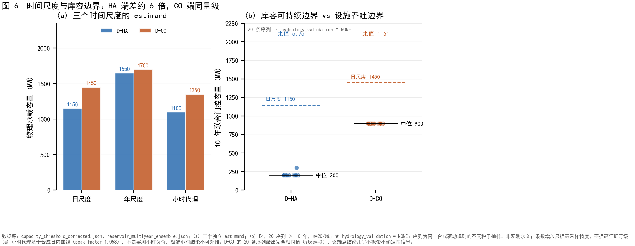
Figure 6. Time-scale and reservoir-boundary results. Panel (a) compares carrying capacity at annual, daily and hourly aggregation; panel (b) sets the multi-year reservoir constraint against the throughput constraint. Annual boundaries sit above the daily ones and the hourly proxy below them, but the hourly proxy rests on a synthesised intraday load curve with assumed training, inference and peak factors, so we report its direction only.

4.4 Limitations
The dominant limitation is that nothing here is calibrated to a real city. All capacity numbers are conditional on synthetic drivers, one parameter set per endpoint and ten uncalibrated thresholds, so they demonstrate mechanism rather than estimate reality. The endpoints are parameter-domain corners, and a 25-city gradient scan checked continuity only. And the threshold rests on four unverified inputs, not one: no parameter among $L$, ${CoC}_{d}$, $C_{p}$ and $C_{r}$ carries a measured anchor. Of these, $C_{p}$ decides the case-city verdict: against 10,090 measured Californian groundwater TDS values the assumed 180 mg L$-1$ sits at the 14th percentile against a median of 420 mg L$-1$, and raising it to that median drives $r^{*}$ from 0.5532 to 0.0870 and to −1.0096 at the neighbouring county median, moving the case city from clearly below the threshold to clearly above it and then into Regime I. The plausible range of an unmeasured parameter straddles the decision boundary. Inverting the closed form gives the requirement: the verdict is "not crossed" iff the true $C_{p}$ is below 230.8 mg L$-1$, so ±25 mg L$-1$ would settle it; the obstacle is availability, not precision. SI S7.10 gives the caveats; the comparison uses groundwater monitoring, not finished water, and does not replace the project value.
Bottleneck attribution rests on a single deterministic scan with no random source, so no sampling error estimate exists. A $±2\%$ perturbation moves daily capacity by up to 250 MW at the water-scarce endpoint, so absolute capacities are unreliable; what survives is the migration structure, with first failures in 1000–1350 and 1450–1500 MW, two non-overlapping intervals (SI Figure S3 gives both the per-constraint first-failure shifts and the capacity interval under simultaneous perturbation of all constraints; the two calibers differ and must not be conflated). Quantisation is why only the zero-effect region and the endpoint decline are cited as numbers. The cool endpoint's negative result was checked on the same three grids: its decline is 50, 25 and 20 MW at 50, 25 and 10 MW resolution, never exceeding 3.45% of its baseline, so the conclusion that it barely moves survives refinement, with the coarse grid slightly overstating it. All 36 pairwise intervention combinations were subsequently run on the same grid in both calibers: 35 of 36 are exactly additive at each endpoint, and the sole non-additive pair — leakage reduction with the combined upgrade — is redundant by construction, since the upgrade already contains leakage reduction, so its interaction equals minus the leakage gain exactly. No pair showed the pattern that would matter for the argument, namely two individually ineffective interventions becoming effective together.
Parameter uncertainty forms a separate body of evidence and must be kept apart from the deterministic comparisons above. Across 1024 Latin-hypercube samples of PUE, design cycles of concentration and the temperature coefficient, the nominal CAWCC sits at P73 and P70 of the respective distributions, with P05–P95 intervals of 950–1200 and 1250–1500 MW (SI Figure S1). The sampling band, about ±150 MW at the water-scarce endpoint, is larger than the 100 MW effect claimed here. That does not refute the conclusion — the 100 MW is a difference between two deterministic scenarios at identical parameters, not a cross-sample comparison — but it bounds what may be claimed: the effect cannot be read as a signal resolvable under parameter uncertainty. Relatedly, global sensitivity shows that the first-order driver of the water-side metric is the distribution-network leakage rate rather than the substitution ratio (SI Figure S2), consistent with a mechanism in which the ratio acts only beyond a threshold and only where the bottleneck is on the water side; the paper's claim is about conditional structure, not about the ranking of main effects.
The grid constraint's semantics are unresolved: the model does not distinguish campus-connection capacity from node-available capacity in the urban grid, which governs how the electrical bottleneck should be read. It may represent an engineering constraint on campus interconnection rather than physical headroom, and is the element most likely to be challenged. A quantitative fact belongs with that caveat: both endpoints set the connection capacity to $1500$ MW, and the cool endpoint's 1450 MW corresponds to a daily-peak load of about $1490$–$1509$ MW, a peak-to-capacity ratio of $0.99$–$1.01$. At 1750 and 2000 MW that ratio rises to $1.20$ and $1.37$, meaning the peak exceeds the connection capacity. The 1450 MW is therefore an artefact of where the capacity was set, not an estimate of a real grid's headroom, and no capacity value here should be read as operationally feasible.
The threshold is not a universal constant but the value at the endpoint parameters; any city's value must be computed from its own. Classification boundaries are thin: when $C^{*}$ approaches either source salinity a small error changes the regime, so we claim a method rather than any city's assignment. Regime I was verified at a design value of 15, engineeringly unrealistic since real towers rarely exceed 8, so that construction serves logical verification rather than description. Validation used one endpoint, one capacity and five ratios, so universality rests on the derivation.
The real-city section is an application, not a verification. We have not observed make-up demand rising as a city crossed $r^{*}$; that needs facility-level time series we do not hold. The two shares have different denominators, cannot be summed, and have an undisclosed period. The city-wide ratio averages over 56 facilities rather than describing any one, and $k$ is caliber-sensitive: the calibers differ by 5.5 points in $r$, the same magnitude as the 5.4-point margin, so the direction is determined while its size is not. The state-wide distribution comes from a selected subsample and cannot be extrapolated.
Three implementation conventions bound the numbers and are declared here rather than in the SI. First, the cycles of concentration are solved from the *target* substitution ratio, not from the fraction actually delivered; where reclaimed supply falls short the model therefore understates make-up demand. Delivery is near-complete over $r≤0.9$ at both endpoints (SI S5.4b), so this is second-order for the main results, and it biases the high-$r$ penalty upward rather than downward. Second, when the mixed make-up exceeds the salinity limit $C_{mix}>L$, the model clamps the cycles at $1.000001$ and returns normally instead of flagging infeasibility, driving make-up towards $10^{6}E$; no result reported here enters that branch, since $C_{mix}$ reaches at most $603$ mg L$-1$ for $r≤0.9$ (at $r=0.9$; $509$ mg L$-1$ at $r=0.7$) against a limit of $2200$ mg L$-1$, but the criterion requires $C_{mix}<L$ as a precondition. Third, water-use effectiveness is only quoted where supply is sufficient: the finalisation step rescales the water volumes when supply falls short but not the WUE itself, so WUE would be overstated under unmet demand. Shortfall is carried by the carrying capacity and total withdrawal, not by WUE.
A fourth convention concerns the salt balance. The model's quality_solute_closure_residual_kg is an accounting identity, not evidence of conservation: it is initialised to zero and then accumulated as start plus inflows minus withdrawals minus end, while solute withdrawal is itself apportioned by volume, so the expression is identically zero. Replacing the declared reclaimed TDS with 0 (physically absurd) or 5000 (extreme) leaves the residual at or below $1.1×10^{-12}$, and a one-day run gives exactly zero; a check that passes under arbitrary inputs carries no evidential weight. Evaluated instead against the correct identity $M C_{makeup}=(B+D-IR) C_{blow}$, the residual reaches about $+89\%$ at 70% reclaimed water, so the salt balance is not strictly closed once internal recovery is active (with $IRF=0.1$ the shortfall is about $8\%$). None of this alters a reported number, because every result in this paper runs the legacy volume-only path, which carries no day-by-day salt ledger; it is stated so that the closure diagnostic in the SI is not read as a verification of conservation.
Finally, the time-scale results are demoted rather than argued. Annual boundaries exceed daily ones by 500 and 250 MW and the hourly proxy falls below by 50 and 100 MW, but the proxy rests on a synthesised intraday curve with assumed training, inference and peak factors; we report its direction only.

5. Conclusions
- A closed-form threshold, $r^{*}=(L/{CoC}_{d}-C_{p})/(C_{r}-C_{p})$, determines the reclaimed-water substitution ratio above which raising the ratio increases total cooling make-up demand; it matches model output to machine precision and requires only four water-quality parameters.
- The criterion is a minimum over limiting constituents, not a TDS-specific formula. The three constituents give 0.5532 (TDS), 0.6842 (chloride) and 0.5217 (hardness), the system threshold is set by whichever is tightest, and the controlling constituent switches with the ratio, so the same city is governed by a different indicator at different ratios. Across a parameter grid TDS is tightest in only 27.7% of combinations, so the reported 0.5532 is this pair of water-quality parameter sets, not a general rule.
- The response is threshold-typed. The penalty is exactly zero for $r≤r^{*}$ and becomes independent of data-centre capacity beyond it, with a $+6.47$ to $+6.48\%$ increase in total withdrawal between 200 and 1600 MW.
- Bottleneck location is an endogenous function of the policy variable. Under a purely physical constraint set the water-scarce endpoint loses about 100 MW as the ratio rises from 0.5 to 0.9, while the grid constraint remains unchanged; the cool endpoint loses essentially nothing under the baseline climate because its bottleneck is electrical.
- Bottleneck identity is separable on a phase diagram in the (abstraction capacity, grid capacity) plane, whose frontier is fixed by the grid connection ratio alone and is independent of abstraction capacity. The two domains' frontiers lie at 1256.25 and 1631.25 MW; the water-scarce endpoint's setting sits 243.75 MW above its frontier and the cool endpoint's 131.25 MW below its own, so the latter's electrical bottleneck is a consequence of where the capacity was set and can be quantitatively overturned.
- Two conditions must hold together for the penalty to change carrying capacity: the ratio must exceed $r^{*}$, and the first-failing constraint must lie on the water side. The cool endpoint establishes the second condition, but that negative result is climate-conditional: under a summer +4 °C heat scenario the same endpoint's decline doubles from 50 to 100 MW. Drought collapses the water-scarce endpoint to 100 MW and flips its bottleneck to the water side, and the compound scenario is infeasible at both endpoints.
- Within current policy ranges the mechanism has no capacity consequence. This exact zero is reproduced on 50, 25 and 10 MW grids and is falsifiable by any non-zero observation, which makes it a stronger claim than a predicted small effect.
- The criterion reduces to a screen requiring two published numbers. Cities whose ratio of potable to reclaimed water use falls below 3.50 necessarily exceed $r^{*}$; among 169 California systems, 13.6% fall below this value.
- Three levers must not be conflated, and they differ by an order of magnitude: the production effect is +350 to +400 MW against −50 to −100 MW for the ratio. Raising production does not offset the ratio penalty — at the highest production the water-scarce endpoint's penalty grows from −50 to −100 MW — and the previously reported bottleneck relocation holds only as the diversion fraction rises from 0.16 to 0.25, not across a two-dimensional grid extending to 0.60.
- The model's material flow yields a fact not previously stated: 78.7% (water-scarce endpoint) and 81.6% (cool endpoint) of AI withdrawal becomes evaporative consumption and does not return to the urban water body, so about four-fifths of facility withdrawal leaves the basin; flow to the receiving water body simultaneously falls 9.7% as AI capacity grows while total withdrawal rises. The two directions must be reported separately.
- The 100 MW is a deterministic scenario difference, not a resolvable statistical signal: across 1024 parameter samples the nominal CAWCC sits at P70–P73 and the sampling band of about ±150 MW exceeds the effect.
- The results demonstrate mechanism under synthetic parameters and are not estimates of any city's carrying capacity; calibration against a city with a published water balance and at least one metered campus remains the step required to convert the criterion into a forecast.

Data availability
All model outputs are archived in validation_artifacts/r2/ of the project repository: the six-estimand capacity thresholds, per-constraint first-failure and informativeness tables, the substitution-ratio scan products, the grid-convergence runs at 50, 25 and 10 MW, the regime-map and validation products, and the confound-control table. The California dataset derives from the 2022 Electronic Annual Report of the California State Water Resources Control Board, and the Santa Clara water balance from its 2025 Urban Water Management Plan. Code for the analytic derivations and the screening calculation accompanies the archive.

Declaration of Generative AI and AI-assisted technologies in the writing process
During the preparation of this work the authors used a large language model-based assistant for drafting, language editing and consistency checking of numerical statements against the archived model outputs. After using this tool the authors reviewed and edited the content as needed and take full responsibility for the publication.

Acknowledgements
[To be completed by the authors: funding sources, institutional support and individuals who provided data or comments.]

References
[1] Alissa H, Nick T, Raniwala A, Arribas Herranz A, Frost K, Manousakis I, et al. Using life cycle assessment to drive innovation for sustainable cool clouds. Nature 2025;641:331–8. https://doi.org/10.1038/s41586-025-08832-3
[2] Alston G, Love N, Haider R. Data center cooling choices shift water impacts across the grid: an integrated water-energy model for sustainable data centers. Preprint 2026. https://doi.org/10.48550/arxiv.2609.25437
[3] Badruzzaman M, Anazi JR, Al-Wohaib FA, Al-Malki AA, Jutail F. Municipal reclaimed water as makeup water for cooling systems: water efficiency, biohazards, and reliability. Water Resour Ind 2022;28:100188. https://doi.org/10.1016/j.wri.2022.100188
[4] Behzadian K, Kapelan ZS. Modelling metabolism based performance of an urban water system using WaterMet2. Resour Conserv Recycl 2015;99:84–99. https://doi.org/10.1016/j.resconrec.2015.03.015
[5] Chen S, Zhang L, Liu B, Yi H, Su H, Kharrazi A, et al. Decoupling wastewater-related greenhouse gas emissions and water stress alleviation across 300 cities in China is challenging yet plausible by 2030. Nat Water 2023;1:534–46. https://doi.org/10.1038/s44221-023-00087-4
[6] Garrido-Baserba M, Sedlak DL, Molinos-Senante M, Barnosell I, Schraa O, Rosso D, et al. Using water and wastewater decentralization to enhance the resilience and sustainability of cities. Nat Water 2024;2:953–74. https://doi.org/10.1038/s44221-024-00303-9
[7] Han Y, Li P, Wierman A, Ren S. Small bottle, big pipe: quantifying and addressing the impact of data centers on public water systems. Preprint 2026. https://doi.org/10.48550/arxiv.2603.02705
[8] Lei N, Lu J, Shehabi A, Masanet ER. The water use of data center workloads: a review and assessment of key determinants. Resour Conserv Recycl 2025;219:108310. https://doi.org/10.1016/j.resconrec.2025.108310
[9] Mytton D. Data centre water consumption. npj Clean Water 2021;4:11. https://doi.org/10.1038/s41545-021-00101-w
[10] Renouf MA, Kenway SJ, Lam KL, Weber TR, Roux E, Serrao-Neumann S, et al. Understanding urban water performance at the city-region scale using an urban water metabolism evaluation framework. Water Res 2018;137:395–406. https://doi.org/10.1016/j.watres.2018.01.070
[11] Saleh NB. Why water demand is no longer enough: rethinking sustainability in AI data centers. Environ Sci Technol 2026;60:18383–6. https://doi.org/10.1021/acs.est.6c08380
[12] Shen J, Shen L, Zhong S, Li D, Li D, Fang J, et al. China's centralized wastewater treatment system reaches efficiency limits in tackling water scarcity. Nat Water 2026. https://doi.org/10.1038/s44221-026-00727-5
[13] Siddik MAB, Shehabi A, Marston LT. The environmental footprint of data centers in the United States. Environ Res Lett 2021;16:064017. https://doi.org/10.1088/1748-9326/abfba1
[14] Wang A, Zhang C, Xu T, Savic D, Jiang J, Xiao P, et al. Global data–water symbiosis reduces AI infrastructure's carbon and water footprint. Environ Sci Ecotechnol 2026;31:100702. https://doi.org/10.1016/j.ese.2026.100702
[15] Xiao T, Fuso Nerini F, Matthews HD, Tavoni M, You F. Environmental impact and net-zero pathways for sustainable artificial intelligence servers in the USA. Nat Sustain 2025;8:1541–53. https://doi.org/10.1038/s41893-025-01681-y

