LumiNova®

LIGHT FAST - SUPER BRIGHT
LONG AFTERGLOW

PHOSPHORESCENT PIGMENTS

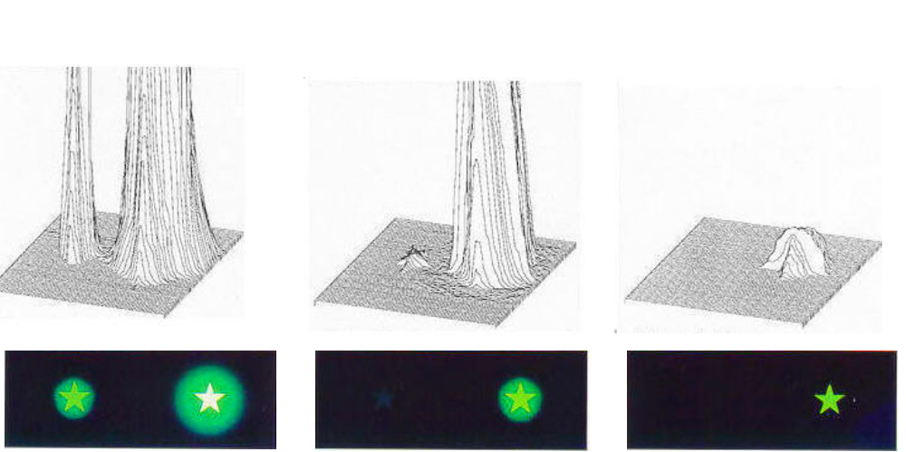

Afterglow after 5 Minutes Afterglow after 60 Minutes Afterglow after 500 Minutes

Conventional Pigment LumiNova® Conventional Pigment LumiNova® Conventional Pigment LumiNova®

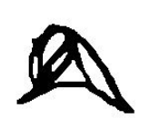

LumiNova®

LIGHT FAST - SUPER BRIGHT
LONG AFTERGLOW
PHOSPHORESCENT PIGMENTS

- What is LumiNova® ?

LumiNova® is a class of newly developed phosphorescent ( glow-in-the dark) pigments which are based on Strontium Oxide Aluminate chemistry. They are drastically different from conventional phosphorescent pigments, which are either based on Zinc Sulphide or on radioisotopes for their self-luminous properties. LumiNova® Pigments are in the TSCA and ELINCS ( nº 416-840-1) inventory and Nemoto & Co, Ltd. Was granted the U.S. patent in 1995 and since then in many other countries worldwide.

LumiNova® was invented and developed by NEMOTO & Co Ltd. of Tokyo, Japan. Nemoto has been in the luminous pigment business since 1941 and is one of the leading phosphorescent pigment manufacturers in the world.
The development of LumiNova® resulted from the demands placed upon Nemoto & Co. Ltd., by the Japanese watch and clock manufacturers which did not want to use radioactive luminous dials in their products. This challenge created LumiNova®!

LumiNova®, which glows practically all night long without the aid of any radioactive substances was chosen as Most Innovative Product in Japan in 1993.

- Features of LumiNova®.

Some of the advantages and distinguishing features of
LumiNova® pigments are:

- Afterglow period of ten times current ZnS based phosphorescent pigments;
- Activation by a wide wavelength band (200-450nm), but best results are obtained with an activation energy under 365nm;
- Initial afterglow brightness of up to ten times of current radio luminescent and photo luminescent pigments;

- Increase in luminescence and afterglow with longer activation time;
- Excellent weather and light fastness;
- Free of hazardous and radioactive substances.

3. Applications of LumiNova®

LumiNova® was originally developed to satisfy the current and future needs of the clock, watch and instrument dial industries, but soon it was found out that like many other new products, the application possibilities are almost limitless.

The following applications are those that come to mind immediately:

- Clock & Watch dials;
- Electronic instrument dial pads;
- Home appliances;
- Lighting apparatus and switches;
- Exit sign boards;
- Emergency signage and low level lighting escape systems;
- Aircraft and automobile dials and instrument panels;
- Firemen's equipment;
- Traffic signs & high visibility signs;
- Fishing equipment;
- Military applications;
- Outdoor path marking;
- Camping equipment;
- Textile printing and textile fibres;
- Writing and printing inks.

All other applications where a long afterglow and/or light fastness is needed.

- Comparison between LumiNova® types and Conventional Phosphorescent Pigments :

 | LumiNova® Green  (G) | LumiNova® Blue Green  (BG) | Conventional Phosphorescent Pigment
Chemical Identity | Strontium Oxide Aluminate | Strontium Oxide Aluminate | ZnS:Cu
Body Colour | Light Yellowish Green | Light Yellowish Green | Yellowish Green
Av. Particle Size | (6) 10-40 μm | (6) 10-40 μm | 20-40 μm
Excitation Energy | 200-450nm | 200-450nm | 200-450nm
Emission Wave Length | 520 nm | 480 nm | 530 nm
(1) (5) Afterglow Brightness | ≈ 300 mcd/m² | ≈ 300 mcd/m² | 20-30 mcd/m²
(2) Afterglow Extinction |  2.000 min. |  2.000 min. | 200 min.
(3) Excitation Time | ≈ 30 min. | ≈30 min. | ≈4 min.
(4) Light Fastness |  1,000 hours |  1,000 hours | 10-24 hours
Chemical Stability | Very Good (except water) | Very Good | Poor to good
(5) Specific Gravity | 3.6 | 3.9 | 4.1

(1) Brightness after 10 minutes excitation with a D₆₅ illuminant of 200 lux for 4 minutes.
(2) Time necessary for afterglow brightness to diminish to 0.32 mcd/m^{2.}
(3) Time required for saturation with standard D₆₅ illuminant at 200 lux.
(4) Time required for initial afterglow to drop to 20% after irradiation with 300 W high pressure mercury
lamp (accelerated light fastness test)
(5) In powder form.
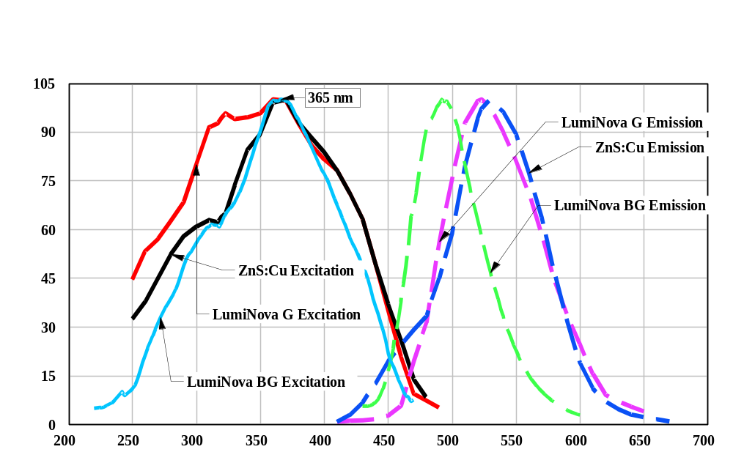(6) Depends on type (based on particle size) of ®.

Excitation & Emission Spectra

LumiNova® Green, Blue Green & ZnS:Cu
Pigments

Relative Intensity (%)

Wavelength (nm)

5. Features & Properties of LumiNova®

Grades of LumiNova® :

Currently LumiNova® is offered in four types.
Differentiation is based on the particle size of the pigment and the afterglow characteristics. As a rule of thumb, the coarser particles will have better brightness and afterglow, and the finer particles are preferred where particle size is of greater importance.

Effect of Light Source on Brightness.

Light Source | Luminous Intensity  (Lux) | Excitation Time to Saturation  (Min)
Sunlight, Clear | > 50,000 | 5
Sunlight, Cloudy | 3,000-50,000 | 5
Dusk | 1,000 | 8
Fluorescent Lamp (Office) | 500 | 10
Fluorescent Lamp (Home) | 200 | 30
Tungsten Lamp (60W) | 30-50 at 3 ft | 40
Headlights ( Yellow tint) | Not effective  (Exposure time too short) | -

Moisture Sensitivity :

LumiNova® are moisture sensitive. In most cases the resin component of the coating would protect the pigment from the effects of atmospheric humidity, but for even better results the pigmented layer should be over coated with a clear coat, which would protect the under layer from humidity.
In cases where the edges might be exposed to humidity, care should be taken that the edges are sealed properly.

Typical Particle Size

Grade | Typical Particle Size (μm)
Grade | D₁₀ | D₅₀ | D₉₀
300 C | 4.55 | 42.00 | 90.60
300 M | 1.85 | 18.60 | 47.00
300 F | 1.00 | 9.40 | 27.60
300 FF(*) | 0.7 | 2.45 | 3.85
(*) For G-300 FF type D_{max} value is 8 μm.

Brightness, Afterglow and Emission Color.

The most effective energy saturation can be obtained when the pigment is exposed under direct ultra violet rays (UV) from the sun, black lamps, halogen lamps, discharge lamps and other light sources which are rich in UV light ( this can be seen also from the Excitation Emission curves). Tungsten lamps are not very effective exciters as their light output is weak in UV. With fluorescent lamps, which are rich in UV, faster excitation is possible when the pigment is placed near them. Afterglow brightness is also proportional to the intensity of UV contained in the excitation light.

Light Fastness :

LumiNova® pigments also have excellent light fastness compared to conventional phosphorescent pigments. Test samples were irradiated with a 300 W High Pressure Mercury lamp for 1,000 hours under a temperature of 38-40ºC and 80% humidity and the results are shown in the following table:

 | Relative Afterglow (%) After Exposure
Pigment | 0 | 10hr | 100 hr | 300 hr | 1000 hr
LumiNova® | 100 | 98 | 98 | 97 | 96
ZnS :Cu Pigment | 100 | 86 | 35 | 0 | 0

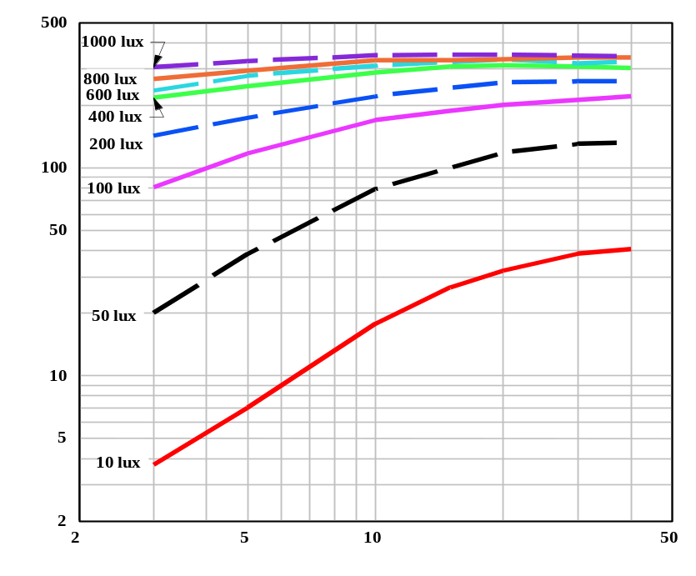
Excitation Light Intensity & Saturation

Afterglow Luminance (mcd/m2)

Excitation Time (minutes)

AfterglowCharacteristics
Effect of Excitation Energy on Afterglow Brightness
Luminance (mcd/m2)

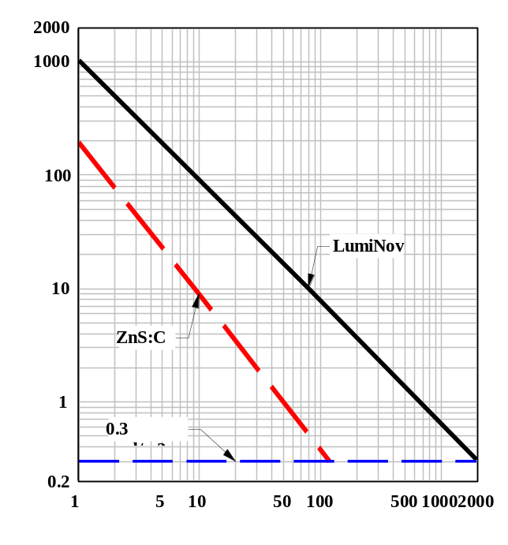

Realtive Intensity (%)

Time (Minutes)

This graph shows the afterglow characteristics of LumiNova® compared to a ZnS :Cu based pigment. The measurements were taken on silk screened surfaces of 100 μm thickness, which were excited with a D⁶⁵ light source at 200 lux for 4 minutes. As the data indicate, LumiNova® is TEN TIMES BRIGHTER and has over TEN TIMES THE AFTERGLOW of ZnS :Cu based pigments.

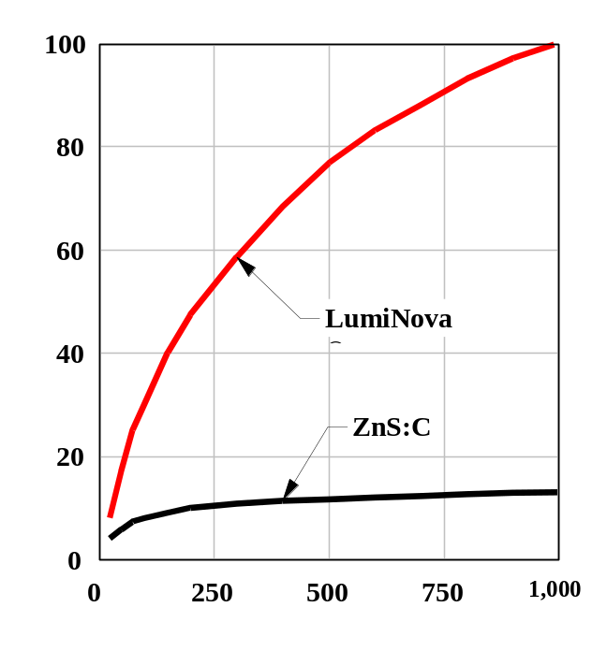

Illuminance (Lux)

The above graph shows that LumiNova®'s afterglow brightness increases with increase in light source intensity. The conventional phosphorescent `pigments reach a plateau around 300 lux light intensity.

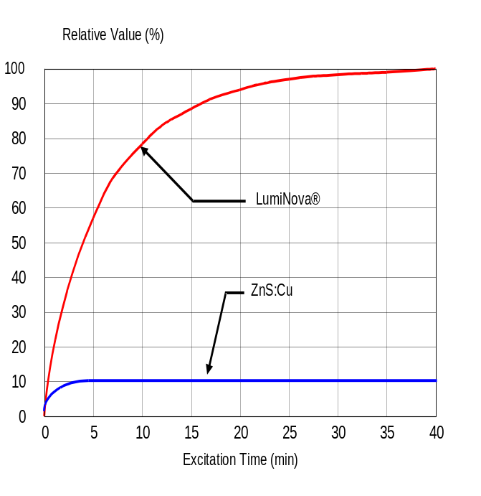
Excitation Time on Afterglow Brightness

LumiNova® shows a much higher capacity for absorbing and storing light energy (i.e. does not easily reach it's saturation point) compared to conventional phosphorescent pigments.
This graph shows the results when both types of pigment were excited using a D₆₅ light source of 200 lux intensity for different lengths of time.

Effect of Weight per Unit Area :

Under constant lighting conditions, increasing the weight per unit area of pigment increases both initial afterglow brightness and the afterglow duration. The table below shows such a study made by exciting paraffin disks of 2 mm thickness, containing different weights per unit area of LumiNova®. The excitation source used was a Xenon lamp at 1000 lux intensity for 5 minutes.

Afterglow Brightness & Duration Based on Weight per Unit Area of LumiNova®

 | Pigment Loading
Time | 10 g/m² | 25 g/m² | 50 g/m² | 100 g/m² | 200 g/m² | 400 g/m²
1 min | 94.5 | 218.9 | 390.8 | 689.2 | 1,231.0 | 2,610.0
5 min | 24.1 | 49.7 | 97.5 | 171.5 | 306.0 | 697.0
10 min | 12.4 | 26.0 | 50.5 | 90.1 | 156.1 | 364.0
30 min | 4.03 | 8.2 | 16.4 | 29.2 | 50.2 | 118.8
60 min (1 hr) | 1.91 | 3.97 | 7.71 | 13.5 | 23.4 | 55.8
90 min (1.5 hr) | 1.16 | 2.45 | 4.81 | 8.62 | 14.7 | 34.8
120 min (2 hr) | 0.84 | 1.75 | 3.45 | 6.06 | 10.4 | 24.8
180 min (3 hr) | 0.53 | 1.13 | 2.14 | 3.62 | 6.38 | 15.4
240 min (4 hr) | 0.36 | 0.79 | 1.5 | 2.66 | 4.57 | 10.9
300 min (5 hr) | 0.28 | 0.62 | 1.17 | 2.1 | 3.4 | 8.38
360 min (6 hr) | ⎯ | 0.48 | 0.91 | 1.75 | 2.76 | 6.47
420 min (7 hr) | ⎯ | ⎯ | 0.78 | 1.4 | 2.23 | 5.62
480 min (8 hr) | ⎯ | ⎯ | ⎯ | 1.2 | 1.91 | 4.77
540 min (9 hr) | ⎯ | ⎯ | ⎯ | ⎯ | 1.7 | 3.97
600 min (10 hr) | ⎯ | ⎯ | ⎯ | ⎯ | ⎯ | 1.05
Extinction Time  (to 0.3mcd/m²) | 270 min  (4.5 hr) | 480 min  (8 hr) | 750 min (12.5 hr) | 1,200 min (20 hr) | 2,400 min (40 hr) | 3,000 min (50 hr)

6. Applications :

LumiNova® pigments may be used in all types of paint, powder coatings, silk screen inks, enamels, plastics and even porcelain ( up to 500ºC). LumiNova® pigments are not stable in water, therefore aqueous systems are not recommended unless special precautions are taken. ( Please contact our Technical Department for discussion). For optimum performance the following suggestions should be useful:
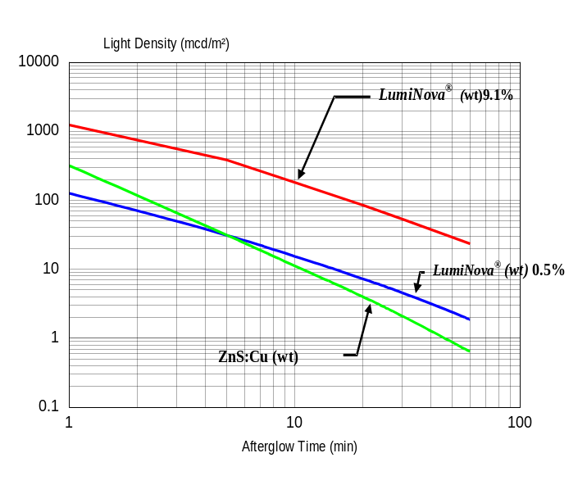
Paints & Coatings:

- Use a transparent solvent vehicle with neutral or alkaline pH.
- Do not grind the pigment, just stir. If possible use light coloured ceramic or glass lined vessels.
- Plan on using about 10 parts of LumiNova® to 6 parts of binder ( by weight).
- Shelf life depends on the moisture content of the vehicle. If moisture is present, shelf life is diminished. Although solvent based paints do not contain moisture, some of them might absorb ambient moisture. Therefore take precautions to minimize this from happening.
- To minimise settling, use a viscous vehicle and/or anti-settling agents. Stir well prior to application.
- Apply with a white base coat under the phosphorescent layer to improve afterglow.
- Apply a clear overcoat to protect the pigment from humidity and to improve gloss.
- All additives should be free of heavy metal compounds.

Inks : Silk Screen & UV Cured :

- Viscosity of inks should be about 3,000- 5,000 poise. During printing, viscosity should be adjusted by using a diluting agent based on printing speed.
- Apply a white base coat under the phosphorescent layer to improve afterglow.
- Minimum film thickness of the LumiNova® layer should be 100 μm. In order to achieve maximum afterglow ( over 8 hours), a film thickness of 130- 150 μm is required. For achieving this thickness two passes may be necessary.
- Ideal screen size would be 80-100 mesh. Larger screen openings would give better results. Preferably, use screens manufactured from synthetic resins.
- One pound of dry LumiNova® pigment can cover a 12 square foot area at a 150 μm film thickness (1 gram covers 25 cm²).
- To minimize settling, use a viscous vehicle and/or anti- settling agents. Also stir well prior to printing.
- It is very important to keep the entire system dry! A yellowing of the resin may indicate the pigment reacting with moisture.

Plastics- General::

- LumiNova® is compatible with acrylic, polyester, epoxy, PVC, polypropylene and polyethylene (HDPE, LDPE, etc) polymers.
- Material can be cast, dipped, coated, extruded or moulded.
- Plan on using less than conventional phosphorescent pigment loadings. ( see following graph)
Masterbatch Manufacturing:
- Preferably use masterbatches or compounds for incorporating LumiNova® into plastics. As LumiNova® is a very hard substance (comparable to alumina) and the particles have a needle like shape
( sharp- edged), it is difficult to incorporate them into
plastic resins directly (they can be regarded as glass
or ceramic powders) .
- Prior to starting manufacturing a masterbatch, the interior of the extruder should be thoroughly cleaned.
- Processing temperature should be set about 10ºC (20ºF) higher than usual. The extruder should be cleaned again by running virgin resin until clean resin starts coming out of the machine.
- The recommended machine configuration is one with a distributive screw design and twin hoppers. Use the first to feed the resin and additives and the second to dose LumiNova® into the polymer belt. This would minimize the chances of LumiNova® abrading the interior surfaces of the extruder.
- If the above is not possible keep the mixing
( interaction) time if pigment and resin as short as
possible. Stirring for a longer period may cause
darkened products.
- The resin and pigment should be thoroughly dried before the extrusion process.
- Using carrier resins in powder form can also minimize darkening.
- Masterbatches containing up to 50% of LumiNova® pigment can be manufactured.
Extrusion Moulding::

- For extrusion a small-bored machine would be preferable as to minimize residence time. Extruders with large inside wall areas or equipped with complicated screw geometries tend to cause darkening of the end product.
- It is recommended to use an extruding temperature as low as possible ( only experimentation will give the right temperature level).
- The optimum back pressure should also be determined by experimentation.
- The colour of the pellets being produced should be observed, they should be the same as the pigment itself.
- The best temperature level inside the barrel is closely related to screw geometry and back pressure, these should be determined after repeated experiments.

Injection Moulding::

- The use of an injection moulding machine equipped with a small chamber is recommended. For instance, for injection moulding of a piece of 50 grams per shot with a duration of 3 minutes, do not use a machine with a 5 kg chamber capacity as it will have enough resin for 100 shots. This means a residence time of 300 minutes. In such a case, the final product would probably be darkened. An adequate sized chamber would be the one in which a resin stays at most for 30 minutes or less.
- A test run with a virgin resin is recommended before injection moulding with LumiNova®.
- Masterbatches or pellets containing LumiNova® must be fully dried up before usage.
- The most adequate moulding temperature should be determined by running experiments at different temperatures.
- It is difficult to inject mould resins containing a stabilizer or resins which are hygroscopic or contain water.

General Precautions:

Although LumiNova® is chemically stable, we would like to repeat here a number of things to avoid:

- Do not grind or mill the pigment. Breaking down the crystals will destroy the afterglow.
- Avoid exposing the pigment to strong acids or heavy metal compounds. They will react and destroy the glow. Also keep away from moisture.
- LumiNova® is a hard material and this might cause abrasion of extruder internal metal surfaces. In order to avoid this problem either use specially surface hardened barrels and screws, or a wax to wet LumiNova® prior to extruding, or use a machine with two entry ports.
- Avoid moisture and aqueous systems. Though once the pigment is incorporated into the solvent based resin system or plastic resin, it is not affected by moisture.
- We have tested our products thoroughly, but the afterglow properties are depending on the pigment quantity used and the manufacturing processing which the pigments are applied. The efficiency of phosphorescent pigment containing articles can only be observed when installed properly and excited under correct lighting conditions as required by proper authorities. Therefore we cannot guarantee that the end products containing LumiNova® conform to the required standards.

7. Conclusion :

LumiNova® is sure to revolutionize the glow-in-the-dark product's field. It's superior light fastness, combined with it's high initial brightness and long afterglow, will create new opportunities for companies that were limited by the restrictions placed upon them by conventional phosphorescent pigments. Now the only limit is the designers imagination!

The information herein is to assist customers into determining whether our products are suitable for their applications. Our products are intended for sale to industrial and commercial customers. We request that customers inspect and test our products before use and satisfy themselves as to contents and suitability. We warrant our products will meet our written specifications. Nothing herein shall constitute any other warranty express or implied, including any warranty or merchantability or fitness, nor of protection from any law or patent to be inferred. All patent rights are reserved. The exclusive remedy for all proven claims is replacement of our materials, and in no event shall we be liable for special, incidental or consequential damages.

Manufactured by :
Nemoto Lumi-Materials Co. Ltd
4-10-9 Takaido-Higashi,
Suginami-ku,
Tokyo 168-0072,
Japan

Imported and distributed by :

G.B.C. (Speciality Chemicals) Ltd
The Old Fire Station, Browns Lane,
Charlbury, Chipping Norton
OXON, OX7 3QW, United Kingdom
Tel : 0044 (0)1608 813088 Fax : 0044 (0)1608 813089
e-mail : info@gbcspecs.co.uk
Website : www.luminova.co.uk

