Madelynn Schina

The purpose of this work is to write code to simulate from a multiple regression model and to evaluate some common statistical properties of the simulation.

- Write a program to create 20 simulated datasets from the following linear regression model.
  - N=100, X1= 0 or 1 with ½ in each group, X2 = age, mean = 39 years and SD = 5, X3 = the interaction between X1 and X2. Set beta0 = 1, beta1 = 1, beta2 = 0.5, beta3 = 0.25. Variance of model error = 1.

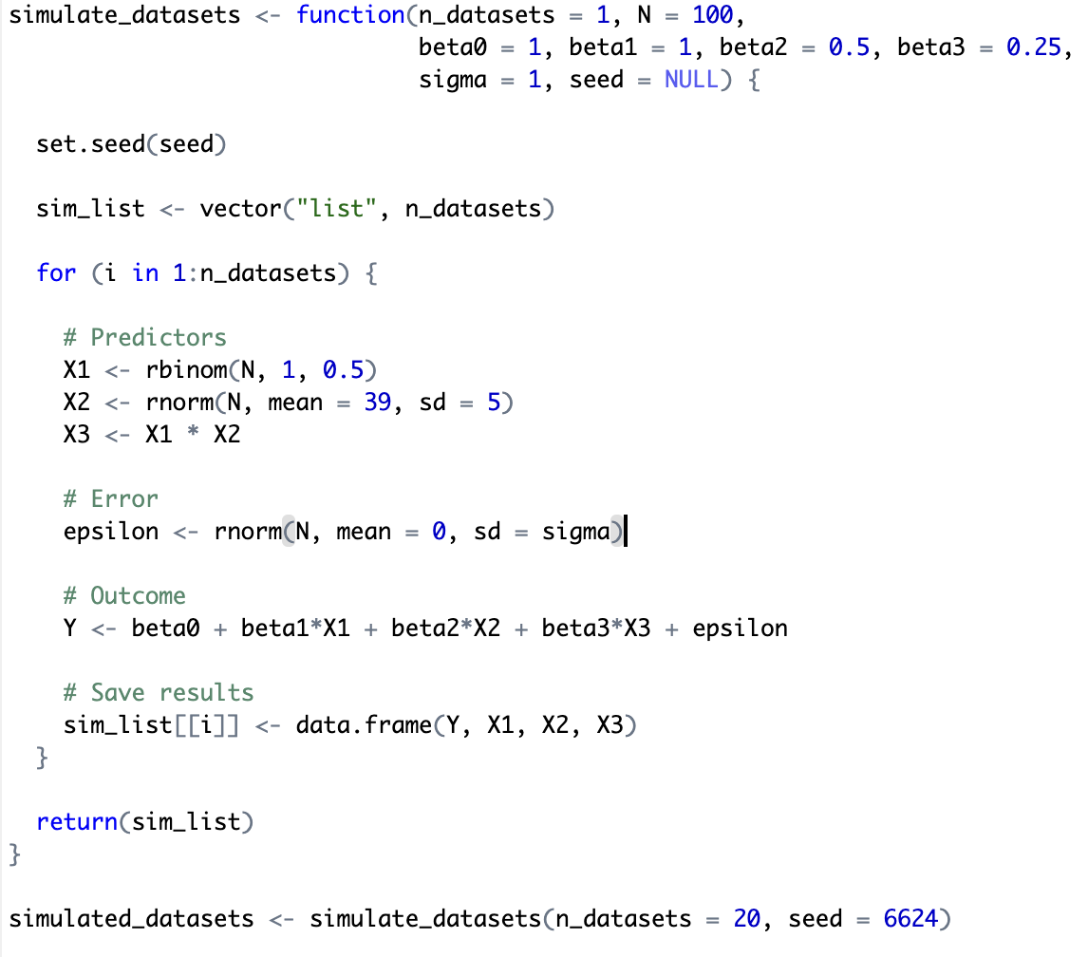

- Plot of the simulated datasets with X2 on the X axis and the simulated outcome on the Y axis. Should we make any changes to the parameters? Is there a reasonable amount of error and variation across the simulated datasets?

The matching trends across all 20 datasets appear as we wound expect, with distinct groups and general positive trends for both. However, the low standard deviation and set sample size limit variation across datasets. Increasing the standard deviation and/or decreasing the sample size would introduce more realistic variability, more similar to what we would expect of real data.
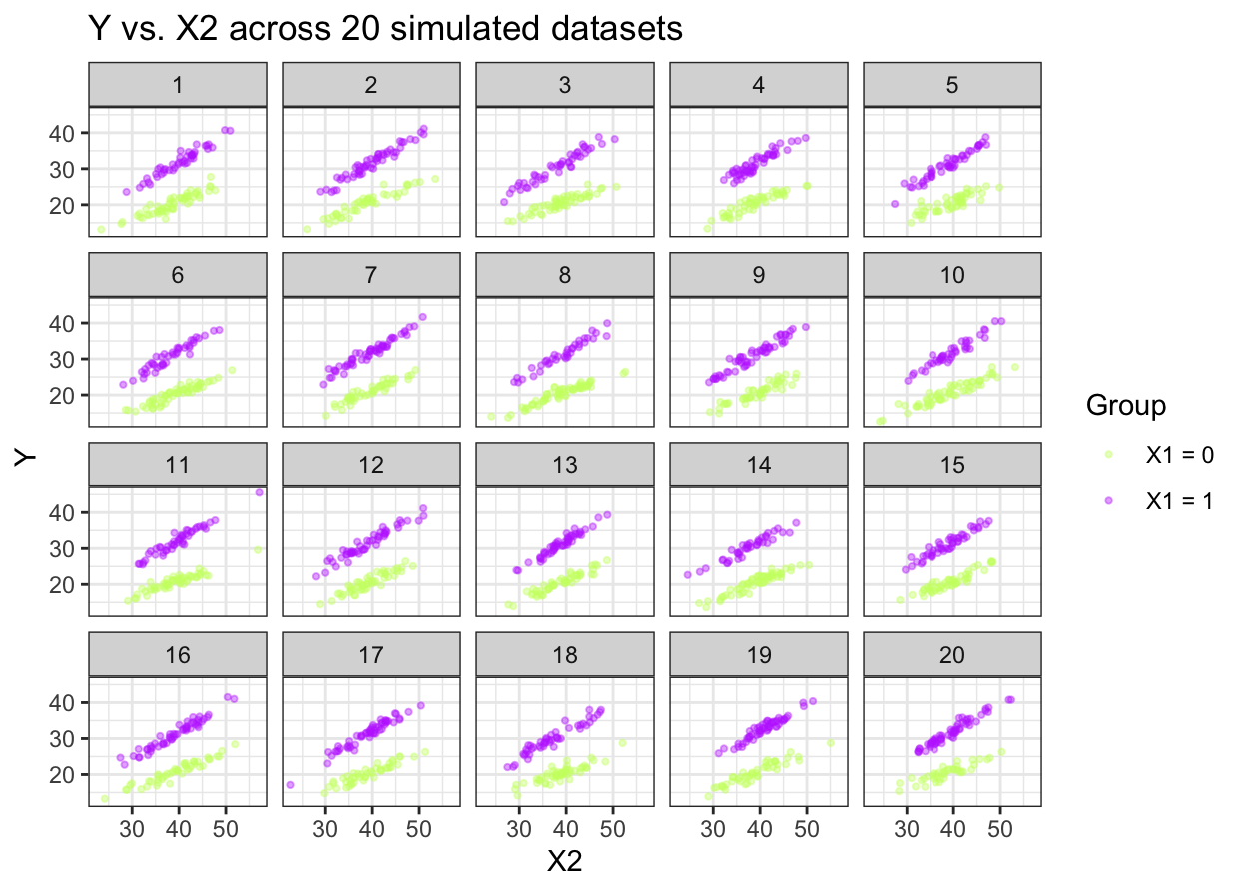

- Summarize the following operating characteristics:
  - Bias of the parameter estimates.
  - Coverage of the 95% CI.
  - Power of the t-tests for each regression coefficient.

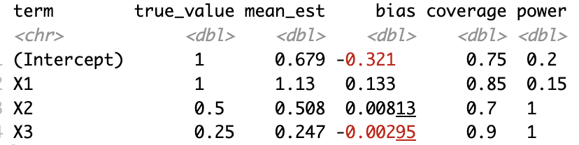

- If we also want to calculate the type I error of beta1, beta2 and beta3, can we do it with this simulation? If no, what additional simulation would we need to create.

No, we cannot calculate Type I error with this simulation because Type I error requires the null hypothesis to be true (i.e., the true coefficient equals zero), but in our current simulation all three coefficients are nonzero meaning any rejections we observe represent correct rejections — power — not false positives. To calculate Type I error, we would need a separate simulation for each coefficient where that coefficient is set to zero while the others remain the same. For example, to evaluate Type I error for β1 we would call simulate_datasets() with beta1 = 0, fit the models, and record the proportion of times the t-test incorrectly rejects H0: β1 = 0. Under a correctly specified model at α = 0.05, we would expect this proportion to be close to 0.05.

