Name: Madelynn Schina
Group Members: Aimee

In worksheet #1 we simulated data from a regression model with two covariates. For the project we will work with a much larger set of covariates and investigate how well various model selection approaches work at identifying the variables that are indeed associated with the outcome. The purpose of this work is to investigate the hdrm (high dimensional regression modeling package) for simulating multiple regression models with a larger number of X variables.

- Download the github package hdrm from the website https://github.com/pbreheny/hdrm.
- Load the library hdrm.
- Investigate the gen_data function using the help in R.
- Now we will investigate using the genData function: submit the following code testdata<- gen_data(100, 10, 5)
  - What is the sample size of this dataset?
    - 100
  - How many X variables are there in the dataset?
    - 10
  - How many of the X variables are associated with the Y (outcome)? Verify by checking the beta coefficients.
    - 5
  - What are the means and SD’s of each X variable?
    - 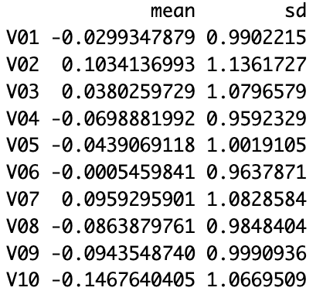
  - Are the X’s correlated with each other or independent?
    - 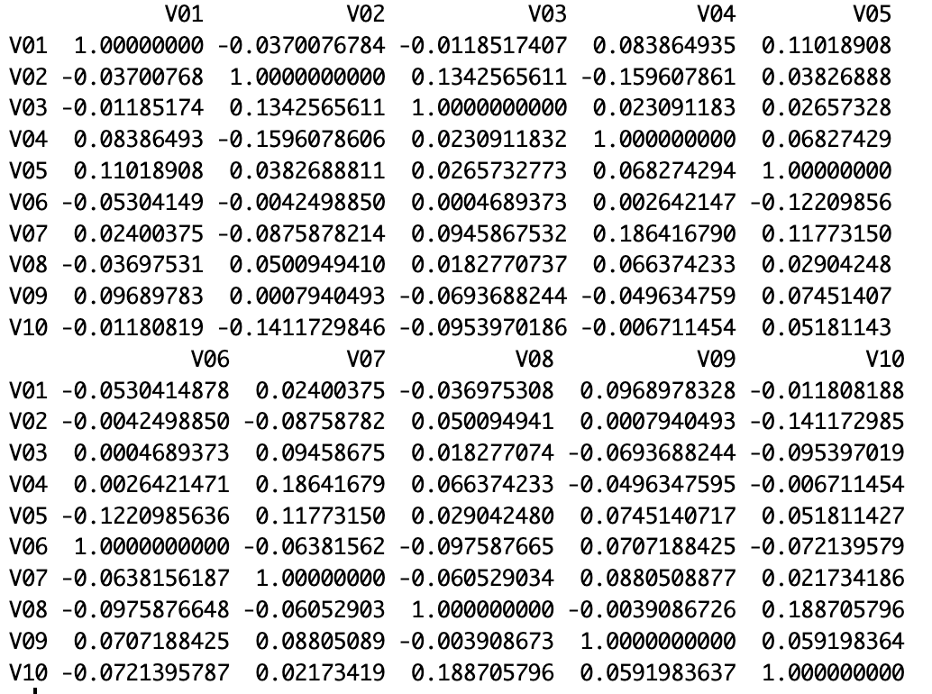
    - 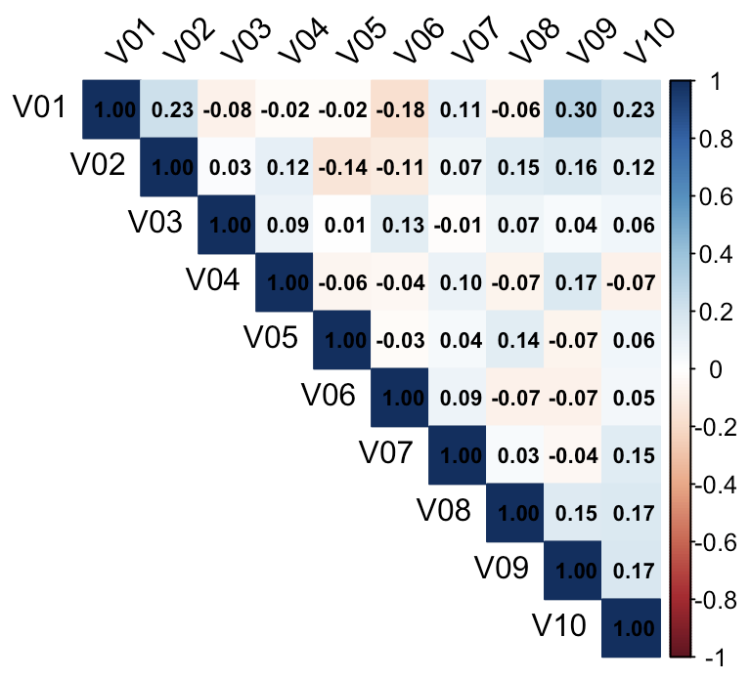
    - The X’s appear to be independent of each other
  - What is the model error (sigma^2_e)? This will take some investigating. Hint: Can you figure out yhat and get an estimate of sigma^2_e?
    - sigma^2_e = 1.066
  - What is the SNR for test data? SNR=R^2/(1-R^2)
    - SNR = 1.272
- Now set the beta coefficients to range between 0.5 and 2 for the X variables with an association and 0 otherwise.
  - What are the means and SD’s of each X variable?
    - 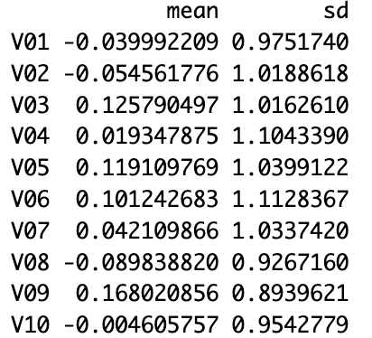
  - Are the X’s correlated with each other or independent?
    - 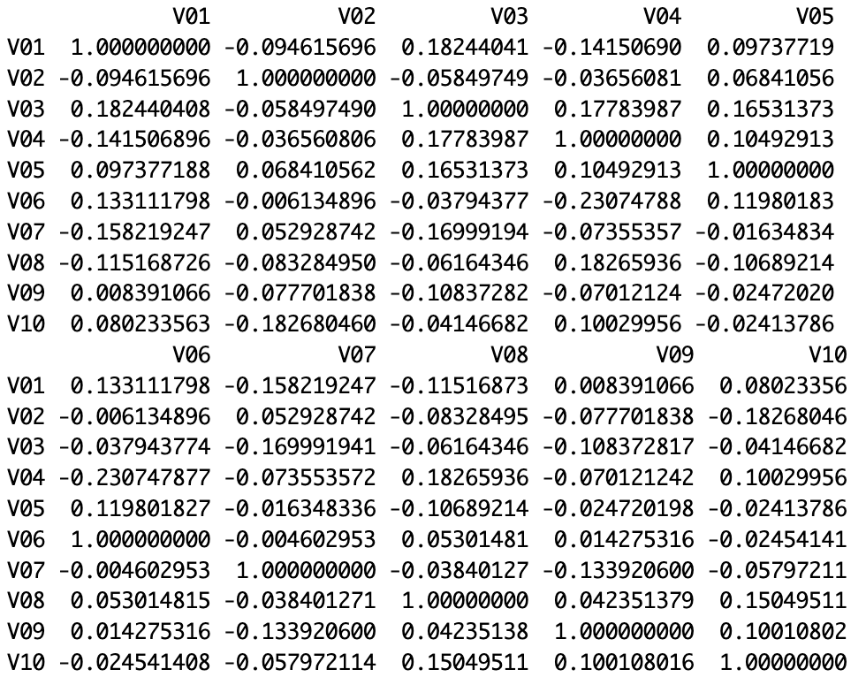
    - 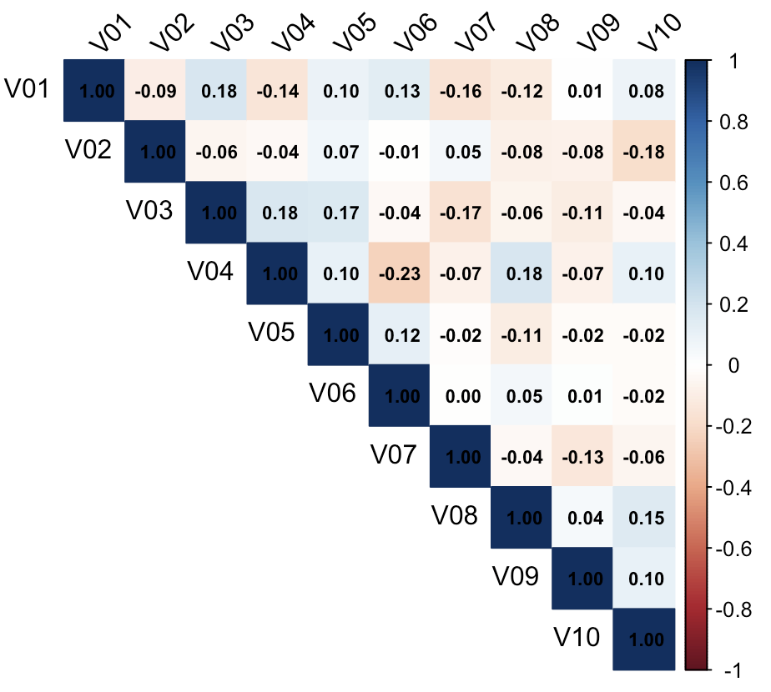
    - The X’s appear to be independent of each other
  - What is the model error (sigma^2_e)? This will take some investigating. Hint: Can you figure out yhat and get an estimate of sigma^2_e?
    - sigma^2_e = 1.193
  - What is the SNR for test data? SNR=R^2/(1-R^2).
    - SNR = 8.805
- Now set the beta coefficients to range between 0.5 and 2 for the X variables with an association and 0 otherwise and introduce an exchangeable correlation of 0.5 between the X variables.
  - What are the means and SD’s of each X variable?
    - 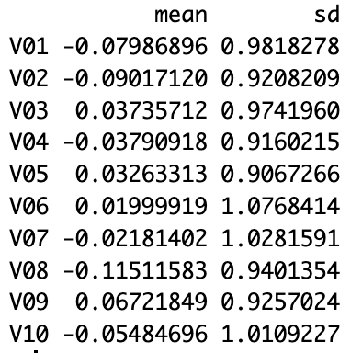
  - What is the var-cov matrix of the X’s?
    - 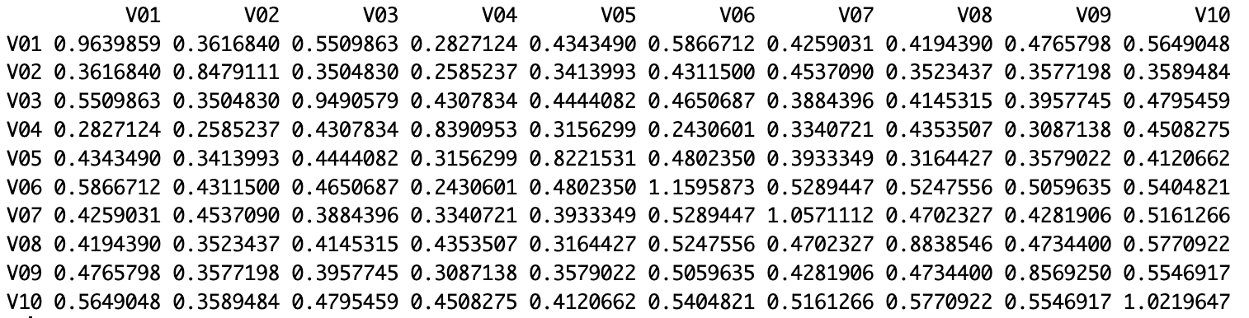
  - What is the model error (sigma^2_e)? This will take some investigating. Hint: Can you figure out yhat and get an estimate of sigma^2_e?
    - sigma^2_e = 1.198
  - What is the SNR for test data? SNR=R^2/(1-R^2)
    - SNR = 15.634

