Name Madelynn Schina

Group Members Aimee, Kayla, Yemi

Part 1: Descriptive Statistics.

- Based on the graphs of PSA and the other variables in the analysis are there any concerning patterns that might result in violations of linear regression assumptions? If yes, discuss a solution to your concern.
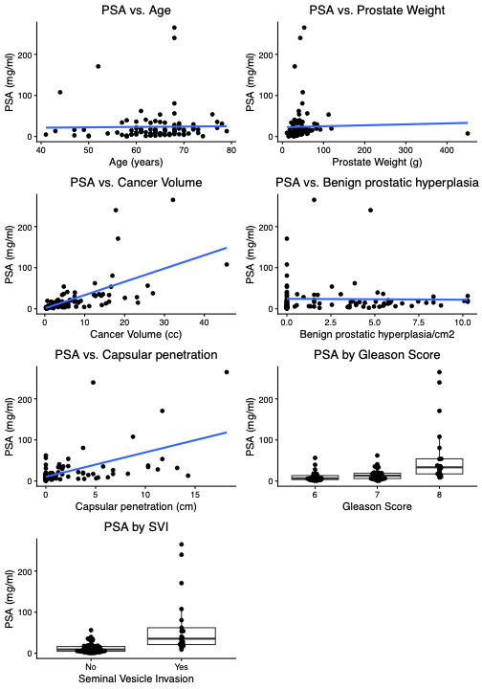
- Concerns
  - Linearity violations, most likely caused by potential outliers
  - Normality violations, some of the variables look skewed
- Potential Solutions
  - Linearity – speak with investigator to see if measurement was a mistake, if a true outlier then remove
  - Normality – log transform necessary variables

- Below are a set of pictures with PSA log transformed for analysis and the very large weight value removed. Are there any remaining concerns with using linear regression on these data? Justify.
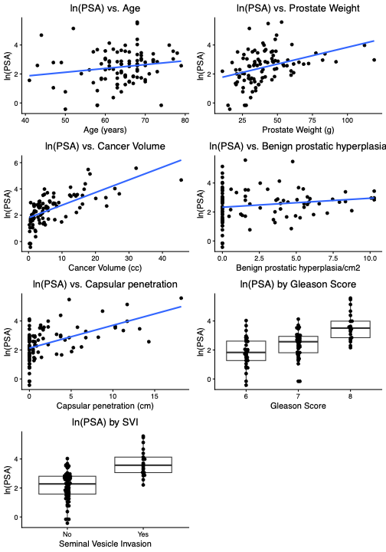

- Inflation of zeros for benign prostatic hyperplasia and capsular penetration, but not too concerned that any additional steps need to be taken at this time

- Modify your draft data analysis plan for your Bayesian regression analysis. At this point, this should include the above information, the Bayesian regression framework and some information about the distributions of the priors. You may also include non-informative or vague priors in your writing at this point. Questions to think about: 1) what models will you fit with what variables, 2) what model building strategies will you use?
- Analysis Plan
  - Log transform PSA and this will be our outcome (log(PSA))
  - Assess potential outliers, if deemed outliers remove them.
  - Assess univariate associations of each covariate
    - Select non-informative priors
      - Normal(0,1000) for each covariate and ½ Normal for variance
  - Assess associations of each individual variable and their interaction terms with SVI
- Note 8 predictors for 97 observations

Part 2: Consider investigating the association between log(PSA) and Gleason Score.

- Write down your statistical model and corresponding likelihood for estimating this association.
- $\log\left(PSA\right)=β_{0}+ β_{1}* G_{7i}+ β_{2}* G_{8i}+ ε_{i}$
- $L\left(β\right)= \prod_{i=1}^{n}{\frac{1}{\sqrt{2πσ^{2}}}exp⁡(-\frac{1}{2σ}{\left(y_{i}-μ\right)}^{2})}$

- Write down the priors for the parameters in this model.
- $β_{0}, β_{1}, β_{3} \sim$ Normal(0, 1000)
- $ε \sim$ Half-Normal(0, $σ^{2}$)

- Write down parameters in your priors for the regression coefficient on Gleason Score that make for non-informative, skeptical, and optimistic priors. Expert opinion priors are a bit tricky to do in class, since we don’t have an expert.
- Non-informative:
  - $β_{0} \sim N(0, 100000)$
  - $β_{1} \sim N(0, 100000)$
  - $β_{2} \sim N(0, 100000)$
  - Non-informative because we set such a large variance, note mean should be a value if you don’t center
- Skeptical:
  - $β_{0} \sim N(0, 1000)$
  - $β_{1} \sim N(0, 1000)$
  - $β_{2} \sim N(0, 1000)$
  - Skeptical because we have a smaller variance than the non-informative
- Optimistic:
  - $β_{0} \sim N(1, 10)$
  - $β_{1} \sim N(1.5, 10)$
  - $β_{2} \sim N(2, 10)$
  - Smaller variance yet again and selecting values for the mean because we believe the null hypothesis is not true and a relationship exists

- The output for this model is provided below for the non-Bayesian linear model estimates and Bayesian posteriors. Interpret the association between Gleason Score and Log(PSA) in a sentence or two using a Bayesian framework.

gleasonmodel <-lm(lpsa ~ gleason, data=psaclean2)
summary.lm(gleasonmodel)

Call:
lm(formula = lpsa ~ gleason, data = psaclean2)

Residuals:
Min 1Q Median 3Q Max
-2.54621 -0.59562 -0.00542 0.59396 2.16434

Coefficients:
Estimate Std. Error t value Pr(>|t|)
(Intercept) 1.8657 0.1715 10.876 < 2e-16 ***
gleason7 0.5204 0.2265 2.297 0.0239 *
gleason8 1.7591 0.2725 6.455 4.85e-09 ***
---
Signif. codes: 0 ‘***’ 0.001 ‘**’ 0.01 ‘*’ 0.05 ‘.’ 0.1 ‘ ’ 1

Residual standard error: 0.9704 on 93 degrees of freedom
Multiple R-squared: 0.3134, Adjusted R-squared: 0.2987
F-statistic: 21.23 on 2 and 93 DF, p-value: 2.548e-08

confint(gleasonmodel)
2.5 % 97.5 %
(Intercept) 1.52502184 2.2063088
gleason7 0.07049249 0.9702521
gleason8 1.21793390 2.3002606

anova(gleasonmodel)
Analysis of Variance Table

Response: lpsa
Df Sum Sq Mean Sq F value Pr(>F)
gleason 2 39.976 19.9878 21.227 2.548e-08 ***
Residuals 93 87.571 0.9416
---
Signif. codes: 0 ‘***’ 0.001 ‘**’ 0.01 ‘*’ 0.05 ‘.’ 0.1 ‘ ’ 1

Table of Bayesian Posterior Results
Parameter | Estimate | Std. Dev. | 95% HPDI
(Intercept) | 1.860 | 0.178 | (1.51, 2.20)
grade7 | 0.522 | 0.233 | (0.0682, 0.993)
grade8 | 1.760 | 0.280 | (1.23, 2.32)
sigma | 0.983 | 0.074 | (0.842, 1.13)

- The posterior distributions indicate that both Gleason indicators are significantly associated with log(PSA)

- Based on this output can you formally assess the “significance” of the association between Gleason Score and Log(PSA) in the frequentist framework? In the Bayesian framework? How would you assess it?
- In the frequentist framework, you can look at the p-values produced from the F-test and that the confidence intervals do not contain 0.
- In the Bayesian framework,

