Name Madelynn Schina

Group members Aimee

A Description of the dataset:
This dataset is from the ComparisonSurv R package and contains data on the survival of participants in a control group and treatment group. The dataset is available in Canvas in the CrossData.csv file.

Each line of the data set provides information on the variables for each person:
Column 1: time: time survived (or until censoring) in days after diagnosis
Column 2: event: censoring status (0 = censored, 1 = died)
Column 3: group: The group indicator for comparison, 0= control group, 1= treatment group.

This is the dataset from the lectures where the survival curves for the two treatment groups crossed:

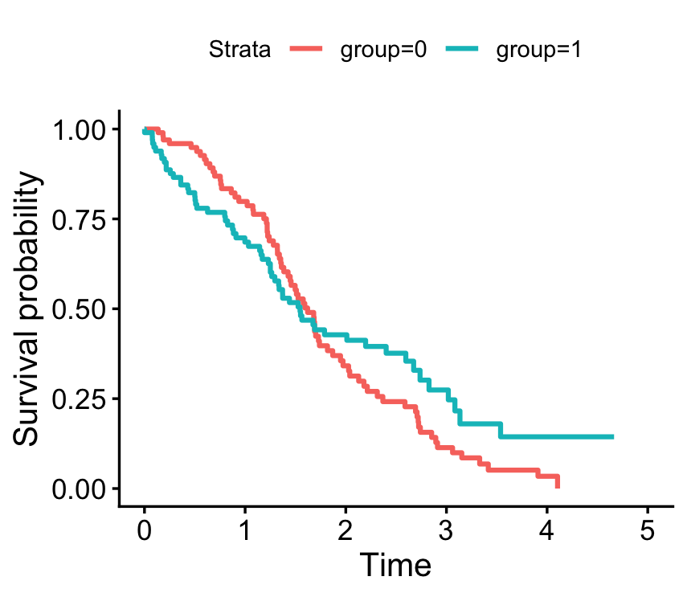
The following questions lead through checking proportional hazard assumptions and fitting models with and without time interactions

- Generate log-minus-log survival curves for the two treatment groups. What does this plot tell you about the proportional hazards assumption for this data? What would you expect to see if the assumption was met?

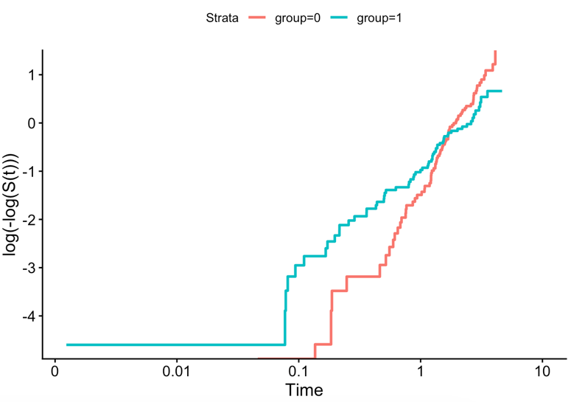
- The plot tells us that the proportional hazards assumption is violated since the curves cross one another.
- If the assumptions were met, the curves would not cross each other and would appear almost identical in shape.

- Calculate and plot Schoenfeld residuals for the group variable. Perform a test of proportional hazards using the Schoenfeld residuals. What do these results tell you? What would you expect to see if the proportional hazards assumption was met?
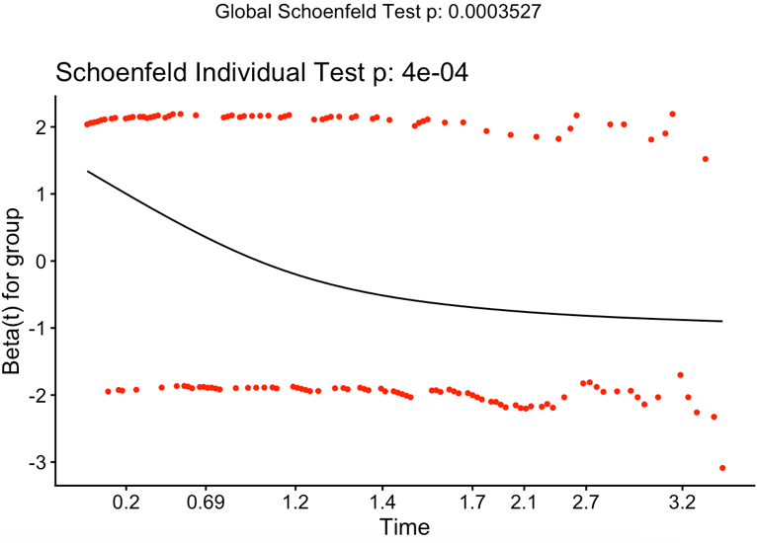
- The plot indicates that the proportional hazards assumption is violated since the trend line is curved and the data points do not appear random.
- If the proportional hazards assumption was met, we would see a straight horizontal trend line with the data points evenly randomly scatter about the line not following any pattern.

- Fit a Cox PH model with group in the model. Interpret this model. How does your interpretation differ from what you see in the survival plot?
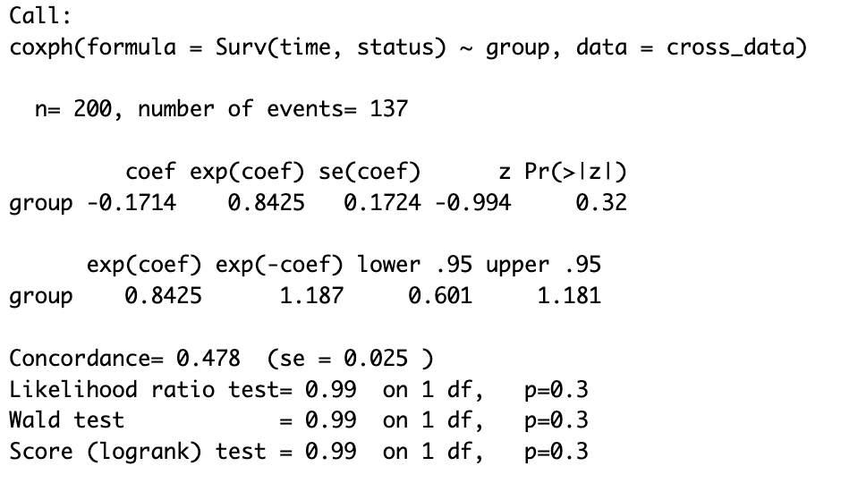
- $\left(e^{\left(-0.1714\right)}-1\right)*100=-15.75\%$
- Subjects in the treatment group have 15.75% lower hazard compared to the control group.
- This does not account for the cross over of the curves that we saw in the plots.

- Fit a Cox PH model with an interaction between group and time (continuous). Interpret the interaction effect. According to this model, how does the hazard of death differ between groups at time=0? At time=4?
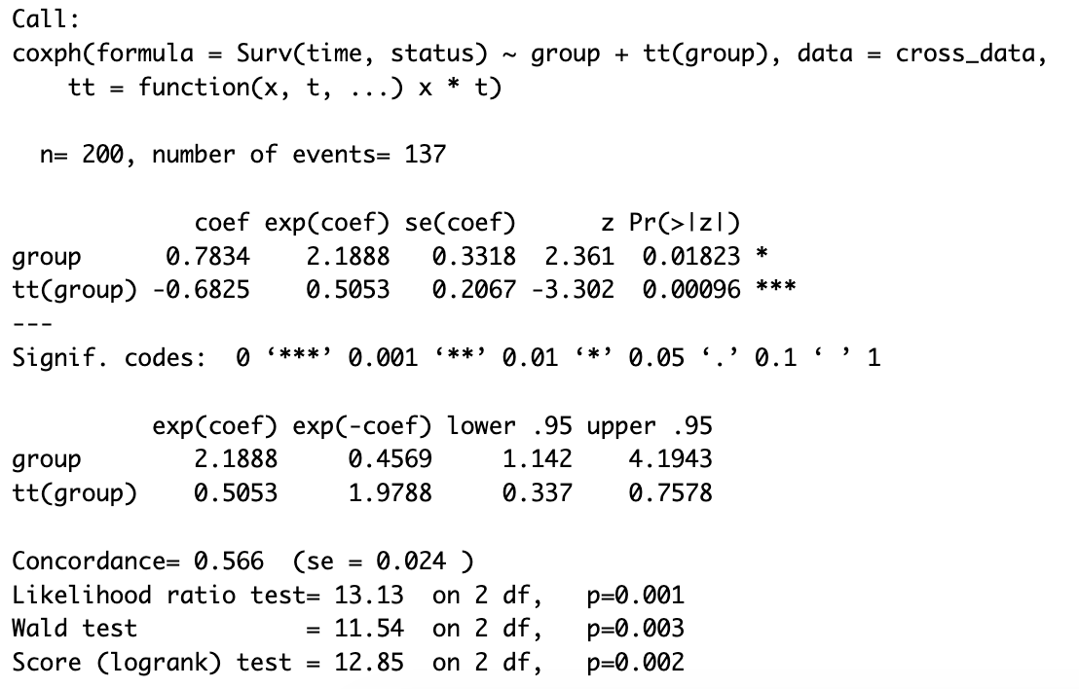
- At t = 0
  - ${(e}^{0.7834+(-0.6825*\left(0\right))}-1)*100=118\%$
  - 118% higher hazard for the treatment group compared to the control group
- At t = 4
  - ${(e}^{0.7834+(-0.6825*\left(4\right))}-1)*100=-85.7\%$
  - 85.7% lower hazard for the treatment group compared to the control group

- Now we’ll use a dichotomous time variable for the interaction, splitting the variable by whether time>=1.5 or time<1.5. Fit a CoxPH model with an interaction between group and this dichotomous version of the time variable. According to this model, how does the hazard of death differ between groups for time>=1.5? For time<1.5?
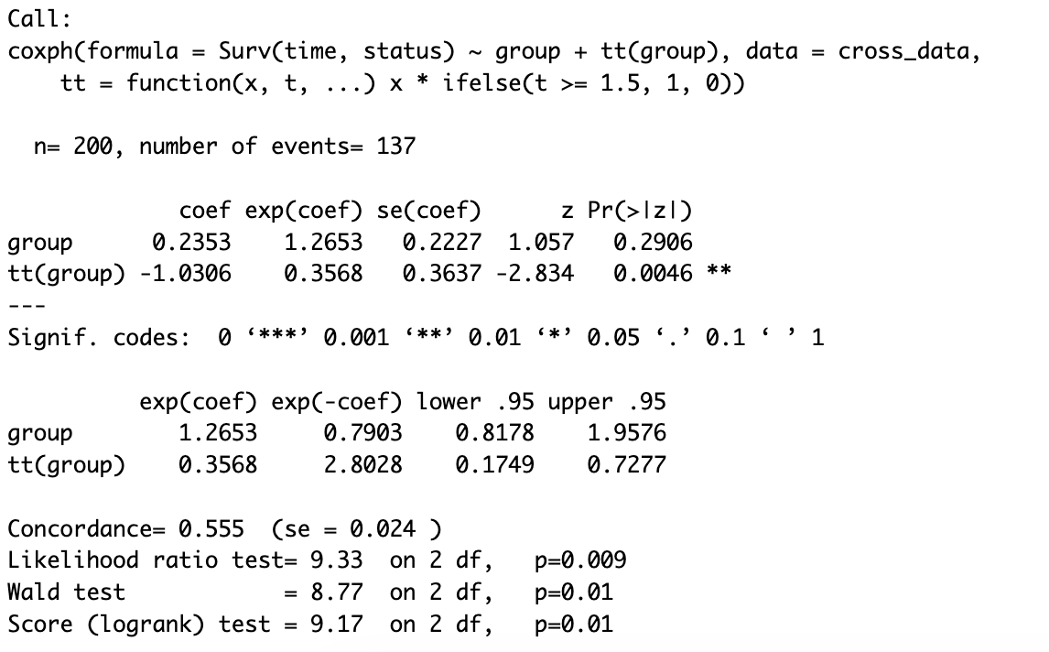
- Time >= 1.5
  - ${(e}^{0.2353+(-1.0306))}-1)*100=-54.85\%$
  - 54.85% lower hazard for treatment group compared to control group
- Time < 1.5
  - ${(e}^{0.2353)}-1)*100=26.54\%$
  - 26.54% higher hazard for treatment group compared to control group

