Name: Madelynn Schina
Group Members: Kayla, Yemi & Aimee

A Description of the project and questions of interest:
The goal of this study is to compare survival between two treatments for ovarian cancer. There are 26 women assigned to one of two treatments. Please assess whether the survival time is longer in one of the two treatments compared to the other.

Each line of the data set has an identification number and provides information on the other variables for each person.
Column 1: futime: time survived in days after diagnosis
Column 2: timefustat: censoring status (0 = censored, 1 = died)
Column 3: age: in years
Column 4: resid.ds: residual disease present (1=no,2=yes)
Column 5: rx: treatment group
Column 6: ecog.ps: ECOG performance status (1 is better, see reference)

The data for this worksheet is an R dataset called ovarian.

Part 1: Orienting yourself to the analysis

- What is the outcome for this analysis?
Time survived in days after diagnosis (futime)

- What is(are) the primary variable(s) of interest for this analysis?
Treatment group (rx)

- What method will you use to estimate and compare survival between the two treatment groups?
Survival analysis will be used for this, specifically a Kaplin-Meier approach.

- What types of descriptive statistics do you want to compute to assess the data and describe the data? How would you put this information into a Table in a report?
Columns for each treatment group and overall. Then summary statistics on survival time, age, and other variables of interest. Also include average time to censored.

- What types of graphs do you want to create to assess and describe the data? What are you looking for with these graphs?
Kaplin-Meier curves to assess the survival over time of each group separately. We are looking for the curves to be different, which would indicate a difference between the two groups.

- Draft a bullet point introduction and preliminary analysis plan.
- Introduction
  - The primary objective of this analysis is to examine the relationship between treatment group and time-to-event outcome
  - Two treatment groups are compared (treatment = 0 vs. treatment = 1) to determine whether treatment affects survival
  - Censoring is present in this dataset, meaning some individuals did not experience the event by the end of the follow-up period
- Preliminary Analysis Plan
  - Descriptive statistics will be computed for all baseline characteristics, presented in a Table 1
  - Censoring will be assessed — the number and proportion of censored observations will be reported per group
  - Kaplan-Meier (KM) survival curves will be estimated separately for each treatment group to visually compare survival over time
  - Median survival time with 95% confidence intervals will be reported for each group

- Compute the Kaplan-Meier estimated survival curve for those on treatment = 1. Verify the first few estimates by hand. The goal is to practice and understand how the K-M estimator works.

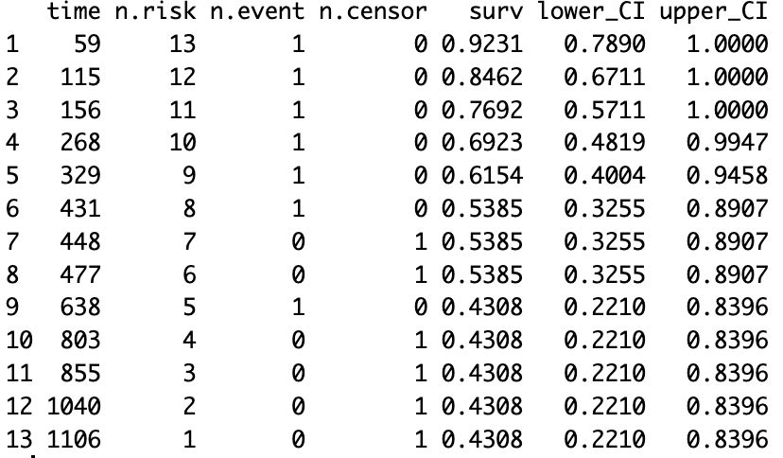

- Estimate the survival curves for each group.
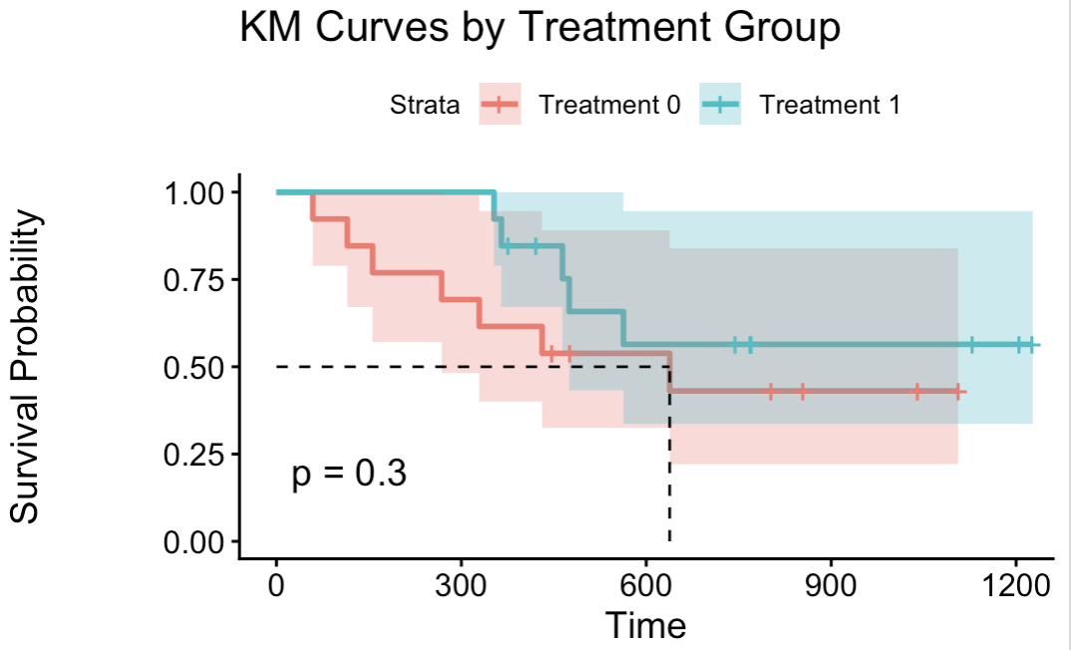

- Write a basic summary of your prelim analysis.
Treatment group 2 has a higher percentage of survival compared to treatment group 1.

