Name Madelynn Schina

Group members Kayla, Yemi & Aimee

A Description of the project and questions of interest:
The goal of this study is to compare survival between two treatments for ovarian cancer. There are 26 women assigned to one of two treatments. Please assess whether the survival time is longer in one of the two treatments compared to the other.

Each line of the data set has an identification number and provides information on the other variables for each person.
Column 1: futime:time survived in days after diagnosis
Column 2: timefustat: censoring status (0 = censored, 1 = died)
Column 3: age: in years
Column 4: resid.ds: residual disease present (1=no,2=yes)
Column 5: rx:treatment group
Column 6: ecog.ps: ECOG performance status (1 is better, see reference)

The data for this worksheet is an R dataset called ovarian.

The following questions lead through conducting a Cox PH analysis of these data and interpreting the results.

- In the last worksheet you estimated the survival curves for the treatment groups. Now, perform a log rank test to assess whether these survival curves differ. Summarize your findings.
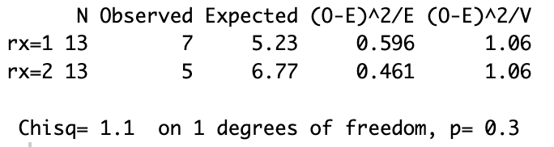
With a p-value of 0.3, there is not a significant difference in survival time in the groups.

- Now actually make the Table 1 for these data including age, residual disease and ECOG performance (you proposed a table in the last worksheet).

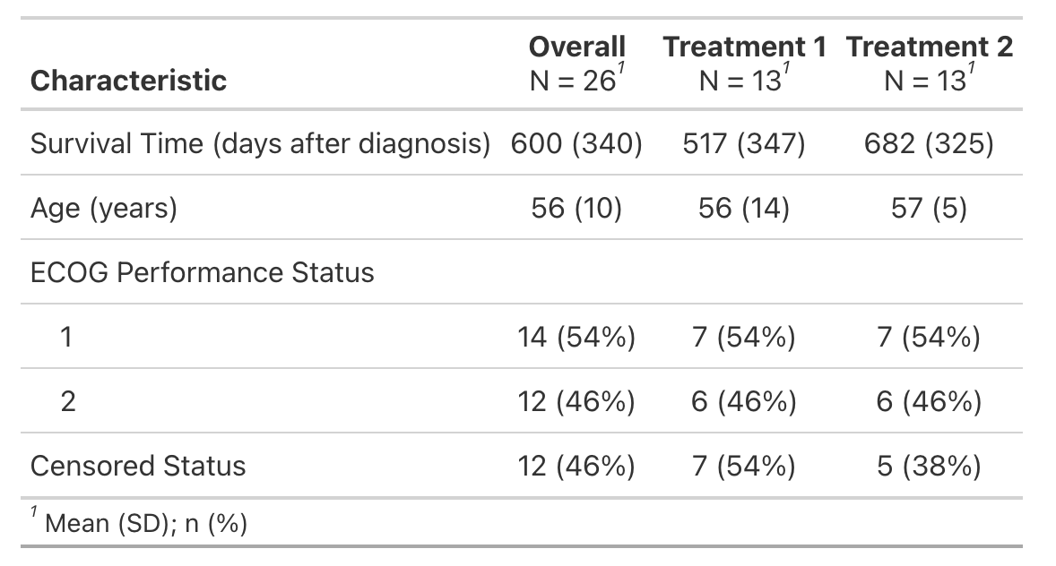

- Fit a Cox PH model with treatment (rx) in the model. Interpret this model.
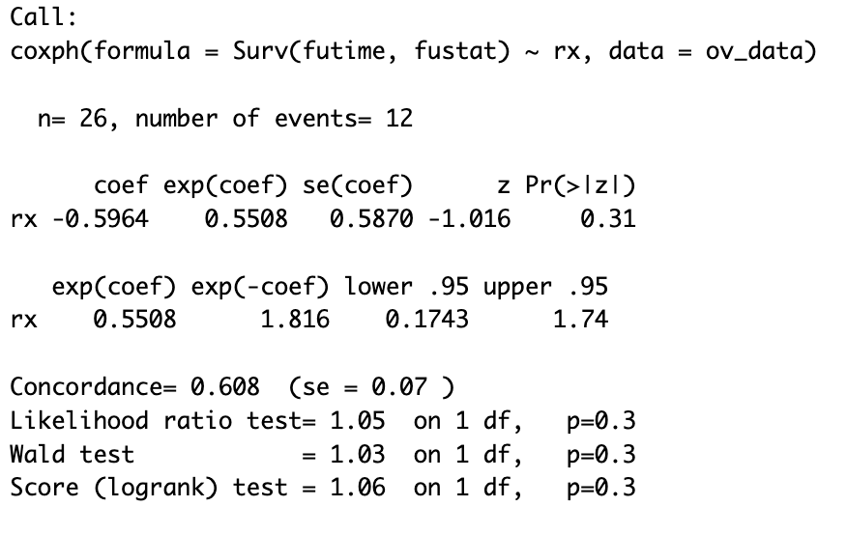
The hazard of death is 44.92% lower for treatment group 2 compared to treatment group 1.

- Fit a Cox PH model with treatment and adjust for potential confounding or precision variables. Interpret this model.
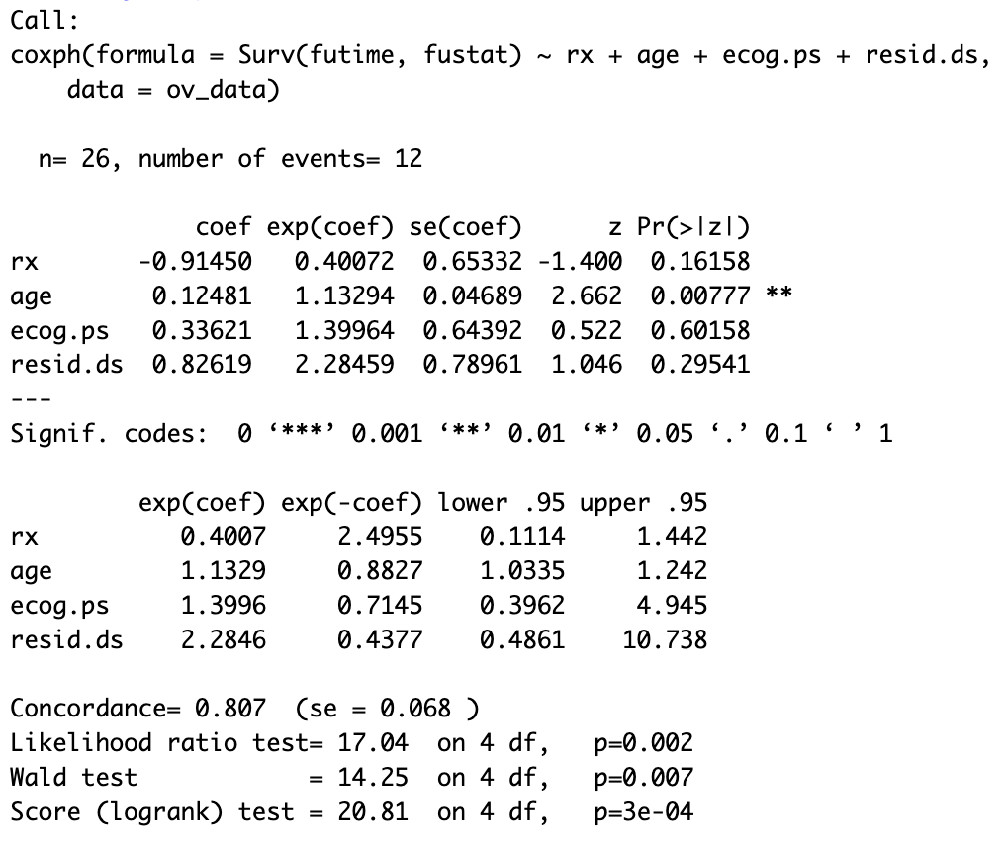

The hazard of death is 59.93% lower for treatment group 2 compared to treatment group 1.

- Draft a data analysis section for this work.
Analysis Plan
- Descriptive statistics will be computed for all baseline characteristics, presented in a Table 1
- Preliminary Analysis included Kaplan-Meier (KM) survival curves will be estimated separately for each treatment group to visually compare survival over time
- Cox PH models were fit with and without adjusting for covariates

- Draft a results section including a results table for this work.
Results
- There does not appear to be a difference in survival times between the two treatment groups

