Name: Madelynn Schina

Group members: Aimee

A Description of the project and questions of interest:
The goal of this study is to compare survival between two treatments for ovarian cancer. There are 26 women assigned to one of two treatments. Please assess whether the survival time is longer in one of the two treatments compared to the other.

Each line of the data set has an identification number and provides information on the other variables for each person.
Column 1: futime:time survived in days after diagnosis
Column 2: timefustat:censoring status (0 = censored, 1 = died)
Column 3: age: in years
Column 4: resid.ds:residual disease present (1=no,2=yes)
Column 5: rx:treatment group
Column 6: ecog.ps:ECOG performance status (1 is better, see reference)

The data for this worksheet is an R dataset called ovarian.

The following questions lead through conducting a Cox PH analysis of these data and interpreting the results.

- Check the PH assumption for all variables using a method of your choice.
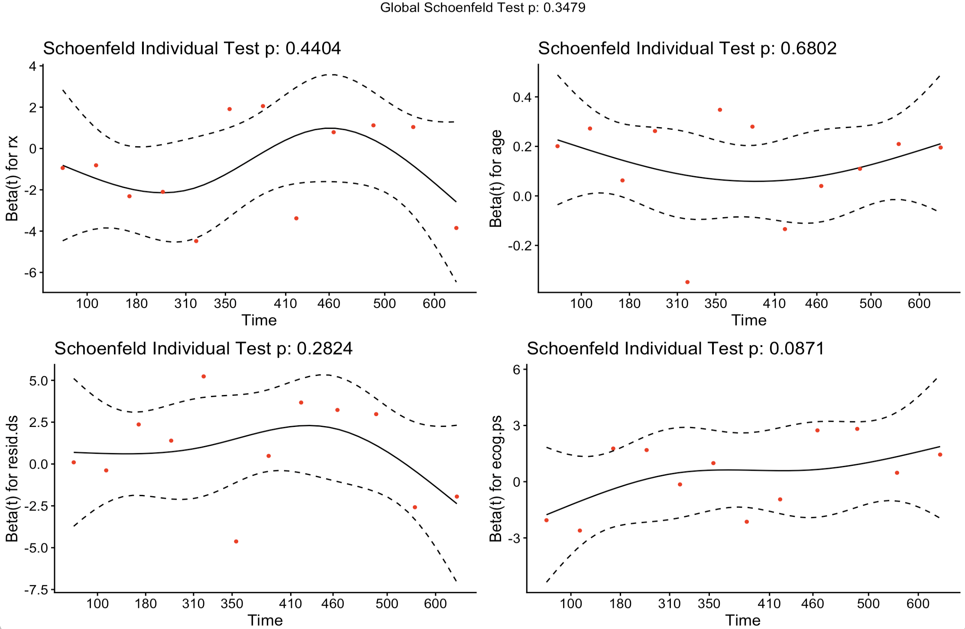
- The plots do not have horizontal trend lines but there are no extreme deviations and the p-values are not significant suggesting no violations.

- Fit a Cox proportional hazard model with treatment, age, residual disease presence, and ECOG performance status included in the model. (Note, as we saw in previous worksheets, most of the variables in this model are not significant, perhaps due to the small sample size. For the purposes of this worksheet, we will pretend that we do think that there are meaningful differences in survival based on these factors.)
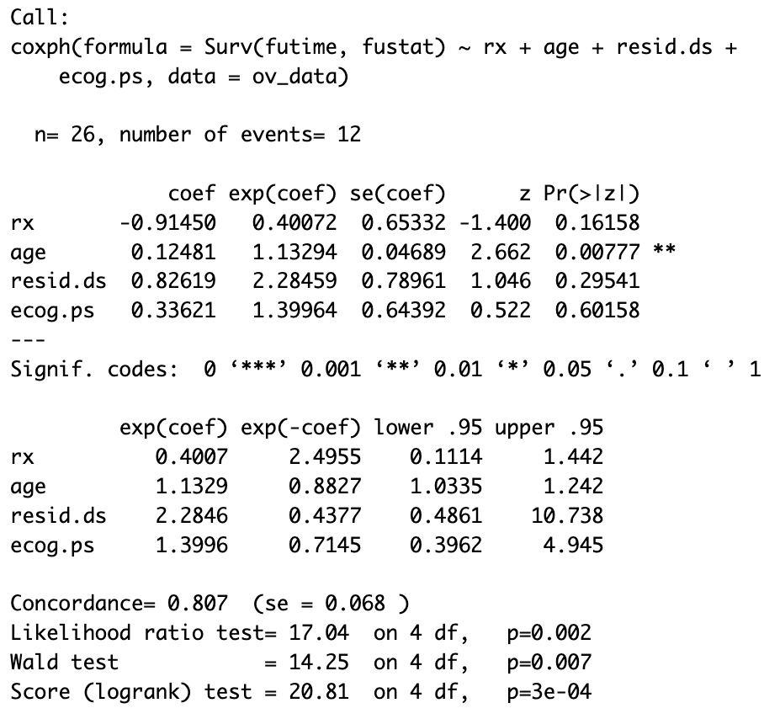

- First, plot the Kaplan Meier estimates for the survival curves for Treatment 1 and Treatment 2. Then, using your Cox model, estimate and plot the survival curves for Treatment 1 and Treatment 2 using the average age and reference levels (residual.ds = 1 and ecog.ps = 1). What is the difference between what the Kaplan Meier and the Cox estimates are showing? When would you use one over the other?
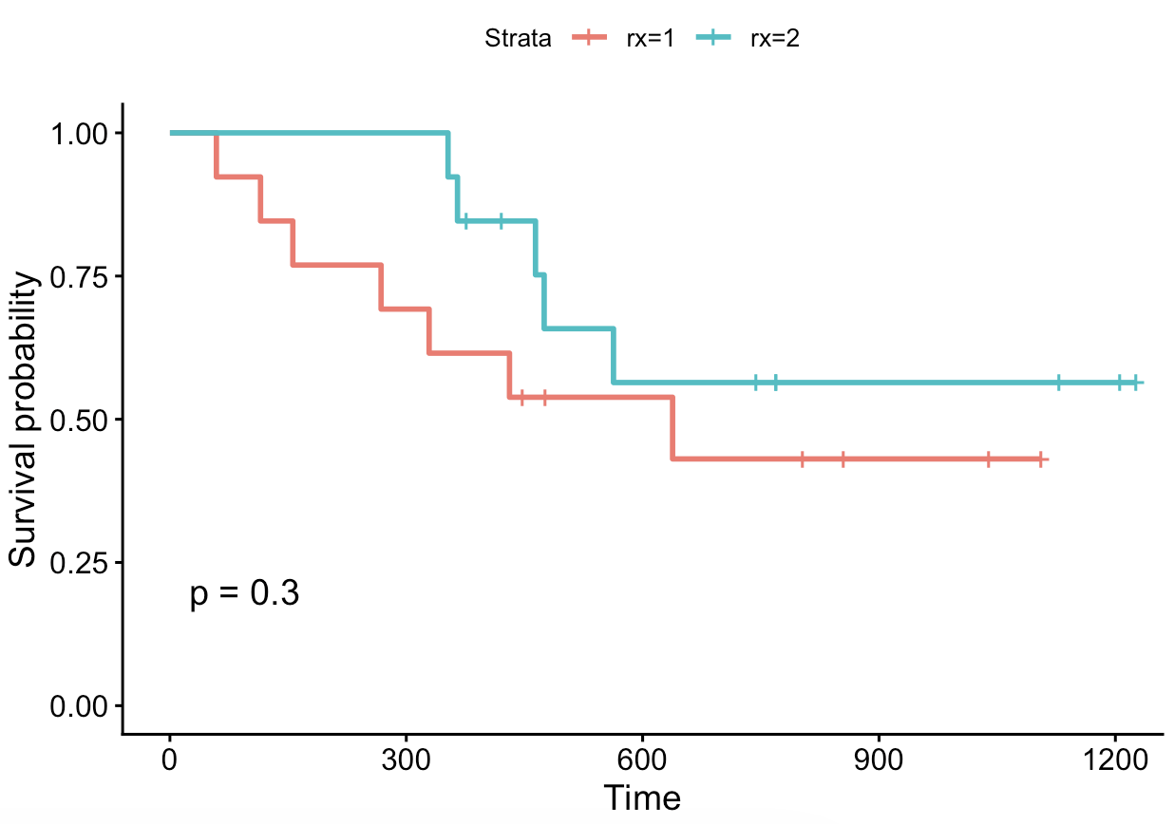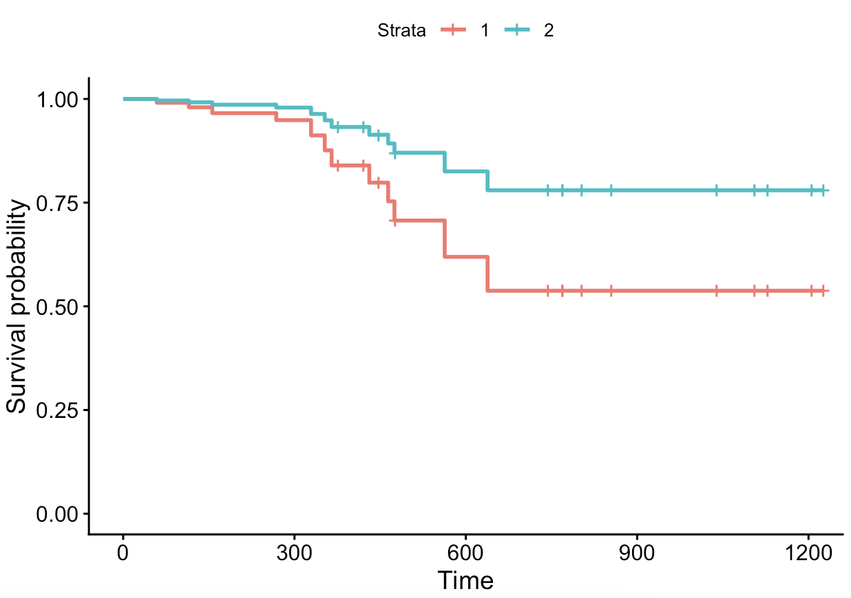
- The Kaplan Meier curves estimate what actually happened as illustrated by the data, and the Cox estimates is highlighting the treatment affect alone while adjusting for the other variables.
- Kaplan Meier curves are more useful for exploratory interests/exploration, while Cox models are useful for interpretations of comparisons.

- The PI would like to compare the probability of surviving the first year for patients treated with treatment = 1 that have different ECOG and residual disease risk factors. Assuming the average age, compute the probability of 1 year survival for each combination of ECOG and residual disease (4 total profiles) for an individual on treatment 1. Describe your results. Which profile has the highest probability of survival?

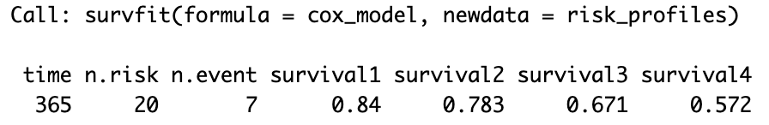

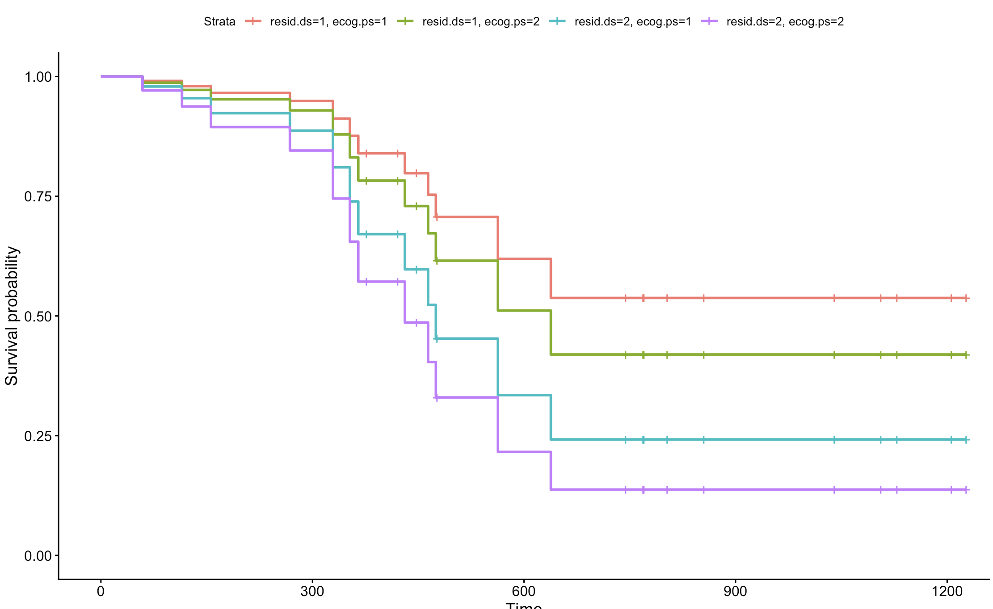
- An individual with ECOG = 1 and residual disease = 1 has the highest probability of survival.
- It appears that residual disease has a stronger impact on survival compared to ECOG.

- The PI is interested in the estimated survival curves and the risk of death in two new patients they are seeing in their practice. Using the profiles below, estimate and plot the survival curves for these patients. Additionally, compute the probability of death within 1, 1.5, and 2 years.

 | Age | Residual Disease | Treatment | ECOG
Patient 1 | 60 | No residual disease | Treatment 1 | ECOG = 1
Patient 2 | 50 | Residual disease | Treatment 2 | ECOG = 2

