Project Title: Vehicle Speed Control using HC-SR04 and PWM

Block Diagram:

Power Supply
L293D
Motor Driver
PWM
3KHz
STM32F407
Microcontroller
DC Motor
HC-SR04
Ultrasonic Distance
Sensor

Ss

Circuit Diagram:
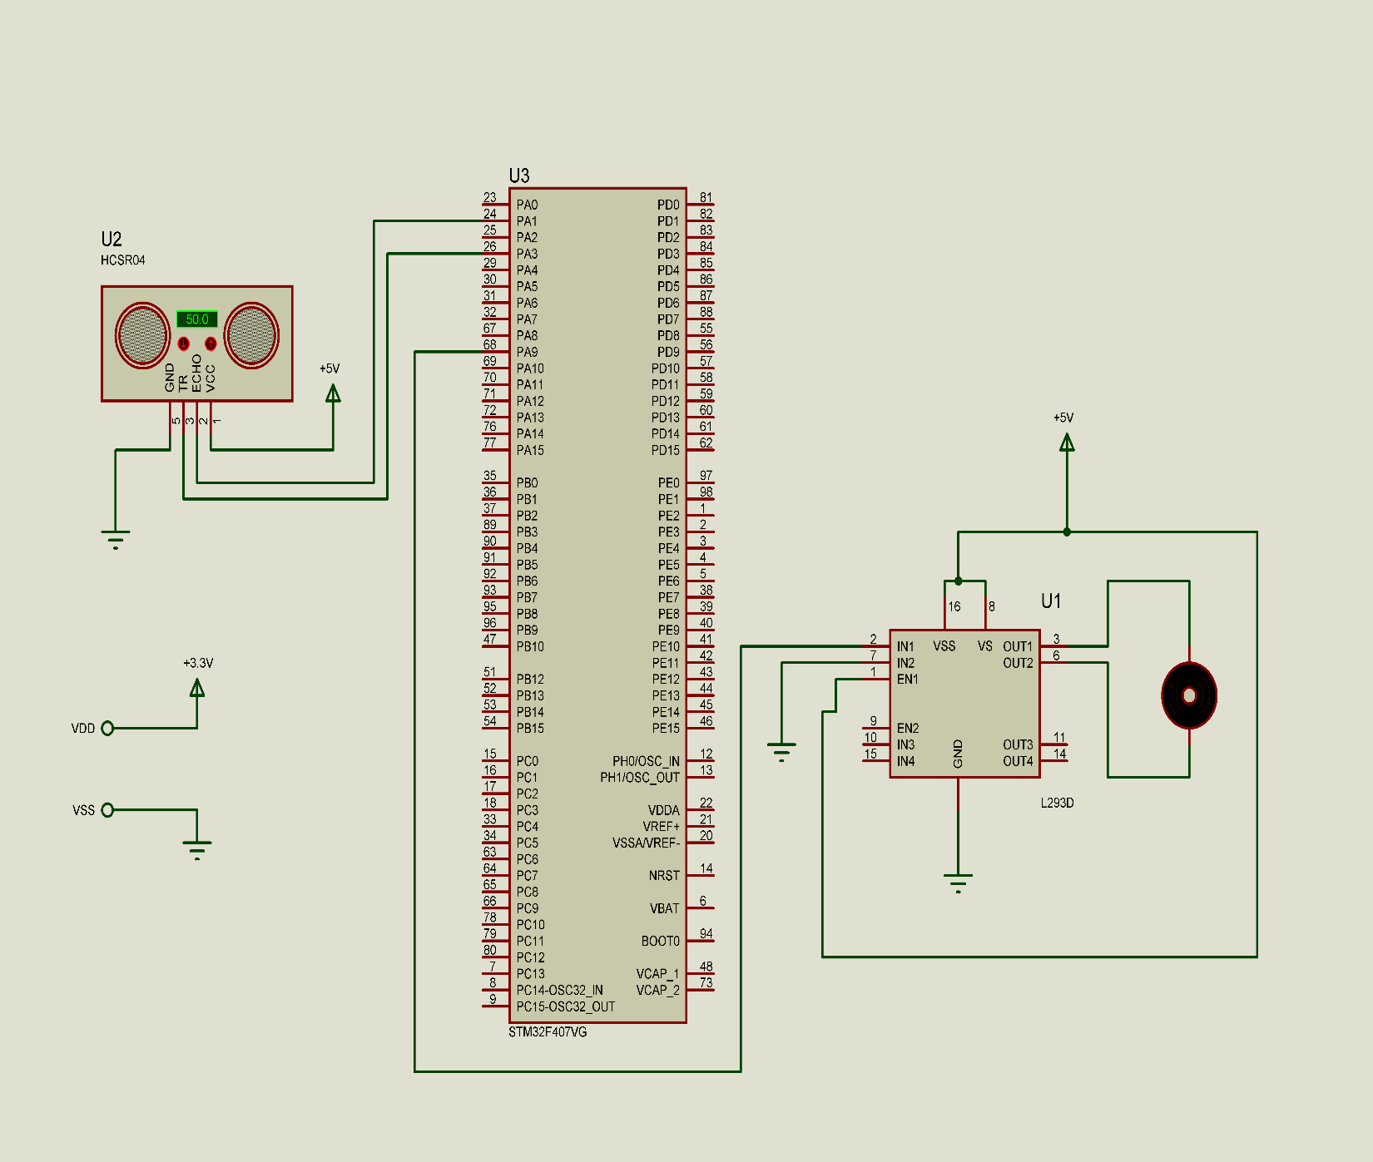

Specifications:
MCU:
Name: STM32F407
Freq: 16MHz
RAM: 192KB
Flash: 1MB
Sensor:
Name: HC-SR04 Ultrasonic distance sensor
Min Distance: 2 cm
Max Distance: 300cm
Motor Driver:
Name: L293D 4-channel motor driver with PWM input.
Min Supply voltage: 5V
Max Supply Voltage: 36V
Motor: 5V DC Brush Motor
Power Supply: 5V-2A DC power supply
Input: HC-SR04 Ultrasonic distance sensor
Output: PWM signal to L293D motor driver, 5V DC Motor
Power Consumption:
MCU: 250mA at 3.3V
Motor: 300mA at 5V
HC-SR04: 15mA at 5V
Motor Driver: 50mA at 5V

