**Name: ____________________________ ID: _____________**

**Department of Computer Science and Engineering**

**CSE340: Computer Architecture   
Summer 2015**

**Quiz-1**

**Full Marks:15 Time: 20 Mins**

1. Simplify the Boolean expression and draw logic circuit: **15**

$z=\overline{A }C\left(A+\overline{B }+\overline{D }\right)+\overline{A }B\overline{C }\overline{D }+A\overline{B }C$

**Name: ____________________________ ID: _____________**

**Department of Computer Science and Engineering**

**CSE340: Computer Architecture   
Summer 2015**

**Quiz-1**

**Full Marks:15 Time: 20 Mins**

1. Simplify the below circuit and draw the simplified circuit: **15**

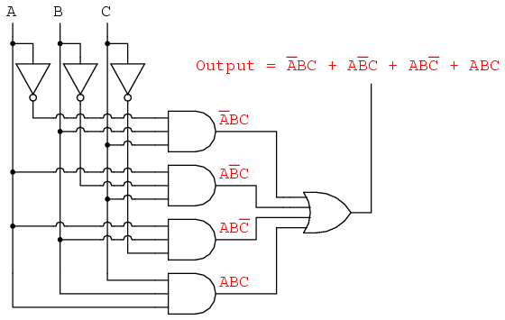

**Name: ____________________________ ID: _____________**

**Department of Computer Science and Engineering**

**CSE340: Computer Architecture   
Summer 2015**

**Quiz-1**

**Full Marks:15 Time: 20 Mins**

1. Design a hardware that can execute shift left, shift right, store new data and clear all stored data operation using D FF. Also explain its operation. **15**