**CSE230 (Sec-1): Quiz#04**

|  |  |
| --- | --- |
| **Name:** | **ID:** |

**1. Suppose E is the event that a randomly generated bit string of length four begins with a 1 and F is the event that this bit string contains an even number of 1 s. Are E and F independent, if the 16 bit strings of length four are equally likely?**

**2. A fair coin is tossed and a 6-sided biased dice is rolled. Find the probability of landing on the head side of the coin and rolling a 3 on the dice [for the biased dice, the probability of getting 3 is twice of the probability of getting any other numbers]**

**3. Find the shortest distance of vertex 4 from vertex 0 (source)? Mention the path.**

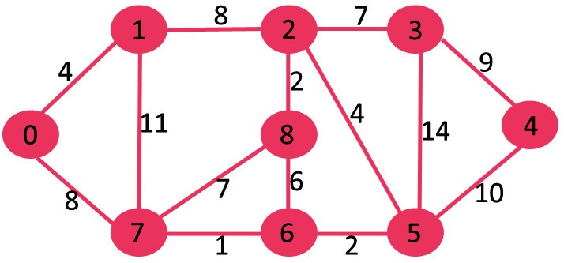

**4. Draw the graph for the following adjacency list?**

