|  |  |
| --- | --- |
| No. of Pages | **3** |
| No. of Questions | 4 |

**Department of Computer Science and Engineering**

**MIDTERM EXAMINATION SUMMER 2012**

**CSE320: Data Communications**

**Total Marks: 60 Time Allowed: 70 minutes**

* Answer ALL **Four (4)** questions.
* Figure in bracket [] next to each question indicates marks for that question.

## Question No. 1

1. Match the following functions to the appropriate layers of the **OSI** model : [4 marks]
   * 1. How to access the media.
     2. Establishing, managing, and terminating sessions in applications
     3. Bit rate and network topology consideration
     4. Selection of the best path to a network.
     5. Compression of video files
     6. Changing MAC addresses hop to hop
     7. No retransmission of data if lost
     8. Adds both header and trailer to the PDU
2. Differentiate between **IP address** and **MAC address**. [2 marks]
3. How do the layers of the **OSI** model correlate to the layers of the **TCP/IP** model? Draw the models. [3 marks]
4. Complete the **frames (1, 2 &3)** shown below with appropriate **port**, **IP** and **MAC addresses** (Use the separate sheet provided). The sender Host A has two applications running; one for email with port number of 49188 and the other for accessing the web server with port number 49167. The frames shown are all intended for the web server. (For indicating MAC addresses just mention the device or device interface) [6 marks]

**Frame 3**

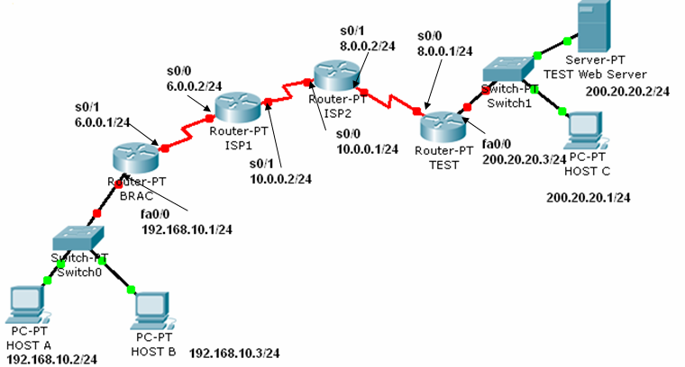

**Frame 2**

**Frame 1**

**Email**

**Web Browser**

**Figure No. 1**

Question No. 2

1. When you write [www.games.com](http://www.games.com) in the URL of a web browser, the first packet sent by your PC is to your local **DNS** server. But your local DNS server does not have the IP address to that URL. Explain what role does the Root and TLD name servers play here. [Assume that there is no problem with the website] [4 marks]
2. From your PC’s command prompt the following command has been given, what does it do?

C:\> telnet 192.167.1.1

[3 marks]

1. Which protocol helps us access the Internet using a laptop without any configuration hassle while drinking coffee at a coffee shop? How does the protocol help? [4 marks]
2. BitTorrent is the most popular P2P protocol today, what are the special features of BitTorrent that makes it very popular? [4 marks]

## Question No. 3

1. In a data network, what field in the TCP header is used to reassemble the packets in the correct order at the destination device? How is the value of that field calculated? [3.5 marks]

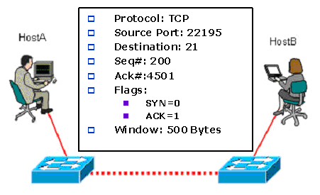

1. Host A and Host B initially had negotiated a window size of 1000 bytes. Now after some data transfer between them, host B receives a segment shown in the above figure no. 2. Explain the segment using the information shown. Why was the window size reduced to 500 bytes? [5 marks]
2. Referring to the same figure no. 2 above, Host A wants to close its connection with host B. What will it do? [3 marks]
3. SMTP has a fixed port number of 25, why? Does all email servers have the port number of 25? What type of port number is it? [3.5 marks]

###### Question No. 4

1. For the given **IP address** find the following information: (Use the separate Sheet Given) [5 marks]

|  |  |
| --- | --- |
| IP Address | 200.23.133.117 |
| Subnet Mask | 255.255.255.224 |
| Network Address |  |
| Broadcast Address |  |
| First Usable Host |  |
| Last Usable Host |  |
| Total No. of usable hosts |  |

1. 0.0.0.0 and 127.0.0.1 IP addresses are never assigned to PCs/Workstations, why? [4 marks]
2. Two web request packets arrive at the router with the destination IP address of 200.20.20.24/24. One has source IP address 192.168.20.115/24 and the other has 192.168.20.116/24, but both have the same source port number 4965. Using the **figure** below, fill up the entries of the following NAT table in the router. (Use the separate Sheet Given) [6 marks]

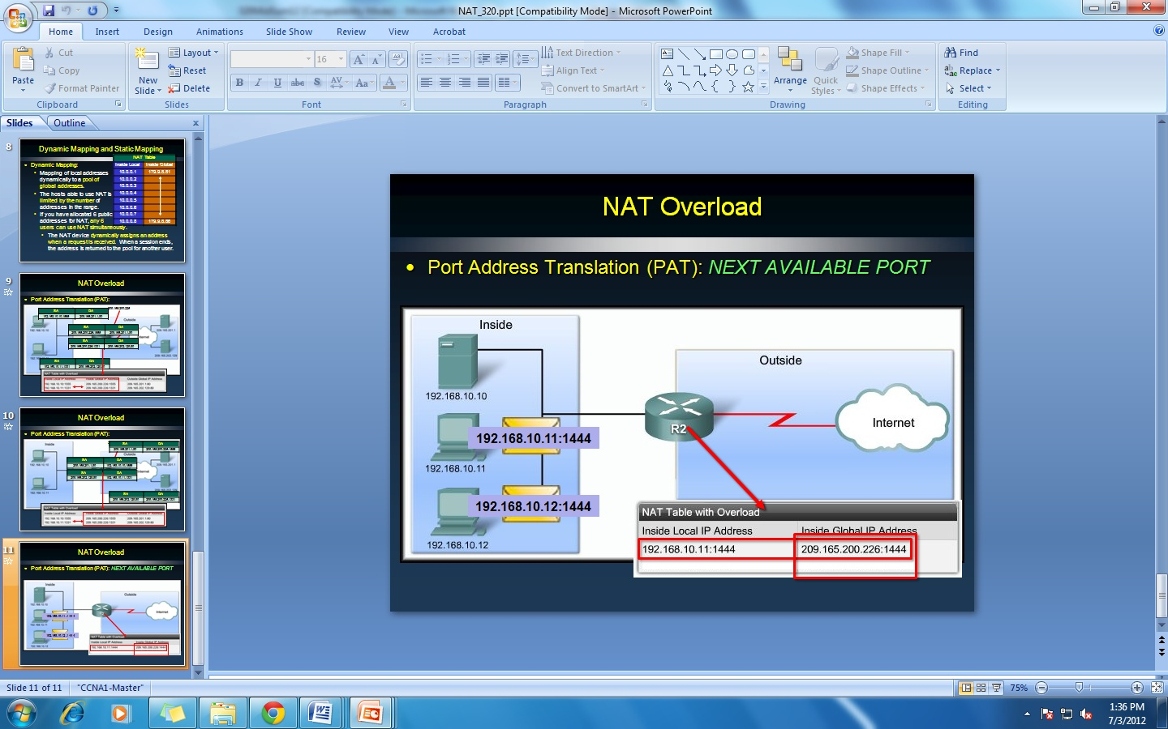

**192.168.20.116:4965**

**192.168.20.115:4965**

**201.39.12.137**

NAT TABLE

##### THE END

**MIDTERM EXAMINATION SUMMER 2012**

**CSE320: Data Communications**

**Extra Sheet**

**Question 1(d)**

|  |  |  |  |  |  |  |  |
| --- | --- | --- | --- | --- | --- | --- | --- |
|  | |  |  |  |  |  |  | | --- | --- | --- | --- | --- | --- | | Frame 1 | |  |  |  |  | | --- | --- | --- | --- | |  |  | |  | | --- | | Data | | | |

|  |  |  |  |  |  |  |  |
| --- | --- | --- | --- | --- | --- | --- | --- |
|  | |  |  |  |  |  |  | | --- | --- | --- | --- | --- | --- | | Frame 2 | |  |  |  |  | | --- | --- | --- | --- | |  |  | |  | | --- | | Data | | | |

|  |  |  |  |  |  |  |  |
| --- | --- | --- | --- | --- | --- | --- | --- |
|  | |  |  |  |  |  |  | | --- | --- | --- | --- | --- | --- | | Frame 3 | |  |  |  |  | | --- | --- | --- | --- | |  |  | |  | | --- | | Data | | | |

**Question No. 4(a):**

|  |  |
| --- | --- |
| IP Address | 200.23.133.117 |
| Subnet Mask | 255.255.224.0 |
| Network Address |  |
| Broadcast Address |  |
| First Usable Host |  |
| Last Usable Host |  |
| Total No. of usable hosts |  |

**Question No. 4(c):**

|  |  |  |
| --- | --- | --- |
| NAT TABLE | | |
| Inside Local Address | Inside Global Address | Outside Global Address |
|  |  |  |
|  |  |  |