**Name: ____________________________ ID: _____________**

**Department of Computer Science and Engineering**

**CSE340: Computer Architecture   
Summer 2015**

**Quiz-1**

**Full Marks:15 Time: 20 Mins**

1. Simplify the Boolean expression and draw logic circuit:

$z=A^{'}BCD+AB^{'}C^{'}D^{'}+AB^{'}CD^{'}+AB^{'}CD+ABC^{'}D^{'}+ABC^{'}D+ABCD'+ABCD$. **15**

**Name: ____________________________ ID: _____________**

**Department of Computer Science and Engineering**

**CSE340: Computer Architecture   
Summer 2015**

**Quiz-1**

**Full Marks:15 Time: 20 Mins**

1. Simplify the below circuit and draw the simplified circuit: **15**

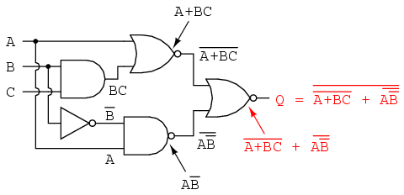

**Name: ____________________________ ID: _____________**

**Department of Computer Science and Engineering**

**CSE340: Computer Architecture   
Summer 2015**

**Quiz-1**

**Full Marks:15 Time: 20 Mins**

1. Draw and explain the operation of a counter that can count clock cycle from 0~13 having a falling edge triggered clock and using a T FF. **15**