**Name: ____________________________ ID: _____________**

**Department of Computer Science and Engineering**

**CSE340: Computer Architecture   
Summer 2013**

**Quiz-3**

**Full Marks: 15 Time: 25 Mins**

1. Draw the missing links? **3**

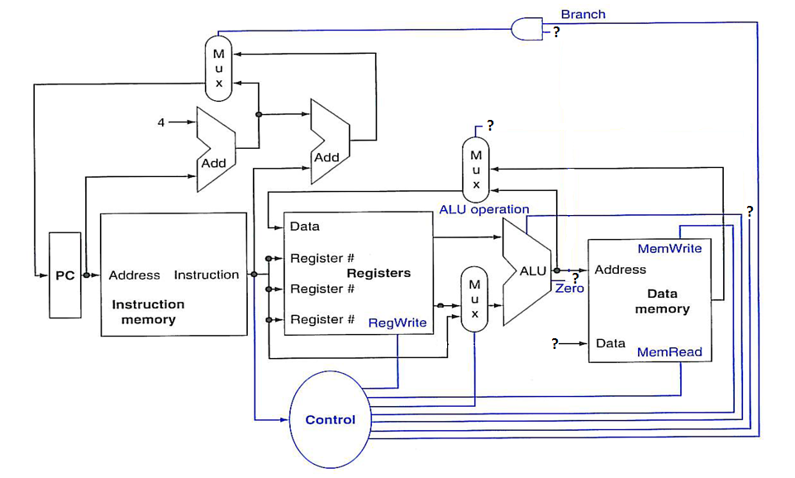

1. What do you mean by combinational elements and State elements? **2**
2. Following figure shows the datapath for **lw** instruction, label the figure where marked “**?**”. **5**

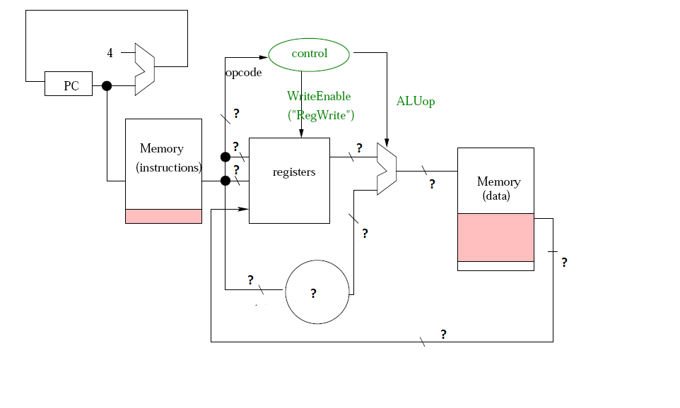

1. How address of the next instruction is calculated in **Jump** instruction, explain with appropriate figure. **5**