CSE 421 Lab Final

Name __________________________________ ID__________________ Section__________________ Mark__________________

**Subnet 0: 32 Hosts Hosts**

**Subnet 3: 2 Hosts**

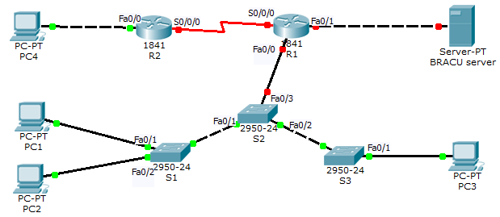

**Subnet 1: 20 Hosts**

**Hosts**

**Subnet 2: 14 Hosts**

|  |  |  |  |  |
| --- | --- | --- | --- | --- |
| **Device** | **Interface** | **IP Address** | **Subnet Mask** | **Default Gateway** |
| **R1** | **Fa0/1** |  |  |  |
| **S0/0/0** |  |  |  |
| **R2** | **Fa0/0** |  |  |  |
| **S0/0/0** |  |  |  |
| **PC1** | **NIC** | 187.170.2.98 | 255.255.255.240 | 187.170.2.97 |
| **PC2** | **NIC** | 187.170.2.106 | 255.255.255.240 | 187.170.2.106 |
| **PC3** | **NIC** | 187.170.2.99 | 255.255.255.240 | 187.170.2.97 |
| **PC4** | **NIC** |  |  |  |
| **BRACU Server** | **NIC** |  |  |  |

In this lab activity, you will be given a network address, and view the subnets to complete the addressing of the network shown in the Topology Diagram. As there will be no dynamic Routing, static routes will need to be configured so that hosts on networks that are not directly connected will be able to communicate with each other.

### ****Task 1: Subnet the Address Space.****

You have been given the **187.170.2.0/24** address space to complete the network design. Identify the IP addresses to complete the table above depending on the number of hosts marked in the topology. Assign subnet numbers depending on the descending order of the number of the hosts.

### ****Task 2: Assign Interface Addresses****

**[IP addresses from 14 hosts which should be your subnet 2 is already filled for you in the table. So just figure out the IP addresses from subnet 0, 1 & 3]**

* Assign the **first** valid host address in **subnet 0** to the **LAN** interface on **R1**.
* Assign the **second** valid host address in **subnet 0** to **BRACU server**.
* Assign the **las**t valid host address in **subnet 1** to the **LAN** interface on **R2**.
* Assign the **second** valid host address in **subnet 1** to **PC4**.
* Assign the **first** valid host address in **subnet 3** to the **WAN** interface on **R1**.
* Assign the **second** valid host address in **subnet 3** to the **WAN** interface on **R2**.

### ****Task 3: Set IP addresses in the devices****

Set IP addresses in the devices below:

* + - BRACU Server.
    - PC4

### ****Task 4: Basic configuration****

### ****Task4a: On router (R1 & R2)****

* Set hostname.
* Set EXEC mode password to **class**.
* Set console password to **cisco**.
* Set passwords for the virtual terminals to **cisco**
* Disable DNS lookup.

### ****Task4b: On Switch (S1, S2 & S3)****

* Set hostname.
* Set console password to **cisco**.
* Set passwords for the virtual terminals to **cisco**

### ****Task 5: VLAN****

### ****[Try to follow the steps chronologically]****

### ****Task5a: VLAN on S1****

* Create the following VLANs with the given names in S1.
  + **VLAN10**, name it to **Building5**
  + **VLAN20**, name it to **Building4**
* Go to S1 and assign:
  + VLAN10 to PC1
  + VLAN20 to PC2
* List port security actions in S1 (Fa0/1 & Fa0/2)
  + Enable port security
  + Set maximum static MACs to 2
  + Enable sticky MAC address
  + Set shutdown for port security violation

### ****Task5b: VLAN on S3****

* Create the following VLANS in S3.
  + **VLAN10**, name it to **Building5**
* Go to S3 and assign:
  + VLAN10 to PC3