|  |  |
| --- | --- |
| No. of Pages | **4** |
| No. of Questions | **5** |

**Department of Computer Science and Engineering**

**MIDTERM EXAMINATION FALL 2012**

**CSE421: Computer Network**

**Total Marks: 60 Time Allowed: 70 minutes**



* Answer ALL **FIVE (5)** questions
* Figure in bracket [] next to each question indicates marks for that question



**Question No. 1**

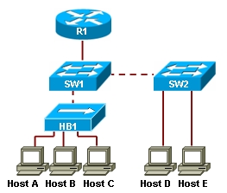

**Figure no. 1**

1. The switch SW1 has to run CSMA/CD, why? When Host C sends a packet to Host D, will the packet be received only by Host D, yes or no, explain your answer? [4 marks]
2. Where is the error checking method “CRC” used? How is the CRC bits calculated? Does the CRC divisor have to be same on both sides, yes or no, why? [5 marks]
3. Compare switches and routers. [3 marks]

**Question 2**

1. Suppose a company is given a block **200.32.64.0/21.** [9 marks]

The company needs to distribute these addresses to three branches Dhaka, Khulna and Chittagong as follows: (Create subnets as per requirements and show calculations.)

1. The first branch, Dhaka needs 500 addresses
2. The second branch, Khulna needs 450 addresses
3. The third branch, Chittagong needs 200 addresses

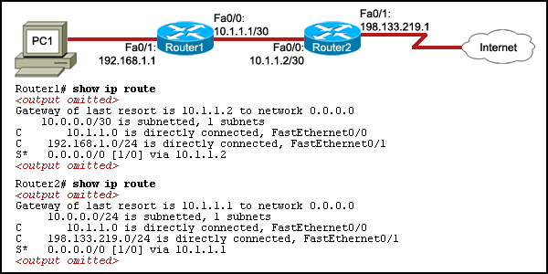

**Figure no. 2**

1. Refer to figure no.2. PC1 is unable to access the Internet. What is the cause of the problem? [3 marks]

**Question 3**

1. Distance vector routing protocol is decentralized, true or false? Explain briefly. [3 marks]
2. What would happen to a packet caught in a routing loop if all the distance vector mechanisms for avoiding such loops failed? Explain how split horizon with poison reverse works using the following network diagram shown in figure no.3. [5 marks]

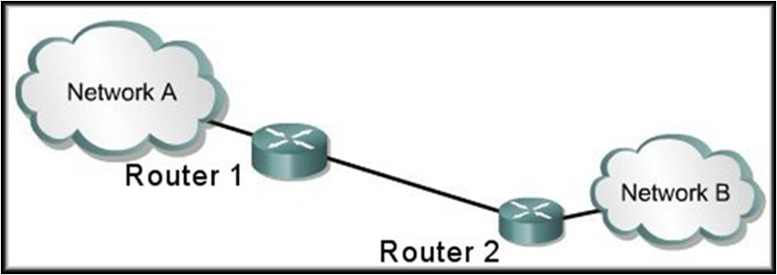

**Figure no. 3**

1. Router 1 is running RIPv2, and the “auto summary” has been issued in Router 1 shown in figure no. 4. Which route/s will Router 1 advertise through its serial port s0/0? [4 marks]

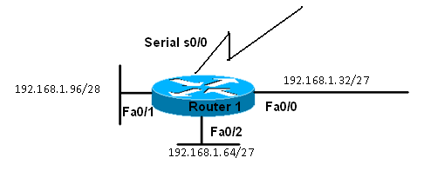

**Figure no. 4**

**Question 4**

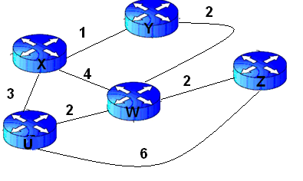

**Figure no. 5**

1. Link state routing protocol uses Dijkstra’s algorithm. Now using Dijkstra’s algorithm, compute the shortest path from Xto all other remote networks shown in Figure no.5. Use the table provided. [ 6 marks]
2. How does a router decide which is its “Router ID**”** in OSPF? [3 marks]
3. For two routers to become OSPF neighbors, what information needs to match? [3 marks]

**Question 5**

1. State at least 3 special features of EIGRP as compared with RIP or OSPF. [3 marks]
2. Router R2 shown in figure no. 6 next page receives two separate route information from R1 and R2 regarding the destination network 192.168.6.0/24. How do Router R2 decide which is the best path, via R1 or via R3? Explain your answer. [4 marks]

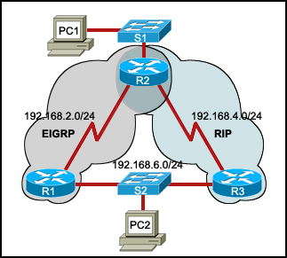

**Figure no. 6**

1. Refer to the network diagram shown below in figure no.7. The router output shown in figure no.8 is an output of which table from which router shown in the network diagram? What does the “P:” shown stand for? And what are these values (20514560/28160) refer to, explain? [5 marks]

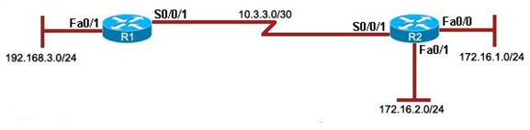

**Figure no. 7**

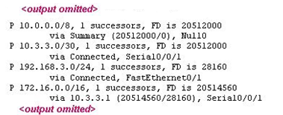

**Figure no. 8**

**THE END**