|  |  |
| --- | --- |
| No. of Pages | **3** |
| No. of Questions | **4** |

**Department of Computer Science and Engineering**

**MIDTERM EXAMINATION SPRING 2014**

**CSE421: Computer Network**

**Total Marks: 60 Time Allowed: 70 minutes**



* Answer ALL **FOUR (4)** questions
* Figure in bracket [] next to each question indicates marks for that question



**Question 1**

1. Suppose a company is given a block **147.32.176.0/23.**

The company needs to distribute these addresses to three branches Dhaka, Khulna and Chittagong as follows: (Create subnets as per requirements and show calculations.)

1. The first branch, Dhaka needs 100 addresses
2. The second branch, Khulna also needs 100 addresses
3. The third branch, Chittagong needs 60 addresses
4. And two serial links network addresses between the three routers.

[9 marks]

1. If either of the following would be correct, which version would be preferred? [3 marks]
2. ip route 192.168.3.0 255.255.255.0 serial 0/0
3. ip route 192.168.3.0 255.255.255.0 192.168.7.2

|  |  |  |  |  |  |  |
| --- | --- | --- | --- | --- | --- | --- |
| **Node z Table** | | |  |  |  |  |
|  | **x** | **y** | **z** | **w** | **u** | **m** |
| **x** | ∞ | ∞ | ∞ | ∞ | ∞ | ∞ |
| **y** | ∞ | ∞ | ∞ | ∞ | ∞ | ∞ |
| **z** | ∞ | 7 | 0 | 1 | ∞ | 4 |
| **w** | ∞ | ∞ | ∞ | ∞ | ∞ | ∞ |
| **U** | ∞ | ∞ | ∞ | ∞ | ∞ | ∞ |
| **m** | ∞ | ∞ | ∞ | ∞ | ∞ | ∞ |

**Question 2**

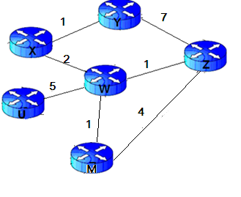

**Figure no. 1**

Distance Vector Routing Protocol uses Bellman Ford’s algorithm. For the above figure no. 1, the table represent the routing tables of node z initially. Router z receives updates from w and y only. All routers are running Distance Vector algorithm. What happens next? (Use Dx(y) = min{c(x,y) + Dy(y), c(x,z) + Dz(y)} for explaining your answer). Draw the final table of Router z. [6 marks]

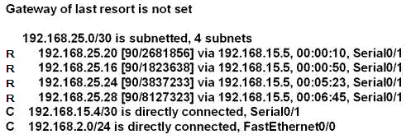

**Figure no. 2**

1. Figure no. 2 represents the routing table of a router running RIPv2, which routes can be summarized to a single route? [3 marks]
2. Explain Split Horizon rule in brief. [3 marks]

**Question 3**

1. How does a router running a link state routing protocol become aware of neighbours that are also running the same routing protocol? And what needs to be the same for the routers to become neighbours? [3 marks]
2. Initially for routers running link state routing protocol, there will be lots of traffic within the network, true or false? Explain in brief. [3 marks]

192.168.1.1

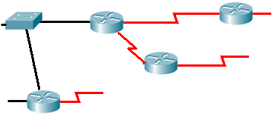

A

172.16.3.1

10.0.0.1

**Figure no. 3**

1. Router A has three active interfaces with IP addresses as shown in figure no. 3. It has no loopback interfaces and a router-id configured as 200.20.21.19. What router ID will it use when it takes part in a DR/BDR election, and why? [3 marks]
2. A serial link is configured to operate at 64 kbps using the clock rate 64000 command on the DCE interface. The bandwidth and cost commands are not used. What will be the calculated OSPF cost for the link? [3 marks]

**Question 4**

**Figure no. 4**

1. Why does EIRGP use RTP for query and update packets but not for acknowledgement packets? [3 marks]



**Figure no. 4**

1. Refer to figure no.4, the output is of which table of which router? This router is running which routing protocol? And what needs to be done so that the default route information is automatically sent via routing updates to other routers? [4 marks]
2. What is the purpose of this command, and what do the numbers represent? [2 marks]

Router(config-if)#**ip bandwidth-percent eigrp 1 40**

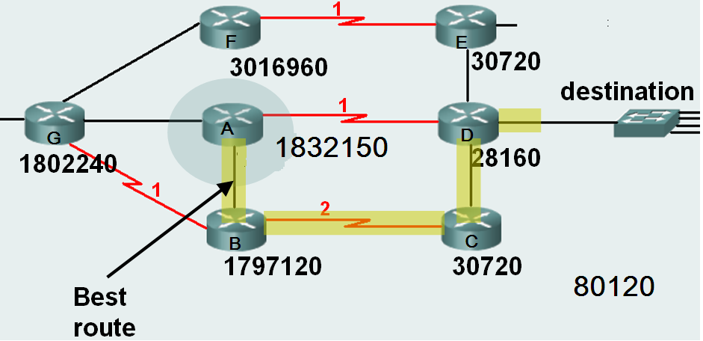

**Figure no. 5**

1. Router A has calculated the best route to the destination. Which router is the successor? Are there any feasible successors? If so, which are they? [3 marks]

**THE END**