|  |  |
| --- | --- |
| No. ofPages | **5** |
| No. of Questions | 8 |

**Department of Computer Science and Engineering**

**FINAL EXAMINATION FALL 2012**

**CSE421/EEE465: Computer Networks**

**Total Marks:90 Time Allowed: 3 Hours**

* Answer **AnySix (6)** questions out of **Eight (8)** questions.
* Figure in bracket [] next to each question indicates marks for that question.

## Question No. 1

1. In HTTP, cookies keep state of the client, how is it done, explain? [4 marks]
2. In DNS searching iterative method is better than recursive method, true or false? Explain. [4 marks]
3. A switch maintains a table to forward frames as shown below in figure no. 1. This switch remains inactive for an hour. Then a ping is sent from 0040.0b78.3dcd MAC to 00do.bab1.b36a MAC. What will the switch do and why? [4 marks]

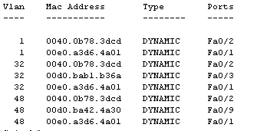

**Figure no. 1**

1. Differentiate between Checksum and CRC error detection method? In which layers are they used mostly? [3 marks]

## Question No. 2

1. How long will a routing loop continue? [3 marks]
2. Explain the methods Split Horizon Rule and Hold Down Timers used in avoiding loops? [6 mark]
3. For the figure no. 2, the tables represent the routing tables of nodes x,y ,z and w initially. Router z receives updates from y, w and x. All routers are running Distance Vector algorithm. What happens next? (Use Dx(y) = min{c(x,y) + Dy(y), c(x,z) + Dz(y)} for explaining your answer) [6 marks]

|  |  |  |  |  |
| --- | --- | --- | --- | --- |
| **Node z Table** | |  |  |  |
|  | **x** | **y** | **z** | **w** |
| **x** | ∞ | ∞ | ∞ | ∞ |
| **y** | ∞ | ∞ | ∞ | ∞ |
| **z** | ∞ | 1 | 0 | 3 |
| **w** | ∞ | ∞ | ∞ | ∞ |

|  |  |  |  |  |
| --- | --- | --- | --- | --- |
| **Node w Table** | | |  |  |
|  | **x** | **y** | **z** | **w** |
| **x** | ∞ | ∞ | ∞ | ∞ |
| **y** | ∞ | ∞ | ∞ | ∞ |
| **z** | ∞ | ∞ | ∞ | ∞ |
| **w** | 6 | 3 | 3 | 0 |

|  |  |  |  |  |
| --- | --- | --- | --- | --- |
| **Node y Table** | | |  |  |
|  | **x** | **y** | **z** | **w** |
| **x** | ∞ | ∞ | ∞ | ∞ |
| **y** | 2 | 0 | 1 | ∞ |
| **z** | ∞ | ∞ | ∞ | ∞ |
| **w** | ∞ | ∞ | ∞ | ∞ |

|  |  |  |  |  |
| --- | --- | --- | --- | --- |
| **Node x Table** | | |  |  |
|  | **x** | **y** | **z** | **w** |
| **x** | 0 | 2 | ∞ | 6 |
| **y** | ∞ | ∞ | ∞ | ∞ |
| **z** | ∞ | ∞ | ∞ | ∞ |
| **w** | ∞ | ∞ | ∞ | ∞ |

**Figure No. 2**

## Question No. 3

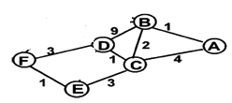

**Figure No. 3**

1. Refer to the figure no. 3 shown above. Link state routing protocol uses Dijkstra’s algorithm. Now using Dijkstra’s algorithm, compute the shortest path from F.Use the table provided. [5 marks]
2. What does a link state packet contain? What does each router do when link state packets have all been exchanged? [4 marks]
3. What is the difference in sending updates in Distance Vector and Link State Routing Protocol? [3 marks]

## Question No. 4

1. What is the difference between Interdomain routing and Intradomain routing? [3 marks]
2. When advertising routes, the attributes or information that BGP helps to send from one router to another, what does ORIGIN and AS_PATH mean? [4 marks]

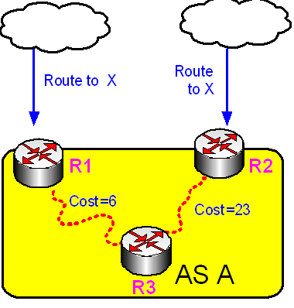

**Figure No. 4**

1. Refer to the exhibit shown in figure no. 4. Router R3 is using Hot potato routing to determine the route to X, but hot potato routing can sometimes backfire, how explain? [4 marks]
2. Short AS_PATH does not mean route is short, true or false? Explain. [4 marks]

## Question No. 5

1. Flow Control and Congestion Control in transport layer are similar in functions, how are they different? [3 marks]
2. Howis the window size determined in TCP? [3 marks]
3. What is the difference between choke packets and explicit signaling? Are they both open loop? [4 marks]

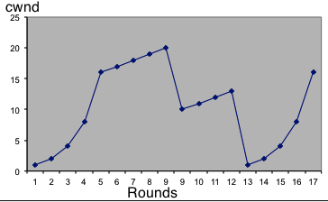

**Figure No. 5**

1. Explain what is happening from where the arrow is pointing shown in figure no. 5? [5 marks]

###### Question No. 6

1. A company has acquired a public address 210.32.196.0/23. It needs four network addresses for its four branches. Dhaka branch has 220 hosts, Khulna has 100 hosts, Barisal and Sylhet has 30 hosts. Create these four addresses using subnetting. Do not forget to show calculations. [5 marks]

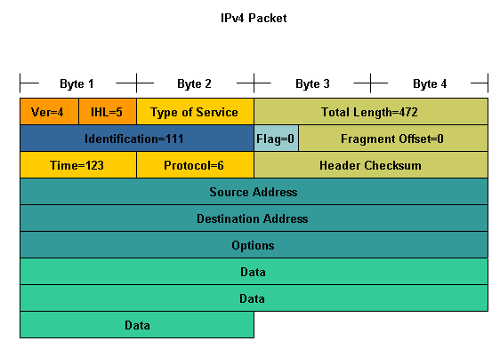

**Figure No. 6**

1. Which fields in the IPv4 header shown in figure no. 6 are used for fragmentation and briefly explain those fields? [5 marks]
2. In “Traceroute” application, the originator sends the first packet with TTL=1, when this packet reaches the first hop, what kind of packet does the router sent in reply ? [2 marks]
3. Ping is usually a helpful application. But using Ping can be used to create problems, how? [3 marks]

###### Question No. 7

1. State some basic differences between wired LANs and wireless LANs. [3 marks]
2. How does a host associate with a wireless access point using passive scanning? [4 marks]
3. How do RTS and CTS packets help to avoid collisions in a wireless setup? [4 marks]
4. 2 access points are connected with a switch creating two overlapping BSS. A host laptop is associated with the first AP and is connected to the Internet. As the host moves it comes closer to the 2nd AP and associates with it. What will happen to previous TCP connections of the host laptop? [4 marks]

###### 

###### Question No. 8

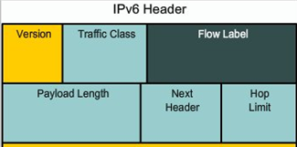

**Figure no. 7**

1. The above figure no. 7represents the partial header of IPv6 (Source IP and Destination IP not shown). Explain the purpose of Next Header field and did IPv4 have a similar header that is a header for the same purpose? [4 marks]

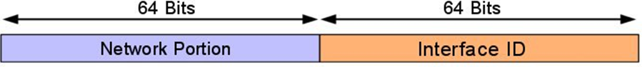

**Figure no. 8**

1. How is the Interface ID assigned using EUI-64 interface ID, that is how is the MAC of the device included in the interface ID part shown in figure no. 8? [4 marks]

**Figure no. 9**

**1a43:f01::22::fa**

1. The above value in the box shown in figure no. 9 represents an IPV6 address. Is it valid? Write it in its original form. [3 marks]
2. “6to4” is what type of transition technique and how does it work? [4 marks]

##### THE END