|  |  |
| --- | --- |
| No. of Pages | **4** |
| No. of Questions | 7 |

**Department of Computer Science and Engineering**

**FINAL EXAMINATION’ FALL 2013**

**CSE421/EEE465: Computer Networks**

**Total Marks: 75 Time Allowed: 2 Hours**

* Answer **Any Five (5)** questions out of **Seven (7)** questions.
* Figure in bracket [] next to each question indicates marks for that question.

## Question No. 1

1. When does a switch send a frame out to all its active ports except the port it received the frame from? And when does it sent only to a specific port? [5 marks]
2. List the steps involved in the error detection method “Checksum” from the sender side. In which layer is this checksum used? [5 marks]
3. We are sending a packet to a different network through a router. An ARP is a broadcast packet, and routers do not forward broadcast packets. So in this case what happens to that ARP packet? [5 marks]

## Question No. 2

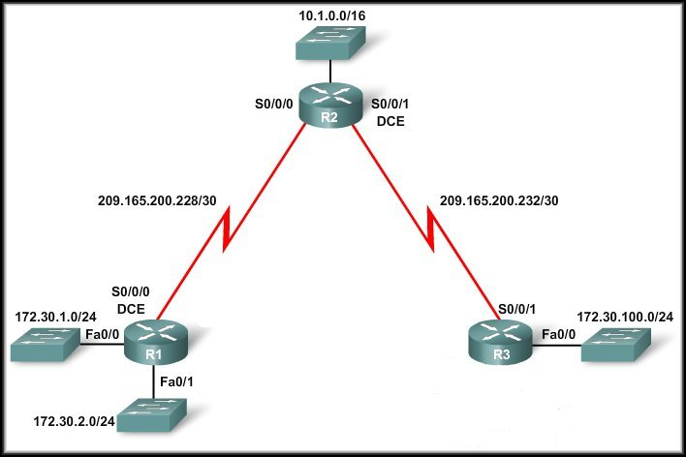

**Figure No. 1**

1. For discontiguous networks, if routers are using RIPv2, then auto summary must be disabled, explain using the network shown in figure no.1 above. [5 marks]

**Figure no. 2**

1. What is the difference between TTL and Count to Infinity? [4 marks]
2. What is the purpose of the command “redistribute static? [3 marks]

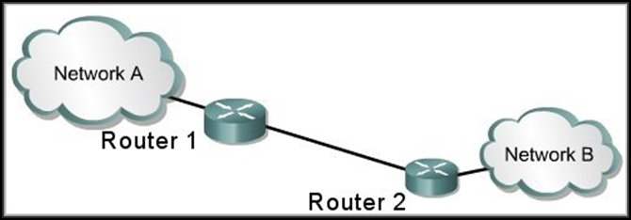

**Figure No. 2**

1. Explain Split Horizon rule briefly using the above figure no.2 ? [3 marks]

## Question No. 3

A routing table contains the entry:

192.168.3.0/24 [110/1786] via 192.168.1.0, 00:00:20, Serial0/0

**Figure No. 3**

1. Refer to the figure no. 3 shown above. What are the numbers in brackets? And how are they calculated? [5 marks]
2. Why do we need DR and BDR? What criteria are used to choose a DR and BDR? What should you do to the configuration of a router that you want to win the election for DR on a multi-access network? [6 marks]
3. How does a router running a link state routing protocol become aware of neighbours that are also running the same routing protocol? How does a router detect that its neighbor has gone down? [4 marks]

## Question No. 4

1. Why do we issue the “default information originate” command in EIGRP ? [4 marks]
2. What is RTP? Why does EIRGP use RTP? [4 marks]



**Figure No. 5**

1. The above figure no. 5 shows multiple unequal cost paths to a destination 192.168.90.0 network. In which table would you find the above paths? What was used to calculate the cost for this path? What does the letter “P” implies? [6 marks]

## Question No. 5

1. Flow Control and Congestion Control in transport layer are similar in functions, how are they different? [3 marks]
2. How is the window size determined in TCP? [3 marks]
3. In Implicit Signaling method, there is no communication between the congested nodes and source nodes. So how does the source node know when to slow down? [4 marks]

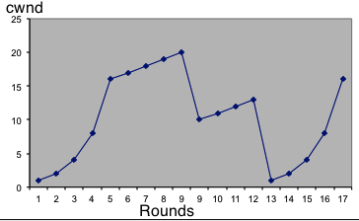

**Figure No. 6**

1. Explain what is happening from where the arrow is pointing shown in figure no. 6 and also why? [5 marks]

###### Question No. 6



**Figure No. 7**

1. Explain hot potato routing using the above figure no. 7? [4 marks]
2. How are loops prevented in BGP? [3 marks]
3. Why does IPv4 must further fragment a packet? If fragmentation occurs how a receiver knows that it has received the last packet? [4 marks]
4. Ping is usually a helpful application. But using Ping can be used to create problems, how explain with one example? [4 marks]

###### 

###### Question No. 7

1. What is the objective of extension headers in IPv6? [4 marks]
2. State the types of address available in IPv6. Which type is missing? [3 marks]
3. How does a host get its IP address using dynamic stateless auto configuration? [5 marks]
4. In the 6 to 4 tunneling process, what happens? [3 marks]

##### THE END