|  |  |
| --- | --- |
| No. of Pages | **6** |
| No. of Questions | 7 |

**Department of Computer Science and Engineering**

**FINAL EXAMINATION FALL 2015**

**CSE421/EEE 465: Computer Networks**

**Total Marks: 100 Time Allowed: 3 Hours**

* Answer **Any** **Five (5)** questions out of **Seven (7)** questions.
* Figure in bracket [] next to each question indicates marks for that question.

###### http://ccnablogcom.c.presscdn.com/wp-content/uploads/2014/07/070214_1803_OSPFPartIV7.jpgQuestion No. 1

**Figure No. 1**

1. Refer to figure no. 1 and table no. 1 identify router IDs, DR, BDR [Marks 5+1+1]

|  |  |  |  |  |
| --- | --- | --- | --- | --- |
| Router | Router-ID | Priority | DR (1/0) | BDR (1/0) |
| R1 |  | 1 |  |  |
| R2 |  | 1 |  |  |
| R3 |  | 1 |  |  |
| R4 |  | 1 |  |  |
| R5 | 201.173.1.5 | 0 |  |  |
| R6 |  | 0 |  |  |

**Table No. 1**

1. The DR and BDR selection process is run only if the DR fails.
2. What happens if the DR in the above mentioned scenario fails? [ 2 marks]
3. Who are the new DR and BDR? [2 marks]
4. What if the failed DR comes back online again? Who are the new DR and BDR then? [3 marks]
5. Why do you think loopback interface has priority over active physical interface during router ID selection process? [3 marks]
6. For two routers to become OSPF neighbors, what information needs to match? [3marks]

###### Question No. 2

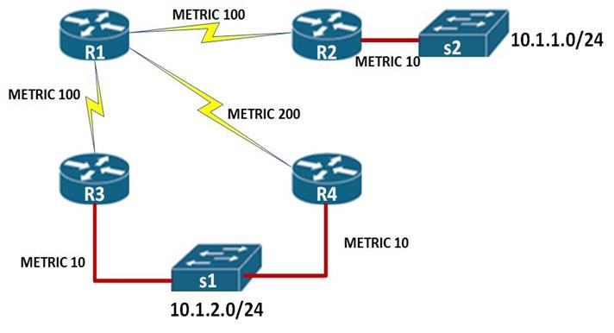

**Figure No. 2**

1. Assume all the routers of figure no. 2 are running EIGRP and lower the metric better the route.
   1. How many paths are there to reach network 10.1.2.0 from router R1? What are the cost metric of those paths? [3 marks]
   2. What is the feasible distance to network 10.1.2.0? Who is the successor? [3 marks]
   3. What are the reported distance from R3 and R4 to R1? [3 marks]
   4. Is there a feasible successor to R1? If yes, who is it? Explain how does it meet the feasibility condition? [5 marks]

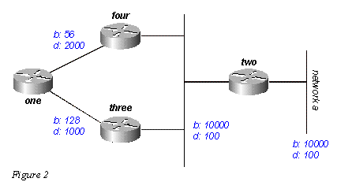

**Figure No. 3**

1. Refer to figure 3 assume all the routers are running EIGRP, for router “one” calculate the cost metrics to reach network **a**: [2+2 marks]
   1. Bandwidth= (107 /***x***)*256. What is the value for ***x***?
   2. Delay = (***y***/10)*256. What is the value for ***y***?
2. “EIGRP updates are partial and bounded” – Explain. [2 marks]

###### Question No. 3

1. In which two cases will a switch broadcast the frame to all outgoing ports that it has received from an incoming port? [3 marks]

line vty 0 4

password 7 030752180500

login

transport input ssh

**Figure No. 4**

1. The following output shown in figure no. 4 was taken from a configuration file of a switch. What does it imply? [4 marks]
2. To prevent DHCP starvation, we use trusted ports, where and why? [4 marks]
3. In a switched network, cut through switching causes delay, true or false, explain briefly? [3 marks]
4. Explain the commands shown in figure no. 5? Three PCs were connected to this port. Now T\this switch is turned off and then on again. What happens if another new PC (different from the first three) tries to connect to the port? What will happen? [6 marks]

SW1(config)#int fa 0/13

SW1(config-if)#switchport port-security

SW1(config-if)# switchport port-security maximum 3

SW1(config-if)#end

**Figure No.5**

**Figure No. 9**

## Question No. 4

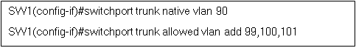

**Figure No. 6**

1. What is the purpose of giving the first and second commands shown in the above figure no.6? What happens if both of the commands are not given, will there be a difference? [4 marks]
2. What is the word “tagging” mean in VLANs? Who or what does the tagging? [4 marks]

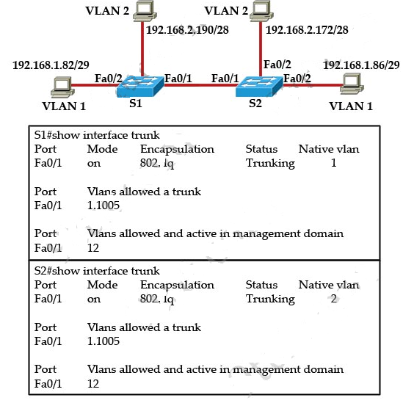

**Figure No. 7**

1. Refer to the diagram above in figure no. 7, it seems that there is a problem in intra VLAN communication, can you identify that problem and solve it? [3 marks]

R(config)#**interface f0/1.22**

R(config-subif)#**encapsulation dot1q 20**

R(config-subif)#**ip add 200.10.30.5 255.255.255.192**

R(config-subif)#**interface f0/1.33**

R(config-subif)#**encapsulation dot1q 30**

R(config-subif)#**ip add 200.10.30.130 255.255.255.192**

R(config-subif)#**interface f0/1.44**

R(config-subif)#**encapsulation dot1q 40**

R(config-subif)#**ip add 200.10.30.200 255.255.255.192**

R(config-subif)# **interface f0/1**

R(config-if)#**no shutdown**

**Figure No. 8**

1. Refer to the commands shown in the above figure no. 8, [2+2+5]
   1. Explain the “encapsulation dot1q 20” command.
   2. The sub-interface number and VLAN number do not match, will it be a problem?
   3. Referring to the commands shown in figure no. 8, suppose that the router receives two frames on physical interface f0/1.The source IP of Frame 1is 172.18.0.4/27 and the destination IP address is 200.10.30.144/26. The source IP of Frame 2 is 200.10.30.6/26 and destination IP is 200.20.30.125/28. What will the router do and why?

###### Question No. 5

1. Suppose that the data bytes of an original datagram of 3960 bytes which includes 40 bytes of header. The datagram is to be sent from PC1 to PC2. The datagram has to go through the network R1 –R2. The network between R1 and R2 only allows maximum data frames of 1200 bytes. The identification number of the first datagram is 111. And header length is 40 bytes. So fragment the data accordingly using the following table structure. [6 marks]
2. What if for the above scenario the don’t fragment bit was on? [2 marks]

|  |  |  |  |  |
| --- | --- | --- | --- | --- |
| Identification  No. | Total length  field | Fragmentation  offset | M: more fragment bit | Range of data bytes in the frame |

[4 marks]

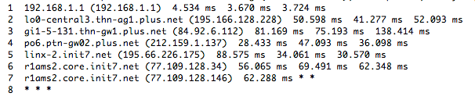

**Figure No. 9**

1. What command will produce the output shown in the above figure no.9? Why is there * * * at the 8th entry? [4 marks]
2. ICMP is used in different scenario to provide error messages to the hosts. Give two examples of different error messages used by ICMP. [5 marks]
3. 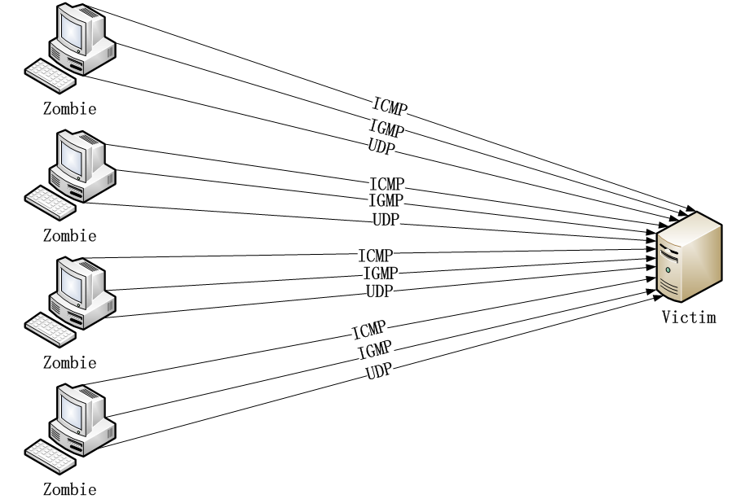Refer to figure no. 10 below, what kind of attack is this? [3 marks]

**Figure No. 10**

###### 

###### Question No. 6

1. Write the shorthand string notation of the following IPv6 address: [3 marks]

**2031: 0000: 130F: 0000: 0000: 09C0: 876A: 130B**

NDP



IPv6 Router

48 bit MAC address

**Figure No. 11**

IPv6 address

1. Explain the IPv6 address management procedure of figure no. 11. If MAC address of the device is **0000: 0B0A: 2D51** and the router interface is configured with the address **2001: DB8: 2222: 7272::/64** what will be the IP address of the device? [8 marks]
2. What is an anycast address? Why IPv6 does not have broadcast addresses? [4 marks]
3. How can an IPv6 packet traverse a network that is still using IPv4? [5 marks]

###### Question No. 7

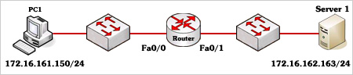

**Figure No. 12**

1. Referring to the above figure no. 12, what will the maximum number of ACLs that can be written in the Router? [3 marks]
2. Referring to the above figure no. 12, write a standard ACL that will not allow PC1 access to Server 1 but all other traffic from any source is allowed to Server 1. [4 marks]
3. Refer to figure no. 12, write another standard ACL that will only allow PC1 to telnet into the Router. [5 marks]
4. Write a named ACL that will allow hosts of CSE Department to have only web and FTP access to the Server 1 and nothing else as shown in figure no. 13. EEE Department is not allowed any kind of access to Server 1. But all other traffics to Sever 2 and the Internet is allowed. DO not forget to place the ACLs appropriately. [8 marks]

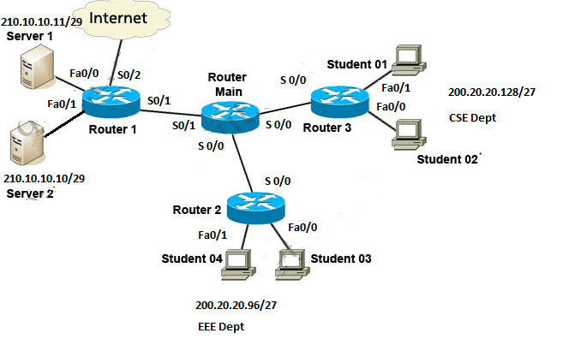

**Figure No. 13**

##### THE END