|  |  |
| --- | --- |
| No. of Pages | **5** |
| No. of Questions | 8 |

**Department of Computer Science and Engineering**

**FINAL EXAMINATION SUMMER 2013**

**CSE421: Computer Networks**

**Total Marks: 90 Time Allowed: 3 Hours**

* Answer **Any** **Six (6)** questions out of **Eight (8)** questions.
* Figure in bracket [] next to each question indicates marks for that question.

## Question No. 1

1. HTTP1.1 can be persistent with or without pipelining. Draw examples of both scenarios. [4 marks]
2. HTTP is always a stateless protocol, true or false. [4 marks]
3. What is the goal of “conditional GET” in HTTP? [3 marks]
4. Cookies do not contain viruses but can make surfing faster, justify this statement. [4 marks]

## Question No. 2

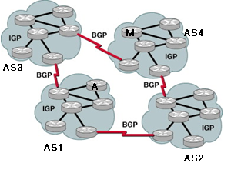

**Figure No. 1**

1. Refer to the diagram shown above, how does Router A decide the path to take to reach Router M, through AS3 or through AS2? [4 marks]
2. Using the figure no.1 explain which AS is a Multihomed AS and a Transit AS? [3 marks]
3. When advertising routes, what are the main attributes or information that BGP helps to send from one router to another? [4 marks]
4. Router B in AS4 shown in figure no. 2 receives two AS_PATHs to 171.12.1.0/25 network in AS1, {AS3,AS2 ,AS1} and {AS5,AS1}, which one will it take? And is that path better than the other? [4 marks]

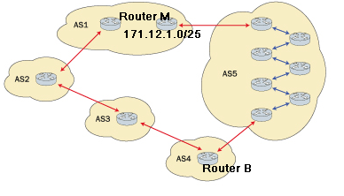

**Figure No. 2**

## Question No. 3

|  |  |  |  |  |
| --- | --- | --- | --- | --- |
| **Node z Table** | |  |  |  |
|  | **x** | **y** | **z** | **w** |
| **x** | ∞ | ∞ | ∞ | ∞ |
| **y** | ∞ | ∞ | ∞ | ∞ |
| **z** | 8 | 12 | 0 | 4 |
| **w** | ∞ | ∞ | ∞ | ∞ |

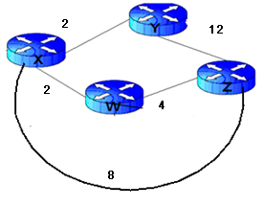

**Figure No. 3**

1. For the above figure no. 3, the table represent the routing table of Router z initially. Router z receives updates from y and then x. All routers are running Distance Vector algorithm. Show how the updates affect the routing table of Router z? Just show Router z’s table. (Use Dx(y) = min{c(x,y) + Dy(y), c(x,z) + Dz(y)} for explaining your answer). [5 marks]

**Figure No. 4**



1. What is the effect of the above commands shown in figure no.4? [3 marks]
2. How does Administrative Distance help to choose a better path for routers? [3 marks]
3. How does “count to infinity” help in preventing routing loops? What is the value of infinite in RIPv2 routing protocol? [4 marks]

## Question No. 4

**Figure No. 2**

1. What are the advantages of using Link state routing protocol over Distance vector routing protocol? [4 marks]

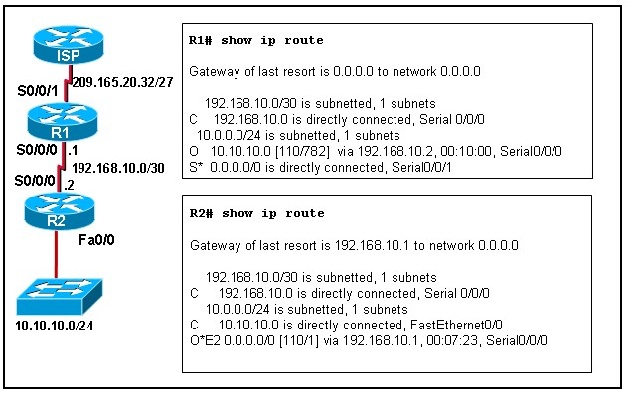

**Figure No. 5**

1. Refer to the exhibit shown in figure no. 5. The last entry in the routing table of R2 corresponds to which route of router R1? What type of route is it? [3 marks]
2. How does a router running a link state routing protocol become aware of neighbours that are also running the same routing protocol? How does a router detect that its neighbor has gone down? [4 marks]
3. How can you configure your most powerful router so that it should win a DR/BDR election even if it does not have the highest router ID? What sort of router is referred to as DROther?

[4 marks]

## Question No. 5

1. How does TCP decide the window size during a communication? In what conditions will a host retransmit if a packet is lost? [4 marks]
2. Congestion control and flow control is the same, true or false, explain. [3 marks]
3. What is the difference between explicit and implicit signaling in congestion? [4 marks]

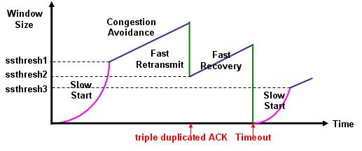

**Figure No. 6**

1. Refer to the diagram above in figure no. 6, why is fast recovery (multiplicative additive) done after 3 duplicate acks were received? How is the ssthresh decided then? [4 marks]

###### Question No. 6

1. Suppose that the data bytes of an original datagram 1200 bytes. The datagram is to be sent from PC1 to PC2. The datagram has to go through the network R1 –R2. The network between R1 and R2 only allows maximum data frames of 360 bytes. The identification number of the first datagram is 555. And header length is 20bytes. So fragment the data accordingly using the following table structure. [4 marks]

|  |  |  |  |  |
| --- | --- | --- | --- | --- |
| Identification  No. | Total length  field | Fragmentation  offset | M: more fragment bit | Range of data bytes in the frame |

[4 marks]

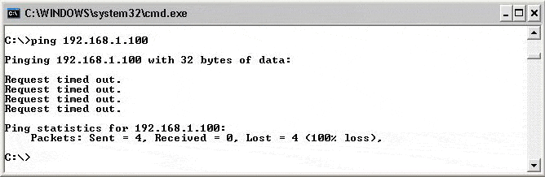

**Figure No. 7**

1. In the above figure no.7, explain what is happening? [4 marks]
2. What is the difference between Traceroute and Ping? [3 marks]
3. How can one create DOS attack using ICMP? [4 marks]

###### Question No. 7

**Gateway of last resort is not set**

**10.0.0.0/8 is variably subnetted, 2 subnets, 2 masks**

**C 10.0.4.0/24 is directly connected, FastEthernet0**

**D 192.168.100.0/24 [90/2195456] via 192.168.4.101, 00:00:08, Serial0**

**D 192.168.101.0/24 [90/2195837] via 192.168.3.1, 00:00:05, Ethernet0**

**C 192.168.4.0/24 is directly connected, Serial0**

**Figure No. 8**

1. The above figure no.8 shows the output from which table? Which value represents the cost of a destination network and how was the cost calculate? [4 marks]
2. Why does EIGRP use RTP? [3 marks]
3. If a neighbour does not appear in the neighbour table, what should you check before troubleshooting the EIGRP configuration? [3 marks]
4. A router M running EIGRP finds 3 routes to the same destination through its 4 neighbors A, B,C and D.

Route through A has FD 3523840 and RD 3011840

Route through B has FD 2297856 and RD 39260

Route through C has FD 3558000 and RD 2115200

Route through D has FD 2297856 and RD 42260

Which route/s will become the successor and feasible successor/s? Explain your answer. [5 marks]

###### 

###### Question No. 8

1. How does the flow label field in the IPv6 header help in data transmission? [3 marks]

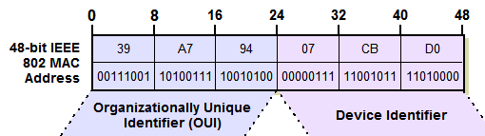

**Figure No. 9**

1. How is the IPv6 address created by using Dynamic Stateless Auto configuration with EUI-64? Use the MAC address provided in figure no. 9 above. [4 marks]
2. What type of address is no longer present in IPv6 and why? [3 marks]

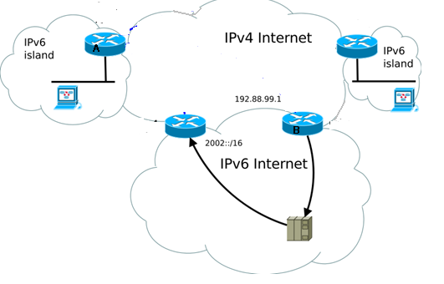

**Figure No. 10**

1. In what efficient way can we maintain communications between the IPv6 islands through IPv4 Internet shown in figure no. 10? [5 marks]

##### THE END