|  |  |
| --- | --- |
| No. of Pages | **3** |
| No. of Questions | 4 |

**Department of Computer Science and Engineering**

**FINAL EXAMINATION SUMMER 2014**

**CSE490/EEE453: WAN Routing and Technologies**

**Total Marks:48 Time Allowed: 50 minutes**

* Answer ALL FOUR **(4)** questions.
* Figure in bracket [] next to each question indicates marks for that question.

## Question No. 1

1. Which switch interface(s) should be configured with an IP address, and why do we need an IP address for the switch? [4 marks]
2. Why do network administrators recommend that you issue the command “no CDP run”? [4 marks]

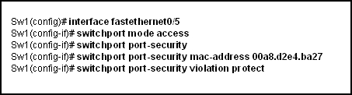

**Figure No. 1**

1. Refer to the figure no.1 above. What happens when a frame from a source MAC address different from 00a8.d2e4.ba27 reaches switch port 0/5? [4 marks]

###### Question No. 2

1. What steps should a network administrator go through before adding an old switch to an existing network? [3 marks]
2. Is a client switch able to obtain VLAN information when it reboots? [2 marks]
3. A client and a transparent switch receives a summary advertisement with a lower configuration revision number than their own. What do they do? [3 marks]
4. List some common problems because of which two switches are not exchanging VTP information. [4 marks]

**Question No. 3**

SW1(config)#int fa 0/18

SW1(config-if)#mls qos trust cos

SW1(config-if)#switchport voice VLAN 150

SW1(config-if)# switchport port mode access

SW1(config-if)# switchport access vlan 20

SW1(config-if)#end

**Figure No. 2**

1. Refer to the commands shown above in figure no. 2, why are there two VLANs associated with a single port fa0/18? [4 marks]

R1(config)#int f0/0.3

R1(config-subif)#encapsulation dot1q 20

R1(config-subif)#ip address 192.173.2.20 255.255.255.240

R1(config-subif)#end

**Figure No. 3**

1. Refer to the commands shown in figure no. 3, the VLAN number and the router subinterface number do not match, will it be a problem? Explain yes or no. And will a PC with the IP address of 192.173.30/28 have the ip address of int fa0/0.3 as its default gateway? [5 marks]

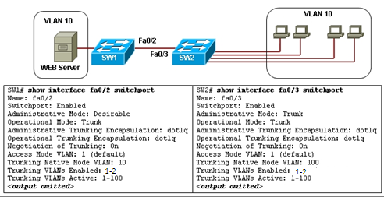

**Figure No. 4**

1. Refer to the exhibit shown in figure no. 4. Users complain that they do not have connectivity to the web server that is connected to SW1. What should be done to remedy the problem? [3 marks]

Question No. 4

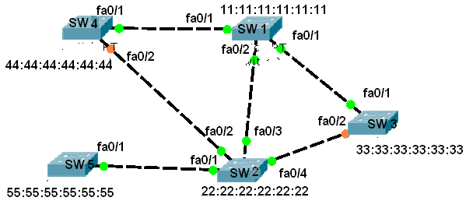

**Figure No. 5**

1. For the above switched network shown in figure no. 5, apply spanning tree protocol and detect the root bridge and the root ports. Give your reason for choosing the root bridge and root ports. [4 marks]

1. By default, what is used to calculate the spanning-tree path cost? [2 marks]
2. What is the difference between port priority and bridge priority? [3 marks]
3. Which states in STP are no longer available in RSTP, and why? [3 marks]

##### THE END