|  |  |
| --- | --- |
| No. of Pages | **3** |
| No. of Questions | 4 |

A

**Department of Computer Science and Engineering**

**MIDTERM EXAMINATION SPRING 2016**

**CSE490/EEE453: WAN Routing and Technologies**

**Total Marks:60 Time Allowed: 55 minutes**

* Answer ALL FOUR **(4)** questions.
* Figure in bracket [] next to each question indicates marks for that question.

## Question No. 1

* 1. Refer to figure no.1, name the different routers and the type of LSA that they send in the separate sheet provided. [7 marks]

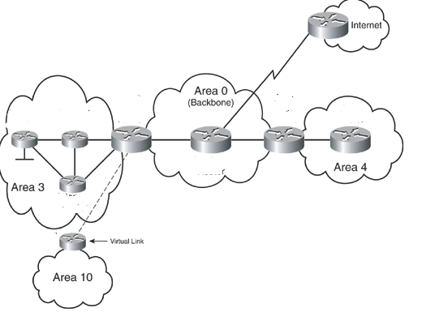

**Figure No. 1**

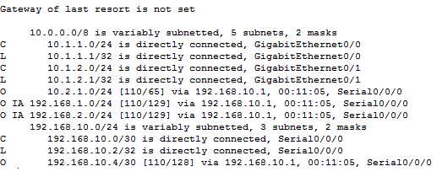

**Figure No. 2**

###### Refer to the output shown in figure no. 2. What are the different OSPF routes present? Which type of OSPF route is not present and why? [5 marks]

###### Question No. 2

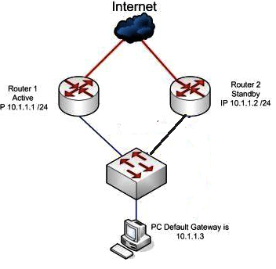

**Figure No. 3**

1. Both Router 1 and Router 2 are running HSRP, so when Router 1 fails, the PC experiences no disruption of service, why? [5 marks]
2. What are the enhanced features of GLBP over HSRP? [4 marks]
3. TRAP and INFORM messages are used where and for what purpose? [3 marks]

Question No. 3

1. In DHCPv6 differentiate between SLAAC and Stateless DHCPv6. [Just draw the process diagram] [5 marks]
2. What is the purpose of the command “ip helper address 200.20.20.10”? [2 marks]

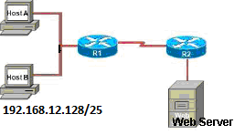

**Figure No. 4**

**Figure No. 11**

1. Configure the router R1 as a NAT server to dynamically assign global outside IP addresses from the NAT pool 201.20.20.32/30 to local inside packets attempting to access the Internet. Then any packet with an IP address from the 192.168.12.128/25 network will be translated with the rest of the pool addresses. [5 marks]

## Question No. 4

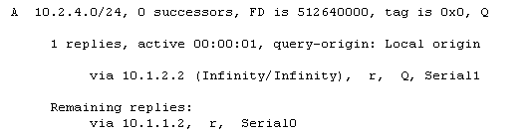

**Figure No. 5**

1. Refer to the output shown in figure no.5. Which table was the output from? Explain the first two lines. [4 marks]

**D*EX 0.0.0.0/0 [170/3651840] via 192.168.10.6, 00:01:08, Serial0/1**

1. The above line is from a routing table of a router. What kind of route is this? Why is the AD 170? [5 marks]
2. What is the advantage of EIGRP storing feasible successor routes as well as successor routes?

[3 marks]

##### THE END